Job Profile comprising Job Description and Person Specification
Job Description

Job Title:  Programme and Partnerships Manager, Richmond Arts Service | Grade:  PO3
Section:  Arts | Directorate:  Environment and Community Services
Responsible to following manager:  Arts Service Manager | Responsible for following staff:  Programmer (Arts Development) Programmer (Exhibitions and Collections) Programmer (Learning and Engagement)
Post Number/s: | Last review date:  May 2024

Working for the Richmond/Wandsworth Shared Staffing Arrangement

This role is employed under the Shared Staffing Arrangement between Richmond and Wandsworth Councils. The overall purpose of the Shared Staffing Arrangement is to provide the highest quality of service at the lowest attainable cost.

Staff are expected to deliver high quality and responsive services wherever they are based, as well as having the ability to adapt to sometimes differing processes and expectations.

The Shared Staffing Arrangement aims to be at the forefront of innovation in local government and the organisation will invest in the development of its staff and ensure the opportunities for progression that only a large organisation can provide.

Job Purpose

The Programme and Partnerships Manager is responsible for the creative and cultural programmes delivered by Richmond Arts Service.

Richmond Arts Service has developed a new vision and team which delivers an artist-led and participatory programme including innovative contemporary work at Orleans House Gallery and the new Richmond Arts and Ideas Festival.

The team also works strategically to develop the arts ecology across Richmond, including sector support initiatives and supporting the borough’s creative learning programmes.

Both direct delivery and strategic work are underpinned by partnerships work – with services from across the council, artists, universities, and local, national and international arts organisations.

The Programme and Partnerships Manager with the Arts Service Manager and the Operations Manager make up the senior leadership of the service, with strategic responsibility for the direction of the service, alongside accountability for service delivery.

The Environment and Community Services Directorate is divided into four divisions and Richmond Arts Service is part of the Culture division alongside Parks, Sports and Libraries.

The post requires an experienced cultural manager, with experience of
developing and managing public programmes, and the partnerships, teams and resources to deliver them.

The Programme and Partnerships Manager will work closely with staff from across the council, Members, partners, members of the public and members of outside organisations.

Specific Duties and Responsibilities

- To lead development and delivery of the programme for the Arts Service for the London Borough of Richmond upon Thames, including development and delivery of public-facing programmes with high levels of public participation.

- To lead the team that is responsible for the creation and delivery of the programme, creating the right environment for the development of high quality and innovative creative projects. There are 8 FTE staff members within this part of Richmond Arts Service, working alongside contractors, sessional staff and volunteers.

- To develop and manage partnerships and commissioning arrangements with arts and non-arts partners. The development and ongoing management of a partnership strategy which maximises opportunities for impact and investment from other sources.

- To lead on Audience Development and Evaluation for Richmond Arts Service, working to ensure we are meeting our vision objectives, measuring impact, and that service users are reflective of local people. This includes overseeing the Marketing and Communication strategy, and related systems and processes.

- To manage budgets and financial targets and where required make operational and service changes to meet financial restrictions. This includes core budgets and securing additional revenue funds for programmes from a variety of sources.

- To develop and contribute to strategic initiatives and policies which increase the effectiveness of our services. Working with other Council services and partners to increase the public benefit on shared priorities.

- To oversee the system of secure storage of, care of, and maintenance of, the
boroughs art collection. Alongside ensuring continuing public access to this
resource. (Directly managed by the Exhibitions and Collections Programmer.)

- To work flexibly across the directorate and provide support and cover to other
senior staff as required.

Generic Duties and Responsibilities

- To contribute to the continuous improvement of the services of the Boroughs of Wandsworth and Richmond.

- To comply with relevant Codes of Practice, including the Code of Conduct and policies concerning data protection and health and safety.

- To adhere to security controls and requirements as mandated by the SSA’s policies, procedures and local risk assessments to maintain confidentiality, integrity, availability and legal compliance of information and systems

- To promote equality, diversity, and inclusion, maintaining an awareness of the equality and diversity protocol/policy and working to create and maintain a safe, supportive and welcoming environment where all people are treated with dignity and their identity and culture are valued and respected.

- To understand both Councils’ duties and responsibilities for safeguarding children, young people and adults as they apply to the role within the council.

- The profile is not intended to be an exhaustive list of the duties the post holder will carry out. Other reasonable duties commensurate with the level of the post, including supporting emergency and priority situations, will form part of the role.
Additional Information
The working hours are 36 hours Monday to Friday. The post includes some flexible working, including weekends and evenings.

Team structure
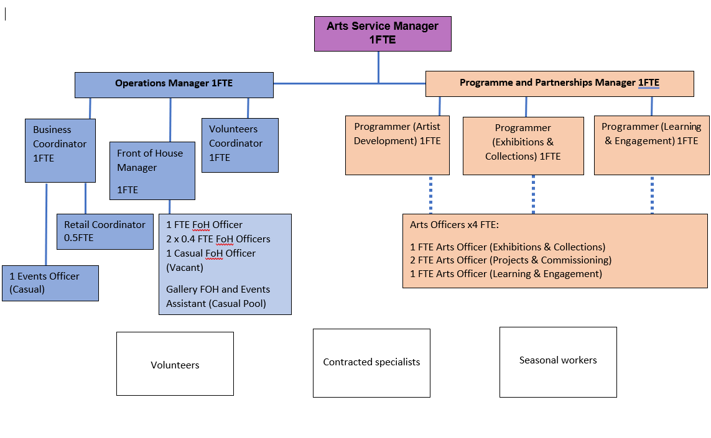
Person Specification

Job Title:  Programme and Partnerships Manager, Richmond Arts Service | Grade:  PO3
Section:  Arts | Directorate:  Environment and Community Services
Responsible to following manager:  Arts Service Manager | Responsible for following staff:  Programmer (Arts Development) Programmer (Exhibitions and Collections) Programmer (Learning and Engagement)
Post Number/s: | Last review date:  May 2024

Our Values
THINK BIGGER
EMBRACE DIFFERENCE
CONNECT BETTER
LEAD BY EXAMPLE
PUT PEOPLE FIRST

Our Values are embedded across the SSA and throughout all roles and responsibilities at all levels of the organisation. Please familiarise yourself with our values as they are an integral part of our recruitment and selection process.

Person Specification Requirements |  |  |  | Assessed by  A/I/T/C  (see below for explanation)
 | Knowledge | Essential | Desirable | Assessed
 | Knowledge of current best innovative practice in cultural development and creative programming | x |  | A/I
 | Knowledge of relevant legislative, procurement and political processes | x |  | A/I
 | Knowledge of leadership approaches for managing creative teams and partnerships | x |  | A/I
 | Knowledge of key issues relating to cultural development, including procuring, commissioning contracting and partnership working | x |  | A/I
 | Knowledge of evaluation frameworks and different approaches to measuring impact | x |  | A/I
 | Experience | Essential | Desirable | Assessed
 | Experience of managing innovative and complex public-facing creative programmes, with multiple partners | x |  | A/I
 | Experience of working with senior leaders and /or politicians, including the management of ‘political’ and sensitive matters | x |  | A/I
 | Experience of managing and leading teams in a fast-moving dynamic environment | x |  | A/I
 | Experience of managing communications on projects or initiatives, including public facing campaigns (this should include use of digital and social media) | x |  | A/I
 | Experience of audience development including the diversification of audiences and strategic planning around Marketing & Communications | x |  | A/I
 | Experience of financial management including managing service reductions and income generation from trusts and other sources | x |  | A/I
 | Skills | Essential | Desirable | Assessed
 | Ability to forward plan and manage relevant risk processes for assets and services | x |  | A/I
 | Ability to share good practice, coaching others through the details of arts programme development and delivery | x |  | A/I
 | Ability to communicate and negotiate clearly and effectively, both orally and in writing, with a wide range of individuals including senior leaders | x |  | A/I
 | Ability to work independently and as an effective team member using own initiative | x |  | A/I
 | Ability to adapt to changing priorities, contexts and deadlines | x |  | A/I
 | Qualifications | Essential | Desirable | Assessed
 | None

A – Application form / CV
I – Interview
T – Test
C - Certificate

