Job Profile comprising Job Description and Person Specification
Job Description

Job Title:  Adult and Children’s Complaints Manager | Grade:  PO6
Section:  Resident Engagement | Directorate:  Chief Executive’s Group
Responsible to following manager:  Statutory and Corporate Complaints Manager | Responsible for following staff:  Complaints Officers (x2)
Post Number/s: | Last review date:  November 2016

Working for the Richmond/Wandsworth Shared Staffing Arrangement

This role is employed under the Shared Staffing Arrangement between Richmond and Wandsworth Councils. The overall purpose of the Shared Staffing Arrangement is to provide the highest quality of service at the lowest attainable cost.

Staff are expected to deliver high quality and responsive services wherever they are based, as well as having the ability to adapt to sometimes differing processes and expectations.

The Shared Staffing Arrangement aims to be at the forefront of innovation in local government and the organisation will invest in the development of its staff and ensure the opportunities for progression that only a large organisation can provide.

Job Purpose:

- Ensuring the Councils have an effective and efficient procedure in place for dealing with complaints in relation to Adults and Children which complies with statutory requirements
- Ensuring statutory adults’ and children’s complaints are dealt with in accordance with agreed procedures
- Promoting learning from complaints across adults and children’s services

Specific Duties and Responsibilities:

- To lead on the day-to-day operation and management of Adult and Children’s complaints procedures, acting as the Complaints Manager as described in the Children Act 1989

- To keep the Councils’ procedure for dealing with complaints in relation to Adult and Children under review, implementing changes where required to ensure efficient and effective compliance with statutory requirements

- To promote complaints policies and procedures across the Adults and Children Services, ensuring information is readily available and meets’ staff needs whilst encouraging compliance, and to ensure advice and training is provided as required.

- To ensure information for the public on adult and children statutory complaints procedures is up to date, easy to understand and accessible

- To provide advice and guidance to Complaints Officers and to quality assure their work on adults and children’s complaints cases

- To take personal responsibility for the management of more complex and sensitive adults’ and children’s complaints, ensuring timescales are adhered to, quality assuring final draft replies, and ensuring senior officers, including Directors, the Monitoring Officer and Chief Executive are kept informed and involved as necessary in individual cases, briefing them directly where necessary

- To ensure professional legal advice is commissioned and that an independent investigation takes place where required, for example by appointing and supervising independent investigating officers, Independent Persons and Review Panels when administering stage 2 and 3 Children Act complaints.

- To identify cases of possible safeguarding concern and work with the Local Children’s Safeguarding Board where necessary

- Working closely with senior officers in Adult and Children Social Services, to design and produce regular reports on statutory adults and children’s complaints and to gather and disseminate learning to Adult and Children Social Services and more widely across the organisation as appropriate

- To work closely with senior officers in Achieving for Children to ensure that the company meets its obligations in respect of complaints management under the contract with the London Borough of Richmond Upon Thames, providing advice and guidance, and reporting on performance to LBRuT’s commissioner of children’s service

- To work with the Corporate and LGO Complaints Manager and to support the FOI and Complaints Manager to allocate work across the complaints team, achieving an appropriate caseload for Complaints Officers and ensuring timescales are met

- To undertake all duties and interactions with employees, partner providers and customer fairly, without unlawful discrimination and with due regard to Equality and Diversity in Employment and Service Delivery Policies

- To ensure that the services for both Councils are dealt with on an equitable basis to deliver the standards required for each, as agreed annually by the Executives of both Councils

Generic Duties and Responsibilities

- To contribute to the continuous improvement of the services of the Boroughs of Wandsworth and Richmond

- To comply with relevant Codes of Practice, including the Code of Conduct and policies concerning data protection and health and safety

- To adhere to security controls and requirements as mandated by the SSA’s policies, procedures and local risk assessments to maintain confidentiality, integrity, availability and legal compliance of information and systems

- To promote equality, diversity, and inclusion, maintaining an awareness of the equality and diversity protocol/policy and working to create and maintain a safe, supportive and welcoming environment where all people are treated with dignity and their identity and culture are valued and respected.

- To understand both Councils’ duties and responsibilities for safeguarding children, young people and adults as they apply to the role within the council.

- The Shared Staffing Arrangement will keep its structures under continual review and as a result the post holder should expect to carry out any other reasonable duties within the overall function, commensurate with the level of the post.

Additional Information
The post will line manage two Complaints Officers.

Current team structure

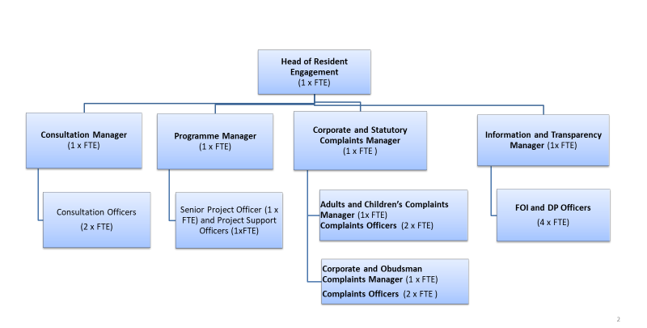

Person Specification

Job Title:  Adult and Children’s Complaints Manager | Grade:  PO6
Section:  Customers and Partnerships | Directorate:  Chief Executive’s Group
Responsible to following manager:  Corporate Complaints and FOI Manager | Responsible for following staff:  Complaints Officers (x2)
Post Number/s: | Last review date:  November 2016

Our Values and Behaviours

The values and behaviours we seek from our staff draw on the high standards of the two boroughs, and we prize these qualities in particular –

- taking responsibility and being accountable for achieving the best possible outcomes – a ‘can do’ attitude to work
- continuously seeking better value for money and improved outcomes at lower cost
- focussing on residents and service users, and ensuring they receive the highest standards of service provision
- taking a team approach that values collaboration and partnership working

Person Specification Requirements | Assessed by  A & I/ T/ C (see below for explanation)
Knowledge
Understanding of children’s and adults’ social care services and their inter-relationships with other similar services in the statutory, private and independent sector | A, I, T
Detailed knowledge of legislation underpinning statutory requirements for the handling of adults’ and children’s services complaints | A, I, T
An excellent understanding of data protection issues and client confidentiality | A, I, T
Experience
Successfully working with senior colleagues across a complex organisation to develop and implement corporate processes, including delivering training and providing information to support the successful operation of processes | A, I
Experience of successfully dealing with very complex/sensitive adults’ and children’s services complaints, including handling difficult conversations with both officers and complainants | A, I
Some experience of managing staff and/or the allocation of caseload to others and monitoring delivery, with positive outcomes | A, I
Skills
Ability to analyse and interpret complex information effectively in order to draw sound, evidenced conclusions | A, I, T
Ability to build strong relationships with senior professional colleagues, establishing credibility in order to conduct effective investigation of complaints | A, I
Strong interpersonal skills including the ability to negotiate with and persuade both officers and complainants and their representatives whilst dealing appropriately with sensitive issues | A, I
Good oral and written communications skills in order to present the Council’s case effectively and to produce clear guidance and information for different audiences | A, I, T
Ability to organise and prioritise own workload, to work under pressure and meet deadlines | A, I
Qualifications
N/A

A – Application form
I – Interview
T – Test
C - Certificate

These values and behaviours will be developed further as the SSA becomes established.

