Job Profile comprising Job Description and Person Specification
Job Description

Job Title:  Statutory and Corporate Complaints Manager | Grade:  MG1
Section:  Resident Engagement | Directorate:  Chief Executive’s Group
Responsible to following manager:  Head of Resident Engagement | Responsible for following staff:  X1 FTE Corporate and LGO Manager  X1 FTE Adult and Children Complaints Manager
Post Number/s:  R003504 | Last review date: February 2020

Working for the Richmond/Wandsworth Shared Staffing Arrangement

This role is employed under the Shared Staffing Arrangement between Richmond and Wandsworth Councils. The overall purpose of the Shared Staffing Arrangement is to provide the highest quality of service at the lowest attainable cost.

Staff are expected to deliver high quality and responsive services wherever they are based, as well as having the ability to adapt to sometimes differing processes and expectations.

The Shared Staffing Arrangement aims to be at the forefront of innovation in local government and the organisation will invest in the development of its staff and ensure the opportunities for progression that only a large organisation can provide.

Job Purpose

- Acting as the strategic lead and responsible for oversight of complaints across both Councils. Responsible for ensuring the Councils have effective, efficient and as far as possible harmonised procedures in place for dealing with:
  - Local Government and Social Care Ombudsman contact and/or cases
  - Housing Ombudsman contact and/or cases
  - Statutory (Adults and Childrens) Complaints
  - Corporate complaints

- Ensuring for all Ombudsman, Statutory and Corporate complaints and investigations are dealt with in accordance with agreed procedures.

- Promoting for all Ombudsman, Statutory and Corporate complaints and investigations a culture of problem solving, early resolution, securing appropriate outcomes and learning across all directorate and services.

Specific Duties and Responsibilities

- To build effective working relationships and promote the work of the team across the organisation, with senior managers and Members in order to support the embedding of the policies and procedures within its remit across the day to day activities of the organisation.

- To work with the Complaints Officers, Information Governance and FOI Team, Customer Services, Legal Services and service Directorates to ensure there are procedures in place for identifying and dealing with Persistent and Vexatious complainants, in order to minimise their impact on the Councils day to day operations.

- To ensure the successful implementation, continued improvement and development of an effective case management system for complaints.

- To ensure timely evidence-based management information reports across all complaints and all stages to senior managers and relevant governance structures. Ensuring risks are appropriately escalated, trends identified while also ensuring learning from complaints is effectively captured, disseminated and actions monitored.

- To ensure that complaints cases are suitably allocated within the team in order to make best use of capacity and skills.

- To ensure that all complaints is managed efficiently and effectively and risk to the Councils is minimised.

- To ensure the Complaints Team has a robust understanding and effectively identifies cases of possible safeguarding concern and works with the Local Children’s Safeguarding Board and Local Authority Designated Officer where necessary to ensure appropriate referrals or alerts are made

- To ensure professional legal advice is commissioned and that an independent investigation takes place where required, for example by appointing and supervising independent investigating officers, Independent Persons and Review Panels when administering stage 2 and 3 Children Act complaints

- To ensure the quality and financial oversight of the work undertaken by Investigating Officers and Independent Persons in relation Statutory Children cases

- To ensure appropriate legal advice is sought and that independent investigations take place (appointment, supervision, review / quality assure reports for independent officer, persons and review panels) where required, in the administration of stage 2 and 3 Children Act complaints. Also, to maintain financial oversight of these investigates and panels.

- To have oversight and where appropriate take responsibility for more complex and sensitive complaints ensuring where appropriate Directors, the Monitoring Officer and Chief Executive are kept informed.

- To ensure the Complaints Team has a robust understanding and effectively identifies cases of possible data protection concern and Information Requests or Rights and works closely with the Information Governance Team on such matters

- To build and maintain effective strategic and working relationships with key external partners, agencies and networks in relation to complaints (e.g. Achieving for Children, Local Government and Social Care Ombudsman, Housing Ombudsman, Complaints Managers Network etc)

- To work closely with senior officers in Achieving for Children to ensure that the company meets its obligations in respect of complaints management under the contract with the London Borough of Richmond Upon Thames.

- To provide effective management of staff, including recruitment, training, development and appropriate application of policies and codes of practice on staffing matters.

- To undertake all duties and interactions with employees, partner providers and customer fairly, without unlawful discrimination and with due regard to Equality and Diversity in Employment and Service Delivery Policies.

- To ensure that the services for both Councils are dealt with on an equitable basis to deliver the standards required for each, as agreed annually by the Executives of both Councils.

Generic Duties and Responsibilities

- To contribute to the continuous improvement of services delivered by the Boroughs of Wandsworth and Richmond.

- To comply with relevant Codes of Practice, including the Code of Conduct and policies concerning data protection and health and safety.

- To adhere to security controls and requirements as mandated by the SSA’s policies, procedures and local risk assessments to maintain confidentiality, integrity, availability and legal compliance of information and systems.

- To promote equality, diversity, and inclusion, maintaining an awareness of the equality and diversity protocol/policy and working to create and maintain a safe, supportive and welcoming environment where all people are treated with dignity and their identity and culture are valued and respected.

- To understand both Councils’ duties and responsibilities for safeguarding children, young people and adults as they apply to the role within the council.

- The Shared Staffing Arrangement will keep its structures under continual review and as a result the post holder should expect to carry out any other reasonable duties within the overall function, commensurate with the level of the post.

Additional Information

- Line management of;
  - X1 Corporate and LGO Complaints Manager
  - X1 Adult and Childrens Complaints Manager
  - Management of associated budgets.

- Post holder will be expected to work flexibly across two locations (Wandsworth Town Hall and Richmond York House/Civic Centre) in order to manage staff, attend meetings and support services across both sites.

- The Councils adopts a positive approach towards work life balance including home working

Current team structure

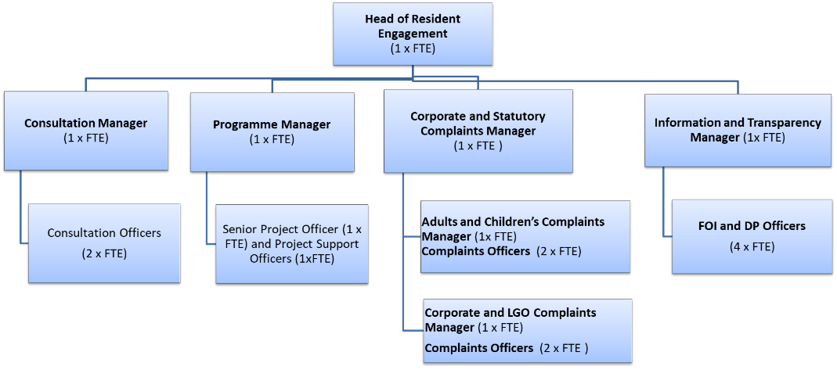
Person Specification

Job Title:  Statutory and Corporate Complaints Manager | Grade:  MG1
Section:  Resident Engagement | Directorate:  Chief Executive’s Group
Responsible to following manager:  Head of Resident Engagement | Responsible for following staff:  X1 FTE Corporate and LGO Manager  X1 FTE Adult and Children Complaints Manager
Post Number/s:  R003504 | Last review date: February 2020

Our Values and Behaviours

The values and behaviours we seek from our staff draw on the high standards of the two boroughs, and we prize these qualities in particular –

- taking responsibility and being accountable for achieving the best possible outcomes – a ‘can do’ attitude to work
- continuously seeking better value for money and improved outcomes at lower cost
- focussing on residents and service users, and ensuring they receive the highest standards of service provision
- taking a team approach that values collaboration and partnership working

Person Specification Requirements |  | Assessed by  A & I/ T/ C
Knowledge
Expertise and a detailed working of Local Government and Social Care Ombudsman, Housing Ombudsman, statutory adult and children services and corporate complaints processes. |  | A, I, T
Expertise and a detailed working knowledge of legislation underpinning statutory requirements for the handling of adult and children services complaints |  | A, I, T
A good working knowledge of data protection, information requests issues (GDPR) and client confidentiality in relation to complaints handling |  | A, I, T
Experience
 | A proven track record of successfully working with senior officers and members across a complex organisation to develop and implement corporate processes, including delivering training and providing information to support the successful operation of processes | A, I
 | Experience of successfully dealing with very complex and sensitive Ombudsman, adult and children services and corporate complaints, including handling difficult conversations with both officers, and complainants | A, I
A proven track record of successfully leading and managing high-performing teams of staff |  | A, I
Experience of successfully managing complaints processes in compliance with statutory requirements |  | A, I, T
Skills
Ability to think, act and plan strategically, and to win respect and operate at senior levels within an organisation |  | A,I
Excellent oral, written and presentation skills to provide clear and concise messages in a variety of internal and external contexts |  | A, I, T
Ability to successfully manage own workload and that of others in an environment where deadlines and priorities frequently change and are often conflicting |  | A, I
Exceptional team management and leadership skills including the ability to effectively tackle performance issues, motivate, develop and empower staff |  | A,I
Exceptional interpersonal skills including the ability to build relationships and establish credibility with internal and external stakeholders (including senior officers, elected members, partners and agencies) |  | A, I,

A – Application form
I – Interview
T – Test
C - Certificate

These values and behaviours will be developed further as the SSA becomes established.

