Job Description

Job Title: Assistant Director | Grade: Hay-3
Section: Adult Social Care & Public Health | Department: Adult Social Care & Public Health
Responsible to: Director of Adult Social Care & Public Health | Date: December 2019
Post Number(s): RWA0003

Working for the Richmond/Wandsworth Shared Service

This is a senior leadership role working for both Richmond and Wandsworth Councils. The purpose of the shared management arrangement is to provide the best possible professional advice, managerial leadership and provision of service to the two boroughs. The role requires a high level of responsiveness to the needs and expectations of both Councils, and the ability to adapt to sometimes differing processes and member expectations. The overall purpose is to provide the highest quality of service at the lowest attainable cost, while meeting the expectations of both Councils. In order to succeed at this level, a high level of drive, stamina and political sensitivity are required, along with the ability to foster effective teamwork, help others achieve their maximum contribution and set standards for continuous improvement.

Job Purpose:
To lead and manage a full range of services providing universal information and advice, prevention, rehabilitation and longer-term support services to older people and vulnerable adults, the focus of all services being the delivery of cost effective support which promotes independence and choice for service users and carers.

Specific Duties and Responsibilities relating to this role:

- To have lead responsibility for delivery of each councils’ statutory responsibilities to vulnerable adults including leading social work services in both councils, across all adult care service user groups including Older Adults, Adults with Mental Health needs, Learning Disabilities and / or Physical Disabilities.

- To ensure an effective approach to work with service users and carers on the assessment and allocation of resource to meet individual needs.

- To lead and work with appropriate NHS organisations, the voluntary sector and other relevant agencies to ensure clients receive a seamless service through the integration of health and social care services.

- Leadership and management of Adult Safeguarding including work on Deprivation of Liberty Safeguards.

- To ensure services offer an effective pathway for service users and carers, from provision of universal information and advice, through to prevention, early intervention, rehabilitation, and longer term support for those with ongoing eligible needs

- To ensure effective joint work with children’s services in both boroughs to support families, and to provide seamless transition for young people needing ongoing support from adult services.

- To manage all direct care services which remain within the council including Emergency out of hours services and in-house care provision.

The above list gives an indication of the full range of responsibilities, but is not intended to be exhaustive.

Generic Duties and Responsibilities

- To ensure that the services for both Councils are dealt with on an equitable basis to deliver the standards required for each, as agreed annually by the Executives of both Councils.

- To provide strategic and motivational leadership of staff, providing a visible presence to the workforce and promoting a good working environment with the primary aim of delivering high quality services.

- To provide effective management of staff, including recruitment, training, development and appropriate application of policies and codes of practice on staffing matters.

- To advise and support Members on all relevant service matters, including advising on legislative developments, making policy proposals, commenting on reports, and attending Member meetings as required.

- To oversee sound business and budget plans and to ensure services and functions are effectively managed within the approved budget.

- To ensure that performance review and improvement and customer focus is embedded within services, as well as seeking innovative and creative solutions to securing highest quality and value for money services.

- To ensure that residents and stakeholders are actively engaged in the future of their communities and services and are able to influence decision making.

- To provide effective commissioning, market testing and contract management of services, ensuring delivery to specification and within budget; and to manage processes for the timely re-procurement of relevant contracts in liaison with procurement and legal colleagues.

- To promote and develop good working relations and collaborative arrangements with relevant third party organisations agencies including private, voluntary and other public organisations, to forge effective partnership working.

- To represent the Council and customers, where appropriate, in dealing with external organisations (Government departments, other public authorities etc.)

- To fully comply with the scheme of delegation including all standing orders and financial controls as specified by either Council.

- To comply with all the relevant Codes of Practice, including the Code of Conduct, and policies and procedures concerning data protection and health and safety.

- To be committed to the promotion of equality, diversity and inclusion for others, both colleagues and clients and maintain an awareness of equality and diversity policies. To work to create and maintain a safe, supportive and welcoming environment where all people are treated with dignity and their identity and culture are valued and respected and to report any instances of inappropriate behaviour or discrimination.

- To be fully aware of and understand the duties and responsibilities arising from the Children’s Act 2004, the London Child Protection Procedures and Working Together in relation to child protection and safeguarding children and young people as this applies to your role within the Council. To also be fully aware of the duties and responsibilities of the 2014 Care Act in relation to safeguarding vulnerable adults in relation to your work role. To ensure that your line manager is made aware and kept fully informed of any concerns which you may have in relation to safeguarding children and adults.

- The shared staffing arrangement will keep its structures under continual review and as a result the post holder should expect to carry out any other reasonable duties and responsibilities within the overall function, commensurate with the grading and level of responsibilities of the post. This post holder will also be expected to take a leading role in keeping services under review.

Additional information

Key dimensions:
- Responsible for a revenue budget of approximately £173m (split between two responsible Assistant Directors).
- Responsible for the direct management of approximately 260fte staff across the two Councils (split between two responsible Assistant Directors).

Current team structure
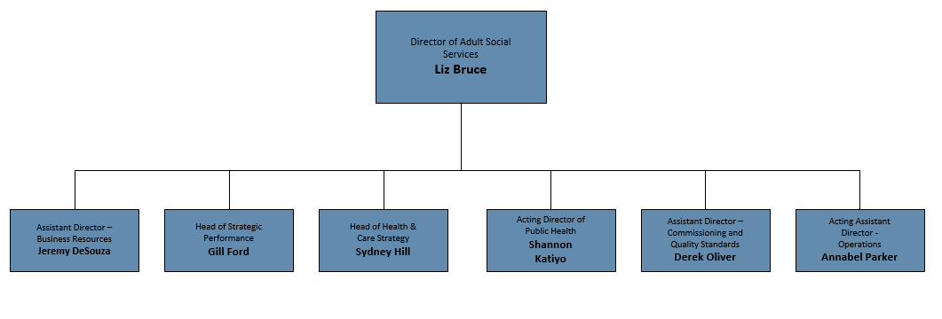

Person Specification

Job Title: Assistant Director | Grade: HAY3
Section: Adult Social Care & Public Health | Department: Adult Social Care & Public Health
Responsible to: Director of Adult Social Care & Public Health | Date: December 2019
Post Number(s): RWA0003

Corporate values & behaviours

All managers will be expected to demonstrate exemplary leadership attributes in the example they set in work ethic, integrity and building a climate of trust and respect. The ability to be alert to political expectations is essential, along with a well informed understanding of statutory requirements, resident expectations (and the particular approaches of the Councils in this regard) and innovative approaches to service delivery. Both boroughs place a high value on effective teamwork, staff engagement, openness and productivity. The ability to recognise the needs of diverse communities, and to incorporate the values of aspiration and achievement for everyone, are essential attributes for success at this level.

Requirements | Assessed by A &  I/ C
Notes for Managers
For advertisement purposes the number of selection criteria is limited to 15; all will be essential for the job and should be clear and measurable. Candidates will need to demonstrate how they meet the criteria and you should consider how you will assess this during the selection process:
A – Application form (for shortlisting) I – Interview C – Certificate (original evidence)
Knowledge and Experience
Proven and substantial experience of successfully managing the health and/or social care profession functions in a local authority | A/I
A track record of successfully leading change and delivering positive outcomes in a challenging environment | A/I
Experience of managing conflicting demands and priorities in a large and complex organization | A/I
Skills
Strong intellect and the ability to think strategically | A/I
Ability to work collaboratively and effectively with partners to deliver key objectives | A/I
Ability to work across complex systems and simplify often complex solutions | I
Visible presence to the workforce and leadership, with an inclusive style | I
Excellent oral, written and presentation skills, including providing clear and concise messages under media and public scrutiny | A/I
Highly developed and persuasive influencing, negotiating and interpersonal skills to influence decision-makers and stakeholders at the highest level | A/I
Ability to foster a climate of determination and creativity, to address challenges, achieve continuous improvement and resolve problems | A/I
Political awareness and sensitivity and the ability to work with elected politicians in varying roles and settings | A/I
Ability to manage contracts for the delivery of significant budgets and schemes | A/I
Qualifications
Educated to degree level or equivalent and a relevant qualification: social work, CQSW, DipSW, BA (hons) Social Work, MSW, occupational therapy - Dip COT. | A
Other Requirements
Commitment to equality and diversity and an understanding of how this applies within the remit of the role | A/I
Robust standard of stamina and resilience to handle the demands of the post, including numerous and varied evening meetings and other out of hours commitments | A/I

