Job Profile comprising Job Description and Person Specification
Job Description

Job Title:  CAFM Manager | Grade: PO3
Section:  FM Performance - Property Services | Directorate:  Housing & Regeneration
Responsible to following manager:  FM Performance Manager | Responsible for following staff:  x1 FTE
Post Number/s: | Last review date: October 2017

Working for the Richmond/Wandsworth Shared Staffing Arrangement

This role is employed under the Shared Staffing Arrangement between Richmond and Wandsworth Councils. The overall purpose of the Shared Staffing Arrangement is to provide the highest quality of service at the lowest attainable cost.

Staff are expected to deliver high quality and responsive services wherever they are based, as well as having the ability to adapt to sometimes differing processes and expectations.

The Shared Staffing Arrangement aims to be at the forefront of innovation in local government and the organisation will invest in the development of its staff and ensure the opportunities for progression that only a large organisation can provide.

Job Purpose
Responsible for management and continuous improvement / development of the SSA FM Concerto CAFM System.
To act as the first point of contact for all CAFM system related queries. Work with the CAFM provider Concerto to continually develop the CAFM system to maximise and automate the system capabilities. To ensure suitable training is delivered to all end users.
To own the full data structure for the CAFM system, ensuring its compatibility with self-delivered and contracted works via automated dynamic scheduling (mobile solution application(s)). Working with the FM Building Services manager to ensure accuracy of asset data required for Planned Maintenance (PPM) schedules.
Ensuring that PPM tasks are linked to SFG20 task descriptions.

Specific Duties and Responsibilities

- Further development and ongoing management of the CAFM system ensuring that PPM and reactive maintenance tasks are validated from inception to completion.
- To provide regular reporting on SSA FM statutory compliance status.
- Develop and maintain a comprehensive technical guide to the CAFM system. This will include new processes and additional features as they are developed and introduced in the CAFM system.
- Establish and maintain good working relationships with all CAFM system users and FM service delivery staff in relation to their management information reporting requirements
- Provide first line support, and manage second and third line escalation routes into the SSA IT team and Concerto to ensure quick, effective issue resolutions. This includes mobile applications support.
- Manage system administration tasks including user issue management
- Own and maintain the electronic asset database used to generate annual PPM Plan.
- Project lead on wider development opportunities for the CAFM system.
- Responsible for using knowledge of CAFM functionality, capability and database operations to ensure the most effective collection and interpretation of data stored to inform major asset management strategies.
- To work with key stakeholders to develop management information and FM performance reporting aligned to KPIs.
- Train FM colleagues to develop a detailed understanding and use of CAFM data applications.
- Identify innovations and continuous improvement opportunities via the CAFM system which drive value for money and process efficiencies.

Generic Duties and Responsibilities

- To contribute to the continuous improvement of the services of the Boroughs of Wandsworth and Richmond.

- To comply with relevant Codes of Practice, including the Code of Conduct and policies concerning data protection and health and safety.

- To adhere to security controls and requirements as mandated by the SSA’s policies, procedures and local risk assessments to maintain confidentiality, integrity, availability and legal compliance of information and systems.

- To promote equality, diversity, and inclusion, maintaining an awareness of the equality and diversity protocol/policy and working to create and maintain a safe, supportive and welcoming environment where all people are treated with dignity and their identity and culture are valued and respected.

- To understand both Councils’ duties and responsibilities for safeguarding children, young people and adults as they apply to the role within the council.

- The Shared Staffing Arrangement will keep its structures under continual review and as a result the post holder should expect to carry out any other reasonable duties within the overall function, commensurate with the level of the post.
Additional Information
Manages:
x1 FTE (CAFM Administrator)

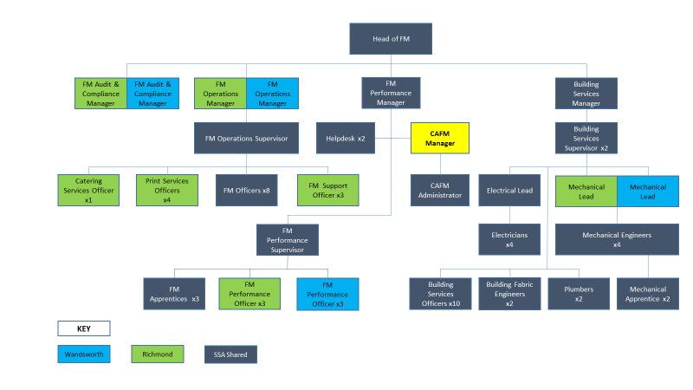
Team Structure

Person Specification

Job Title:  CAFM Manager | Grade: PO3
Section:  FM Performance -Property Services | Directorate:  Housing & Regeneration
Responsible to following manager:  FM Performance Manager | Responsible for following staff:  x1 FTE
Post Number/s: | Last review date: October 2017

Our Values and Behaviours
The values and behaviours we seek from our staff draw on the high standards of the two boroughs, and we prize these qualities in particular –

- taking responsibility and being accountable for achieving the best possible outcomes – a ‘can do’ attitude to work
- continuously seeking better value for money and improved outcomes at lower cost
- focussing on residents and service users, and ensuring they receive the highest standards of service provision
- taking a team approach that values collaboration and partnership working.

Person Specification Requirements | Assessed by  A & I/ T/ C
Knowledge
Excellent knowledge of CAFM system methodology and how systems can be developed to meet the specific needs of the user group | A & I
In depth knowledge of CAFM systems, including mobile applications | A & I
A sound knowledge of Information Security, Data Protection and Business Continuity issues so that these can be considered during the development of an IT system | A & I
An understanding of the Council’s organisation and methods in order to appreciate the potential for CAFM system development | A & I
Sound knowledge of management systems including ISO55000 | A & I
Experience
Experience of developing CAFM systems to meet the specific needs of FM user groups | A & I
Experience of dealing with CAFM system suppliers and developing system improvements | A & I
Demonstrable previous experience managing a CAFM system | A & I
Experience of facilities management, including both Hard and Soft FM
Experience of successfully managing change and contributing to / advising a project team | A & I
Skills
Exceptional IT skills - to develop systems and innovate practical solutions to meet FM user demands | A & I
Good presentation and speaking skills | A & I
The ability to assimilate information and apply it to CAFM system development by developing workflow solutions | A & I
The ability to organise and prioritise own workload, to work under pressure and meet deadlines. | A & I
Qualifications
‘A’ level education; or vocational qualifications in relevant management or administration subjects or equivalent | A & I

A = Application form, I = Interview, T = Test, C = Certificate

