Job Profile comprising Job Description and Person Specification
Job Description

Job Title:  Parks and Events Police Constable | Grade:  PP4 - PP6
Section:  Parks and Events Police Service | Directorate:  Environment and Community Services
Responsible to following manager:  Chief Officer of the Parks and Events Police Service | Responsible for following staff:  N/A
Post Number: | Last review date:  01/04/2023

Working for the Richmond/Wandsworth Shared Staffing Arrangement

This role is employed under the Shared Staffing Arrangement between Richmond and Wandsworth Councils. The overall purpose of the Shared Staffing Arrangement is to provide the highest quality of service at the lowest attainable cost.

Staff are expected to deliver high quality and responsive services wherever they are based, as well as having the ability to adapt to sometimes differing processes and expectations.

The Shared Staffing Arrangement aims to be at the forefront of innovation in local government and the organisation will invest in the development of its staff and ensure the opportunities for progression that only a large organisation can provide.

Job Purpose

The Parks and Events Police Service are responsible for the routine patrolling of the parks, commons, and open spaces within Wandsworth; the enforcement of byelaws, dog control public spaces protection orders and other park regulations; and the policing of events. Our officers are attested as constables by a magistrate and have powers within the parks, commons, and open spaces. They also have a specific duty to ensure that these spaces remain safe and welcoming places for everyone to visit. The Parks and Events Police provide a service 365 days a year and officers are on duty during peak hours.

Directly responsible to the Chief Officer of the Parks and Events Police Service for the operational policing and patrolling of the Borough’s parks, commons, and open spaces, including the policing of events within the borough.
Specific Duties and Responsibilities

- Required to be attested before a Magistrate, under Article 18 of the Ministry of Housing and Local Government Provisional Order Confirmation (Greater London Parks and Open Spaces) Act 1967 and hold the office of Constable.
- Required to work a regular shift pattern as laid down by the Chief Officer of the Parks and Events Police Service and when required, work outside normal working hours.
- Required to wear the prescribed uniform in accordance with the Parks and Events Police Uniform Policy, unless directed to the contrary by the Chief Officer of the Parks and Events Police Service.
- Required to be subject to the provisions of the Official Secrets Act and the Council’s Code of Conduct.
- Required to hold a full current UK Driving Licence (manual or equivalent standard as agreed by DVLA) and to be able to pass the Council’s Driving Standards Test.
- Required to undergo and satisfactorily pass an enhanced Disclosure and Barring Service check.
- Responsible for patrolling by motor vehicle, bicycle, or foot, all parks, commons and open spaces and other property under the control of the Council as required.
- Responsible for the prevention and detection of crime. Enforces Statute Law, Common Law, Byelaws, and other regulations, taking appropriate action where necessary to ensure that the Council’s facilities can be enjoyed by law abiding citizens. Maintains public order and protects life and property within the parks and open spaces and throughout the borough whenever appropriate.
- Responsible for ensuring as far as is practical, that where there are conflicting interests between individuals or groups, an equitable balance of the use of parks and open spaces and other Council facilities within the borough is achieved. Where appropriate checks that the users of Council facilities are duly authorised.
- Responsible for dealing with incidents within the borough using the powers available to a Parks and Events Police Constable. When required, a Constable may perform an arrest using either any person powers, or (with or without warrant) when legally entitled to, in compliance with the Police and Criminal Evidence Act 1984. When required and using minimum force, a Constable may use both Staff Protection Training and issued equipment, to achieve a legitimate arrest.
- Responsible for making independent decisions on the basis of legal knowledge and judgement whether to deprive a person of his / her liberty. Such decisions may have to be made on occasions in emergency situations where there is no recourse to reference or other advice.
- If requested, attends police stations to give general support to other Officers dealing with prisoners. Assists in the presentation of evidence to the Custody Sergeant, completes reports, and may if requested assist in taped interviews, fingerprinting and photographing of suspects. The assisting Officer may also interview and take statements from victims, witnesses, and parents of juveniles. In addition, a Constable may be required to follow up with any subsequent enquiries and documentation, as directed by the relevant authority.
- In less serious crimes, takes appropriate action including cautioning, issuing fixed penalty notices, reporting for prosecution, or arresting. Makes reasonable enquiries at the scene and decides by references to the Crown Prosecution Service Code of Practice and considering all circumstances, whether to caution or report offenders to ensure compliance with the law. Makes pocketbook entries and submits incident reports as required.
- Required to work with or on behalf of other departments of the Council and other Local Authorities and relevant agencies to enforce Statute Law, Byelaws and regulations, traffic and crowd control and provide suitable evidence in support of Anti-Social Behaviour Orders and Contracts as required. Also responsible for acting as an authorised Council Officer to issue fixed penalty notices for relevant offences, on behalf of the Council, throughout the Borough.
- In the event of burglaries or damage to Council property, attends the scene, searches for intruders, preserves evidence and awaits the arrival of a Metropolitan Police Scenes of Crime Officer. Responsible for securing the property taking such action as necessary.
- When required, will staff the Control Room, monitoring, accepting, and responding to all enquiries, complaints, or other calls from whatever source. Responsible for the operation of all facilities within the Control Room, including CCTV and for familiarisation with all emergency procedures contained within the emergency file. In an emergency, responsible for activating emergency procedures until relieved by a senior Officer.
- Records details of missing persons and undertakes searches in the immediate vicinity as required.
- Acts as an authorised officer empowered to seize dangerous and stray dogs, where necessary.

- Required to provide police escorts for the Mayor and other dignitaries as necessary.
- Required to carry out rescues of human and animal victims as necessary and for co-ordinating the response of Emergency Services. Responsible for dealing with ill and injured persons. Administers first aid where necessary.
- Deals with incidents of sudden death, ensuring appropriate agencies are informed and maintaining the security of the scene of the incident for Scenes of Crime Officers.
- Liaises with outside agencies including the Metropolitan Police Service, Fire Brigade, Ambulance Service, British Transport Police, and the RSPCA as required. Takes part in planned joint operations when required.
- Acts as the initial point of contact between unauthorised encampment families, the Council and all other stakeholders affected by unauthorised campsites on Council property, ensuring that the Council’s protocol for unauthorised encampments is followed at all times.
- When required, supervises the control, movement and parking of vehicles in and on any park or open space or other area designated and applies the provisions of the Road Traffic Act and Highway Code as required, particularly in relation to events organised within the borough, and Chelsea Flower Show.
- In the absence of the Chief Officer of the Parks and Events Police Service or Sergeant, takes responsibility for the supervision of Reserve Constables and Reserve Support Officers.

Generic Duties & Responsibilities
- Attends Crown / Magistrates’ Courts or any official enquiry to give evidence under oath, and to present cases as the Officer in the Case.
- Completes all necessary paperwork following cautions, fixed penalty notices, prosecutions and arrests as laid down in Council and pre-trial issues procedure.
- Required to learn and use the correct procedure in all radio communication. Responsible for monitoring the Council’s radio system at all times whilst on duty to enable a quick response to an emergency.
- Required to collect and deliver confidential documents and reports on behalf of the Department and collect and serve summonses and other documents on behalf of the Borough Solicitor or the Council.
- Required to collect, bank monies and issue receipts on the Council’s behalf. Provides a police escort for cash in transit and ensures that correct procedures are adhered to at all times for deposits / withdrawals from the safe.

- Ensures that when on duty, all equipment, transport, and uniforms are maintained in good order, used correctly and all damage is reported and recorded correctly.
- Receives, stores, and returns property, which has been recovered from thefts or loss and ensures that the appropriate documentation is completed. Seizes and deals with property suspected of being involved in crime.
- Inspects fishing permits, multiple dog walking licences and all permits for event and filming activity authorised to use Council facilities, ensuring that they are valid. Inspects playground equipment and decides whether the equipment is safe to use. Isolates and reports all unsafe equipment as required.
- Required to attend Parks and Events Police or other police training courses e.g., Statute Law, Council Byelaws, Personal Safety Training, First Aid, Defibrillator training, Health & Safety training, event traffic and crowd control and all other such training relevant to the duties of a Parks and Events Police Constable.
- To comply with all the council’s Codes of Practice, including the Code of Conduct, and policies and procedures concerning data protection and health and safety.
- To be committed to the promotion of equality, diversity and inclusion for others, both colleagues and clients; to work to create and maintain a safe, supportive and welcoming environment where all people are treated with dignity and their identity and culture are valued and respected, and to report any instances of inappropriate behaviour or discrimination.
- To be fully aware of and understand the duties and responsibilities arising from the Children’s Act 2004, the London Child Protection Procedures and Working Together in relation to child protection and safeguarding children and young people as this applies to your role within the Council. To also be fully aware of the principles of safeguarding as they apply to vulnerable adults in relation to your work role. To ensure that your line manager is made aware and kept fully informed of any concerns which you may have in relation to safeguarding and/or child protection.
- To carry out any other reasonable duties and responsibilities as required by the Chief Officer of the Parks and Events Police Service.

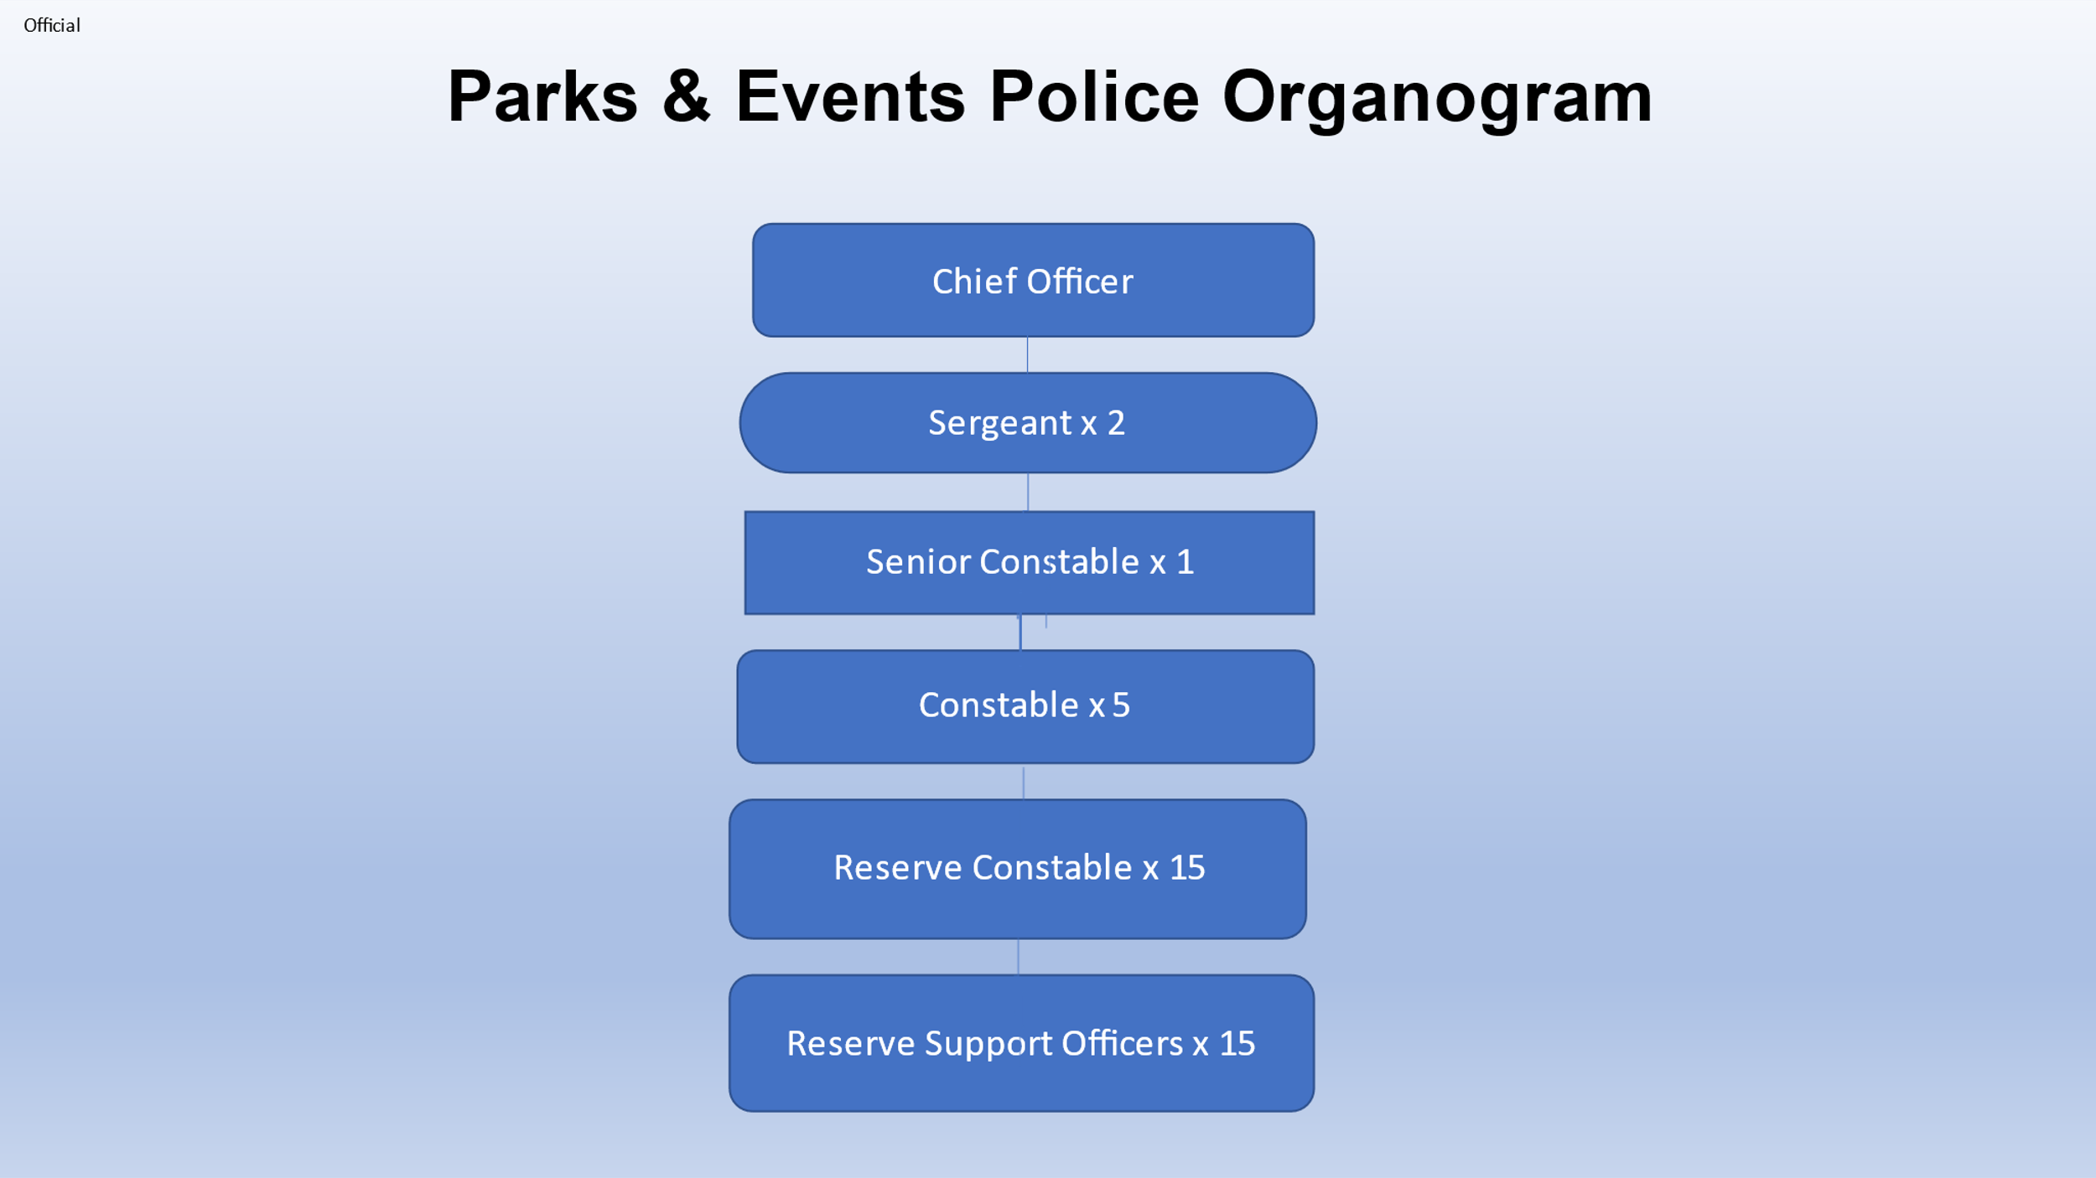

.
Person Specification

Job Title:  Parks and Events Police Constable | Grade:  PP4 - PP6
Section:  Parks and Events Police Service | Directorate:  Environment and Community Services
Responsible to following manager:  Chief Officer of the Parks & Events Police Service | Responsible for following staff:  N/A
Post Number/s: | Last review date:  01/04/2023

Our Values and Behaviours

The values and behaviours we seek from our staff draw on the high standards of the two boroughs, and we prize these qualities in particular:

Being open. This means we share our views openly, honestly and in a thoughtful way. We encourage new ideas and ways of doing things. We appreciate and listen to feedback from each other.

Being supportive. This means we drive the success of the organisation by making sure that our colleagues are successful. We encourage others and take account of the challenges they face. We help each other to do our jobs.

Being positive. Being positive and helpful means we keep our goals in mind and look for ways to achieve them. We listen constructively and help others see opportunities and the way forward. We have a ‘can do’ attitude and are continuously looking for ways to help each other improve.

Person Specification Requirements | Assessed by  A  & I/ T/ C (see below for explanation)
Knowledge
A general understanding of safeguarding children, young people and vulnerable adults and its relevance to the role and a willingness to attend training as required and to undergo and satisfactorily pass an enhanced Disclosure and Barring Service check. | A & I
Ability to demonstrate an understanding of the Council’s equal opportunities policy in respect of service delivery and an awareness of the needs of differing cultural groups and other minority groups | A & I
Experience
Recent experience of working within one of the following services: Home Office Police Service, Parks Police Service, British Transport Police, or other Police Service where enforcing the law, rules and regulations have been necessary. | A & I
Experience of dealing with traffic control and the monitoring, control, and safety of crowds at events. | A & I
Experience of attending court and presenting evidence and assisting members of the public both face to face and on the telephone. | A & I
Experience of monitoring and operating CCTV, using Microsoft IT packages and databases, including electronic incident logging systems. | A & I
Skills
Ability and willingness to investigate alleged offences and to carry out enforcement duties, often in challenging, confrontational, and sensitive situations, whilst remaining tactful, professional, and courteous. | A & I
Ability to record and process information and to write clear and concise reports and statements and to organise and prioritise work to meet service needs and deadlines. | A & I
Ability to work successfully as part of a team whilst being able to use individual initiative and to work with minimum supervision. | A & I
Ability to to react immediately to any emergency including being able to give chase and apprehend individuals, undertake police patrols on foot or by bicycle and undertake a broad range of manual handling duties involving people and equipment. | A & I
Required to work alternating shift patterns, including weekends, Bank Holidays and unsociable hours. | A & I
Required to wear the prescribed uniform or plain clothes as directed, maintaining a smart and presentable appearance always. | A & I
Required to undertake enforcement training, including legislation and bye-law procedures, personal safety training, first aid training and crowd control training. | A & I
Required to hold a full current UK Driving Licence (manual or equivalent standard as agreed by DVLA) and to be able to pass the Council’s Driving Standards Test. | A & I
Qualifications
Evidence of ongoing professional development. | A & I & C

A – Application form / CV
I – Interview
T – Test
C - Certificate

