Job Profile comprising Job Description and Person Specification
Job Description

Job Title:  Pensions Assistant | Grade:  Scale 4
Section:  Pensions Shared Service | Directorate:  Resources
Responsible to following manager:  Pensions Manager - Benefits | Responsible for following staff: N/A
Post Number/s: Various | Last review date: January 2023

Working for the Richmond/Wandsworth Shared Staffing Arrangement

This role is employed under the Shared Staffing Arrangement between Richmond and Wandsworth Councils. The overall purpose of the Shared Staffing Arrangement is to provide the highest quality of service at the lowest attainable cost.

Staff are expected to deliver high quality and responsive services wherever they are based, as well as having the ability to adapt to sometimes differing processes and expectations.

The Shared Staffing Arrangement aims to be at the forefront of innovation in local government and the organisation will invest in the development of its staff and ensure the opportunities for progression that only a large organisation can provide.

Job Purpose

- To be responsible to the Team Leader assisting with the effective and efficient management of the Pensions Shared Service covering all its participating authorities.

- For all participating authorities, to undertake the administration of pension related policies, practices and procedures for the Local Government Pension Scheme (LGPS) with particular reference to the calculation of all benefit entitlements.

- To have knowledge of the LGPS, relevant compensation schemes, HMRC (maximum benefits and social security entitlements) and pensioner payroll.

Specific Duties and Responsibilities

- Responsible for the accurate calculations of entitlements to benefits and their payments in to and out of the participating authorities’ pension funds and revenue accounts.

- Responsible for checking and recording new entrants to the LGPS for all participating authorities.

Specific Duties and Responsibilities

- In accordance with the provisions of the Local Government Pension Scheme, compensation regulations, employer discretionary policies and overriding HMRC, social security and pensions legislation, calculates entitlements to (and where appropriate the payment of): redundancy or severance, additional contributions, cash equivalent transfer values, refunds of contributions and deferred benefits.

- Assists with Pensioner Payroll input for new entrants and changes for existing Pensioners ensuring the input is accurate and meets the payroll deadlines each month. Liaises with payroll providers, HR, legal, schools, auditors and other relevant officers providing information and assistance when requested.

- Enters payment details on the relevant creditor system, ensuring that payments made to and from the respective pension funds and revenue accounts are correctly allocated and recorded on relevant systems to enable accurate data to be extracted for monitoring and reconciling payments.

- Provides assistance and guidance on pensions generally in writing, on the telephone and in person to all employees answering straight forward enquiries in respect of: additional voluntary contributions, transfers of pension rights, retirement and death benefits, refunds of contributions and permitted maximum benefit accrual.

- Undertakes scanning and indexing and post distribution within the team, entering relevant workflow tasks on Altair as required.

Generic Duties and Responsibilities

- To contribute to the continuous improvement of the services of the Boroughs of Wandsworth and Richmond.

- To comply with relevant Codes of Practice, including the Code of Conduct and policies concerning data protection and health and safety.

- To adhere to security controls and requirements as mandated by the SSA’s policies, procedures and local risk assessments to maintain confidentiality, integrity, availability and legal compliance of information and systems

- To promote equality, diversity, and inclusion, maintaining an awareness of the equality and diversity protocol/policy and working to create and maintain a safe, supportive and welcoming environment where all people are treated with dignity and their identity and culture are valued and respected.

- To understand both Councils’ duties and responsibilities for safeguarding children, young people and adults as they apply to the role within the council.

- The Shared Staffing Arrangement will keep its structures under continual review and as a result the post holder should expect to carry out any other reasonable duties within the overall function, commensurate with the level of the post.

Team structure

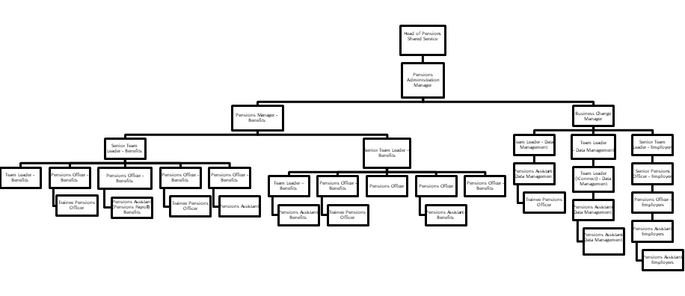
Person Specification

Job Title:  Pensions Assistant | Grade:  Scale 4
Section:  Pensions Shared Service | Directorate:  Resources
Responsible to following manager:  Pensions Manager - Benefits | Responsible for following staff: N/A
Post Number/s: Various | Last review date: January 2023

Our Values and Behaviours

The values and behaviours we seek from our staff draw on the high standards of the two boroughs, and we prize these qualities in particular:

Being open. This means we share our views openly, honestly and in a thoughtful way. We encourage new ideas and ways of doing things. We appreciate and listen to feedback from each other.

Being supportive. This means we drive the success of the organisation by making sure that our colleagues are successful. We encourage others and take account of the challenges they face. We help each other to do our jobs.

Being positive. Being positive and helpful means we keep our goals in mind and look for ways to achieve them. We listen constructively and help others see opportunities and the way forward. We have a ‘can do’ attitude and are continuously looking for ways to help each other improve.

Person Specification Requirements |  |  |  | Assessed by  A/I/T/C  (see below for explanation)
 | Knowledge | Essential | Desirable | Assessed
 | Knowledge and high capability of using the Microsoft Office packages (e.g. Word and Excel) |  |  | A,I
 | Experience | Essential | Desirable | Assessed
 | Experience of the LGPS or other DB pension scheme(s) |  |  | A,I,T
 | Skills | Essential | Desirable | Assessed
 | Proven ability to undertake detailed mathematical calculations accurately. Please note, the interview process includes a numerical assessment. |  |  | A,T
 | Talk confidently to members and be able to explain complex rules or processes in a clear and appropriate way
 | Recognise when a procedure or policy is not working as effectively as it could and make suggestions as to how it could be improved
 | Organise and prioritise own workload
 | An understanding of the Council’s equal opportunities policy in respect of service delivery and an awareness of the needs of differing cultural and minority groups.
 | Qualifications | Essential | Desirable | Assessed
 | Minimum of 3 GCSE’s or equivalent at Grades A-C including Maths and English. |  |  | A,C

A – Application form / CV
I – Interview
T – Test
C - Certificate

