Job Profile comprising Job Description and Person Specification
Job Description

Job Title: Development Project Manager | Grade: PO5 – MG1
Section: Housing Strategy and Development | Directorate: Housing and Regeneration
Responsible to: Head of Housing Development | Responsible for: Development Support Officer and Assistant Development Support Officer
Post Number/s: | Last Review Date:

Working for the Richmond/Wandsworth Shared Staffing Arrangement

This role is employed under the Shared Staffing Arrangement between Richmond and Wandsworth Councils. The overall purpose of the Shared Staffing Arrangement is to provide the highest quality of service at the lowest attainable cost.

Staff are expected to deliver high quality and responsive services wherever they are based, as well as having the ability to adapt to sometimes differing processes and expectations.

The Shared Staffing Arrangement aims to be at the forefront of innovation in local government and the organisation will invest in the development of its staff and ensure the opportunities for progression that only a large organisation can provide.

Job Purpose

Development Project Managers play an important role in delivering the objectives of Wandsworth Council’s housing development programme. In 2017 the Council set a target of delivering a minimum of 1,000 low cost homes through its own development programme. Working to the Head of Housing Development (HHD) this is one of four posts in the current structure that will provide project management of the programme.

The postholder is expected to work collaboratively with council and departmental colleagues, supported by specialist consultants, and external contractors. The postholder will be responsible for coordination of activity required to deliver schemes and to maintain the working relationships and commissioning arrangements necessary to deliver schemes effectively and within budget.

Whilst the post is part of the SSA, the focus of this post is to assist and lead in the delivery of Wandsworth Council’s council build programme.

At the direction of the HHD, DPM’s will manage Development Support Officer(s) and Assistant Development Support Officer(s) if appointed. The DPM will be responsible for staff management and delegation of duties commensurate with their role, whilst retaining overall responsibility for a portfolio of development projects.

This post is career graded. Pay and progression is dependent on experience and the level of responsibility taken for the delivery of council led development schemes and supporting the delivery of the overall programme. It is envisaged that the DPMs will provide more general and specialised advice depending upon their past experience and exigencies of the service. This might include, but is not limited to, advice on property, rights and ownership matters, approaches to construction and value engineering and/or taking responsibility for the management of staff in the Development Team.

Specific Duties and Responsibilities

- Reports to the HHD and deputises for that post in the postholder’s absence as directed by Assistant Director Housing Strategy and Development.

- Responsible as directed for: -

- Delivery of a portfolio of projects on time and to agreed budgets via liaison with a range of internal and external stakeholders, consultants and contractors, assuming responsibility from the earliest feasibility stages through to handover, thereafter, oversight of contractor performance throughout defects liability periods;
- Coordination and procurement of services, council and external, as they relate to delivery of development projects;
- As required represents the Council at local, regional and national level in respect to the Council’s development programme and its projects.

- Responsible for the delivery of Council led development schemes from initiation to completion. This includes responsibility for project level budgets and plans to ensure timely, effective and efficient delivery.

- Responsible for reviewing and authorising payments related to the delivery of projects, maintaining scheme cashflows and income forecasts, ensuring projects are delivered within approved budgets, or seeking appropriate approvals for any variations where required in accordance with WBC’s published procedures.

- Liaises with the Housing Area Offices, Property and Design Services, Leasehold and Procurement Team, Technical and other services, to identify Council owned sites that are potentially suitable for development and to assess viability and to recommend and take forward selected projects. This will include considering whether Council held landholding assets may achieve more development potential through combining with adjacent publicly or privately held landholdings or assets or benefit the Council from their sale.

- Responsible for appointment of design and technical teams and related consultancy services to undertake feasibilities. This will include engaging cost consultancies, assessing optimal size and tenure mix, assessing risks in relation to proposed development and undertaking as required resident and stakeholder consultation of plans and seeking initial planning views.

- Assesses options for procurement routes to deliver best-value products and services. Working with WBC’s Procurement team, appoint lead consultants and contractors where appropriate for the feasibility, design and/or construction of individual sites. Responsible for liaising with Procurement to agree scopes of services (including surveys), forms, pricing and evaluation criteria, preparing the necessary documentation for tender. Thereafter working with the Council’s legal, technical and procurement advisors to ensure robust contractual terms are in place.

- Ensures that any matters relating to property and rights are identified, assessed and dealt with to minimise development risk. This includes legal impediments to development, including covenants, easements, appropriation issues and rights to light. To liaise where appropriate with the Leasehold and Procurement Team, Property Services, Legal Services and external statutory agencies on obtaining legal title reports and statutory permissions to enable development. Responsibilities will include ensuring that compensation payments are negotiated as required by the Council’s Property Services team.

- Prepares reports when required for distribution to the Director of Housing and Regeneration, AD Housing Strategy and Development, other Housing Officers, the Assistant Director of Property Services and other Council Departments and the Cabinet Member for Housing. This will also include preparing committee reports and for the councils’ executive to seek relevant approvals for Council led development, variations and to report progress. Also prepares and submits Standing Order reports where urgent approval is required to progress developments.

- Take responsibility for driving best value throughout the development process whilst delivering high quality products and services, meet the Council’s and other GLA / national standards via well-documented files and folders ready for periodic audit inspections.

- With support from retained technical consultants, to consider and make recommendations to the HHD on any change control notices (including ensuring the Council’s Procurement Code has been adhered to) or budget variations that will add long-term value to schemes and to ensure the Director of Resources is informed of any budget variations.

- Once lead consultants are procured, to be the lead council officer in project managing the lead consultants, throughout the commission to ensure their work is fit for purpose and delivers on time and within budget.

- Responsible for resident consultation and ongoing resident and stakeholder liaison, including ensuring ward members are kept informed of any proposals, meetings etc in their ward. This includes procuring and instructing consultants and contractors in relation to what is required and expectations to successfully deliver projects, attending residential consultation meetings and ongoing quality assurance of resident liaison. This work may also include identifying environmental or other works which ameliorate the impact of development and benefit local communities in turn. Contributes to the Development Team’s overall communications plan.

- Where appropriate, liaises with the Council’s letting, homeownership and regeneration teams to ensure that housing developed is meeting local housing needs and demands and is appropriately targeted and prioritised.

- Assists with overall programme management and reporting. Reviews and maintains the Programme Master Spreadsheet of Council led residential development projects pending arrival of new project-management software, ensuring records and forecasts are regularly updated. Ensure all necessary handover information is collated from the earliest stages of projects ready for timely transfer to allocations / sales teams as appropriate.

- Responds to Public, Councillor and MP enquiries and Freedom of Information Act requests regarding matters pertaining to Council landholding or assets that are being considered for Council led development.

- Keeps abreast of Homes England, MHCLG and GLA policy and other publications in relation to the delivery of Council led development. To ensure where external funding is secured, that the scheme meets any funding requirements and to submit or instruct appropriate colleagues to submit funding claims as required to meet deadlines.

- Undertakes the responsibilities of being line manager for the Development Support Officer and Assistant Development Support Officer posts (if appointed) in compliance with WBC’s codes of practice, ensuring delivery of the posts duties as directed by the HHD to benefit and support the Development Team’s work.

- As required and directed by the HHD on occasion to cover and assist with the work of the Development Team to ensure that the team meets its work and programme objectives.

Generic Duties and Responsibilities

- To contribute to the continuous improvement of the services of the Boroughs of Wandsworth and Richmond.

- To comply with relevant Codes of Practice, including the Code of Conduct and policies concerning data protection and health and safety.

- To adhere to security controls and requirements as mandated by the SSA’s policies, procedures and local risk assessments to maintain confidentiality, integrity, availability and legal compliance of information and systems

- To promote equality, diversity, and inclusion, maintaining an awareness of the equality and diversity protocol/policy and working to create and maintain a safe, supportive and welcoming environment where all people are treated with dignity and their identity and culture are valued and respected.

- To understand both Councils’ duties and responsibilities for safeguarding children, young people and adults as they apply to the role within the council.

- The Shared Staffing Arrangement will keep its structures under continual review and as a result the post holder should expect to carry out any other reasonable duties within the overall function, commensurate with the level of the post.
Additional Information
Career Grading

Wandsworth Council operates a career grade process designed to retain staff who have demonstrated growth and development in their current role.

Progression from PO5 – MG1 will be assessed based on the skills and experience the postholder initially has and subsequently acquires, to enable them to undertake the duties/responsibilities without supervision, as well as any line management responsibilities associated with the post.

NOTE – WHILST THE REQUIREMENTS FOR PROGRESSION ARE SET OUT BELOW THERE IS LIKELY TO BE A LEVEL OF PERMEABILITY IN TERMS OF HOW TASKS AND WORK IS ALLOCATED. THIS WOULD REFLECT THE EXIGENCIES OF THE SERVICE BUT ALSO RECOGNISING THE NEED FOR OFFICERS TO DEMONSTRATE SKILLS AND TO HAVE THE OPPORTUNITY TO APPLY EXPERIENCE, SO THAT PROGRESSION CAN BE MADE IN AND BETWEEN SCALES (E.G. DEMONSTRATING THAT TASKS IDENTIFIED FOR A HIGHER SCALE CAN BE DELIVERED).

SCALE PO5

Undertakes duties as set out above but within the following parameters:

- Responsible for smaller scale projects which involve development on sites of up to 20 homes (scheme budget est. £8m with 5-10 schemes in portfolio). These will generally be schemes commissioned from the inhouse Design Service.
- Commissioning of services and contractors will be under the supervision of the HHD.
- Whilst the post will be responsible for writing reports and making recommendations as set out above (to bring schemes forward for development or sale) this will be done on the basis of final review, revision and sign off to be given by the HHD.
- It is expected the post will undertake some routine tasks as required and directed for the Development Team (e.g. ensuring property checks are undertaken, dealing with Rights of Light matters).
- There is no expectation that the postholder would manage staff unless exigencies of the service required this.

SCALE PO6

- Responsible for initiation and delivery of projects up to 50 units (est. scheme value up to £20m per scheme). It is also likely that the post will hold a greater number of projects in their portfolio and in turn would be responsible for appointment of services to support delivery (e.g. external project management resource. Additionally, these schemes would require appointment of planning consultancies).
- Commissioning of services and contractors will be undertaken with minimal supervision (with appropriate requirements in place to update and seek recommendations as required).
- Likely to take on a more specialist area of responsibility and expertise for the team including but not limited to property matters, construction, procurement, feasibility and planning matters, cost planning.
- There is likely to be a higher level of contact with lead members and representation of the Development Team at higher level external events.
- Would be expected to manage staff including agency staff and internal and/or external consultancies.

SCALE MG1

- Responsible for initiation and delivery of all sizes of projects noting that the programme has sites that could deliver 100 plus units. These are also likely to be more complex sites requiring a range of skills which would include understanding infrastructural requirements and how these would be considered and addressed, potentially mini regenerations and considering marriage value opportunities. Essentially, bringing skills bought and learnt into play.

- Work on projects with minimum supervision including leading on contact with lead members, drafting reports etc.

- Take responsibility for elements of overall programme management as directed by the HHD including making recommendations to maintain programme objectives

- Will be involved in (and as directed) developing overall strategy and policy to help meet the objectives of the programme (namely to maximise use of Council land to deliver homes). This would be done with minimum supervision.

- Would develop and present reports to lead officers and members and committees. This is likely to include coordinating content as required from other DPMs and other officers involved in delivery (e.g. where reports are covering several projects or reporting on the progress of the overall programme).

Team structure

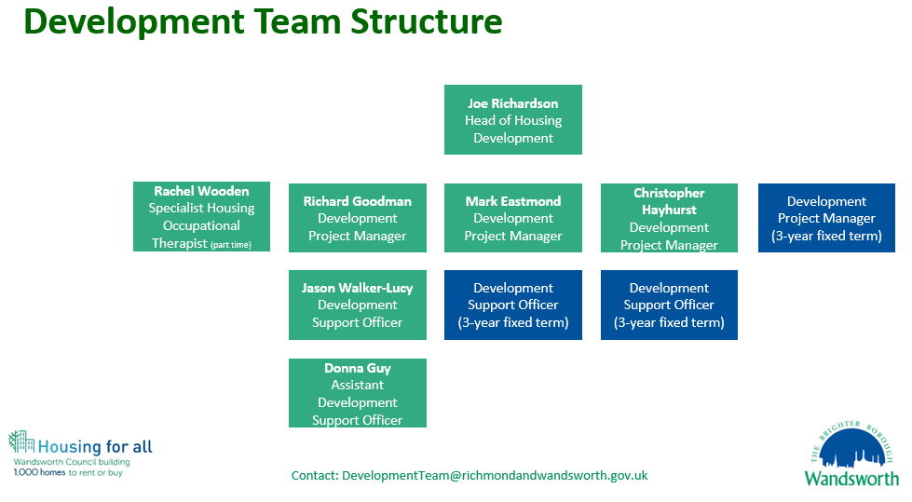Person Specification

Job Title: | Grade:
Section: | Directorate:
Responsible to: | Responsible for:
Post Number/s: | Last Review Date:

Our Values and Behaviours

The values and behaviours we seek from our staff draw on the high standards of the two boroughs, and we prize these qualities in particular:

Being open. This means we share our views openly, honestly and in a thoughtful way. We encourage new ideas and ways of doing things. We appreciate and listen to feedback from each other.

Being supportive. This means we drive the success of the organisation by making sure that our colleagues are successful. We encourage others and take account of the challenges they face. We help each other to do our jobs.

Being positive. Being positive and helpful means we keep our goals in mind and look for ways to achieve them. We listen constructively and help others see opportunities and the way forward. We have a ‘can do’ attitude and are continuously looking for ways to help each other improve.

Person Specification Requirements | Assessed by  A  & I/ T/ C (see below for explanation)
Knowledge
Be able to demonstrate sound knowledge of the development of housing, through direct experience in the field | A&I/T
Be able to demonstrate sound knowledge of the financing and viability of housing development | A&I/T
Demonstrate an understanding of Equal Opportunities and resident consultation and how it would apply to the responsibilities of this post in delivering successful housing development projects in an urban environment. | A&I
Be able to demonstrate an understanding of the responsibilities arising from the Children Act 2004 in relation to child protection and young people as this applies to your role within the Council. To be aware of the principles of safeguarding as they apply to vulnerable adults in relation to the work role | A&I
Experience
Experienced project manager and able to demonstrate successful delivery of projects.
Able to demonstrate an understanding of economic appraisal processes in the development of housing and to be able to interpret and analyse data | A&I/T
Management experience.
Demonstrate an ability to work with external contractors, consultancies and senior colleagues in other Departments in the development and delivery of housing projects.
Demonstrate an ability to be able to deal confidently, sensitively and calmly with residents, Councillors, senior Council officers throughout the Council and developers and members of the public to deliver complex projects and schemes. | A&I
Demonstrate experience and knowledge of RIBA 0-7 stages, procurement, legal and project management delivery | A&I
Skills
Be able to work as part of a team | A&I
Be able to communicate effectively, orally and in writing, on a wide range of  complex issues | A&I
Be reliable and able to manage own workload and deal with competing priorities and deadlines with minimal supervision. | A&I
Be able to collate information, maintain files and records accurately on computerised and manual recording systems | A&I
Demonstrate sound administrative and office skills | A&I
Be able to use IT packages including word processing, spreadsheets and database systems. | A&I/T
Qualifications
Be qualified in a relevant property or construction discipline, chartered member of relevant professional body or otherwise able to demonstrate a multi-year track record of successful development project delivery.

A – Application form / CV
I – Interview
T – Test
C - Certificate

