Job Profile comprising Job Description and Person Specification
Job Description

Job Title:  Development Support Officer | Grade: PO1 –PO2 Career Grade
Section:  Housing Strategy and Development | Directorate:  Housing and Regeneration
Responsible to following manager: Development Project Manager | Responsible for following staff:  None
Post Number/s: TBA | Last review date:

Working for the Richmond/Wandsworth Shared Staffing Arrangement

This role is employed under the Shared Staffing Arrangement between Richmond and Wandsworth Councils. The overall purpose of the Shared Staffing Arrangement is to provide the highest quality of service at the lowest attainable cost.

Staff are expected to deliver high quality and responsive services wherever they are based, as well as having the ability to adapt to sometimes differing processes and expectations.

The Shared Staffing Arrangement aims to be at the forefront of innovation in local government and the organisation will invest in the development of its staff and ensure the opportunities for progression that only a large organisation can provide.

Job Purpose

Reporting to the Development Project Manager (DPM), support the Housing Development team in delivering the objectives of Wandsworth Council’s housing development programme.

The primary nature of the role is to assist the DPM in providing client management services to deliver Wandsworth’s Housing Development programme. Project management skills of the postholder will be developed through a combination of sub-projects such as overseeing the handover process of a given job(s) alongside focussed training, ultimately taking overall responsibility for a given project(s).
The postholder is expected to work collaboratively with council and departmental colleagues, supported by specialist consultants, and external contractors. The postholder will be responsible for coordination of activity required to deliver schemes and to maintain the working relationships and commissioning arrangements necessary to deliver schemes effectively and within budget.

Whilst the post is part of the SSA the focus of this post is to assist and lead in the delivery of Wandsworth Council’s council build programme.

This post is career graded. Pay and progression is dependent on experience and the level of responsibility taken for the delivery of council led development schemes and supporting the delivery of the overall programme.

Specific Duties and Responsibilities

1. Reports to the Development Project Manager (DPM) and as directed provides assistance across the broad spectrum of activities undertaken by the team to deliver objectives of the 1,000 homes programme.

2. To be responsible for supporting the DPM in regular updates to appraisal and budgetary management systems including timing and budgetary changes where directed. To set up purchase orders, liaison with contractors and consultants, processing orders and invoices for approval.

3. As directed by the DPM to be responsible for the production of communication and consultation material required to successfully take forward the housing development programme, including coordination of production and delivery of newsletters to local residents, answering general public, councillor, MP and Freedom of Information requests, updating of consultation material produced in liaison with the Council’s Communications Team.

4. As directed by the DPM and in conjunction with WBC’s Procurement and legal teams, to commission specialist surveys including Rights of Light, Geotechnical Investigations, measured surveys, utilities scans etc. Contribute to the assembly of other legal information via liaison with the Council’s appointed legal representatives or external solicitors, such as reports on title, consultant and construction contracts, sales information packs and site disposals.

5. Under the direction of the DPM, responsible for ensuring all internal stakeholders are engaged at all relevant project stages from feasibility stages to handover. Contributes to reviews of site plans and proposals, including identifying areas in which value can be added through focussed interjections on wider estates, such as improved landscaping, new bin & cycle storage etc.

6. As directed by the DPM, where planning permission is obtained, to work with the Leasehold and Procurement Team, Technical Services, Central Procurement Team, Design Serves or external consultants on procuring contractors. Thereafter, to attend monthly site meetings in conjunction with WBC’s appointed Employers Agents and Clerks of Works teams, leading on the coordination of colours and materials selection decisions with Housing and Sales colleagues.

7. Responsible for assembling handover information for a portfolio of sites, ensuring contractors and consultants collate information in good time for uploading to WBC’s property database: NPS. Monitor defects performance of contractors during defects liability periods, resolving site-specific issues where possible, reporting evidence of poor performance to the HHD.

8. Keeps abreast of Homes England, MHCLG and GLA policy and other publications in relation to the delivery of Council-led development. Recommends and contributes to process and procedural updates in response to emerging guidance and best practice accordingly.

9. Responsible for ensuring files and folders are regularly updated with relevant scheme information – particularly core information relevant to internal and/or GLA audits of sites within the DPM’s portfolio.

10. As directed by the DPM assist in preparing initial reports for the Assistant Director of Housing Strategy and Development and the Director of Resources on whether a site is appropriate for Council-led development (and if not, the reasons why), the type and quantum of housing that could be delivered and the cost associated as well as any savings to the Council that may arise from the development.

Career Grades - Progression to PO2

As the officer develops in the post, it is expected they will require less day-to-day supervision, taking on more general project management duties, including co-ordination of design feasibilities through appointed consultants, co-ordinating the scheme programme and seeking to ensure key milestones are met, arranging, facilitating and where applicable chairing meetings with consultants, development team colleagues and other relevant colleagues, such as technical services and liaising where necessary with the HHD and/or DPM on more complex legal and technical matters.

Generic Duties and Responsibilities

- To contribute to the continuous improvement of the services of the Boroughs of Wandsworth and Richmond.

- To comply with relevant Codes of Practice, including the Code of Conduct and policies concerning data protection and health and safety.

- To adhere to security controls and requirements as mandated by the SSA’s policies, procedures and local risk assessments to maintain confidentiality, integrity, availability and legal compliance of information and systems

- To promote equality, diversity, and inclusion, maintaining an awareness of the equality and diversity protocol/policy and working to create and maintain a safe, supportive and welcoming environment where all people are treated with dignity and their identity and culture are valued and respected.

- To understand both Councils’ duties and responsibilities for safeguarding children, young people and adults as they apply to the role within the council.

- The Shared Staffing Arrangement will keep its structures under continual review and as a result the post holder should expect to carry out any other reasonable duties within the overall function, commensurate with the level of the post.

Specific Duties and Responsibilities

Additional Information
Team structure

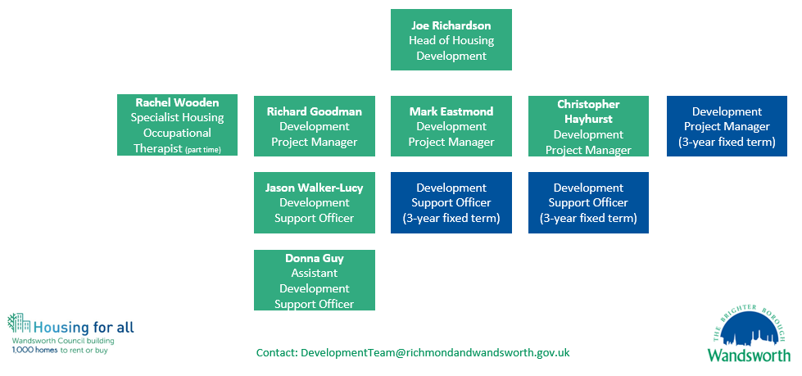
Person Specification

Job Title:  Development Support Officer | Grade: PO1 –PO2 Career Grade
Section:  Housing Strategy and Development | Directorate:  Housing and Regeneration
Responsible to following manager: Development Project Manager | Responsible for following staff:  None
Post Number/s: TBA | Last review date:

Our Values and Behaviours

The values and behaviours we seek from our staff draw on the high standards of the two boroughs, and we prize these qualities in particular:

Being open. This means we share our views openly, honestly and in a thoughtful way. We encourage new ideas and ways of doing things. We appreciate and listen to feedback from each other.

Being supportive. This means we drive the success of the organisation by making sure that our colleagues are successful. We encourage others and take account of the challenges they face. We help each other to do our jobs.

Being positive. Being positive and helpful means we keep our goals in mind and look for ways to achieve them. We listen constructively and help others see opportunities and the way forward. We have a ‘can do’ attitude and are continuously looking for ways to help each other improve.

Person Specification Requirements | Assessed by  A & I / T/ C (see below for explanation)
Knowledge
Be able to demonstrate knowledge of the development of housing, preferably through direct experience in the field | A&I
Be able to demonstrate good administrative, data management and analytical skills | A&I
Be able to demonstrate knowledge of the financing of housing development, | A&I
Demonstrate an understanding of Equal Opportunities and how it might apply to dealings with housing developments, developers and colleagues | A&I
Be able to demonstrate an understanding of the responsibilities arising from  the Children Act 2004 in relation to child protection and young people as this applies to your role within the Council. To be aware of the principles of  safeguarding as they apply to vulnerable adults in relation to the work role | A&I
Knowledge of computer packages including Word, Outlook and Excel with the potential to develop an understanding of and skills to use bespoke IT packages relevant to Council self build projects | A&T
Experience
Be able to demonstrate an ability to interpret and analyse data | A, I&T
Demonstrate an ability to work with external agencies and senior colleagues across a range of professional disciplines in the development of housing projects | A&I
Demonstrate an ability to deal confidently, sensitively and calmly with Councillors, senior Council officers throughout the Council, developers, and members of the public. Demonstrate a clear understanding of confidentiality and information sharing arrangements. | A&I
Experience of record keeping, database operation and producing quantitative and qualitative reports and demonstrate an understanding of financial controls required in the processing of invoices. | A&I
Skills
Be able to work as part of a team | A&I
Be able to communicate effectively, both orally and in writing and possess strong numeracy and analytical skills | A&I
Be reliable and able to manage own workload and deal with competing priorities and deadlines with minimal supervision. | A&I
Be able to collate information, maintain files and records accurately on computerised and manual recording systems | A&I
Demonstrate excellent organisational and administrative skills | A&I
Be able to use IT packages including word processing, spreadsheets and database systems. | A&I or C
Qualifications

A – Application form / CV
I – Interview
T – Test
C - Certificate

