Deputy Headteacher Candidate Information Pack

Together, Sparking Imaginations
Contents

Pack includes
- Letter from the Headteacher
- About Beatrix Potter School
- Our Vision
- Facts and Statistics
- Our new Deputy Headteacher
- What Beatrix Potter can offer
- Application Process and Guidance
- Important Dates
- Job Description and Person Specification

Letter from the Headteacher
Thank you for considering Beatrix Potter School as the next step in your career.
Visitors to the school are always struck by our sense of community and child centred ethos. Our nurture and care for the children is palpable. We value relationships within our team, with our families, with supporting agencies and governors, and most of all with our children. Our children are outward looking, polite and friendly. Every day they make us proud. We enjoy learning from them too. We are lucky to have large grounds and well sized classrooms throughout, which gives us a sense of open green space and air to breathe in our city school.
At Beatrix Potter, we have a particular focus on active learning. We follow the 5Es in our classrooms, bringing about opportunities for evaluation, engagement, exploration, elaboration and explanation. The right candidate will be passionate about pedagogy, innovation and developing practice. They will have a keen interest in critical thinking skills and creativity, as well as the benefits for the children in working collaboratively. You will also be very interested in assessment, both how staff access and utilise formative assessment, as well as the larger learning from summative assessment that leads to strategising.
Our vision ‘to develop a kind, inquisitive, respectful community where all are inspired to be active, creative and deep thinking, and to have no limits,’ is underpinned by five supporting arches.
- Excellent Teaching and Learning
- Happy Confident Individuals
- Kind Caring Community
- Environmental Guardians
- Aspirations Selves
These in turn are underpinned by our 12 values which you can read more about on the next page.
We are proud to be a London school and of our inclusive nature where children’s diverse heritages are celebrated, and the unique nature of each child and adult is treasured. We aim to provide our children with opportunities to extend their experiences, understanding and interest in the world around them, increasing their awareness of different cultures, beliefs and lifestyles.
We are seeking a candidate who can lead and inspire development in a supportive way, someone who takes others on the journey with them. Equally the right candidate will be confident in knowing how to hold each of us to the highest standards and help us to reach them.
If you have any questions please direct them to Win Drake our school Business Manager in the first instance. I strongly encourage candidates to arrange a visit to Beatrix Potter to see the school in action and to meet with myself to have an informal discussion about the role. There is no other school that I would rather be at, and I hope that you will share my passion and pride when you visit. Wishing you ever success.
Best wishes
Mrs. Amanda Robertson
Headteacher

Vision
To develop a kind, inquisitive, respectful community where all are inspired to be active, creative and deep thinking. To have no limits.
Mission
To build an inspiring place of learning where individuality and diversity are celebrated. Children engage, explore and evaluate, gaining confidence to be their best ambitious selves.
Our Values Are:
Be Proud
Kindness
Respect
Friendship
Resilience
Creativity
Equality
Curiosity
Gratitude
Responsibility
Hope
Courage
5 Arches
Excellent
Teaching
and
Learning
Happy
Confident
Individuals
Kind
Caring
Community
Environmental
Guardians
Aspirational
Selves
Together, Sparking Imaginations

Facts and Statistic
We are a two form school and currently have 326 children on roll – with capacity for 446. Like many other Wandsworth schools, we suffered falling roll at the time of the Covid pandemic and also in response to Brexit. Our EYFS (one Nursery class of 28 maximum) and KS1 is well populated, but further up in the school some classes are small, and our current Year 5 now has one class rather than two.
However, we are a school with rising roll in the last two years. We are oversubscribed with 291 applications for our 60 places in Reception this September, 66 of which named us as first choice.
18.1% of the school are pupil premium, and we are proud to play a part in the lives of a number of looked after children.
28.5% of our children have another language as their first language and we have a number of refugee families in our community. We are proud to serve a diverse community which offers education to a range of ethnic groups including families with heritages in Africa, the Caribbean, Asia and Eastern Europe.
11.7% of our childlen have SEND and 2.1% have EHCPs, although this number will soon be growing as applications are processed.
Attendance is currently standing at 95% and persistent absence at 11% - two statistics that are in line with national but we are working to improve on.

Our new Deputy Headteacher will:
- Develop high quality teaching and learning across the school
- Be kind, empathetic and compassionate, truly interested in the wellbeing and development of others
- Be knowledgeable and experienced in safeguarding
- Be honest and open, eager to develop themselves and to share motivations and intended outcomes
- Inspire staff, children, families and governors with their passion for education, and role model their enthusiasm for education
- Continue the development of our curriculum prioritising exciting learning with logical progression that is easy for staff to access and deliver
- Use data effectively to drive whole school improvement
- Lead on summative assessment that maintains our focus on workload
- Build colleagues’ skills and capacity through bespoke collaborative professional development
- Have a deep understanding of attachment theory and how this might manifest itself
- Teach in class for 1 day a week (to release an ECT) and will cover from time to time if no other resources are available
Beatrix Potter School Can Offer:
- A welcoming, positive and supportive team across all groups who truly want the best for the children
- A significant proportion of time out of class in order to focus on the leadership and improvement of the school
- An ethos where wellbeing is an important consideration
- Opportunities to develop and build knowledge and skills in leadership (CPD to your knowledge and skills, including potential enrolment on NPQH or equivalent)
- Training tailored to your development needs
- Responsive children who are keen to learn and develop
- A highly supportive parental community who respond well to enthusiasm and creativity
- The support of two Assistant Headteachers
- A supportive governing body
- A salary package commensurate with the size of the school
- An exciting era in the school as developments in teaching and learning are embedded
- A school that is developing and growing, moving from strength to strength – a genuinely exciting time to join the school and help shape the future

Application Process
Please use the downloadable Wandsworth application from. You will need to complete all sections of this and write a supporting statement addressing each point in the person specification. You will need to demonstrate how you meet the criteria giving examples, where applicable. Your statement should be approximately two sides of A4 in length.
Your completed application form and statement should be returned to Win Drake, School Business Manager at the email address above.
At Beatrix Potter we are committed to safeguarding and promoting the welfare of children, young people and vulnerable adults and expect all staff and volunteers to share this commitment. This post is subject to a satisfactory enhanced DBS check. The school will apply on your behalf and will pay the necessary fee. Offers of employment will be conditional until DBS and medical clearance is received.

Our Safeguarding Policy is available on the website and our Code of Conduct on request. This will also be an important part of your induction.

Shortlisted candidates will have their references sought from the current or most recent employer prior to interview. Offers of employment are dependent on the receipt of satisfactory references.

Should you need any further information, please contact the school on 0208 8741482 or email Win Drake at sbm@beatrixpotter.wandsworth.sch.uk

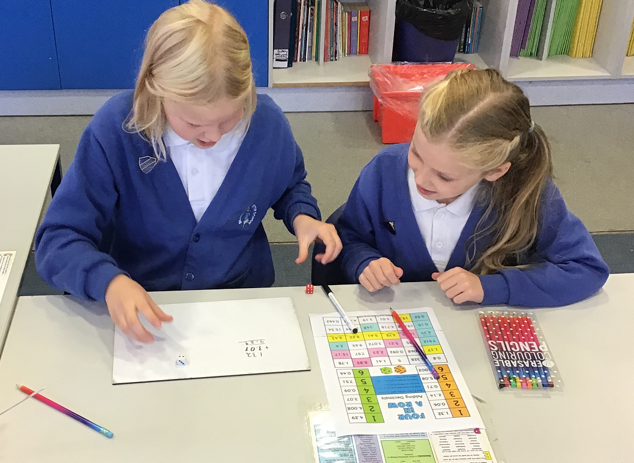

Important Dates

Closing date for applications: Wednesday 28th June 2023 at 12 noon

Shortlisting: Thursday 29th June 2023

References requested: Thursday 29th June 2023

Interview selection process: Monday 3rd July 2023

Interested candidates re strongly encouraged to visit the school. Please note: the school reserves the right to interview and appoint prior to the closing date

Please contact Win Drake, on 020 8874 1482 or email at sbm@beatrixpotter.wandsworth.sch.uk to arrange a visit.

Wishing you every success with you application

Job description: Deputy Headteacher
Beatrix Potter School is committed to creating a diverse workforce. We’ll consider all qualified applicants for employment without regard to sex, race, religion, belief, sexual orientation, gender reassignment, pregnancy, maternity, age, disability, marriage or civil partnership.

Job details
Salary: L9 to L15
Hours: Fulltime
Contract type: Fulltime Permanent
Reporting to: Headteacher
Responsible for: Assistant Headteachers, Key Stage Leaders, Teaching staff

Main purpose
The Deputy Headteacher, under the direction of the Headteacher, will:
- Take a major role in formulating the aims and objectives of the school, establishing the policies through which they shall be achieved, managing staff and resources to achieve the aims and objectives of the school and monitor progress towards their achievement.
- Undertake the professional duties of the Deputy Headteacher reasonably delegated to you by the Headteacher
- Undertake the professional duties of the Headteacher, in the event of their absence from the school.
- In partnership with the Headteacher and the Senior Leadership Team, provide professional leadership and management of teaching and learning throughout the school.
- To provide professional leadership and management of School Strategic Plan priorities as delegated by the Headteacher
- If the Headteacher is absent, the Deputy Headteacher will also be expected to fulfil the professional responsibilities of a Headteacher, as set out in the School Teachers’ Pay and Conditions Document (STPCD).

Qualities
The Deputy Headteacher will:
- Uphold public trust in school leadership and maintain high standards of ethics, behaviour and professional conduct maintaining empathy and compassion with all whilst working for the best interests of the school’s pupils
- Build positive and respectful relationships across the school community
- Be highly organised
- Be creative, reflective and innovative
- Be sensitive to the needs of others in the face of new developments
- Be an excellent communicator

2. Duties and responsibilities
As a Teacher

- You are to carry out the duties of a school teacher as set out in the Pay and Conditions Document and subject to any amendments due to Government legislation. This includes any duties as may be reasonably directed by the Headteacher.
- To facilitate and encourage learning which enables students to achieve high standards, to share and support the corporate responsibility for the well-being, education and discipline of all children.
- All staff are expected to uphold the school’s principles and policies which underpin good practice and the raising of standards and are expected to uphold and promote the school’s aims and values.
- All staff will be involved in working together, as part of a team, to develop areas of provision that impact positively on learning and teaching across the school.
- All staff will take an active role in the School Self Evaluation process. As Deputy Headteacher you will be expected to lead a team through the School Self Evaluation process.
- All staff are expected to actively undertake professional development through taking a keen interest in researching the latest developments and thinking, leading in coaching and mentoring, self-evaluation and peer review.
- Being a role model to others for excellent teaching and learning through a minimum of a one day a week classroom teaching

3. Performance Management

To undertake own annual Performance Management, setting and agreeing targets linked to the school strategic plan priorities with the Headteacher.
To performance manage other staff as a part of the distributed leadership structure for performance management across the school

4. Key Areas

4.1. Impact on educational progress beyond your own assigned pupils:

Strategic direction/Shaping the future

Support the Headteacher in:
- Ensuring the vision for the school is clearly articulated, shared, understood and acted upon effectively by all. Demonstrating the vision and values of the school in everyday work and practice
- Motivating and working with others to create a shared culture and positive climate
- Assist the Headteacher in the ongoing and annual review of standards of leadership, teaching and learning in specific areas of responsibility and across all areas of school provision, consistent with the procedures in the school self evaluation policy
- Play an active part in shaping the School Strategic Plan, leading on the delivery in specific areas (such as safeguarding and teaching and learning) actively involving all staff in its design and execution.
- Develop and implement policies and practices for the curriculum which reflects the school’s commitment to high achievement and is consistent with national and local strategies and policies
- Uphold educational standards in order to prepare pupils from all backgrounds for their next phase of education and life
- Ensure a culture of staff professionalism
- Encourage high standards of behaviour from pupils, built on rules and routines that are understood by staff and pupils and clearly demonstrated by all adults in school
- Use consistent and fair approaches to managing behaviour, in line with the school’s behaviour policy
- Reflect and revisit relevant policies, including behaviour, reshaping them when necessary
- Work with subject coordinators to develop long, medium and short term plans that are logical in their progression, aspirational in their content and reflect current pedagogical excellence
- Monitor the progress made in achieving subject/area plans and targets, and evaluate the effect on teaching and learning
- Work with outside agencies and stakeholders to inform future action
- Ensure rigorous approaches to identifying, managing and mitigating risk
- Allocate financial resources appropriately, efficiently and effectively
- Identify problems and barriers to school effectiveness, and develop strategies for school improvement that are realistic, timely and suited to the school’s context
- Make sure these school improvement strategies are effectively implemented

4.2. Leading Learning and Teaching, developing and enhancing the teaching practice of others:

- Work with the Headteacher to raise the quality of teaching and learning and pupil’s achievement across all subjects and stages, setting high expectations and monitoring and evaluating effectiveness of learning outcomes
- To take a keen interest in developing pedagogy, developing own knowledge and skills as well as those of others leading to innovative and effective methods of teaching drawn from evidenced research
- Lead a subject area as delegated by the Headteacher
- Engage all staff in the creation, consistent implementation and improvement in schemes of work and curriculum plans which encapsulates key school learning strategies
- Establish curriculum leadership, including subject coordinators with relevant expertise and access to professional networks and communities
- Induct all new teachers into the school, ensuring the effective building of knowledge of systems, procedures and standards at Beatrix Potter school
- Support the Assistant Headteacher for Inclusion in designing and implementing induction for new members of the support staff team.
- Manage staff well with due attention to workload
- Provide regular feedback for colleagues in a way which recognises good practice and supports their progress against professional and performance management objectives resulting in a tangible impact on students learning
- Ensure teaching is underpinned by subject expertise, supporting and developing whole staff, phase teams and individuals to enhance performance.
- Effectively use formative assessment to inform strategy and decisions, setting supportive pupil progress meetings and holding staff to account for meeting the targets set at these
- Develop and maintain highly effective formative and summative assessment structures within the school, using valid, reliable and proportionate approaches to assessing pupils’ knowledge and understanding of the curriculum
- Oversee the organisation, arrangements for summative assessment as well as reporting to stakeholders and relevant agencies
- To be creative and open minded in designing and implementing staff development, including coaching and mentoring as well as planning, organising and delivering staff meetings, where necessary bringing in outside expertise
- Plan, delegate and evaluate work carried out by team(s) and individuals
- Create, maintain and enhance effective relationships
- Recruit and select teaching and support staff
- Ensure the use of evidence-informed approaches to reading so that all pupils are taught to read

4.3. Securing Accountability

- Work with the Headteacher to ensure the school’s accountability to a wide range of groups, ensuring that pupils enjoy and benefit from a high quality education, for promoting collective responsibility within the whole school community
- Develop a school ethos which enables everyone to work collaboratively, share knowledge and understanding, celebrate success and accept responsibility for outcomes
- Understand and welcome the role of effective governance, including accepting responsibility
- Ensure that staff understand their professional responsibilities and are held to account
- Ensure the school effectively and efficiently operates within the required regulatory frameworks and meets all statutory duties
- Work successfully with other schools and organisations
- Maintain working relationships with fellow professionals and colleagues to improve educational outcomes for all pupils
- Develop and present a coherent, understandable and accurate account of the school’s performance to a range of audiences including governors, parents and carers, with particular reference to assessment, curriculum behaviour and safeguarding
- Reflect on personal contribution to school achievements and take account of feedback from others
- Agree, monitor and evaluate the subject pupil progress targets to make a measurable contribution to whole school targets
- Provide guidance on a choice of teaching and learning methods/strategies, coach and mentor, model and demonstrate, act as a consultant for other staff
- Exemplify good practice, Undertake shared planning, team teaching etc
- Develop and implement systems for recording individual pupil’s progress
- Evaluate the quality of teaching and standards of achievement, setting targets for improvement

4.4. Resource Management

- Work with the Headteacher to provide effective organisation and management of the school and seek ways to improve organisational structures and functions based on rigorous self-evaluation
- Work with the Headteacher to ensure the school and the people and resources within it are organised and managed to provide an efficient, effective and safe learning environment
- Oversee and evaluate the subject/area budget allocation to ensure the budget is spent in line with subject/area learning priorities and best value principles
- Secure and allocate resources to support effective learning and teaching within the subject area(s)
- Monitor and control the use of resources and budget according to the school’s agreed financial procedures

4.5. Developing Self and Working with Others

- Lead on wellbeing for the staff team, seeking out and analysing feedback, researching latest thinking and working with the Headteacher to bring about a highly motivated team who are supported to achieve their own wellbeing
- Work with the Headteacher to build a professional learning community who are interested in their own development and keen to develop effective innovations in teaching and learning as well as pastoral care
- Support staff, within your team and within the whole school, in achieving high standards through effective continuing professional development
- Be committed to your own professional development
- Implement successful performance management processes with allocated team of staff
- Treat people fairly, equitably and with dignity and respect to create and maintain a positive school culture
- Build a collaborative learning culture within the school and actively engage with other schools to build effective learning communities
- Acknowledge the responsibilities and celebrate the achievements of individuals and teams
- Develop and maintain a culture of high expectations for self and others
- Regularly review own practice, set personal targets and take responsibility for own professional development

4.6. Strengthening Community

- Work with the Headteacher to engage with the internal and external school community to secure positive engagement, equity and entitlement
- Work with the Headteacher to collaborate with other schools and organisations in order to share expertise and bring positive benefits to their own and other schools
- Work with the Headteacher to work collaboratively at both strategic and operational levels with parents and carers and across multiple agencies for the well-being of all children and their families

4.7. Additional and special educational needs (SEN) and disabilities
- Under the direction of the Headteacher, the Deputy Headteacher will:
- Promote a culture and practices that enables all pupils to access the curriculum
- Have ambitious expectations for all pupils with SEN and disabilities
- Make sure the school works effectively with parents, carers and professionals to identify additional needs and provide support and adaptation where appropriate
- Make sure the school fulfils statutory duties regarding the SEND Code of Practice.

5. Specific Duties for Deputy Headteacher

- To be the Designated Safeguarding Lead for the school, keeping up to date with the training and executing this responsibility to the highest standard
- To be the teacher for Looked After Children, prioritising their welfare, wellbeing and education, reporting as necessary to outside agencies
- To be the Wellbeing Lead for the school, ensuring relevant training takes place and that all stakeholders are supported to meet their wellbeing needs
- To be the Educational Visits Coordinator, authorising trips, overseeing the risk assessment and communications to families
- To oversee all day to day absences and covers for absence, liaising with the Headteacher if there is an impact on the budget.
- To create and oversee whole school timetables
- To provide professional leadership and management of key areas of the School Strategic Plan as agreed, on an annual basis, with the Headteacher
- To be responsible for behaviour policy & practice across the school
- To provide professional leadership and management of the Primary Curriculum and its assessment (both formative and summative).
- To take an active role in the Senior Leadership Team, contributing to the development of identified areas leading to high standards of teaching, effective use of resources and improved standards of learning and achievement for all children
- To identify and pursue leadership and management development opportunities (to be agreed and negotiated with the Headteacher who will give support throughout)

Person specification
criteria | qualities
Qualifications  and training | - Qualified teacher status  - Degree  - Further training appropriate to senior leadership  - NPQ in leadership (desirable)
Experience | - Successful leadership and management experience in a school  - Classroom Teaching experience of no less than 5 years  - Involvement in school self-evaluation and development planning  - Demonstrable experience of successful line management and staff development  - Demonstrable experience of curriculum creation and implementation  - Demonstrable experience of bringing about positive change in response to analysis of attainment and progress  - Experience as either a Designated Safeguarding Lead (DSL) or a Deputy DSL
Skills and knowledge | - Data analysis skills, and the ability to use data to set targets and identify weaknesses  - Understanding of high-quality teaching, and the ability to model this for others and support others to improve  - Understanding of school finances and financial management  - Effective communication and interpersonal skills  - Ability to communicate a vision and inspire others  - Ability to support others to develop and improve own practice as a positive process  - Ability to build effective working relationships
Personal qualities | - A commitment to getting the best outcomes for all pupils and promoting the ethos and values of the school  - Ability to work under pressure and prioritise effectively  - Commitment to maintaining confidentiality at all times  - Commitment to safeguarding and equality, ensuring that personal beliefs are not expressed in ways that exploit the position.  - Enthusiasm and interest in research and implementing pedagogy  - Empathy and compassion leading to positive relationships  - A desire to support all members of the community to find and make the most of opportunities available to them

