Candidate Information Pack-
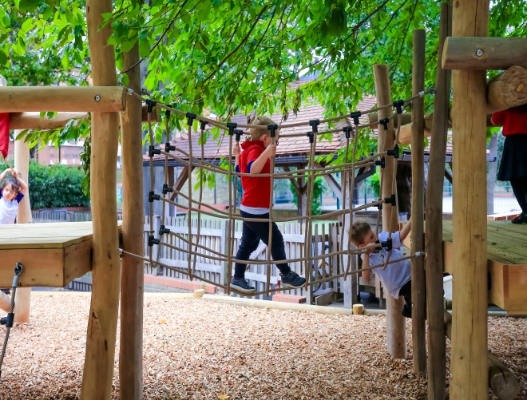
Teaching Assistant
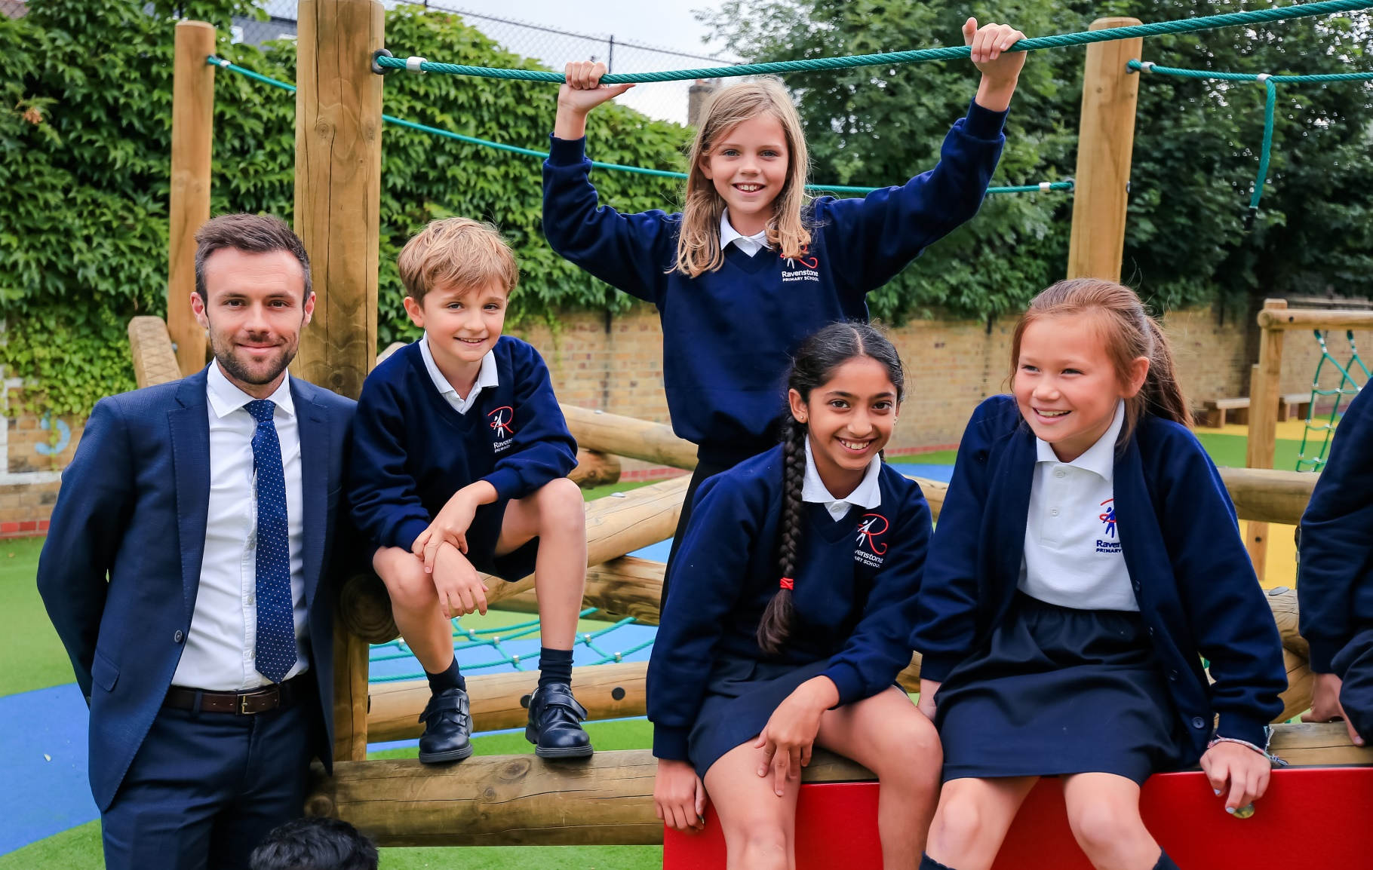
RAVENSTONE PRIMARY SCHOOL
Teaching assistant - April 2020

Welcome and thank you for considering Ravenstone. I hope that this application pack gives you everything you need to consider working with us.
Ravenstone is a fantastic school. Every child that steps through the gates is welcomed into an aspirational, creative community that focuses on allowing children to flourish as individuals and reach their potential academically.
As Headteacher I passionately believe that we should allow our children to experience a wide range of creative enrichment opportunities and develop as confident, caring individuals who excel academically, and reach their full potential. It is this mixture that makes Ravenstone so special. We will not sacrifice any of these elements.
I believe that the success of a school is down to its teachers and I am proud to say that everything we focus on and do is to develop as professionals and deliver the best possible education for every child in our school. We constantly strive to improve and introduce initiatives that will inspire every pupil to achieve and become motivated individuals who can succeed in their futures.
We do everything we can to provide our pupils with the skill set to challenge the norm and become successful. Our curriculum is tailored towards the needs of the pupils and ranges from, high quality dance and music lessons, swimming in Year 4, 5 and 6 as well as a mastery approach to the core subjects and importantly a PSHE scheme of work that teaches our pupils to be safe, astute and adding to the world that they are growing up in.
Our 2019 OFSTED inspection highlighted so many wonderful aspects of our school and clearly shows our commitment towards staff wellbeing and development. I am incredibly proud of our exceptionally talented staff that strive to get the very best out of every child. I want to continue to provide my team with the best possible career opportunities to thrive as teachers and future leaders.
Please do get in touch if I can help in any way possible.

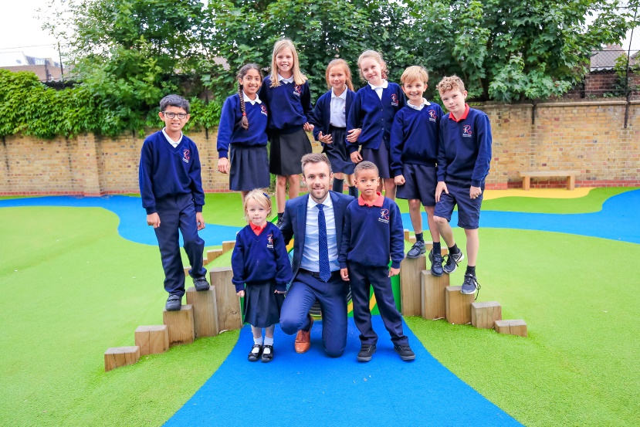
Joe Croft
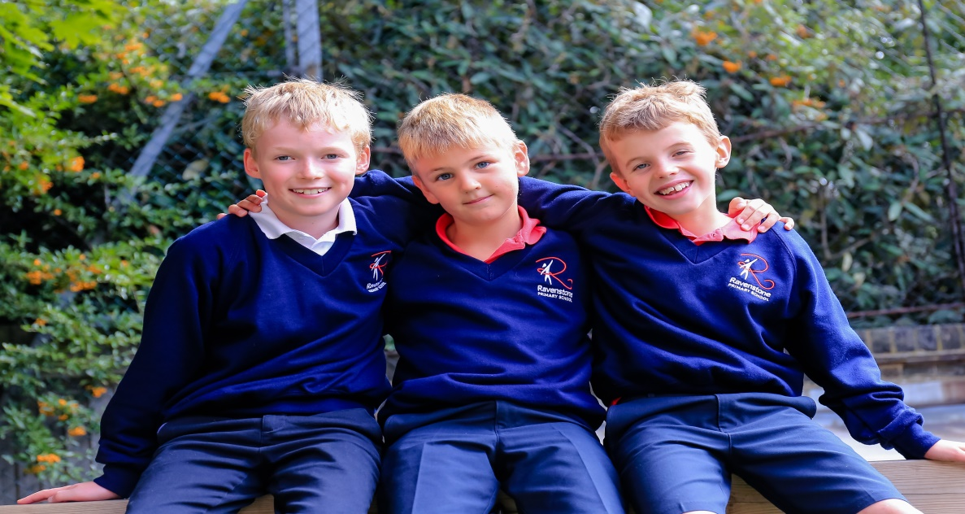

About Ravenstone
Ravenstone is a community primary school in Balham, funded by the London Borough of Wandsworth. The school has served the local community for the last 100 years. We are conveniently placed for public transport links – Balham main line train and tube station is 3 minutes away with easy access to all of London, Kent, Surrey and Sussex. We also have parking available onsite. The open space of Tooting Bec Common and the vibrant Balham centre are a few minutes from the school.
School organisation
410 children are currently on roll including full-time and part-time nursery children. These are arranged in 15 classes and the nursery. We are a two form entry school.
School focus
We are committed to the continuous improvement of every aspect of school life for children at Ravenstone. We seek to deliver an outstanding educational experience of the highest quality for children of diverse backgrounds and abilities. Enthusiasm, enjoyment, creativity, imagination and high expectations of both pupils and staff are at the centre of a wide variety of learning activities.
Our school vision is ‘Children reaching their potential in the heart of the community’ and our core values are Happy, Kind, Creative, Honest, Determined. We promote this in everything we do and we strive to allow our children to be confident individuals are understand themselves and will grow into well rounded adults who add to the world we live in.
As a school we focus on developing the adult as much as the child. We believe if every member of staff is the best they can possible be while constantly looking at ways to improve then this will provide our children with an outstanding environment to learn within.
Our ultimate aim is to become outstanding and continue to become a centre of excellence within the local community and beyond.

Community
We are proud to serve and be supported by our community. We offer a vibrant and rewarding environment with a committed team of hardworking staff, supportive governors and enthusiastic parents. The children are happy and keen to learn. We pride ourselves on the friendliness, confidence and character of our children.
The partnership between school and home is very important to us. We value parental involvement and have a thriving parents’ and carers’ association, Friends of Ravenstone, which organises social events and raises funds for the school which are used to enhance the children’s educational experience. Recently funds have been used to develop our music provision, the redevelopment of parts of the playground, the purchase of IT equipment and contributions to school trips and school journey.
We welcome volunteers from both the parent body and the local community to help in the school with reading, gardening, chess and newspaper clubs.
Everyone is encouraged to make a positive contribution to the wider community; on a local level, the school council recently organised a collection for a nearby foodbank. Looking further afield, for the last 14 years, we have had a partnership with a school in Yameriga, Ghana and Ravenstone children have been very active in supporting projects there.
Listening to pupils
The children elect representatives from each class to participate in the school council and discuss topics that are meaningful to the children. We value hearing pupils’ views and opinions and present them with regular opportunities in lessons and assemblies to voice these. Such information can offer ideas on how to improve their learning experience.
We have an established peer mentoring and mediation scheme so that the trained mentors can support their peers in the playground.
Curriculum enrichment/Ravenstone Entitlement
The Ravenstone entitlement is an offer to every child in the school. This offer includes at least one external trip, one inspirational internal visit and a curriculum themed day every term. We believe that every child deserved to learn in an engaging and purposeful learning environment that inspires them to become curious and ambitious.
Ravenstone celebrates each child’s participation and achievement in a wide range of activities including languages, food, art, sport, music and dance. We want all pupils to experience London’s rich diversity and we organise school trips as well as visits to the school by outside speakers.
Sport is one of the cornerstones of the school’s identity. We are fortunate to have a full time dedicated sports teacher and part time dance teacher and Ravenstone regularly excels in inter-school competitions. We have represented Wandsworth in athletics and swimming at the London Youth Games. Though competition is encouraged, children understand that sport is primarily undertaken for enjoyment and can be accessed by all, regardless of ability or experience.
Extra-curricular
We run a number of clubs before and after school and during lunchtimes: for example, choir, gardening, chess and newspaper club. We also have several externally-run clubs.
Working at Ravenstone
- A focus on work life balance and managing workload
- A culture of learning together
- Additional planning/leadership release at the end of every half term and term.
- A good school on the journey to outstanding
- A school that allows for teachers to flourish and allocates a large percentage of their budget to staff development
- An exceptionally well-resourced learning environment
- An Outstanding leadership team who think differently
- Excellent professional development and career progression opportunities
- A collaborative and caring school community which is culturally diverse and inclusive
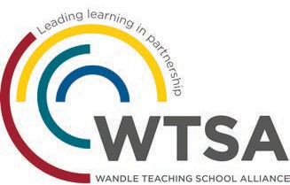
- Wonderful pupils
Maths Hub

The London South West Maths Hub aims to support schools in seven boroughs (Wandsworth, Merton, Sutton, Kingston, Richmond, Hillingdon and Hammersmith & Fulham) through a range of national and local projects each year. The core purpose of the Hub is to engineer a school based support network to develop Mastery style teaching at all levels of education.

As a school Ravenstone has embraced the support offered by the maths hub and our lead teacher is a mastery specialist and works with a range of other local schools.

Hillingdon and Hammersmith & Fulham) through a range of national and local projects each year. The core purpose of the Hub is to engineer
a school based support network to develop Mastery style teaching at all levels of education.

Wandle Teacher School Alliance

Ravenstone works as part of the Wandle Teacher School Alliance. The Alliance consists of a wide range of schools from different phases and specialisms and institutions who work together in a variety of ways to identify and tackle key issues within schools. We have a dedicated and enthusiastic staff in all phases and sectors. This depth and breadth of experience offers trainee teachers a unique opportunity to explore the many complex and exciting areas of teaching and learning. Whatever stage you are in your career the Teaching School and its partners offer a comprehensive package to support both career and professional development right through to Headship and Masters qualifications.

JOB DESCRIPTION
Position: Teaching asssitant – KS1 or KS2
Grade: 1C
Responsile to: Assistant Headteacher and Head of Phase
Detail
1. Purpose of the Job

Responsible, under the direction or instruction of the teacher or line manager, to work with individual pupils or to work with small groups to supervise physical and general care of pupils, including those with SEN. Also to support access to learning for pupils and provide general support to the teacher in the management of pupils and the classroom.

Main Responsibilities

1. SUPPORT FOR PUPILS

- Attend to the pupils’ personal needs, and implement related personal programmes, including social, health, physical, hygiene, first aid and welfare matters including medical procedures following appropriate training
- Supervise and support pupils ensuring their safety and access to learning
- Establish good relationships with pupils, acting as a role model and being aware of and responding appropriately to individual needs
- Promote the inclusion and acceptance of all pupils
- Encourage pupils to interact with others and engage in activities led by the teacher
- Encourage pupils to act independently as appropriate
- Ensure children are learning and making progress
- Deliver small group interventions
- Deliver 1-1 interventions
- Provide feedback to the class teacher on how the children are progressing
- Carry out lunch and break duty
- Address behavior concerns

2. SUPPORT FOR THE TEACHER

- Prepare the classroom as directed for lessons and clear afterwards and assist with the display of pupils work
- Be aware of pupil problems, progress and achievements and report to the teacher as agreed
- Undertake pupil record keeping as requested
- Support the teacher in managing pupil behaviour, reporting difficulties as appropriate
- Gather and report information from and to parents or carers as directed
- Provide basic clerical and administrative support e.g. photocopying, typing, filing, collecting money etc.

3. SUPPORT FOR THE CURRICULUM
- Support pupils to understand instructions
- Supporting pupils in undertaking literacy and numeracy tasks as directed by the teacher
- Supporting pupils in using basic ICT as directed
- Prepare and maintain equipment and resources as directed by the teacher and assist pupils in their use

SUPPORT FOR THE SCHOOL

- Be aware of and comply with policies and procedures relating to child protection, health, safety and security, confidentiality and data protection, reporting all concerns to an appropriate person
- Be aware of and support difference and ensure all pupils have equal access to opportunities to learn and develop
- Contribute to the overall ethos, work and aims of the school
- Appreciate and support the role of other professionals
- Attend relevant meetings as required
- Participate in training and other learning activities and performance development as required
- Assist with the supervision of pupils out of lesson times, including before and after school
- Accompany teaching staff and pupils on visits, trips and out of school activities as required
- To be fully aware of and understand the duties and responsibilities arising from the Children Act 2004 and Working Together in relation to child protection and safeguarding children and young people as this applies to the worker’s role within the organisation
- To be fully aware of the principles of safeguarding as they apply to vulnerable adults in relation to the worker’s role
- To ensure that the worker’s line manager is made aware and kept fully informed of any concerns which the worker may have in relation to safeguarding and/or child protection

PERSON SPECIFICATION
- EXPERIENCE
- Working with or caring for children of relevant age

- QUALIFICATIONS
- Good numeracy and literacy skills
- Completion of Teacher Assistant Induction Programme
- Willingness to participate in development and training opportunities

- KNOWLEDGE AND SKILLS
- Basic knowledge of first aid
- Use basic technology – computer, video, photocopier etc.
- Ability to relate well to children and to adults
- Work constructively as part of a team, understanding classroom roles and responsibilities and your own position within these
- An understanding of the schools equal opportunities policy and how it is implemented

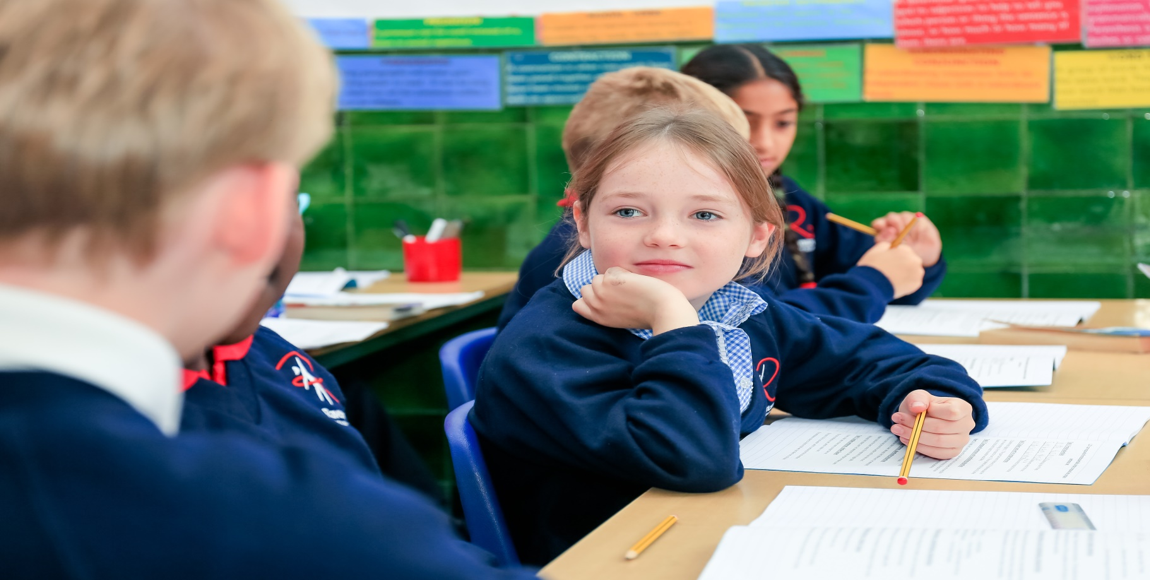
Contact us;
Telephone: 0208 673 0594020 7622 1619
Email:
Info@ravenstone.wandsworth.sch.uk

RAVENSTONE PRIMARY SCHOOL
Teaching Assistant
April 2020

Are you looking towards teaching in an outstanding educational environment and would you like the opportunity to be part of a dynamic and very committed team?
If so you should apply to work at Ravenstone Primary school where you will benefit from:

- Excellent professional development and career progression opportunities.
- Strong values and relationship based approaches with a care for work life balance
- Working with highly aspirational and caring group of professionals who care deeply.
- An exceptionally well resourced learning environment.
- A caring and supportive whole school community which is culturally diverse and inclusive.

Visits are welcome and actively encouraged. Please see details below to book a slot
To apply please download an application and details from this web page or from the Wandsworth Council website https://jobs.wandsworth.gov.uk/

Completed applications should be returned to the school by email on: info@ravenstone.wandsworth.sch.uk

School tours: Week commencing 2nd March February (please contact us to arrange a time)
Closing Date: 13th March - Interviews: 20th March
We are committed to safeguarding and promoting the welfare of children, young people and vulnerable adults and expect all staff and volunteers to share this commitment. This post is subject to an enhanced DBS check. CVs are not accepted.

