Job Profile comprising Job Description and Person Specification

Job Description

Job Title:  MARAC Coordinator | Grade:  PO1
Section:  Customers and Partnerships | Directorate:  Chief Executives Group
Responsible to following manager:  VAWG Manager | Responsible for following staff:  N/A
Post Number/s: | Last review date: June 2021

Working for the Richmond/Wandsworth Shared Staffing Arrangement

This role is employed under the Shared Staffing Arrangement between Richmond and Wandsworth Councils. The overall purpose of the Shared Staffing Arrangement is to provide the highest quality of service at the lowest attainable cost.

Staff are expected to deliver high quality and responsive services wherever they are based, as well as having the ability to adapt to sometimes differing processes and expectations.

The Shared Staffing Arrangement aims to be at the forefront of innovation in local government and the organisation will invest in the development of its staff and ensure the opportunities for progression that only a large organisation can provide.

Job Purpose

To effectively coordinate and administrate the Domestic Violence and Abuse Multi Agency Risk Assessment Conference (MARAC) which includes receiving referrals and risk assessments, agenda setting, recording minutes and actions; ensuring that partner agencies complete their actions and maintaining relevant databases. To work in partnership with a range of stakeholders and deliver MARAC training. To support the VAWG Manager and Vulnerabilities Manager with administration of the governance structure surrounding Domestic Violence and Abuse.
Specific Duties and Responsibilities

- To administer the MARAC to ensure the effective operation, performance and delivery of the MARAC, in partnership with key stakeholders. To ensure that duties are undertaken with due regard and compliance with the Data Protection Act and other legislation.

- To facilitate and ensure consistency in referral of cases to the MARAC from the full range of potential referring agencies based on the use of a common risk identification tool and referral form for victims.

- To prepare monthly MARAC agendas and ensure that listed referrals meet MARAC threshold. To ensure that cases are reviewed in the most time effective manner and that any specialist attendees are present.

- To request MARAC case research from local GP surgeries on a monthly basis.

- To prepare relevant documentation to a high standard, including the minutes and agreed actions, and circulate to partner agencies within agreed timescales.

- To analyse MARAC referral data in order to identify any gaps in key referral agencies and to liaise with the full range of potential referral agencies, in particular those working with minority or hard to reach groups to ensure that the needs of all victims are met.

- To maintain:
- Orderly files on SharePoint system
- An action log following each MARAC meeting to include recording where actions are complete, cannot be completed or are incomplete, and bringing these to the attention of the MARAC Chair.
- A tracking system of all MARAC cases and to notify panel members when twelve months have passed since the original referral so that cases can be de-flagged by partners from their respective systems.
- The MARAC data collection process, to ensure that relevant data is collected so that the outputs and outcomes from the MARAC can be monitored. This includes completing the quarterly SafeLives MARAC returns.
- MARAC attendance spreadsheet which monitors agency/staff attendance of MARAC.

- Work with MARAC panel members to refresh, review, develop and implement the MARAC Operating Protocols and MARAC Information Sharing Protocols to ensure the effective coordination and delivery of the MARAC.

- Ensure that all relevant members of staff from the voluntary, statutory and community sector are familiar with the MARAC process, and on their role and responsibilities within it. To develop and deliver MARAC briefing sessions for professionals in order to raise awareness of MARAC, Domestic and Sexual Violence (DSV) and Violence Against Women and Girls (VAWG) policy areas and of the Councils’ approach to tackling VAWG.

- To monitor and maintain the secure inbox for MARAC and the management of the MARAC secure filing systems.

- To prepare performance reports on the MARAC, including statistical reports, for VAWG meetings and the Community Safety Partnership. To work with SafeLives on the development of the MARAC which will include supporting the quality assurance process and the London MARAC development programme.

- Assist the VAWG Manager and Vulnerabilities Manager with the administration of any meetings associated with VAWG and provide other ad-hoc administrative support to these officers as required.

- To assist with planning, implementation and administration of Domestic Abuse awareness raising events such as the White Ribbon campaign.

- To develop and maintain effective working relationships with MARAC partner agencies.

- To develop and maintain effective working relationships with panels such as Integrated Offender Management (IOM) and Multi-Agency Public Protection Arrangements (MAPPA).

- Attend relevant training and courses on new legislation and specialist courses in order to maintain good communication and personal development in relation to DSV, VAWG, Safeguarding Children and Safeguarding Adults.

Generic Duties and Responsibilities

- To contribute to the continuous improvement of the services of the Boroughs of Wandsworth and Richmond.

- To comply with relevant Codes of Practice, including the Code of Conduct and policies concerning data protection and health and safety.

- To adhere to security controls and requirements as mandated by the SSA’s policies, procedures and local risk assessments to maintain confidentiality, integrity, availability and legal compliance of information and systems.

- To promote equality, diversity, and inclusion, maintaining an awareness of the equality and diversity protocol/policy and working to create and maintain a safe, supportive and welcoming environment where all people are treated with dignity and their identity and culture are valued and respected.

- To understand both Councils’ duties and responsibilities for safeguarding children, young people and adults as they apply to the role within the council.

- The profile is not intended to be an exhaustive list of the duties the post holder will carry out. Other reasonable duties commensurate with the level of the post, including supporting emergency and priority situations, will form part of the role.

Additional Information
- Post holder may be expected to work flexibly across two locations (Wandsworth Town Hall and Richmond Civic Centre).

Team structure

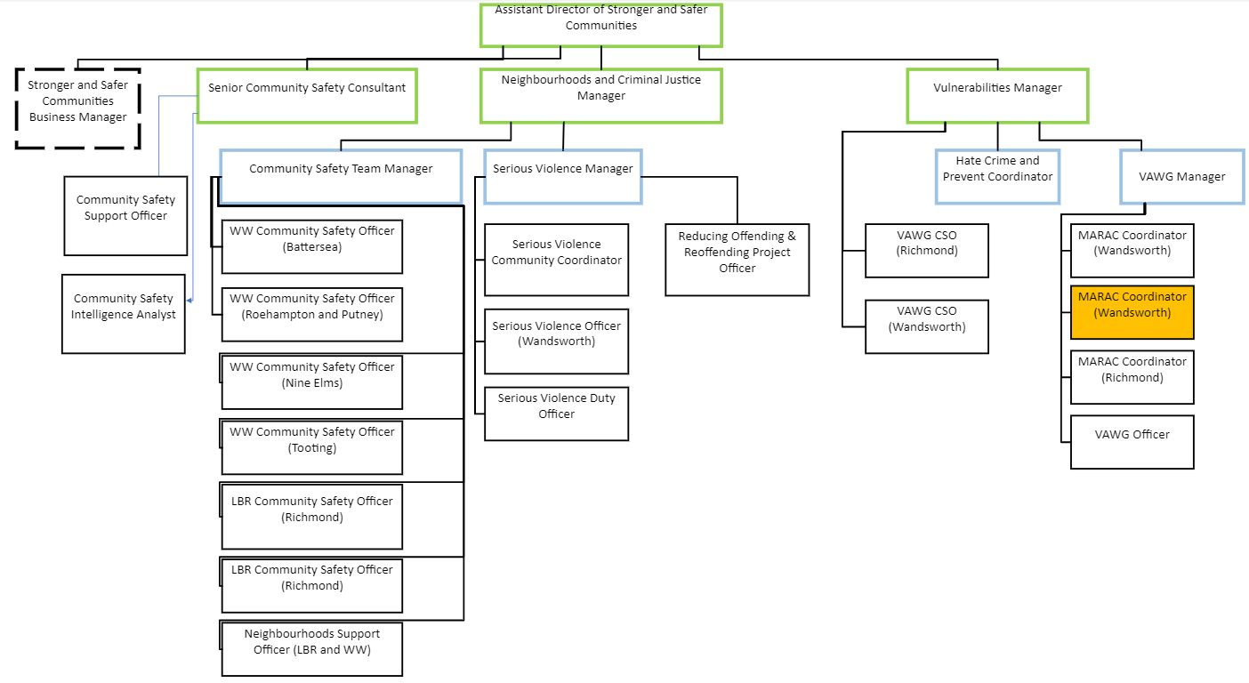
Person Specification

Job Title: MARAC Coordinator | Grade: PO1
Section: Customers and Partnerships | Directorate: Chief Executives Group
Responsible to: VAWG Manager | Responsible for: N/A
Post Number/s: | Last Review Date: June 2021

Our Values
THINK BIGGER
EMBRACE DIFFERENCE
CONNECT BETTER
LEAD BY EXAMPLE
PUT PEOPLE FIRST

Our Values are embedded across the SSA and throughout all roles and responsibilities at all levels of the organisation. Please familiarise yourself with our values as they are an integral part of our recruitment and selection process.

 | Person Specification Requirements |  |  | Assessed by  A/I/T/C  (see below for explanation)
 | Knowledge | Essential | Desirable | Assessed
 | An understanding of relevant legislation, policy and procedure relating to domestic violence and abuse | x |  | A/I
 | An understanding of how all agencies work within these defined fields | x |  | A/I
 | An understanding of MARAC operating and information sharing protocols and their possible applications | x |  | A/I
 | Experience | Essential | Desirable | Assessed
 | Experience of multi-agency work, particularly project management | x |  | A/I
 | Experience and /or knowledge of the MARAC process | x |  | A/I
 | Experience of performance reporting | x |  | A/I
 | Experience of improving access to multi-agency support to tackle domestic abuse | x |  | A/I
 | Experience of working with and negotiating and influencing the police and other statutory and voluntary partners at a strategic and operational level | x |  | A/I
 | Skills | Essential | Desirable | Assessed
 | Experience of data management and the ability to use Microsoft Office (Word, Excel, Outlook, Access) | x |  | A/I
 | Excellent time management and organisational skills including the ability to meet tight deadlines | x |  | A/I
 | Ability to use initiative and judgement in dealing with colleagues and partner agencies without direct supervision | x |  | A/I
 | Ability to communicate clearly and concisely (both written and oral) | x |  | A/I
 | Ability to work as a team member and within a line management structure | x |  | A/I
 | Ability to build effective relationships both internally and externally, showing sensitivity for other’s viewpoint and valuing diversity | x |  | A/I
 | Familiarity with data collection and analysis | x |  | A/I
 | Ability to provide high quality documents and maintain confidentiality | x |  | A/I
 | Familiarity with both the statutory and voluntary sector |  | x | A/I
 | Accuracy and attention to detail | x |  | A/I
 | Ability to deliver training | x
 | Qualifications | Essential | Desirable | Assessed
 | Good standard of general education | x |  | A/C

A – Application form
I – Interview
T – Test
C – Certificate

