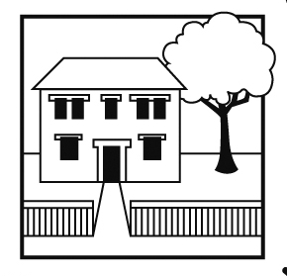
Balham Nursery School
Executive Headteacher: Ms Emma Williams B.Ed (ECE)
72 Endlesham Road, London SW12 8JL
Telephone: 020 8673 4055
Email: admin@balham-nursery.wandsworth.sch.uk
Website: www.balham-nursery.wandsworth.sch.uk

26th July 2022

Dear Applicant

Senior Administrative Officer
Term Time Only - 40 weeks per annum (to include all staff training days and 5 days during school holidays)

Thank you for your interest in applying for the position of Senior Administrative Officer at Balham Nursery School. You can find further information about the school and the post, including a job description and person specification, and download an application form at https://jobs.richmondandwandsworth.gov.uk Please also visit our website www.balham-nursery.wandsworth.sch.uk

The first step in the selection process is your application. To get the most out of your application, please ensure you read through the person specification carefully and provide specific examples to demonstrate how you meet all the shortlisting criteria. Your completed application should be returned to Emma Williams, Executive Headteacher at admin@balham-nursery.wandsworth.sch.uk.

The deadline for us to receive your completed application is 12 noon on Monday, 22nd August 2022.

Successful applicants will be invited to an interview on Thursday, 25th August 2022.

If you have any special requirements to enable you to fully participate in the application and/or selection process, or have any questions about the application process, please contact me by e-mail to admin@balham-nursery.wandsworth.sch.uk. Please ensure you provide a telephone number where you can be contacted or where we can leave a message.

We look forward to receiving your application.

Yours faithfully

Emma Williams
Executive Headteacher

