**Job Profile comprising Job Description and Person Specification**

**Job Description**

|  |  |
| --- | --- |
| **Job Title:**  Cemeteries Officer | **Grade**:  SC5 – SO1 |
| **Section:**  Contracts and Leisure  (Registrars and Cemeteries) | **Directorate:**  Environment and Community Services |
| **Responsible to following manager:**  Registration and Cemeteries Service Manager | **Responsible for following staff:**  Not applicable |
| **Post Number/s:** | **Last review date:** July 2021 |

**Working for the Richmond/ Wandsworth Shared Staffing Arrangement**

This role is employed under the Shared Staffing Arrangement between Richmond and Wandsworth Councils. The overall purpose of the Shared Staffing Arrangement is to provide the highest quality of service at the lowest attainable cost.

Staff are expected to deliver high quality and responsive services wherever they are based, as well as having the ability to adapt to sometimes differing processes and expectations.

The Shared Staffing Arrangement aims to be at the forefront of innovation in local government and the organisation will invest in the development of its staff and ensure the opportunities for progression that only a large organisation can provide.

**Job Purpose**

To assist with the efficient and effective day to day running of the Cemeteries Service and to attend funeral services in the six cemeteries within Richmond, ensuring all duties comply with Burial Law, Health & Safety Legislation and the Institute of Cemetery and Crematorium Management Code of Safe Working Practice, in line with the standards set by the Charter for the Bereaved.​

**Specific Duties and Responsibilities**

1. Acts as ‘first point of contact’, provides a professional and customer focused service that is sympathetic, without becoming emotionally involved.
2. Receives and responds to incoming communications e.g. general telephone calls, letters, and emails, and resolves general enquiries at the first point of contact.
3. Takes bookings for burials, undertakes preliminary checks, and assists in obtaining and recording all necessary information and legal documentation required in advance of the funeral.
4. Assists with general administration duties. Keeps accurate records and assists in the analysis of information and compiles data. Maintains security and confidentiality of information, records and documents.
5. Collects fees, including cash handling.
6. Completes and returns disposal certificates in line with statutory requirements and maintains the burial database, ensuring the records are up-to-date and comply with Burial Law.
7. Attends cremated remains interments and scattering of ashes, and assists with chapel services, memorial services, and filming events.
8. Contributes to service developments and improvements as requested.
9. Works as required in ways that develop good working relations and collaborative arrangements with internal and external stakeholders.
10. Supports and maintains office systems and uses IT systems as required.
11. Completes ICCM/APSE course in Bereavement Awareness and undertakes other relevant training as required to develop customer service, administrative, and IT skills.
12. Performs any other duties commensurate with the grade deemed appropriate by the Head of Service or the Registration and Cemeteries Service Manager.

**Additional duties for progression to Scale 6**

1. Undertakes COTS Burial Health and Safety course and officiates burials at any of the six cemeteries managed by the London Borough of Richmond upon Thames. Supervises the safety of mourners and other service users during the burial process, ensuring that the coffin can be carried to the grave without mishap, and that there is a safe access for all attendees. Liaises with on-site cemetery operatives as required.
2. Responsible for ensuring all legal preliminaries are fulfilled, including receiving and checking the green Form 9 certificate for disposal, Coroner’s order for burial, or MoJ exhumation licence, as appropriate.
3. Acts as a chapel attendant, assisting the mourners, liaising with officiants, organists, families, funeral directors, and ministers to ensure a smooth-running service.
4. Represents the Council when meeting with families before, during and after the funeral. Escorts the funeral cortege from the time it enters the cemetery to the time it leaves, liaising with the Funeral Directors to ensure the funeral takes place in a dignified and orderly manner, and in accordance with burial law.
5. Ensures the advice and information given to customers is clear, accurate and given in a sympathetic manner, without becoming emotionally involved with the customer.
6. Undertakes banking and financial record keeping in accordance with the council’s financial regulations.
7. Actively contributes and participates in change programmes within the service.

**Additional duties for progression to Scale SO1**

1. Manages, updates, and circulates weekly burial schedules across the Cemeteries and Parks teams. Coordinates and monitors schedule of grounds work requests, in conjunction with the Grounds Supervisor.
2. Compiles routine statistical data for reporting and benchmarking as required by management, regional or national groups, or professional bodies. Has good working knowledge of the reporting functionality of the IT system BACAS.
3. Assists with regular reviewing and updating of published information, literature, and web pages.
4. Assists with implementation of programmes of work to improve the cemeteries sites, service, and user experience, fulfil legal or statutory requirements, and change office processes and procedures.
5. Provides a high level of service-specific experience and expertise, which enables accurate advice and guidance to be given to customers, new staff, and stakeholders.
6. Completes ICCM/APSE courses on cemeteries management and compliance, exhumations, exclusive rights of burial to assist the Senior Cemeteries Officer, and undertakes other training as required and commensurate with grade.
7. Deputises for the Senior Cemeteries Officer as required.

**Generic Duties and Responsibilities**

* To contribute to the continuous improvement of the services of the Boroughs of Wandsworth and Richmond.
* To comply with relevant Codes of Practice, including the Code of Conduct and policies concerning data protection and health and safety.
* To adhere to security controls and requirements as mandated by the SSA’s policies, procedures and local risk assessments to maintain confidentiality, integrity, availability and legal compliance of information and systems.
* To promote equality, diversity, and inclusion, maintaining an awareness of the equality and diversity protocol/policy and working to create and maintain a safe, supportive and welcoming environment where all people are treated with dignity and their identity and culture are valued and respected.
* To understand both Councils’ duties and responsibilities for safeguarding children, young people and adults as they apply to the role within the council.
* The Shared Staffing Arrangement will keep its structures under continual review and as a result the post holder should expect to carry out any other reasonable duties within the overall function, commensurate with the level of the post.

**Additional Information**

* To be responsible for the safety of mourners and other service users during the burial process, ensuring safe access to the grave for the coffin bearers and all other attendees.
* To attend funerals within any cemetery at short notice regardless of weather and/or ground conditions.

**Current Team Structure**

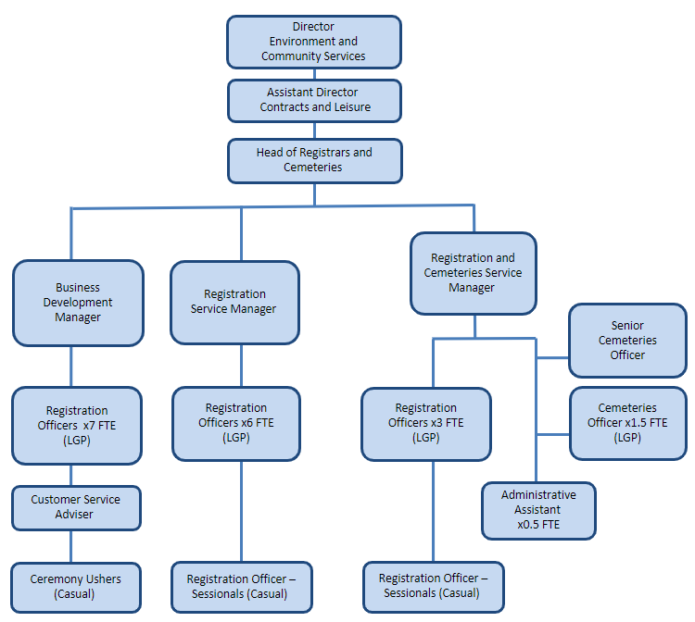

**Person Specification**

|  |  |
| --- | --- |
| **Job Title:**  Cemeteries Officer | **Grade**:  SC5 – SO1 |
| **Section:**  Contracts and Leisure  (Registrars and Cemeteries) | **Directorate:**  Environment and Community Services |
| **Responsible to following manager:**  Registration and Cemeteries Service Manager | **Responsible for following staff:**  Not applicable |
| **Post Number/s:** | **Last review date:** July 2021 |

**Our Values and Behaviours**

The values and behaviours we seek from our staff draw on the high standards of the two boroughs, and we prize these qualities in particular:

**Being open.** This means we share our views openly, honestly and in a thoughtful way. We encourage new ideas and ways of doing things. We appreciate and listen to feedback from each other.

**Being supportive.** This means we drive the success of the organisation by making sure that our colleagues are successful. We encourage others and take account of the challenges they face. We help each other to do our jobs.

**Being positive.** Being positive and helpful means we keep our goals in mind and look for ways to achieve them. We listen constructively and help others see opportunities and the way forward. We have a ‘can do’ attitude and are continuously looking for ways to help each other improve.

|  |  |
| --- | --- |
| **Person Specification Requirements** | **Assessed by A &**  **I/ T/ C (see below for explanation)** |
| **Knowledge** | |
| Knowledge of Burial Law, ICCM Code of Safe Working Practice, Health & Safety Legislation | A&I |
| Knowledge of ICT packages and ability to use them effectively | A&I |
| **Experience** | |
| Previous experience of using office systems and processes | A&I |
| Experience of dealing with a wide range of people, both internal and external, including dealing with the bereaved and people in distress, in a sympathetic manner | A&I |
| Experience of prioritising workloads and taking appropriate action in an emergency in a calm and controlled manner | A&I |
| Effective interpersonal skills | A&I |
| **Skills** | |
| Ability to maintain accurate records and accounts, and manage physical and electronic data in line with legislation and policy | A&I |
| Ability to organise and officiate events including funerals and memorial services, and manage large gatherings of people sensitively, safely, and assertively | A&I |
| Ability to represent the council positively and professionally, and demonstrate high standards of customer service | A&I |
| Ability to understand, interpret and follow legal guidelines and processes to ensure compliance with statutory legislation | A&I |
| Ability to communicate in a professional manner, both verbally and in writing, providing consistent and clear advice. Ability to deal with difficult conversations sensitively. | A&I |
| **Qualifications** | |
| Current full UK driving licence | A |

**A – Application form**

**I – Interview**

**T – Test**

**C – Certificate**