Job Profile comprising Job Description and Person Specification

Job Description

Job Title:  Consultant in Public Health – Adults, Social Care and Healthcare Public Health  (12 months fixed term) | Grade:  MG3
Section:  Public Health | Directorate:  Adult Social Care and Public Health
Responsible to following manager:  Director of Public Health | Responsible for following staff:  Senior Public Health Lead x 1 FTE  Senior Public Health Lead (Clinical) x 1 FTE  Public Health Programmes Support Officer x 1 FTE
Post Number/s: | Date:  May 2019

Working for the Richmond/ Wandsworth Shared Staffing Arrangement

This role is employed under the Shared Staffing Arrangement between Richmond and Wandsworth Councils. The overall purpose of the Shared Staffing Arrangement is to provide the highest quality of service at the lowest attainable cost.

Staff are expected to deliver high quality and responsive services wherever they are based, as well as having the ability to adapt to sometimes differing processes and expectations.

The Shared Staffing Arrangement aims to be at the forefront of innovation in local government and the organisation will invest in the development of its staff and ensure the opportunities for progression that only a large organisation can provide.

Job Purpose

To provide public health leadership across a range of activities and services for adults and older people and people with long term conditions, managing a team of Public Health Leads in conducting needs assessments, action planning, commissioning and evaluation to tackle relevant public health issues.
Specific Duties and Responsibilities

- Support the Director of Public Health in their role reporting to and supporting the work of relevant Council committees and governance bodies, including Health & Wellbeing Board, Public Health Board, Clinical Commissioning Group Governing Body, etc.

- Manage the delivery of the Core Offer to Richmond and Wandsworth Clinical Commissioning Groups.

- Lead on Public Health activity relating to public health issues affecting adults and adult social care, and lead the delivery of the Healthcare Public Health function.

- Conduct needs assessments, action planning, commissioning and evaluation to tackle relevant public health issues.

- Manage the commissioning and delivery of contracts with primary care providers for the delivery of sexual health testing and contraception, smoking cessation, and NHS Health Checks services in primary care settings.

- Lead the delivery of the clinical governance and quality assurance function, providing advice and guidance to all relevant local authority and NHS services to ensure services are safe and effective.

- Provide commissioning support for relevant Public Health services dispersed to other departments, including falls prevention.

Standard Consultant in Public Health Responsibilities approved by Faculty of Public Health:
Management arrangements

The post holder will be professionally accountable to the employing authority and managerially accountable to the employing authority via their line manager, the Director of Public Health. Professional appraisal will be required. An initial job plan will be agreed with the successful candidate prior to that individual taking up the post based on the draft job plan attached. This job plan will be reviewed as part of the annual job planning process.
The post holder:

- will manage three staff; this role includes line management duties, recruitment, appraisals, disciplinary and grievance responsibilities.

- will manage budgets covering core Public Health services, including primary care commissioning.

- will be expected to deputise for the Director of Public Health as required.

- will manage Specialty Registrars in Public Health.

Professional obligations
The post holder will be expected to:
- Participate in the organisation’s staff appraisal scheme and departmental audit, and ensure appraisal and development of any staff for which s/he is responsible.

- Contribute actively to the training programme for Foundation Year Doctors/ Specialty Registrars in Public Health as appropriate, and to the training of practitioners and primary care professionals within the locality.

- Pursue a programme of CPD, in accordance with Faculty of Public Health requirements, or other recognised body, and undertake revalidation, audit or other measures required to remain on the GMC/GDC Specialist Register or the UK Public Health (Specialist) Register or other specialist register as appropriate.

- Practise in accordance with all relevant sections of the General Medical Council’s Good Medical Practice (if medically qualified) and the Faculty of Public Health’s Good Public Health Practice.

These professional obligations should be reflected in the job plan. The post-holder may also have external professional responsibilities, e.g. in respect of training or work for the Faculty of Public Health. Time allocation for these additional responsibilities will need to be agreed with the line manager.

Personal Qualities
In general the post holder will be expected to be able to cope with multiple and changing demands, and to meet tight deadlines. A high level of intellectual rigour, political awareness, negotiation and motivation skills and flexibility are required. The post holder will deal with complex public health issues, advise the health and wellbeing board and make recommendations regarding services, patient care and wider determinants of health. A high level of tact, diplomacy and leadership is required and an ability to understand other cultures, advise, challenge and advocate to enable effective working across organisational boundaries and influencing without direct authority.

Key tasks

The job description will be subject to review in consultation with the post holder in the light of the needs of the employing organisation and the development of the speciality of public health and any wider developments in the field of public health.

CORE COMPETENCY AREAS
Surveillance and assessment of the population’s health and well-being
- To ensure the proper design, development and utilisation of information and intelligence systems to underpin public health improvement and action for the population across disciplines and organisations.
- To receive, interpret, provide and advise on highly complex epidemiological and statistical information about the health of populations to the Local Authority, NHS and voluntary organisations.
- To ensure the use of the best available evidence base to support the assessment of health needs, health inequalities, health impact assessment and the identification of areas for action within the local population.
- To write and/or contribute to national and local policy forming reports on the health of the populations of Richmond and Wandsworth.

Assessing the evidence of effectiveness of health and healthcare interventions, programmes and services
- To provide expert public health advice and leadership to support and inform an evidence-based approach within ethical frameworks for commissioning and to develop high quality equitable services, across primary, secondary and social care, and across sectors including local authorities, voluntary organisations and others, in potentially contentious and hostile environments where barriers to acceptance may exist.
- To be responsible for leading on service development, evaluation and quality assurance governance in specific areas and for preparing and adjusting action plans in line with changing needs and changing geographical boundaries.
- To provide expert advice to support evidence based commissioning, prioritisation of services for the population (and in some circumstances for the individual) in order to maximise opportunities for health.

Policy and strategy development and implementation
- To lead on behalf of both Councils on the communication, dissemination and implementation and delivery of national, regional and local policies, developing inter-agency and interdisciplinary strategic plans and programmes, with delegated authority to deliver key public health targets.
- To act in an expert advisory capacity on public health knowledge, standards and practice, across the spectrum of public health at Board or equivalent level.
- To be responsible for the development and implementation of multi-agency long-term public health programmes as required, based on identification of areas of potential health improvement, the diversity of local needs and the reduction of inequalities.
- To ensure proper linkages between the health agenda and strategies related to the wider determinants including for example, community safety, the environment and sustainability.

Leadership and collaborative working for health
- To take the lead role on behalf of both Councils in developing inter-agency and interdisciplinary short and long-term strategic plans for securing health improvement both in the general population and in vulnerable groups at high risk of poor health and reduced life expectancy, in partnership with a range of agencies such as those in the statutory, non-statutory, voluntary and private sectors and by taking lead responsibility with a defined local authority. This requires the ability to work cross-directorate and across other agencies and voluntary organisations.
- To work with primary care professionals and community staff to raise awareness of their public health role.
- To lead on the integration of health, social services and voluntary organisations to promote effective joint working to ensure delivery of the wider government targets.
- To influence external agencies in their public health policy decisions by working with complex professional, managerial and population groups and other organisations in the statutory, non-statutory and private sectors.

DEFINED COMPETENCY AREAS

Health Improvement
- To be responsible for designated areas of health improvement programmes, public health surveillance, population screening or geographical areas.
- To take a leadership role in specified areas with local communities and vulnerable and hard to reach groups, helping them to take action to tackle longstanding and widening health inequality issues, using community development approaches as appropriate.
- To provide expert knowledge to ensure effective community involvement with regard to all the work of the organisation including commissioning and prioritising high cost services and to ensure that policies and strategies are interpreted, developed and implemented at all levels.

Health Protection
- To take responsibility for safeguarding the health of the population in relation to communicable disease, infection control and environmental health, including delivery of immunisation targets.
- To communicate effectively and diplomatically with a wide audience including the media and the public to change practice in highly challenging circumstances such as communicable disease outbreaks, chemical incidents, immunisation and screening.

Service Improvement
- To provide expert advice to support evidence based commissioning, prioritisation of health and social care services for the population (and in some circumstances provide highly specialised advice on preferred treatment options or protocols based on the evidence for individual patients) in order to maximise opportunities for health.
- To be responsible for implementation of NICE and National Service Frameworks or equivalent national standards, guidance and frameworks.
- To lead the developments of clinical networks, clinical governance and audit.
- To review evidence and provide highly specialised advice on preferred treatment options or protocols based on the evidence for individual patients.

Public Health Intelligence
- To analyse and evaluate quantitative and qualitative data and research evidence from a range of sources to make recommendations and inform decision making which has long term impacts.
- To compare, analyse and interpret highly complex options for running projects identified as key public health priorities, and communicate this information across organisations and the local community.
- To present, analyse and communicate knowledge in a way that appeals to diverse groups, influences decision-making and supports community engagement.
- To be responsible for the identification and implementation of appropriate health outcome measures, care pathways, protocols and guidelines for service delivery across patient pathways for the local population.
- To work with the information and intelligence of Public Health England and other organisations to strengthen local, regional and national public health intelligence and information capacity.

Academic Public Health/ Research and Development
- To undertake and commission literature reviews, evaluative research surveys, audits and other research as required to inform equitable service and reduce health inequalities. This may involve taking the lead on R&D public health and related activities.
- To develop links with local universities to ensure the work of the organisation is based on a sound research and evidence based.
- To develop public health capacity through contributing to education and training and development within the Directorate, and within the wider public facing workforce.

Medically qualified members of the public health team are expected to play certain roles in medical leadership, in relationships with the medical profession and in bringing a medical perspective to public health advice. A medically qualified holder of this post would be expected to share these roles with other medically qualified members of the team.

Generic Duties and Responsibilities

- To contribute to the continuous improvement of the services of the Boroughs of Wandsworth and Richmond.

- To comply with relevant Codes of Practice, including the Code of Conduct, and policies concerning data protection and health and safety.

- To adhere to security controls and requirements as mandated by the SSA’s policies, procedures and local risk assessments to maintain confidentiality, integrity, availability and legal compliance of information and systems.

- To promote equality, diversity, and inclusion, maintaining an awareness of the equality and diversity protocol/policy and work to create and maintain a safe, supportive and welcoming environment where all people are treated with dignity and their identity and culture are valued and respected.

- To understand both Council’s duties and responsibilities for safeguarding children, young people and adults as they apply to the role within the council.

- The Shared Staffing Arrangement will keep its structures under continual review and as a result the post holder should expect to carry out any other reasonable duties within the overall function, commensurate with the level of the post.
Additional Information
- Lead on budget management for specific topic areas.
- Directly manage the Senior Public Health Lead, Senior Public Health Lead (Clinical) and Public Health Programmes Support Officer.
- Deputise for the Director of Public Health as and when required.
- Attend evening meetings and committees as required.
- Post holder will be expected to work flexibly across two locations (Wandsworth Town Hall and Twickenham Civic Centre) in order to manage staffing teams across both sites.

Indicative Team Structure (to be updated)

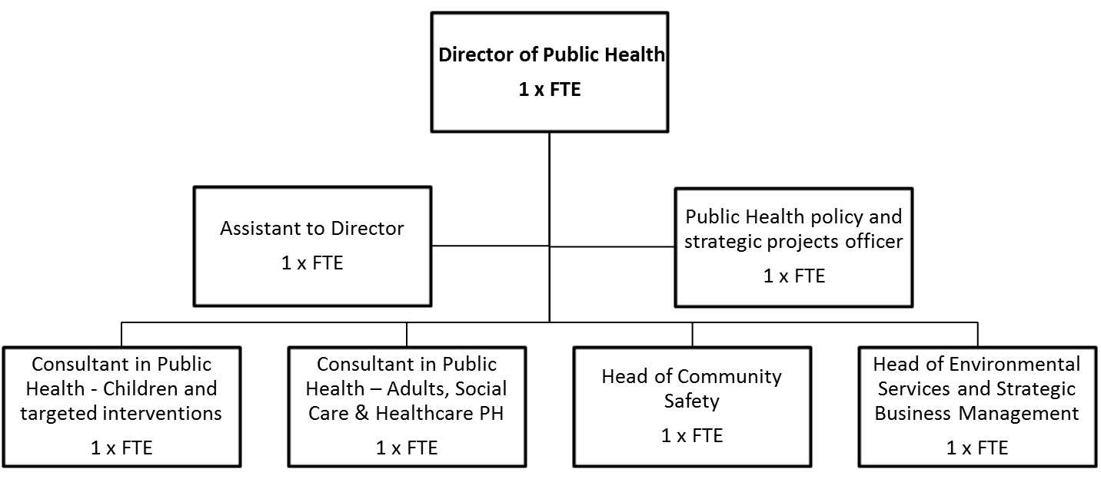

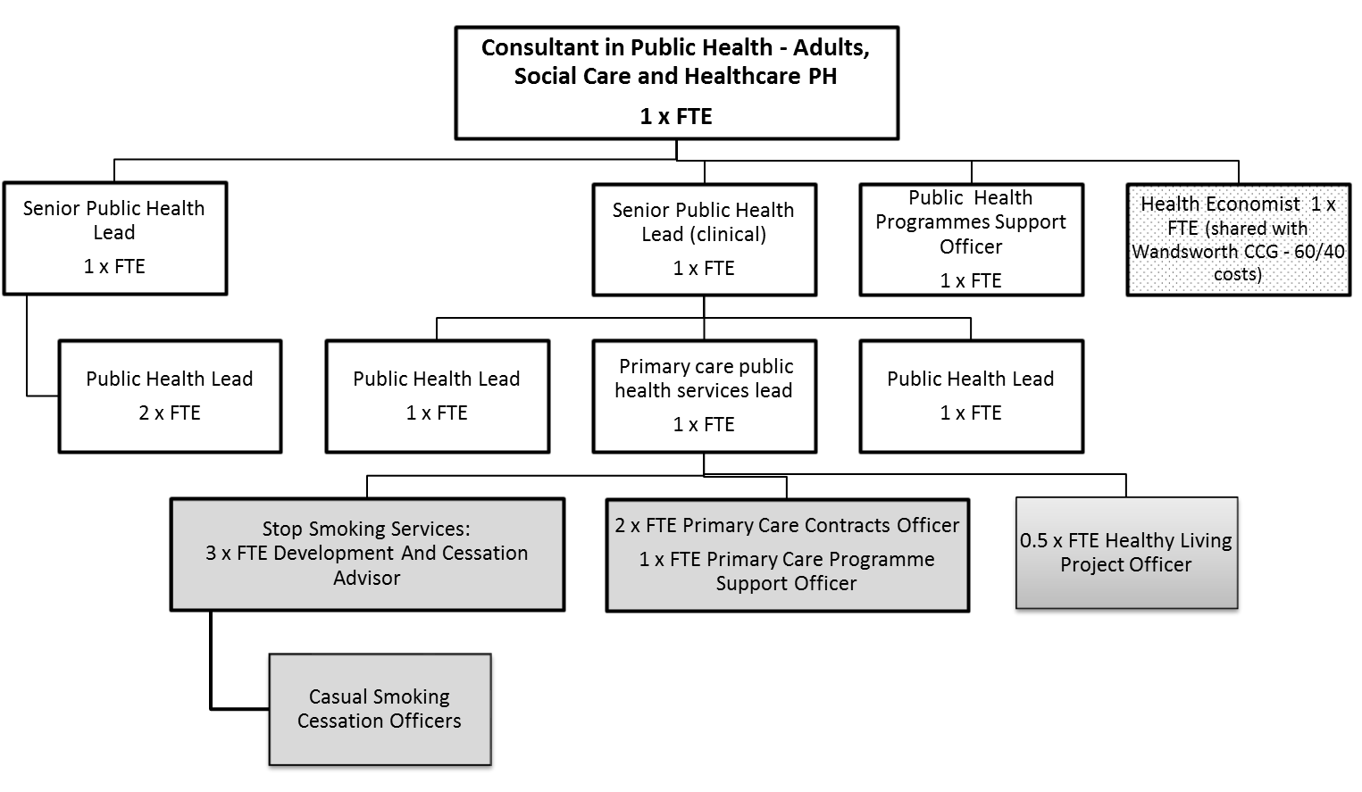
Person Specification

Job Title:  Consultant in Public Health – Adults, Social Care and Healthcare Public Health | Grade:  MG3
Section:  Public Health | Directorate:  Adult Social Care and Public Health
Responsible to following manager:  Director of Public Health | Responsible for following staff:  Senior Public Health Lead x 1 FTE  Senior Public Health Lead (Clinical) x 1 FTE  Public Health Programmes Support Officer x 1 FTE
Post Number/s: | Date:  May 2019

Our Values and Behaviours

The values and behaviours we seek from our staff draw on the high standards of the two boroughs, and we prize these qualities in particular –

- taking responsibility and being accountable for achieving the best possible outcomes – a ‘can do’ attitude to work
- continuously seeking better value for money and improved outcomes at lower cost
- focussing on residents and service users, and ensuring they receive the highest standards of service provision
- taking a team approach that values collaboration and partnership working.

Person Specification Requirements | Assessed by A & I/ T/ C (see below for explanation)
Knowledge
High level of understanding of epidemiology and statistics, public health practice, health promotion, health economics and health care evaluation. | A/I
Understanding of NHS and local government cultures, structures and policies. | A/I
Knowledge of methods of developing clinical quality assurance, quality improvement and evidence based clinical and/or public health practice. | A/I
Understanding of social and political environment. | A/I
Understanding of interfaces between health and social care. | A/I
Experience
Project management skills. | A/I
Staff management and training. | A/I
Practical experience in facilitating change. | A/I
Budget management skills. | A/I
Skills
Strategic thinker with proven leadership skills. | A/I
Excellent oral and written communication skills (including dealing with the media) and presentation skills. | A/I
Effective interpersonal, motivational and influencing skills. | A/I
Ability to respond appropriately in unplanned and unforeseen circumstances. | A/I
Sensible negotiator with practical expectation of what can be achieved. | A/I
Substantially numerate, with highly developed analytical skills using qualitative and quantitative data. | A/I
Computer literate. | A/I
Ability to design, develop, interpret and implement policies. | A/I
Ability to concentrate for long periods (e.g. analyses, media presentations). | A/I
Resource management skills. | A/I
Qualifications
Inclusion in the GMC Specialist Register/GDC Specialist List/UK Public Health Register (UKPHR) for Public Health Specialists. | A/C
If included in the GMC Specialist Register/GDC Specialist List in a specialty other than public health medicine/dental public health, candidates must have equivalent training and/or appropriate experience of public health medicine practice. | A/C
Public health specialty registrar applicants who are not yet on the GMC Specialist Register/GDC Specialist List in dental public health/UKPHR must provide verifiable signed documentary evidence that they are within 6 months of gaining entry at the date of interview; all other applicants must provide verifiable signed documentary evidence that they have applied for inclusion in the GMC/GDC/UKPHR specialist registers [see shortlisting notes below for additional guidance]. | A/C
Applicants must meet minimum CPD requirements (i.e. be up to date) in accordance with Faculty of Public Health requirements or other recognised body. | A/C

A – Application form
I – Interview
T – Test
C – Certificate

These values and behaviours will be developed further as the SSA becomes established.

