Job Profile comprising Job Description and Person Specification
Job Description

Job Title:  Enterprise Coordinator (EC) – Careers Hubs | Grade: PO1
Section:  South London Partnership | Directorate: Chief Executive
Responsible to following manager:  Operational Lead – Careers Hub | Responsible for following staff:  n/a
Post Number/s: | Last review date:  10th December 2021

Working for the Richmond & Wandsworth Better Service Partnership

This role is employed under the Richmond & Wandsworth Better Service Partnership. The overall purpose of Richmond & Wandsworth is to provide the highest quality of service at the lowest attainable cost.

Staff are expected to deliver high quality and responsive services wherever they are based, as well as having the ability to adapt to sometimes differing processes and expectations.

Richmond & Wandsworth Better Service Partnership aims to be at the forefront of innovation in local government and the organisation will invest in the development of its staff and ensure the opportunities for progression that only a large organisation can provide.

Job Purpose
The Careers & Enterprise Company has been set up to inspire and prepare young people for the fast-changing world of work. It has established a network of coordination (Enterprise Adviser Network) across England in partnership with Local Enterprise Partnerships, with over 200 full time Enterprise Coordinators now working with clusters of 20 schools and colleges, or 15 schools and colleges in “Careers Hubs”.

Significant focus has been on improving links between employers and schools and colleges, to create powerful, lasting connections. Over 3000 Enterprise Advisers - business volunteers who have signed up to provide strategic support to individual schools and colleges – are now part of the Enterprise Adviser Network (EAN).

South London Partnership have established a careers Hub in south London and are looking for an Enterprise Coordinators to work closely with schools, colleges, and businesses to create innovative, high quality careers programmes.

The Enterprise Coordinator (EC) sits at the heart of the local careers hub in order to help schools and colleges improve their careers and enterprise activities and to engage with the world of work. The EC will ensure the careers hub is embedded into the South London Partnerships economic recovery action plan and make it easier for employers to engage with schools and colleges. Through establishing the local and national contexts the EC will focus everyone’s efforts on programmes and activities that are most effective in motivating young people, supporting independent choice, and supporting positive outcomes for young people. This will be achieved by:

- Building and Strengthening Networks
- Supporting Careers Leaders
- Backing the Gatsby Benchmarks

Specific Duties and Responsibilities

- Establishing and developing your Network

- Ensuring there is strong careers hub governance within the sub-region and growing the careers hub locally by engaging and supporting a cluster of 25 schools and Enterprise Advisers
- Recruiting senior level Enterprise Advisers (EAs) from local businesses and successfully matching them to schools and colleges within the careers hub
- Building and maintaining effective relationships with senior leaders in local schools and colleges within the cluster. Ensuring the impact the EA, The Careers and Enterprise Company and local network can have on their school improvement planning and careers strategy is understood and the development needs of each school are identified.
- Supporting EAs in scoping, identifying and addressing the needs of their matched school.
- Acting as an ambassador for The Careers & Enterprise Company and South London Partnership, including raising the profile of the careers hub through utilising existing communication and marketing channels in order to engage with key local stakeholders.
- Cascading learning from The Careers & Enterprise Company by delivering CPD sessions to school and business audiences.

- Building Careers and Enterprise Plans

- Supporting EAs and Careers Leaders including induction training, coordinating network meetings and identifying and delivering ongoing training to meet individual EAs’ and CL’s development needs.
- Organise and attend regular EA/CL meetings to ensure progress is being made across all benchmarks and school priorities addressed.
- Establishing methods of recognising and highlighting best practise to ensure the network is accessing and delivering the most impactful activities.
- Supporting The Careers & Enterprise Company grant recipients to ensure they are coordinating delivery with the LEP and local careers hub and providing feedback on them to your Regional Lead and the Investment Team.
- Building and understanding the local context of careers provision and providers including NAS, NCS, and JCP and how these fit with the national context.
- As per The Careers & Enterprise Company reporting cycle, contribute to the monitoring and impact tracking of the careers hub by submitting the EAN register.
- Attending The Careers & Enterprise Company EC national and local training events and meetings to keep up to date with The Careers & Enterprise Company and career hub developments.
- Keeping up-to-date on the progress and success of the careers hub and sharing this knowledge across the local and national network, the latter in the form of case studies to your Regional Lead
- Supporting local growth and development strategies and opportunities by sharing information and intelligence with Careers Leaders and the careers hub.

Implementation and Impact

- Regularly reviewing the network to ensure the members (at all levels) remain engaged and proactive, via communications, training and support.
- Staying abreast of best practise examples, emerging guidance and legislation and considering the differing audiences you will need to cascade this information to.
- Track the progress of your schools/colleges (using a variety of tools and resources), identifying trends, gaps and solutions.
- Analysing and understanding the impact of the network on your local economy and skills strategy and feeding information back to The Careers & Enterprise Company.
- Recognising and monitoring risks within the network and ensuring a strategic approach is adopted with the SLP and your Operational Hub Manager, Hub Lead or Regional Lead.

Generic Duties and Responsibilities

- To contribute to the continuous improvement of the services of Richmond & Wandsworth Better Service Partnerships.

- To comply with relevant Codes of Practice, including the Code of Conduct and policies concerning data protection and health and safety.

- To adhere to security controls and requirements as mandated by Richmond and Wandsworth procedures and local risk assessments to maintain confidentiality, integrity, availability and legal compliance of information and systems

- To promote equality, diversity, and inclusion, maintaining an awareness of the equality and diversity protocol/policy and working to create and maintain a safe, supportive and welcoming environment where all people are treated with dignity and their identity and culture are valued and respected.

- To understand both Councils’ duties and responsibilities for safeguarding children, young people and adults as they apply to the roles within the Councils.

- The profile is not intended to be an exhaustive list of the duties the post holder will carry out. Other reasonable duties commensurate with the level of the post, including supporting emergency and priority situations, will form part of the role.
Additional Information

Team structure

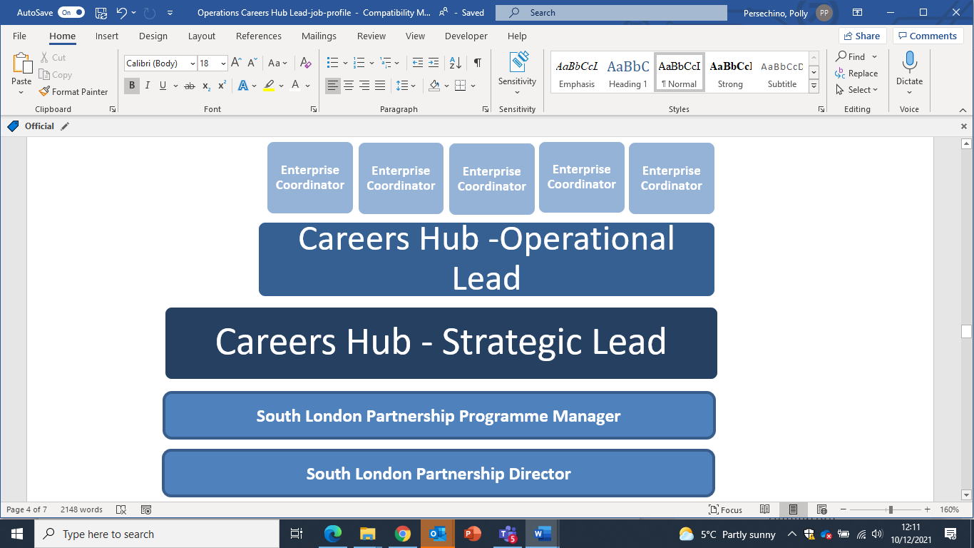
Person Specification

Job Title: Enterprise Coordinator | Grade: P01
Section: South London Partnership | Directorate: Chief Executive
Responsible to: Operational Lead – South London Careers Hub | Responsible for: n/a
Post Number/s: | Last Review Date: Dec 2021

Our Values
THINK BIGGER
EMBRACE DIFFERENCE
CONNECT BETTER
LEAD BY EXAMPLE
PUT PEOPLE FIRST

Our Values are embedded across Richmond & Wandsworth Better Service Partnership and throughout all roles and responsibilities at all levels of the organisation. Please familiarise yourself with our values as they are an integral part of our recruitment and selection process.

Person Specification Requirements |  |  |  | Assessed by  A/I/T/C  (see below for explanation)
 | Knowledge | Essential | Desirable | Assessed
 | An understanding of school culture and the challenges faced by schools in delivering careers and enterprise, and the current careers education and corporate social responsibility landscapes | Y |  | A, I
 | An understanding of relevant local and national policy relating to skills and economic development and the issues and barriers to employment faced by young people. | Y |  | A, I
 | Experience | Essential | Desirable | Assessed
 | Demonstrable experience of engaging and building relationships with leaders from schools, colleges and businesses | Y |  | A,I
 | Demonstrable experience of leading the delivery of programmes or projects with multiple stakeholders | Y |  | A,I
 | A strong track record of stakeholder engagement and management and of communicating with a variety of audiences, preferably in the education and careers sector | Y |  | A,I
 | Skills | Essential | Desirable | Assessed
 | Excellent communication and interpersonal skills, with the ability to persuade and influence a variety of audiences and encourage others to use new ways of working | Y |  | A,I
 | Excellent customer service skills and able to build relationships at all levels, both internally and with a range of external stakeholders to develop a collaborative network and shared objectives. | Y |  | A,I
 | Proactive, with the ability to work independently, managing and adapting conflicting priorities and deadlines | Y |  | A,I
 | Able to think and plan strategically to measure and drive performance. |  | Y | A,I
 | Able to identify and mitigate risks, working collaboratively to find solutions. | Y |  | A,I
 | Adaptable, tenacious, determined, positive and resilient with the ability to deal with ambiguity in a changing environment. | Y |  | A,I
 | Competent use of a range of digital and IT and social media platforms in order to improve and raise awareness of the direct impact of the network |  | Y | A,I
 | Qualifications | Essential | Desirable | Assessed
 | Minimum of NVQ level 3 in an appropriate qualifications or equivalent relevant professional qualification or experience |  | Yes | A, I, C

A – Application form / CV
I – Interview
T – Test
C - Certificate

