**Job Profile comprising Job Description   
and Person Specification**

**Job Description**

|  |  |
| --- | --- |
| **Job Title:**  Conservation Officer | **Grade**:  Scale 6 – PO1 |
| **Section:**  Spatial and Transport Planning | **Directorate:**  Environment and Community Services |
| **Responsible to following manager:**  Principal Conservation and Urban Design Officer | **Responsible for following staff:**  N/A |
| **Post Number/s:** | **Last review date:**  April 2016 |

**Working for the Richmond/ Wandsworth Shared Staffing Arrangement**

This role is employed under the Shared Staffing Arrangement between Richmond and Wandsworth Councils. The overall purpose of the Shared Staffing Arrangement is to provide the highest quality of service at the lowest attainable cost.

Staff are expected to deliver high quality and responsive services wherever they are based, as well as having the ability to adapt to sometimes differing processes and expectations.

The Shared Staffing Arrangement aims to be at the forefront of innovation in local government and the organisation will invest in the development of its staff and ensure the opportunities for progression that only a large organisation can provide.

**Job Purpose:**

To assist with the delivery of high quality, robust and transparent decision making within tight time frames on conservation and/or urban design matters to ensure that the Planning and Transport Strategy Division is recognised as delivering an excellent planning service for all of our customers. The Conservation Officer will assist on conservation and/or urban design matters, providing comprehensive and detailed advice on high profile planning applications, pre-application advice requests and correspondence to agreed and identifiable timescales, to deliver a successful planning outcome and provide a high quality urban environment / public realm and to protect the boroughs’ heritage assets. To undertake less specialist projects related to conservation and urban design and its broader implementation within the boroughs, as allocated by the Principal Conservation and Urban Design Officer and Spatial Planning and Design Team Manager. To undertake appropriate training to help acquire the skills and knowledge in order to become self-reliant in dealing with technical and people issues as required.

1. To be responsible to the Principal Conservation and Urban Design Officer and work under the supervision of a Senior Conservation and Urban Design Officer.
2. To undertake planning projects or casework, under supervision on a full range of conservation and urban design matters, working to identifiable deadlines in a manner that is consistent with meeting corporate targets and objectives.
3. To provide conservation and urban design comments to straightforward planning applications.
4. To assist on work to assess, engage and set out clear and robust policy formulation including the early drafts of accurate, well written officer reports based on an up-to-date and relevant evidence base.
5. To assist in the preparation and review of Conservation Area Appraisals and Management Strategies / Plans as required to ensure an up to date guidance is available for all conservation areas.
6. To ensure that policy formulation is undertaken with due regard to the Local Development Scheme and Statement of Community Involvement.
7. To obtain an up-to-date knowledge of national and regional planning policy and relevant legislation and to take a proactive approach to relevant changes in legislation.
8. To assist in identifying issues and proposing improvements within the context of current and future service requirements in order to continually deliver high quality, customer focused planning services to managers and our full range of customers.
9. To assist on projects or components of larger projects in order to deliver organisational objectives as well as enabling agreed changes in planning practice and processes to take place, taking personal responsibility for detailed project management as required.
10. On occasion to present your own recommendations to internal and public meetings on basic conservation and urban design issues in a clear and concise manner.
11. To assist in providing advice and guidance in response to planning best practice, procedure or policy within a legal/organisational policy framework.
12. To assist in meeting service-wide and corporate performance indicators, targets and customer service standards for the full range of your own workload and also any work of technical support officers that you are supervising.
13. To assist on the preparation of specialist evidence in respect of appeals including presenting evidence at Public Inquiries, Hearings and written representations.
14. To participate in matters relating to policy compliance and enforcement matters and conflict resolution to ensure high quality innovative outcomes that reflect Council-wide objectives and policies.

CRITERIA FOR PROGRESSION TO SO1

* To undertake conservation and urban design projects or casework at the following level under the limited supervision of a Senior Conservation and Urban Design officer:
* straightforward policy reviews
* more complex briefs and legal agreements
* preparation of straightforward briefs/site appraisals and minor environmental improvement schemes
* planning applications or enforcement cases requiring substantial negotiations.
* To assess, negotiate and set out clear and robust recommendations in an accurate, well written officer report based on relevant planning policies and other material considerations.
* To provide advice and guidance as required in response to planning best practice, procedure or policy within a legal/organisational policy framework and develop solutions or recommendations to meet service needs.
* To ensure that you meet service-wide and corporate performance indicators, targets and customer service standards.
* To initiate, participate in and where necessary take a management role on matters relating to compliance and enforcement matters and conflict resolution to ensure high quality innovative outcomes that reflect Council-wide objectives and policies.

CRITERIA FOR PROGRESSION TO SO2

* To undertake conservation and urban design projects or casework at the following level with the minimum of supervision:
* more complex planning policy reviews
* publicity, drafting and presentation of information
* complex written representation appeals and complaints investigations
* straightforward legal agreements
* observations on planning applications where variety of policies need to be reconciled
* preparation of environmental improvement schemes (including client role).
* To undertake conservation and urban design projects or casework at the following level under the supervision of a Senior Conservation and Urban Design Officer:
* contribute to complex policy reviews
* attendance as planning witness at public inquiries.
* To deal with straightforward enquiries about other work in the Spatial and Transport Planning or Development Management Services.
* To seek to coach and facilitate the acquisition of skills and knowledge in others so that they are better equipped to be self-reliant in dealing with technical and people issues
* To seek to attend as planning witness at court or public inquiry under the supervision of a Senior Planner.

CRITERIA FOR PROGRESSION TO PO1

* To undertake planning projects or casework at the following level with the minimum of supervision:
* contribute to complex policy reviews
* comment on complex planning applications requiring substantial negotiations.
* To be familiar with, and deal with enquiries about, work in any part of Spatial and Transport Planning.
* To prepare and give evidence on behalf of the Council at Public Examinations and Inquiries.

**Generic Duties and Responsibilities**

* To contribute to the continuous improvement of the services of the Boroughs of Wandsworth and Richmond.
* To comply with relevant Codes of Practice, including the Code of Conduct and policies concerning data protection and health and safety.
* To adhere to security controls and requirements as mandated by the SSA’s policies, procedures and local risk assessments to maintain confidentiality, integrity, availability and legal compliance of information and systems
* To promote equality, diversity, and inclusion, maintaining an awareness of the equality and diversity protocol/policy and working to create and maintain a safe, supportive and welcoming environment where all people are treated with dignity and their identity and culture are valued and respected.
* To understand both Councils’ duties and responsibilities for safeguarding children, young people and adults as they apply to the role within the council.
* The Shared Staffing Arrangement will keep its structures under continual review and as a result the post holder should expect to carry out any other reasonable duties within the overall function, commensurate with the level of the post.

**Additional Information**

Not applicable

**Current team structure**

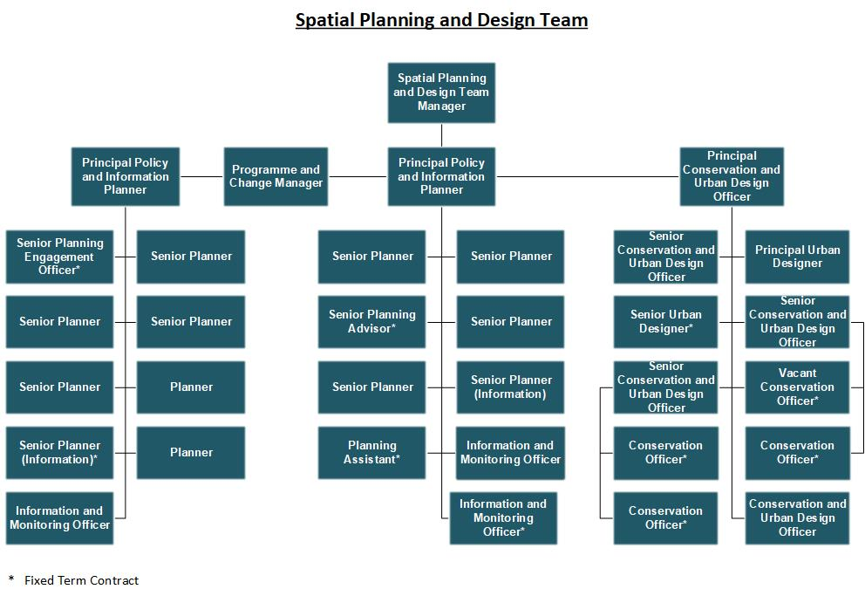

**Person Specification**

|  |  |
| --- | --- |
| **Job Title:**  Conservation Officer | **Grade**:  Scale 6 to PO1 |
| **Section:**  Spatial and Transport Planning | **Directorate:**  Environment and Community Services |
| **Responsible to following manager:**  Principal Conservation and Urban Design Officer | **Responsible for following staff:**  N/A |
| **Post Number/s:** | **Last review date:**  April 2016 |

**Our Values and Behaviours**

The values and behaviours we seek from our staff draw on the high standards of the two boroughs, and we prize these qualities in particular:

**Being open.** This means we share our views openly, honestly and in a thoughtful way. We encourage new ideas and ways of doing things. We appreciate and listen to feedback from each other.

**Being supportive.** This means we drive the success of the organisation by making sure that our colleagues are successful. We encourage others and take account of the challenges they face. We help each other to do our jobs.

**Being positive and helpful.** This means we keep our goals in mind and look for ways to achieve them. We listen constructively and help others see opportunities and the way forward. We have a ‘can do’ attitude and are continuously looking for ways to help each other improve.

|  |  |
| --- | --- |
| **Person Specification Requirements** | **Assessed by**  **A**  **& I/ T/ C (see below for explanation** |
| **Knowledge** | |
| A working knowledge and understanding of planning, urban design, policy guidance and circulars, practice and case law and the ability to apply that knowledge to conservation and urban design matters, within agreed timeframes in order to deliver a responsive, high quality service. | A/I/T |
| Knowledge and understanding of effective customer relations and customer care practices. | A/I/T |

|  |  |
| --- | --- |
| **Experience** | |
| Experience in conservation and urban design work including assisting in the preparation of local plan documents or equivalents. | A/I |
| **Skills** | |
| Effective report writing skills including preparation of local plan documents, committee reports, development plan examination statements or equivalents. | A/I/T |
| Articulate in written and oral communication skills with particular reference to report and letter writing, public speaking, presentation skills and communicating with Members, the public, staff and other professionals. | A/I |
| Ability to analyse and interpret data and present key facts including policy implications in the preparation of reports, policy formulation and other material. | A/I/T |
| Ability to prepare briefs for and assist in the selection, control and monitoring of consultants. | A/I |
| Ability to work on designated projects with supervision. | A/I |
| To work effectively to meet challenging deadlines and manage competing and changing priorities. | A/I |
| To work as part of a team taking into account the needs of other Council Departments and with a willingness and ability to share knowledge with other staff. | A/I |
| Able to use initiative to identify solutions to problem solving and demonstrating a 'can-do' attitude to improvements in service delivery. | A/I |
| Ability to assist in identifying need for change and to introduce and manage changes designed to improve service delivery. | A/I |
| Clear understanding of IT systems generally including Microsoft Office, Internet Explorer and Objective (desirable). | A/I/T |
| **Qualifications** | |  |
| A degree in heritage / building conservation, planning, urban design, or other appropriate professional qualification and a member of IHBC, RTPI, RIBA or other equivalent professional body, or eligible for or working toward full membership. | A/C |

**A – Application form**

**I – Interview**

**T – Test**

**C – Certificate**