**Job Profile comprising Job Description and Person Specification**

**Person Specification**

|  |  |
| --- | --- |
| **Job Title:**  Head of Registrars and Cemeteries  (Superintendent Registrar) | **Grade:**  MG1 |
| **Section:**  Contracts and Leisure  (Registrars and Cemeteries) | **Directorate:**  Environment and Community Services |
| **Responsible to following manager:**  Assistant Director - Contracts and Leisure | **Responsible for following staff:**  Registration and Cemeteries Service Manager  Registration Service Manager  Business Development Manager |
| **Post Number/s: RWE1003** | **Last review date: June 2021** |

**Working for the Richmond/ Wandsworth Shared Staffing Arrangement**

This role is employed under the Shared Staffing Arrangement between Richmond and Wandsworth Councils. The overall purpose of the Shared Staffing Arrangement is to provide the highest quality of service at the lowest attainable cost.

Staff are expected to deliver high quality and responsive services wherever they are based, as well as having the ability to adapt to sometimes differing processes and expectations.

The Shared Staffing Arrangement aims to be at the forefront of innovation in local government and the organisation will invest in the development of its staff and ensure the opportunities for progression that only a large organisation can provide.

**Job Purpose**

Responsible to the Assistant Director for Contracts and Leisure, for delivering services associated with Registrars and Cemeteries, and to lead, manage and develop those services at an operational and strategic level.

**Specific Duties and Responsibilities**

1. Ensure the consistent delivery of high quality, efficient and effective services which deliver against the Council’s policies and the Council’s statutory responsibilities and ensure services for both Councils are dealt with on an equitable basis and delivered to the standards required of each.
2. Assist in the overall management of the Contracts and Leisure division to ensure consistency, opportunity, quality, and innovation is secured through collaboration and joint working and to support colleagues in working as a divisional team.
3. Lead the Registration and Cemeteries service and be responsible for ensuring all statutory and non-statutory functions are carried out in accordance with the relevant Acts, Registrar General Guidelines and Council policies and to assume responsibility for the safekeeping and access to deposited registers and other associated statutory duties; and, to act as Data Controller to maintain security and confidentiality of information, records, documents and premises.
4. To ensure all duties comply with Burial Law (the Local Cemeteries Order 1977), Health and Safety Legislation and the Institute of Cemetery and Crematorium Management’s Code of Safe Working Practice.
5. Ensure maintenance of accurate burial and memorial records, ensuring all information meets statutory legislation and to ensure the legal processes for grave ownership are followed correctly for each individual case and to interpret and follow appropriate legislation and legal processes.
6. Assume statutory responsibility for the preliminaries to marriages, civil partnerships and civil partnership conversions and be responsible for the inspection, certification and registration of premises used for civil weddings and other ceremonies, advising with the Proper Officer as necessary.
7. Work effectively within a political environment and to prepare and present clear recommendations and advice to Cabinet, other Committees and to individual Members; to provide advice and support Members on all relevant Registrar and Cemeteries service matters, including advising on legislative developments and making policy proposals.
8. Providing clear strategic planning and being the Council’s principal advisor on services within the Registrars and Cemeteries portfolio with a view to developing and managing strategic partnerships on related issues for both Councils. Prepare and manage the implementation of service plans across all services within the portfolio, to support the achievement of targets for each service. Prepare the Annual Performance Report for the General Register Office.
9. To ensure business and budget plans are produced for all functions within the service and ensure they are effectively managed within the approved budgets.
10. To provide strategic, operational and motivational leadership of staff, providing a visible presence to the workforce and promoting a good working environment with the primary aim of delivering high quality services. Lead, manage, motivate and develop all staff in the service.
11. Lead, develop and implement service strategies to engage the workforce and create opportunities for continuous improvement.
12. Responsibility for promoting and developing registration, citizenship and cemeteries services and for implementing new legislation as required by the Registrar General and cascading training.
13. Promote and develop good working relationships with internal and external contacts (General Registration Office, Home Office Immigration and Nationality Directorate), other stakeholders, community groups and working partners (e.g. Mayoralty, Coroners Service, hospital authorities) to promote and to forge collaborative and effective partnership working, best practice and high quality services.
14. To ensure business and budget plans are produced for all functions within the service and ensure they are effectively managed within the approved budgets.
15. Perform ceremonial and organisational duties for marriage, civil partnerships and citizenship ceremonies and non-statutory ceremonies and be responsible for the provision of group and individual citizenship ceremonies in collaboration with the Mayoralty.

**Generic Duties and Responsibilities**

* To contribute to the continuous improvement of the services of the Boroughs of Wandsworth and Richmond.
* To comply with relevant Codes of Practice, including the Code of Conduct and policies concerning data protection and health and safety.
* To adhere to security controls and requirements as mandated by the SSA’s policies, procedures and local risk assessments to maintain confidentiality, integrity, availability and legal compliance of information and systems.
* To promote equality, diversity, and inclusion, maintaining an awareness of the equality and diversity protocol/policy and working to create and maintain a safe, supportive and welcoming environment where all people are treated with dignity and their identity and culture are valued and respected.
* To understand both Councils’ duties and responsibilities for safeguarding children, young people and adults as they apply to the role within the council.
* The Shared Staffing Arrangement will keep its structures under continual review and as a result the post holder should expect to carry out any other reasonable duties within the overall function, commensurate with the level of the post.

**Additional Information**

Responsible for revenue budgets.

To act as Data Controller with regard to registration information and maintain awareness of the relevant legislation (Registration Acts, Data Protection Act).

Responsible for the management of:

Registration Service Manager

Registration and Cemeteries Service Manager

Business Development Manager

The service is delivered via a number of sites across both Councils. Service responsibilities may require attendance at evening meetings and occasional weekends.

Attendance in response to emergencies and ‘out of hours’ emergencies may be required.

**Current team structure**

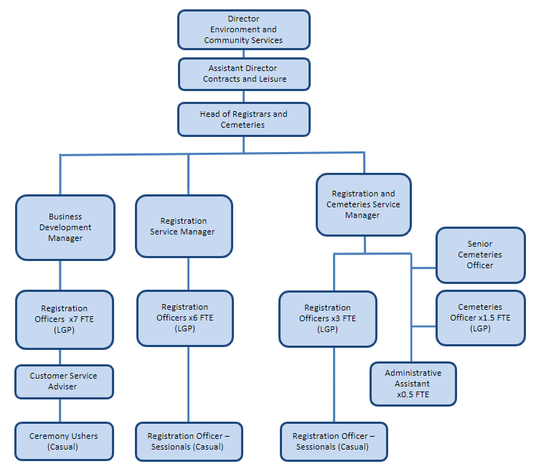

**Person Specification**

|  |  |
| --- | --- |
| **Job Title:**  Head of Registrars and Cemeteries (Superintendent Registrar) | **Grade:**  MG1 |
| **Section:**  Contracts and Leisure  (Registrars and Cemeteries | **Directorate:**  Environment and Community Services |
| **Responsible to following manager:**  Assistant Director Contracts and Leisure | **Responsible for following staff:**  Registration and Cemeteries Service Manager  Registration Service Manager  Business Development Manager |
| **Post Number/s: RWE1003** | **Last Review date: June 2021** |

**Our Values and Behaviours**

The values and behaviours we seek from our staff draw on the high standards of the two boroughs, and we prize these qualities in particular:

**Being open.** This means we share our views openly, honestly and in a thoughtful way. We encourage new ideas and ways of doing things. We appreciate and listen to feedback from each other.

**Being supportive.** This means we drive the success of the organisation by making sure that our colleagues are successful. We encourage others and take account of the challenges they face. We help each other to do our jobs.

**Being positive.** Being positive and helpful means we keep our goals in mind and look for ways to achieve them. We listen constructively and help others see opportunities and the way forward. We have a ‘can do’ attitude and are continuously looking for ways to help each other improve.

|  |  |
| --- | --- |
| **Person Specification Requirements** | **Assessed by A & I/ T/ C (see below for explanation** |
| **Knowledge** | |
| Knowledge and experience of how to manage an effective, cost effective customer focused service | A&I |
| Knowledge and experience of strategically leading, developing and motivating staff to improve service delivery | A&I |
| **Experience** | |
| Experience at a senior level in the provision of public services, preferably at head of service level | A&I |
| Experience of delivering successfully to multiple and competing deadlines | A&I |
| Experience of managing highly effective services | A&I |
| Experience of successful resource management, the setting, managing and controlling of substantial and complex budgets and procurement of services | A&I |
| Experience of managing large complex budgets | A&I |
| Experience of successfully delivering complex programmes | A&I |
| Evidence of successfully leading change in a positive way |  |
| Experience of working in partnership to achieve service objectives | A&I |
| **Skills** | |
| Ability to work in a senior management team in developing strategic and operational policies and activity | A&I |
| Understanding and ability to establish strategic plans and targets to assist in measuring impact of services | A&I |
| Ability to think and work strategically at a divisional and service level to achieve agreed priorities and objectives | A&I |
| Ability to work closely with a range of external partners and agents | A&I |
| Ability to maintain accurate records and systems in line with statutory legislation | A&I |
| **Qualifications** | |
| Educated to degree level and a relevant qualification or equivalent by experience | A&C |

**A – Application form**

**I – Interview**

**T – Test**

**C – Certificate**