Job Profile comprising Job Description and Person Specification
Job Description

Job Title: Payroll Team Leader | Grade: PO2
Section: Human Resources | Directorate: Change and Innovation
Responsible to following manager:  Payroll Manager | Responsible for following staff:  Payroll Coordinators
Post Number/s:  FPL01 | Last review date:  18/10/2024

Working for the Richmond & Wandsworth Better Service Partnership

This role is employed under the Richmond & Wandsworth Better Service Partnership. The overall purpose of Richmond & Wandsworth is to provide the highest quality of service at the lowest attainable cost.

Staff are expected to deliver high quality and responsive services wherever they are based, as well as having the ability to adapt to sometimes differing processes and expectations.

Richmond & Wandsworth Better Service Partnership aims to be at the forefront of innovation in local government and the organisation will invest in the development of its staff and ensure the opportunities for progression that only a large organisation can provide.

Job Purpose
To work with Payroll Coordinators in delivering and accurate and effective payroll services for allocated areas of the councils’ payrolls, as well as assisting with other section workloads and deadlines when required. To respond to enquiries and queries.

Specific Duties and Responsibilities
- To administer, run, process and finalise multiple payrolls using iTrent payroll system and Business Objects.
- To ensure all payroll deadlines are met by closely liaising with and monitoring the Payroll Coordinators.
- To maintain a high level of payroll system knowledge to enable the accurate running of allocated payrolls from start to finish, within specific deadlines.
- To maintain a high level of HMRC knowledge to enable informed and correct responses to stakeholders’ enquiries.
- Employing best use of available payroll coordinator resources for absence cover, vacancies and unplanned work peaks.
- To monitor the performance of Payroll Coordinators to identify training needs and liaising with Payroll Manager to facilitate the trainings requirements.
- To support the Payroll Manager by monitoring progress against targets. Identifying problems at an early stage and escalating to Payroll Manager.
- To ensure inputting and checking accuracy by Payroll Coordinators by monitoring and auditing work.
- To ensure compliance with specified payroll and HR procedures, reviewing payroll procedures and internal checks within the payroll teams.
- To ensure that Process Manuals are up to date.
- To communicate with Payroll Manager and team members to ensure a smooth flow of guidance, changes and key information.
- To ensure all queries addressed to the team are monitored and resolved quickly.
- To handle complex queries e.g. HMRC, National Statistics, DWP and solicitors, phased return calculations, maternity/paternity/adoption pay etc.
- To maintain an in-depth knowledge of the iTrent payroll system to optimize payroll processes, informing the Payroll Manager of any wider system problems.
- To monitor performance of team, conducting 1 to 1 meetings and appraisals and setting individual objectives.
- To provide assistance and training to team members with Statutory Pay, interpretation of tax and other payroll operational and statutory regulations.
- Availability on occasion to work additional time to ensure that deadlines are met.

Generic Duties and Responsibilities

- To contribute to the continuous improvement of the services of Richmond & Wandsworth Better Service Partnerships.

- To comply with relevant Codes of Practice, including the Code of Conduct and policies concerning data protection and health and safety.

- To adhere to security controls and requirements as mandated by Richmond and Wandsworth procedures and local risk assessments to maintain confidentiality, integrity, availability and legal compliance of information and systems

- To promote equality, diversity, and inclusion, maintaining an awareness of the equality and diversity protocol/policy and working to create and maintain a safe, supportive and welcoming environment where all people are treated with dignity and their identity and culture are valued and respected.

- To understand both Councils’ duties and responsibilities for safeguarding children, young people and adults as they apply to the roles within the Councils.

- The profile is not intended to be an exhaustive list of the duties the post holder will carry out. Other reasonable duties commensurate with the level of the post, including supporting emergency and priority situations, will form part of the role.
Additional Information

Team structure

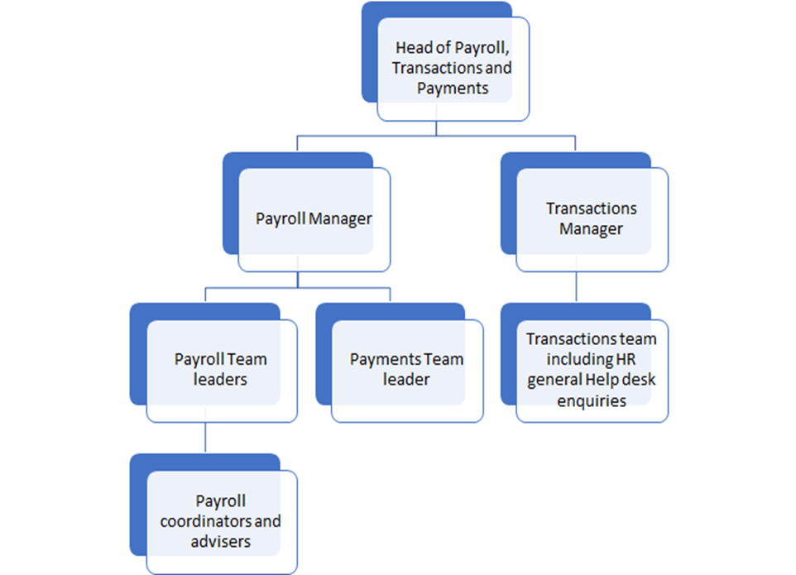
Person Specification

Job Title: Payroll Team Leader | Grade: PO2
Section: Human Resources | Directorate: Change and Innovation
Responsible to: Payroll Manager | Responsible for: Payroll Coordinators
Post Number/s: FPL01 | Last Review Date: 18/10/2024

Our Values
THINK BIGGER
EMBRACE DIFFERENCE
CONNECT BETTER
LEAD BY EXAMPLE
PUT PEOPLE FIRST

Our Values are embedded across Richmond & Wandsworth Better Service Partnership and throughout all roles and responsibilities at all levels of the organisation. Please familiarise yourself with our values as they are an integral part of our recruitment and selection process.

Person Specification Requirements |  |  |  | Assessed by  A/I/T/C  (see below for explanation)
 | Knowledge | Essential | Desirable | Assessed
 | Solid and current knowledge of PAYE, National Insurance, Statutory Sick Pay, Statutory Maternity, Paternity and Adoption and all legislative requirements. | Y |  | I & T
 | Understanding and experience of multiple terms and conditions of employment. | Y |  | I
 | Experience | Essential | Desirable | Assessed
 | iTrent Payroll software |  | Y | I & T
 | Microsoft Excel including V Lookups | Y |  | I
 | Supervising and working on a team in payroll production for multiple large payrolls with multiple pay days, ensuring accuracy and meeting deadlines | Y |  | I
 | Strong people management experience and skills, with the ability to motivate and lead. | Y |  | I & T
 | Ability to ensure all work is accurate and produced on time, while maintaining strict financial controls. | Y |  | I
 | Skills | Essential | Desirable | Assessed
 | IT literate with good keyboard skills. | Y |  | I
 | Knowledge of Business Objects report writing software. |  | Y | I
 | High level of skill set in using Microsoft Office applications including spreadsheets for data manipulation and VLOOKUPs and other formulae. | Y |  | I
 | Excellent verbal and written communication skills. | Y |  | I & T
 | Ability to work and maintain good working relationships with clients, team members and other stakeholders | Y |  | I
 | Qualifications | Essential | Desirable | Assessed
 | A minimum of 5 GCSEs with grade A – C, including English Language and Mathematics | Y |  | A
 | CIPP Foundation Degree |  | Y | A

A – Application form / CV
I – Interview
T – Test
C - Certificate

