Job Profile comprising Job Description and Person Specification
Job Description

Job Title:  Teaching Assistant | Grade:  SSA Scale 3
Section:  WSSS – Willow Hearing Support Centre | Directorate: Children’s Services
Responsible to following manager:  Hannah Lovegrove Campion | Responsible for following staff: N/A
Post Number/s:  WE2103-RWC9140420199 | Last review date: July 2023

Working for the Richmond/Wandsworth Shared Staffing Arrangement

This role is employed under the Shared Staffing Arrangement between Richmond and Wandsworth Councils. The overall purpose of the Shared Staffing Arrangement is to provide the highest quality of service at the lowest attainable cost.

Staff are expected to deliver high quality and responsive services wherever they are based, as well as having the ability to adapt to sometimes differing processes and expectations.

The Shared Staffing Arrangement aims to be at the forefront of innovation in local government and the organisation will invest in the development of its staff and ensure the opportunities for progression that only a large organisation can provide.

CONTEXT

Responsible, under the direction and instruction of the teacher or line manager, to support the overall teaching and learning of pupils with hearing needs and/or other learning needs; including the physical, academic, and general care of pupils who have moderate or profound deafness. Willow Hearing Support Centre is based within a mainstream primary school in Tooting. It caters for deaf children aged 3-11. Children accessing the centre use written and oral English as their primary form of communication, and use hearing equipment, such as hearing aids or cochlear implants, to help them to access sound.

Job Purpose

Specific Duties and Responsibilities

- Support pupil(s) personal, social, emotional, physical well-being
- Supervise and support pupil(s) always ensuring their safety and access to learning.
- Ability to encourage and build / maintain good relationships with pupil(s) and their families, acting as a role model and being aware of and responding appropriately to individual needs.
- Offering tailored support and guidance to pupil(s) in line with their Educational Health and Care Plans.
- Work collaboratively with other professionals such as specialist teachers and other professionals to meet the outcomes specified on their plan(s).
- To work with staff at the Willow and at the host school to provide a positive and holistic learning experience for the pupil(s)
- Keep records of pupil(s) behaviour, attainment, assessment, and learning.
- Support the pupil(s) in a mainstream class setting, as well as during 1:1 and small group intervention activities.
- Provide verbal and written feedback to parents and professionals around areas of learning in line with the provision of the EHCP and other key meetings.
- Contribute to progress and review meetings as required and in line with the grade and responsibility of the role.
- Attend any required specific training relating to the education and care of pupil(s) in your care. Contribute to the development and growth of the Willow HSC.
- Encourage pupil(s) to act independently, as appropriate on an individual basis.

SUPPORTING PUPILS ACCESS LEARNING AND THE CURRICULUM

- Support pupil(s) who may have profound and multiple needs and who are deaf or have a moderate to profound hearing loss in undertaking all curriculum activities as planned and directed by the teacher(s).
- Support teachers / therapists / pupils to implement therapy programs in a holistic way throughout the school day.
- Support pupils to understand instructions in appropriate ways. This could include, but are not limited to, simplifying language / BSL signing / using picture symbols / using objects of reference.
- Assist pupils in using specialist ICT and assisted technology for learning and communication purposes.
- Support pupils in physical activity and in play
- Be an advocate for the pupil(s) in your caseload.
- Undertake pupil record keeping as requested — writing / videoing / photographing.
- Gather and report information from and to parents or carers as and when directed.

Generic Duties and Responsibilities

- To contribute to the continuous improvement of the services of the Boroughs of Wandsworth and Richmond.
- To comply with relevant Codes of Practice, including the Code of Conduct and policies concerning data protection and health and safety.
- To adhere to security controls and requirements as mandated by the SSA’s policies, procedures, and local risk assessments to maintain confidentiality, integrity, availability and legal compliance of information and systems.
- To promote equality, diversity, and inclusion, maintaining an awareness of the equality and diversity protocol/policy and working to create and maintain a safe, supportive, and welcoming environment where all people are treated with dignity and their identity and culture are valued and respected.
- To understand both Councils’ duties and responsibilities for safeguarding children, young people, and adults as they apply to the role within the council.
- The profile is not intended to be an exhaustive list of the duties the post holder will carry out. Other reasonable duties commensurate with the level of the post, including supporting emergency and priority situations, will form part of the role.

General

- Work to school’s policies and procedures, particularly regarding equal opportunities, health and safety and confidentiality

- Always demonstrate professional accountability.

- Practice within the professional codes of conduct

- Any other duties commensurate with the post and grade that may be required by the Head of Wandsworth Sensory Support Service, Teacher in Charge - Willo

Additional Information
Safeguarding | Be fully aware of and understand the duties and responsibilities arising from the Children’s Act and Working Together in relation to child protection and safeguarding children and young people as this applies to the worker’s role within the organisation.  Be fully aware of the principles of safeguarding as they apply to vulnerable adults to the workers role.  Ensure that the worker’s line manager is made aware and kept fully informed of any concerns which the worker may have in relation to safeguarding and/or child protection
Leadership | To work under overall supervision of the Teacher in Charge
CPD | Commitment to own personal development and to undertake mandatory training as required
Teaching and learning in support role | To undertake a planned programme of teaching and support as agreed with the Teacher in Charge
Service and Self Review | Participate in the Service’s Self Review of performance.  Review methods of effective teaching and learning
Behaviour / Risk Management | Work with other colleagues to always ensure safety of both workers and users
Supporting other colleagues | Take instruction and Support Class teacher in the class
REVIEW | This job description does NOT define all the duties and responsibilities commensurate with the post. As such, it will be reviewed at the end of the academic year or earlier if necessary and may be amended at any time after consultation with you.

Team structure
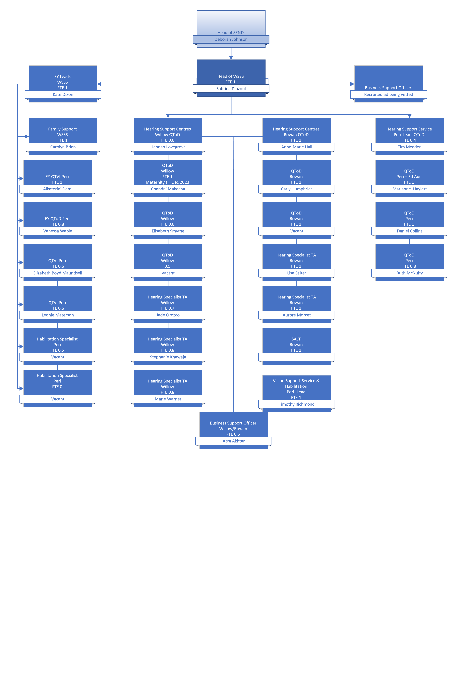
Person Specification

Job Title:  SEN Teaching Assistant | Grade: SSA Scale 3
Section:  WSSS- Willow Hearing Support Centre | Directorate: Children’s services
Responsible to: Hannah Lovegrove Campion | Responsible for: N/A
Post Number/s:  WE2103-RWC9140420199 | Last Review Date: July 2023

Our Values and Behaviours

The values and behaviours we seek from our staff draw on the high standards of the two boroughs, and we prize these qualities in particular:

Being open. This means we share our views openly, honestly and in a thoughtful way. We encourage new ideas and ways of doing things. We appreciate and listen to feedback from each other.

Being supportive. This means we drive the success of the organisation by making sure that our colleagues are successful. We encourage others and take account of the challenges they face. We help each other to do our jobs.

Being positive. Being positive and helpful means, we keep our goals in mind and look for ways to achieve them. We listen constructively and help others see opportunities and the way forward. We have a ‘can do’ attitude and are continuously looking for ways to help each other improve.

Person Specification Requirements |  |  | Assessed by  A/I/T/C  (see below for explanation)
Knowledge | Essential | Desirable | Assessed
General knowledge of the EYFS, KS1 and KS2 curriculum |  | X | A/I
Basic understanding of childhood development |  | X | A/I
Experience | Essential | Desirable | Assessed
Previous SEN experience working with or caring for children and young people. | × |  | A/I
Experience of working with children aged 3-11 | × |  | A/I
Ability to use of basic technology — computer, video, digital cameras photocopier etc | × |  | I
Knowledge/ understanding of issues that may face people with disabilities | × |  | I
Experience of working with children with a wide range of challenging behaviours | × |  | I
Exceptional awareness of the principles of safeguarding and understand the duties and responsibilities arising from the Children Act 2004 and Working Together in relation to child protection and safeguarding children and young people | × |  | I
Specialised knowledge of working with pupils who are deaf or have sensory needs |  | × | A/I
Previous experience working in the educational Environment |  | × | A
Skills | Essential | Desirable | Assessed
Ability to establish constructive relationships with pupils and working as part of a team, as well as the ability to build a rapport with a key child and their family. | × |  | I
Ability to communicate effectively with families / carers, team members, Manager, and external agencies | × |  | I
Knowledge/ understanding of issues that may face people with disabilities | × |  | I
An understanding of the needs of vulnerable people | × |  | I
Ability to work effectively as part of a team | × |  | I
Ability to summarise and record information in a way that can be readily understood by others. | × |  | I
Ability to be patient, calm and flexible always | × |  | I
Willingness to complete training on sensory awareness |  | × | I
Qualifications | Essential | Desirable | Assessed
Basic Literacy and Numeracy qualifications | × |  | A/I/C
Good command of English — both verbal and written | × |  | A/I
Relating to specialist approaches that maybe used in school e.g., Manual Handling / Makaton signing / British Sign Language |  | × | A/I/C
Basic First Aid |  | × | A/I/C

A – Application form / CV
I – Interview
T – Test
C - Certificate

