Job Profile comprising Job Description and Person Specification
Job Description

Job Title:  Communications and Campaigns Officer | Grade:  P03
Section:  Communications | Directorate:  Chief Executive
Responsible to following manager:  Senior Communications and Campaigns Officer | Responsible for following staff:  n/a
Post Number/s:  pending | Last review date:  May 2024

Working for the Richmond/Wandsworth Shared Staffing Arrangement

This role is employed under the Shared Staffing Arrangement between Richmond and Wandsworth Councils. The overall purpose of the Shared Staffing Arrangement is to provide the highest quality of service at the lowest attainable cost.

Staff are expected to deliver high quality and responsive services wherever they are based, as well as having the ability to adapt to sometimes differing processes and expectations.

The Shared Staffing Arrangement aims to be at the forefront of innovation in local government and the organisation will invest in the development of its staff and ensure the opportunities for progression that only a large organisation can provide.

The Communications Team is at the centre of the Council and has a high impact on the services and audiences it serves. It provides strategic leadership on media relations, public relation, event management, community engagement, publications, social media management and monitoring, branding, design and the councils websites. It is also responsible for the operational oversight, delivery and coordination of all communications activity across the wider council.

Job Purpose
As the Communications and Campaigns officer you will be responsible for developing and implementing communication plans to promote Wandsworth Council's projects, policies, and services. You will support behaviour change campaign efforts, communications planning, storytelling and content creation across the organisation, and help deliver proactive PR initiatives to enhance the council's reputation.

Specific Duties and Responsibilities
- To confidently lead account areas directly working with Cabinet members and senior leaders, external stakeholders and suppliers.
- To make empowered, informed and expert decisions around the right communications solution to a range of council initiatives.
- Communications Account Manager for Directorate Portfolios represented by the Councillor
- Communications planning (GRIDS), and campaign delivery
- Develop and implement campaign and communication strategies to support the council's objectives and priorities
- Proactively create compelling communications materials to communicate key messages to various audiences.
- Support the planning and execution of integrated campaigns across multiple channels, including digital, social media, print, and events.
- Monitor and evaluate the effectiveness of PR and communication activities, providing regular reports and insights to the Senior Communications Manager
- Stay informed about developments in PR, and communications, and apply insights to enhance our approach.
Generic Duties and Responsibilities

- To contribute to the continuous improvement of the services of the Boroughs of Wandsworth and Richmond.

- To comply with relevant Codes of Practice, including the Code of Conduct and policies concerning data protection and health and safety.

- To adhere to security controls and requirements as mandated by the SSA’s policies, procedures and local risk assessments to maintain confidentiality, integrity, availability and legal compliance of information and systems

- To promote equality, diversity, and inclusion, maintaining an awareness of the equality and diversity protocol/policy and working to create and maintain a safe, supportive and welcoming environment where all people are treated with dignity and their identity and culture are valued and respected.

- To understand both Councils’ duties and responsibilities for safeguarding children, young people and adults as they apply to the role within the council.

- The profile is not intended to be an exhaustive list of the duties the post holder will carry out. Other reasonable duties commensurate with the level of the post, including supporting emergency and priority situations, will form part of the role.
Additional Information
Our Values
THINK BIGGER
EMBRACE DIFFERENCE
CONNECT BETTER
LEAD BY EXAMPLE
PUT PEOPLE FIRST

Our Values are embedded across the SSA and throughout all roles and responsibilities at all levels of the organisation. Please familiarise yourself with our values as they are an integral part of our recruitment and selection process.

Team structure
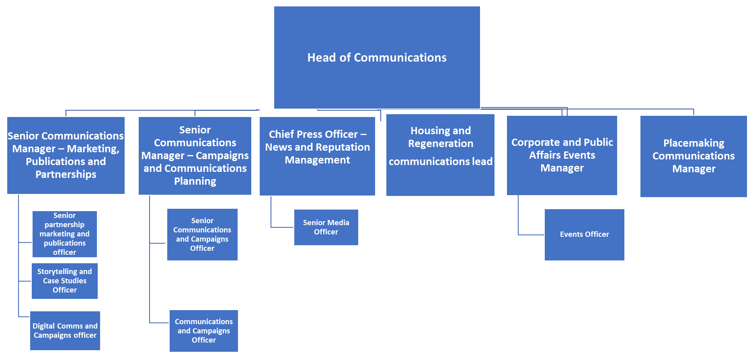

Person Specification

Job Title: Communications and Campaigns officer | Grade: P03
Section: Corporate Communications | Directorate: Chief Executive
Responsible to: Senior Communications and Campaigns Officer | Responsible for: N/A
Post Number/s: | Last Review Date: May 2024

Our Values and Behaviours

The values and behaviours we seek from our staff draw on the high standards of the two boroughs, and we prize these qualities in particular:

Being open. This means we share our views openly, honestly and in a thoughtful way. We encourage new ideas and ways of doing things. We appreciate and listen to feedback from each other.

Being supportive. This means we drive the success of the organisation by making sure that our colleagues are successful. We encourage others and take account of the challenges they face. We help each other to do our jobs.

Being positive. Being positive and helpful means we keep our goals in mind and look for ways to achieve them. We listen constructively and help others see opportunities and the way forward. We have a ‘can do’ attitude and are continuously looking for ways to help each other improve.

Person Specification Requirements |  |  |  | Assessed by  A/I/T/C  (see below for explanation)
 | Knowledge | Essential | Desirable | Assessed
 | Outstanding writing, editing, and verbal communication skills | x |  | A&T
 | Knowledge of local government policies and issues |  | x | A&I
 | Excellent interpersonal skills, with the ability to build relationships and collaborate effectively with diverse stakeholders. | x |  | I
 | Experience | Essential | Desirable | Assessed
 | Experience in PR, media relations, or as a journalist/student journalist |  | x | A
 | Demonstrated ability to develop and execute successful PR campaigns, including crisis communications management. |  | x | A
 | Knowledgeable of Wandsworth borough. |  | x | A
 | Skills | Essential | Desirable | Assessed
 | Ability to tailor messages for different audiences. | x |  | T
 | Strategic thinking and problem-solving abilities, with a results-driven mindset | x |  | I&T
 | Clear understanding of how to use and assess the effectiveness of social media and other e-marketing tools. | x |  | A&I
 | Qualifications | Essential | Desirable | Assessed
 | Bachelor's degree in communications, public relations, journalism, or a related field |  | x | A

A – Application form / CV
I – Interview
T – Test
C - Certificate

