Job Profile comprising Job Description and Person Specification
Job Description

Job Title:  Consultation Officer | Grade:  PO2
Section:  Resident Engagement | Directorate:  Chief Executive’s Group
Responsible to following manager:  Consultation Manager | Responsible for following staff:  Non Applicable
Post Number/s: | Last review date:

Working for the Richmond/Wandsworth Shared Staffing Arrangement

This role is employed under the Shared Staffing Arrangement between Richmond and Wandsworth Councils. The overall purpose of the Shared Staffing Arrangement is to provide the highest quality of service at the lowest attainable cost.

Staff are expected to deliver high quality and responsive services wherever they are based, as well as having the ability to adapt to sometimes differing processes and expectations.

The Shared Staffing Arrangement aims to be at the forefront of innovation in local government and the organisation will invest in the development of its staff and ensure the opportunities for progression that only a large organisation can provide.

Job Purpose

- Assist in enhancing community engagement for both Councils ensuring it informs service delivery, commissioning and decision making

- Undertake consultation and analysis projects and provide advice in relation to consultation and community engagement best practice

Specific Duties and Responsibilities

- To undertake individual consultation and research projects on behalf of colleagues in services across the organisation

- To combine and analyse data from a range of sources to provide intelligence about residents and service users to support effective community engagement and strategic commissioning decisions

- To prepare briefings and reports on consultation, community engagement and research

- To make best use of the software applications available to the organisation (consultation software, DataRich, GIS, analytics software etc) to enhance the quality and impact of the products delivered by the consultation team

- To act as a source of expertise on consultation, community involvement and research on customer insight, providing advice and promoting best practice across the Council and partners

- To ensure that the services for both Councils are dealt with on an equitable basis to deliver the standards required for each, as agreed annually by the Executives of both Councils

- To contribute as required to the commissioning, market testing and contract management of services provided by the consultation team

Generic Duties and Responsibilities

- To contribute to the continuous improvement of the services of the Boroughs of Wandsworth and Richmond

- To comply with relevant Codes of Practice, including the Code of Conduct and policies concerning data protection and health and safety

- To adhere to security controls and requirements as mandated by the SSA’s policies, procedures and local risk assessments to maintain confidentiality, integrity, availability and legal compliance of information and systems

- To promote equality, diversity, and inclusion, maintaining an awareness of the equality and diversity protocol/policy and working to create and maintain a safe, supportive and welcoming environment where all people are treated with dignity and their identity and culture are valued and respected

- To understand both Councils’ duties and responsibilities for safeguarding children, young people and adults as they apply to the role within the council

- The Shared Staffing Arrangement will keep its structures under continual review and as a result the post holder should expect to carry out any other reasonable duties within the overall function, commensurate with the level of the post

- Additional Information

Post holder may be expected to work flexibly across two locations (Wandsworth and Richmond)

Current team structure

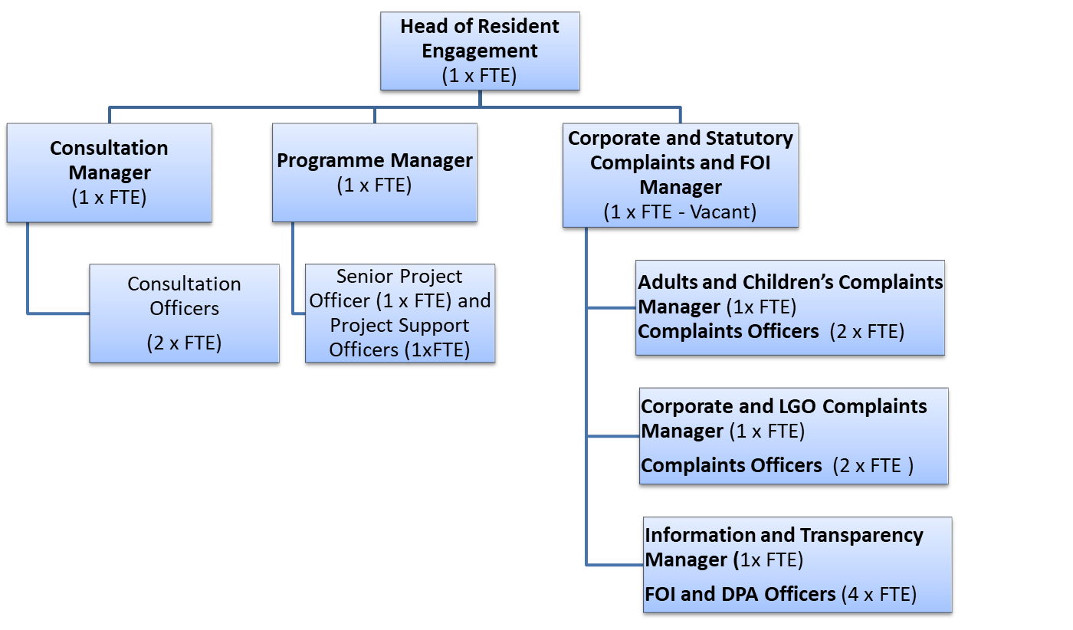
Person Specification

Job Title:  Consultation Officer | Grade:  PO2
Section:  Customers and Partnerships | Directorate:  Chief Executive’s Group
Responsible to following manager:  Head of Resident Engagement | Responsible for following staff:  Non Applicable
Post Number/s: | Last review date:

Our Values and Behaviours

The values and behaviours we seek from our staff draw on the high standards of the two boroughs, and we prize these qualities in particular:

Being open. This means we share our views openly, honestly and in a thoughtful way. We encourage new ideas and ways of doing things. We appreciate and listen to feedback from each other.

Being supportive. This means we drive the success of the organisation by making sure that our colleagues are successful. We encourage others and take account of the challenges they face. We help each other to do our jobs.

Being positive. Being positive and helpful means we keep our goals in mind and look for ways to achieve them. We listen constructively and help others see opportunities and the way forward. We have a ‘can do’ attitude and are continuously looking for ways to help each other improve.

Person Specification Requirements | Assessed by  A & I/ T/ C (see below for explanation)
Knowledge
Knowledge of different data collection methods (polls, focus groups, surveys etc) and experience of using them as appropriate to meet business need | A/I
Working knowledge of web editing, analytics and experience integrating visual media into static content (eg YouTube videos, Twitter content into report/web pages) | A/I
Experience
Analysing data and producing reports to support business decision-making | A/T/I
Experience of working within a team and independently and working flexibly to contribute to a number of workstreams simultaneously | I
Experience of using consultation, analysis and visual presentation software | A/I
Skills
Excellent analytical and critical thinking skills with ability to analyse financial and non-financial data and draw robust conclusions | A/T/I
Ability to communicate and present results of analysis effectively and persuasively, orally and in writing, for a range of audiences | I
Ability to work co-operatively and constructively with colleagues at all levels in order to understand business needs and ensure products deliver on those needs whilst meeting consultation best practice standards | I
Excellent IT skills – MS Office (Word, Excel, PowerPoint and Outlook) | A/T/ I
Ability to organise and prioritise own workload, to work under pressure and meet deadlines | I
Qualifications

A – Application form
I – Interview
T – Test
C - Certificate

