Job Profile comprising Job Description and Person Specification
Job Description

Job Title:  Community Safety Officer | Grade:  PO3
Section:  Community Safety Service | Directorate:  Chief Executives Group
Responsible to following manager:  Community Safety Team Manager | Responsible for following staff:  N/A
Post Number/s:  1 | Last review date: 08/02/2021

Working for the Richmond/Wandsworth Shared Staffing Arrangement

This role is employed under the Shared Staffing Arrangement between Richmond and Wandsworth Councils. The overall purpose of the Shared Staffing Arrangement is to provide the highest quality of service at the lowest attainable cost.

Staff are expected to deliver high quality and responsive services wherever they are based, as well as having the ability to adapt to sometimes differing processes and expectations.

The Shared Staffing Arrangement aims to be at the forefront of innovation in local government and the organisation will invest in the development of its staff and ensure the opportunities for progression that only a large organisation can provide.

Job Purpose

The post-holder will be responsible for a defined geographic area and for building strong relationships with statutory and voluntary sector organisations, communities, and individuals to collectively address persistent and problematic crime and anti-social behaviour. To encourage and develop the involvement of the public through Neighbourhood Watch and business participation groups. Work to deliver priorities and actions in the Community Safety Plan.

Specific Duties and Responsibilities

- Provide leadership and coordination within a defined area to build a network of key individuals, statutory and voluntary sector organisations to reduce crime and anti-social behaviour, build community cohesion and reduce the fear of crime through neighbourhood profiling and the ECINS platform

- To identify and provide leadership on borough crime trends and hot spots by working closely with community groups such as Online Watch Link (OWL), Neighbourhood Watch, Residents’ Associations, business groups and forums to support crime reduction and crime prevention in line with the Mayor’s Office for Policing and Crime (MOPAC) priorities within the Community Safety Plan.

- To identify organisations and/or locations of significant community safety risk and develop key relationships with the relevant management teams. To ensure Emergency Planning and other relevant teams internally and externally are briefed on any relevant issues and to assist in the mitigation of any associated risk.

- To support OWL and subsequent Neighbourhood Watch Associations in areas identified as crime hotspots or vulnerable to crime. To ensure that information is provided to OWL coordinators on a regular basis.

- Coordinate actions under the Anti-social Behaviour, Crime and Policing Act 2014. To identify best practice in the implementation of ASB tools and powers in line with these priorities including:

- To support the CMARAC process with relevant referral and review materials; to coordinate complex case actions with other risk management panels or processes.

- To identify and develop key relationships and referral pathways with health/mental health teams, social care, drug treatment providers, outreach/triage services and advocacy groups to ensure effective referral and signposting for those who are rough sleeping, street drinking or begging; or who are otherwise deemed vulnerable.

- Collate and present information for review to the Community Trigger Panel.

- To work with Police Teams, Housing, RSLs and other providers to maintain a database of CBO’s, Injunctions and ABCs including positive requirements as required by the Community Safety Manager.

- Represent the Community Safety Service as required at ward and community meetings such as Ward Panels.

- To assist in the development of literature and presentation materials on Community Safety through the communications grid with the support of the Insight and Analytics Team and Communications Team.

- Attend community events and engage with the public to raise awareness of crime issues and provide crime prevention advice.

- To investigate and respond to Member Enquiries and Freedom of Information requests as delegated by the Community Safety Team Manager.

- To take on key responsibilities in key projects as laid down by the Community Safety Team Manager and report back when necessary to the Senior Management Team on progress. This includes developing specialist knowledge, sharing best practice, or running key initiatives across both boroughs.

Generic Duties and Responsibilities

- To contribute to the continuous improvement of the services of the Boroughs of Wandsworth and Richmond.

- To comply with relevant Codes of Practice, including the Code of Conduct and policies concerning data protection and health and safety.

- To adhere to security controls and requirements as mandated by the SSA’s policies, procedures and local risk assessments to maintain confidentiality, integrity, availability and legal compliance of information and systems

- To promote equality, diversity, and inclusion, maintaining an awareness of the equality and diversity protocol/policy and working to create and maintain a safe, supportive and welcoming environment where all people are treated with dignity and their identity and culture are valued and respected.

- To understand both Councils’ duties and responsibilities for safeguarding children, young people and adults as they apply to the role within the council.

- The Shared Staffing Arrangement will keep its structures under continual review and as a result the post holder should expect to carry out any other reasonable duties within the overall function, commensurate with the level of the post.
Additional Information
- Post holder will be expected to work flexibly across two locations (Wandsworth Town Hall and Richmond Civic Centre) and where necessary and authorised will be required to work from home

- To work evenings and weekends as required to provide a high-quality service and ensure engagement meets the targeted audience.

Team structure

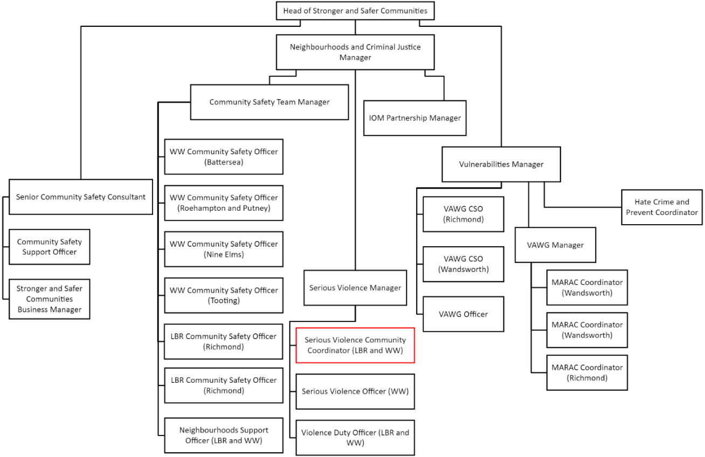
Person Specification
Job Title:  Community Safety Officer | Grade:  PO3
Section:  Community Safety Service | Directorate:  Chief Executives Group
Responsible to following manager:  Community Safety Team Manager | Responsible for following staff:  N/A
Post Number/s:  1 | Last review date: February 2021

Our Values and Behaviours

The values and behaviours we seek from our staff draw on the high standards of the two boroughs, and we prize these qualities in particular:

Being open. This means we share our views openly, honestly and in a thoughtful way. We encourage new ideas and ways of doing things. We appreciate and listen to feedback from each other.

Being supportive. This means we drive the success of the organisation by making sure that our colleagues are successful. We encourage others and take account of the challenges they face. We help each other to do our jobs.

Being positive. Being positive and helpful means, we keep our goals in mind and look for ways to achieve them. We listen constructively and help others see opportunities and the way forward. We have a ‘can do’ attitude and are continuously looking for ways to help each other improve.

Person Specification Requirements |  |  |  | Assessed by  A/I/T/C  (see below for explanation)
 | Knowledge | Essential | Desirable | Assessed
 | Knowledge of key legislation especially in the Anti-Social Behaviour, Crime and Policing Act 2014 and the Data Protection Act 2018. | x
 | An understanding of how-to problem solve community issues to understand harm and risk. It is desirable to understand the SARA model. | x
 | An understanding of the importance of partnerships in community safety and how these can be developed. | x
 | Experience | Essential | Desirable | Assessed
 | Experience of partnership or multi-agency work in order to achieve shared objectives. | x
 | Experience of working in a community safety related role which involved communicating effectively with the public on all matters involving Community Safety, | x
 | Skills | Essential | Desirable | Assessed
 | Ability to organise and prioritise own workload, within defined requirements for the role. | x
 | Good written and communication in order to deliver reports clearly and concisely. | x
 | Ability to analyse local crime trends and other relevant crime sources. | x
 | Basic knowledge of and ability to use standard IT packages (Microsoft Office and Outlook). Desirable but not essential to use ECINS | x
 | Qualifications | Essential | Desirable | Assessed
 | Degree level or equivalent by experience. | x

A – Application form / CV
I – Interview
T – Test
C - Certificate

