Job Profile comprising Job Description and Person Specification
Job Description

Job Title:  SLP Employment and Skills Project Support Officer | Grade:  Scale 5 £29,562-£34,779
Section:  South London Partnership | Directorate:  Chief Executive
Responsible to following manager:  SLP Skills & Employment Programme Lead | Responsible for following staff:  n/a
Post Number/s:  POS001028 & POS001029 | Last review date:  16.5.25

Working for the Richmond & Wandsworth Better Service Partnership

We’re Richmond & Wandsworth Better Service Partnership, the shared public service team for Richmond and Wandsworth Councils. Like any local authority, our role is to deliver the agenda of our elected members on behalf of the people who live and work in our part of the world. We deliver key services to our communities including social care, public health, children’s services, housing and regeneration and environmental and community services.

Our joint workforce creates efficiency and resilience by bringing more creativity to the way we work, more objectivity and adaptability too, helping us deliver better services for all our residents.

We’re here to help our communities thrive in a changing world, and to be there for the people who need us most we believe we need to keep adapting. That’s why, at Richmond & Wandsworth Better Service Partnership, you’ll be at the forefront of innovation in local government, and we’ll invest in you and offer you opportunities to grow in a way only our unique organisation can.

Job Purpose
- Assist the Skills & Employment Programme Lead, the Head of Economy, Skills and Employment and other senior officers by taking forward project work on the delivery of plans relating to the devolved funding as they relate to employment and skills across the SLP area.

- Manage discrete projects relating to Skills & Employment funded activity across the SLP boroughs.

- Assist the Head of Economy Skills and Employment and the Programme Lead in establishing and maintaining project reporting in relation to other SLP employment and skills activity including, no wrong door, careers hubs, green skills academy and the South London LSIP

- Ensure that robust project reports and data sets are produced, and an analysis is completed in each discrete area as they arise.

- To support digital engagement of our trailblazer communications

Specific Duties and Responsibilities

- To co-ordinate and provide project support, relating to Skills & Employment activity across the SLP boroughs.

- To work with the Programme Lead to coordinate specific areas of work relating to the project and administrative arrangements for a sub-regional programme that identify economically inactive and unemployed residents.

- To provide project information and data analysis required for the above project

- To provide project support to other SLP employment and skills project activity as required.

- To provide support to commissioning and contract management of financial information for each of the above area projects.

Generic Duties and Responsibilities

- To contribute to the continuous improvement of the services of Richmond & Wandsworth Better Service Partnerships.

- To comply with relevant Codes of Practice, including the Code of Conduct and policies concerning data protection, handling complaints and health and safety.

- To adhere to security controls and requirements as mandated by Richmond and Wandsworth procedures and local risk assessments to maintain confidentiality, integrity, availability and legal compliance of information and systems

- To promote equality, diversity, and inclusion, maintaining an awareness of the equality and diversity protocol/policy and working to create and maintain a safe, supportive and welcoming environment where all people are treated with dignity and their identity and culture are valued and respected.

- To understand both Councils’ duties and responsibilities for safeguarding children, young people and adults as they apply to the roles within the Councils.

- The profile is not intended to be an exhaustive list of the duties the post holder will carry out. Other reasonable duties commensurate with the level of the post, including supporting emergency and priority situations, will form part of the role.
Additional Information

Team structure

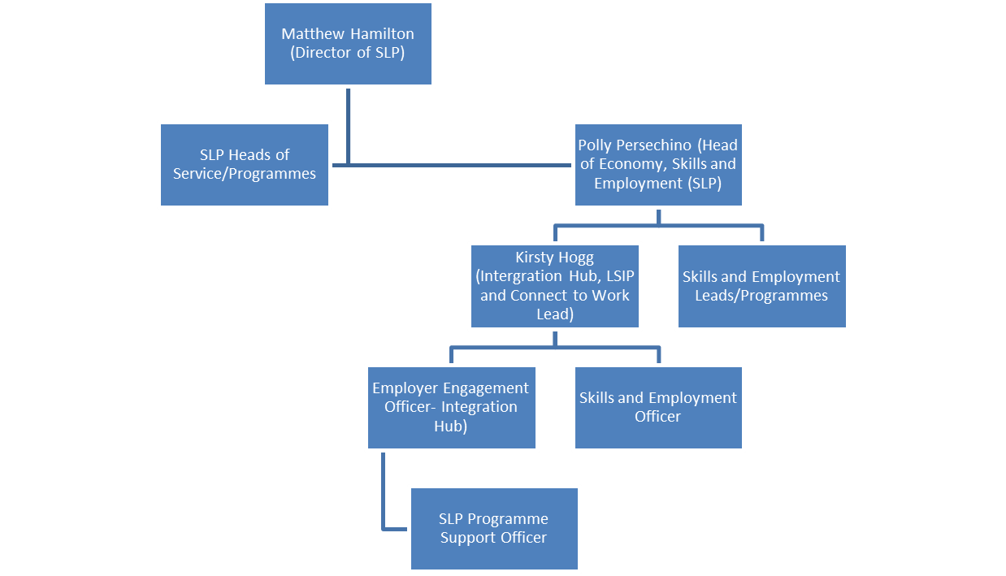
Person Specification

Job Title:  SLP Employment and Skills Project Officer | Grade:  Scale 5 £29,562-£34,779
Section:  South London Partnership | Directorate:  Chief Executive
Responsible to following manager: Skills and Employment Programme Manager | Responsible for following staff:  n/a
Post Number/s:  POS001028 & POS001029 | Last review date:  16.2.25

Our Values
THINK BIGGER
EMBRACE DIFFERENCE
CONNECT BETTER
LEAD BY EXAMPLE
PUT PEOPLE FIRST

Our Values are embedded across Richmond & Wandsworth Better Service Partnership and throughout all roles and responsibilities at all levels of the organisation. Please familiarise yourself with our values as they are an integral part of our recruitment and selection process.

Person Specification Requirements |  |  |  | Assessed by  A/I/T/C  (see below for explanation)
 | Knowledge | Essential | Desirable | Assessed
 | A good understanding of the employment and skills opportunities and challenges across the South London Partnership areas | A/I
 | Experience | Essential | Desirable | Assessed
 | Experience of administering and supporting delivery of projects and programmes |  | A/I
 | Experience of working with councils on employment and skills activity |  | A/I
 | Skills | Essential | Desirable | Assessed
 | Ability to collect, collate, summarise and analyse information and draft high quality reports for management | A/I/T
 | Competence in the use of Microsoft Word, Excel. Basic knowledge of and ability to use standard IT packages (Microsoft Office and Outlook) | A/I/T
 | Ability to develop, maintain and review a range of different project management reporting, including information technology systems | A/I
 | Ability to organise and prioritise own workload, to work under pressure and meet deadlines | A/I
 | Good oral, written and presentation skills to provide clear and concise messages in a variety of internal and external contexts | A/I
 | Qualifications | Essential | Desirable | Assessed
 | Level 3 qualification or equivalent work experience | A/I

A – Application form / CV
I – Interview
T – Test
C - Certificate

