Job Profile comprising Job Description and Person Specification
Job Description

Job Title:  Quality & Systems Team Leader | Grade:  PO3
Section:  Technical Support, Revenues | Directorate:  Resources
Responsible to following manager:  Information & Systems Manager | Responsible for following staff:  7 FTE
Post Number/s: RWR0380 | Last review date:  September 2022

Working for the Richmond/Wandsworth Shared Staffing Arrangement

This role is employed under the Shared Staffing Arrangement between Richmond and Wandsworth Councils. The overall purpose of the Shared Staffing Arrangement is to provide the highest quality of service at the lowest attainable cost.

Staff are expected to deliver high quality and responsive services wherever they are based, as well as having the ability to adapt to sometimes differing processes and expectations.

The Shared Staffing Arrangement aims to be at the forefront of innovation in local government and the organisation will invest in the development of its staff and ensure the opportunities for progression that only a large organisation can provide.

Job Purpose
- To manage the workflow and resources of the Information and Systems Team on a day to day basis ensuring service targets, customer service and priorities are met including managing service quality assurance.

Specific Duties and Responsibilities
- Responsible for managing a Team to provide the Benefit, Council Tax and Parking services with system support, management information and quality assurance through a range of duties including but not solely:

- Responsible for maintaining databases to ensure the accuracy of statutory returns and externally reported performance
- Responsible for collating statistical performance overview and individual officer performance data for day to day management of services for Service Heads, Head of Service and Director of Resources.
- Responsible for ensuring quality assurance checks completed for the Benefits Service , including high risk exception reports
- Responsible for testing and implementation of systems to ensure they are fit for purpose and consistent with regulations for the Benefits Service
- Responsible for testing and implementation of Council Tax and Benefits Year-end, including liaison with external printers and other relevant council sections.
- Responsible for ensuring timely and accurate responses to requests for Data Protection files and FOI requests.
- Responsible for DWP accuracy review work including support and liaison with external officers
- Local Agent for Employee Authentication Scheme EAS, responsible for setting up new CIS and TUO users across Wandsworth Council

- To ensure that the services for both Councils are dealt with on an equitable basis to deliver the standards required for each, as agreed annually by the Executives of both Councils.

- To provide operational and motivational leadership of staff, providing a visible presence to the workforce and promoting a good working environment with the primary aim of delivering high quality services

- To ensure all Member queries about service delivery are dealt with promptly and effectively

- To advise and support managers on relevant matters affecting the service

- To assist as required with performance review and improvement measures on an ongoing basis, helping to ensure that a customer focus is embedded within the function and innovative and creative solutions are evaluated to securing the highest quality and value for money function.

- To contribute as required to change programmes within the service

- To contribute towards the development of good working relations and collaborative arrangements with relevant third party organisations including private, voluntary and other public organisations

- To act as deputy Information and Systems Manager as required.

Generic Duties and Responsibilities
- To contribute to the continuous improvement of the services of the Boroughs of Wandsworth and Richmond.

- To comply with relevant Codes of Practice, including the Code of Conduct and policies concerning data protection and health and safety.

- To adhere to security controls and requirements as mandated by the SSA’s policies, procedures and local risk assessments to maintain confidentiality, integrity, availability and legal compliance of information and systems

- To promote equality, diversity, and inclusion, maintaining an awareness of the equality and diversity protocol/policy and working to create and maintain a safe, supportive and welcoming environment where all people are treated with dignity and their identity and culture are valued and respected.

- To understand both Councils’ duties and responsibilities for safeguarding children, young people and adults as they apply to the role within the council.

- The Shared Staffing Arrangement will keep its structures under continual review and as a result the post holder should expect to carry out any other reasonable duties within the overall function, commensurate with the level of the post.

Additional Information
- Responsible for 7 FTE:
- 3 x PO1 System Support Officers
- 3 x SO1 Quality Assurance Officers
- 1x Sc6 Technical Support Officer
- 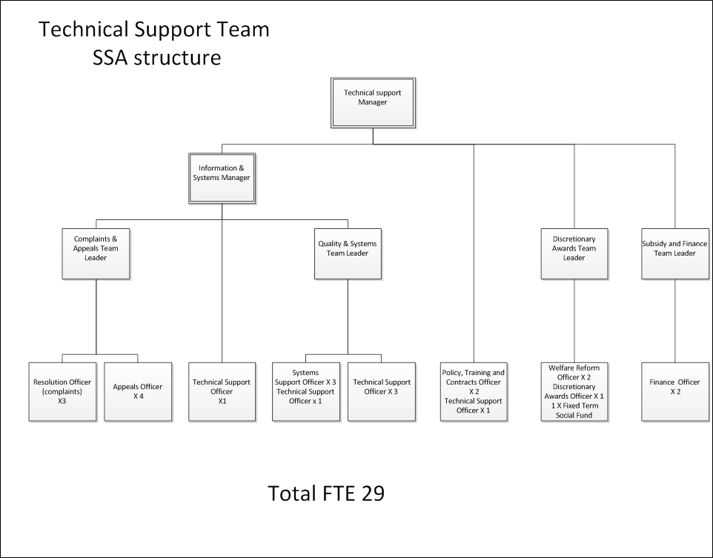
Person Specification

Job Title:  Quality & Systems Team Leader | Grade:  PO3
Section:  Technical Support, Revenues | Directorate:  Resources
Responsible to following manager:  Information & Systems Manager | Responsible for following staff:  7 FTE
Post Number/s: | Last review date:  September 2022

Our Values and Behaviours
The values and behaviours we seek from our staff draw on the high standards of the two boroughs, and we prize these qualities in particular:
Being open. This means we share our views openly, honestly and in a thoughtful way. We encourage new ideas and ways of doing things. We appreciate and listen to feedback from each other.
Being supportive. This means we drive the success of the organisation by making sure that our colleagues are successful. We encourage others and take account of the challenges they face. We help each other to do our jobs.
Being positive. Being positive and helpful means we keep our goals in mind and look for ways to achieve them. We listen constructively and help others see opportunities and the way forward. We have a ‘can do’ attitude and are continuously looking for ways to help each other improve.

Person Specification Requirements | Assessed by  A  & I/ T/ C (see below for explanation)
Knowledge
In depth knowledge of legislative and statutory requirements for either:  - Benefit Assessments  - Council Tax account management  - Parking Permit or PCNs | A/I
In depth knowledge of at least one of the IT applications that support:  - Benefit Assessments  - Council Tax account management  - Parking Permit or PCNs | A/I
An understanding of the top line performance processes | A/I
An understanding of the legislation that underpins data protection and freedom of information | A/I
Experience
Experience of successfully managing a team for either:  - Benefit Assessments  - Council Tax account management  - Parking Permit or PCNs | A/I
Experience of being responsible for the maintenance and updating of IT systems for either:  - Benefit Assessments  - Council Tax account management  - Parking Permit or PCNs | A/I
Significant experience of successfully managing own workload and that of others in an environment where deadlines and priorities frequently change and are often conflicting | A/I
Significant experience of using standard IT packages to an advanced level as required for the role. This may include report writing (Word), presentations (PowerPoint) and manipulating statistical data (Excel/Access). | A/I
Some experience of appropriately managing shared staff resources across more than 1 team to ensure that the targets and deadline of all teams are met. | A/I
Skills
Ability to address challenges, resolve problems and achieve continuous improvement in a pressurised environment. | A/I
Good oral and written skills to provide clear and concise messages. | A/I
Ability to organise and prioritise own workload, to work under pressure and meet deadlines. | A/I
Qualifications
Relevant management or professional qualification, accredited learning qualification or equivalent experience. | C

A – Application form
I – Interview
T – Test
C - Certificate

