Job Profile comprising Job Description and Person Specification
Job Description

Job Title: Cost of Living Project Manager | Grade: PO3
Section: Cost of Living Programme Team - Revenues | Directorate: Resources
Responsible to following manager:  Cost of Living Programme Manager | Responsible for following staff:  None
Post Number/s: tbc | Last review date: July 2023

Working for the Richmond/Wandsworth Shared Staffing Arrangement

This role is employed under the Shared Staffing Arrangement between Richmond and Wandsworth Councils. The overall purpose of the Shared Staffing Arrangement is to provide the highest quality of service at the lowest attainable cost.

Staff are expected to deliver high quality and responsive services wherever they are based, as well as having the ability to adapt to sometimes differing processes and expectations.

The Shared Staffing Arrangement aims to be at the forefront of innovation in local government and the organisation will invest in the development of its staff and ensure the opportunities for progression that only a large organisation can provide.

Job Purpose

Many local households are struggling to make their incomes stretch to cover the rising cost of living. Both Richmond and Wandsworth Councils have allocated reserves to supporting households through the Cost of Living Crisis. A Cost of Living Programme team has been established to oversee the allocation of this funding and co-ordinate a comprehensive response to help residents with both immediate crisis assistance and longer term resilience to financial shocks.

The post holder will lead on cross-cutting Cost of Living projects that deliver on the longer term aims of the programme, specifically, how we work in partnership with the voluntary and community sector to support residents, how data and insight is embedded across all departments and how we can change as an organisation to put people before process when supporting those in poverty or who are struggling with the cost of living.
Specific Duties and Responsibilities

- Manage key projects identified as priorities for the Cost of Living Programme through all stages of the project lifecycle from initiation through to closure.

- Scope out and define project parameters, costs and resources. Prepare business cases as part of project initiation.

- Draw up and maintain project plans, identifying dependencies and resource requirements and assessing and monitoring risks to project delivery.

- Work across organisational boundaries and with external partners to deliver projects. This will include working with staff outside of the post holder’s team, gaining the support of all project participants through persuasion and negotiation is key.

- Map out key project stakeholders, prepare and deliver against a communications plan, ensuing that all stakeholders are engaged, informed and supportive of the project as required.

- Prepare and present regular highlight reports to Programme Board to keep them informed on the progress of projects and any risks or issues. Monitor and control the progress of projects against the project plan.

- Establish, in consultation with Programme Board and the Programme Manager, a range of measures including performance indicators to ensure that the council can measure the effectiveness, progress (against delivery milestones), efficiency and success of specific projects and provide information to internal audiences and for external scrutiny.

- Ensure internal and/or external funding sources for projects are identified and secured through funding bids and or approval processes and manage project budgets and other financial resources associated with the project.

- At the end of projects, analyse success against performance indicators and prepare a project closure and lessons learned document to inform future direction.

- Keep up to date with latest national and regional policy agenda, identify opportunities and make recommendations for the ongoing evolution of this programme.

- Provide support to the Programme Manager on other projects and act as cover for the Programme Manager as required. This could include representing the Cost of Living Team at meetings and external events.

Generic Duties and Responsibilities

- To contribute to the continuous improvement of the services of the Boroughs of Wandsworth and Richmond.

- To comply with relevant Codes of Practice, including the Code of Conduct and policies concerning data protection and health and safety.

- To adhere to security controls and requirements as mandated by the SSA’s policies, procedures and local risk assessments to maintain confidentiality, integrity, availability and legal compliance of information and systems

- To promote equality, diversity, and inclusion, maintaining an awareness of the equality and diversity protocol/policy and working to create and maintain a safe, supportive and welcoming environment where all people are treated with dignity and their identity and culture are valued and respected.

- To understand both Councils’ duties and responsibilities for safeguarding children, young people and adults as they apply to the role within the council.

- The Shared Staffing Arrangement will keep its structures under continual review and as a result the post holder should expect to carry out any other reasonable duties within the overall function, commensurate with the level of the post.
Additional Information
The post holder will be required to work flexibly across two locations (Wandsworth Town Hall and Richmond Civic Centre), with opportunities for home working.

Team structure
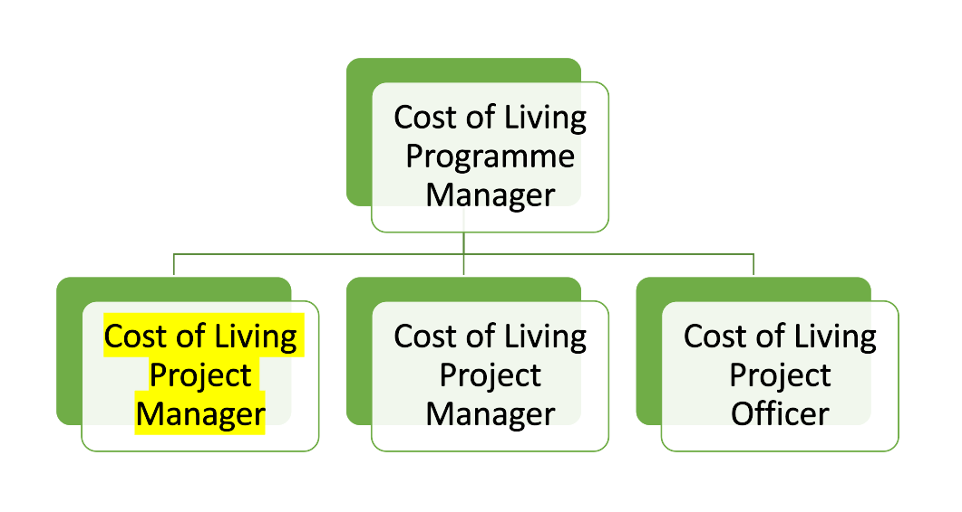
Person Specification

Job Title: Cost of Living Project Manager | Grade: PO3
Section: Cost of Living Programme Team - Revenues | Directorate: Resources
Responsible to following manager:  Cost of Living Programme Manager | Responsible for following staff:  None
Post Number/s: tbc | Last review date: July 2023

Our Values and Behaviours

The values and behaviours we seek from our staff draw on the high standards of the two boroughs, and we prize these qualities in particular:

Being open. This means we share our views openly, honestly and in a thoughtful way. We encourage new ideas and ways of doing things. We appreciate and listen to feedback from each other.

Being supportive. This means we drive the success of the organisation by making sure that our colleagues are successful. We encourage others and take account of the challenges they face. We help each other to do our jobs.

Being positive. Being positive and helpful means we keep our goals in mind and look for ways to achieve them. We listen constructively and help others see opportunities and the way forward. We have a ‘can do’ attitude and are continuously looking for ways to help each other improve.

Person Specification Requirements |  |  |  | Assessed by  A/I/T/C  (see below for explanation)
 | Knowledge | Essential | Desirable | Assessed
 | Good working knowledge of project management methodologies | x |  | A/I
 | Good knowledge of the drivers of the Cost of Living Crisis and best practice on tackling poverty and improving financial resilience | x |  | A/I
 | Good general knowledge across a broad range of local government services in order to ensure that projects are consistent with both Council’s overall policies and direction |  | x | A/I
 | Knowledge and understanding of budgetary and financial procedures |  | x | A/I
 | Experience | Essential | Desirable | Assessed
 | Substantial project management experience in local government or a relevant field | x |  | A/I
 | Working successfully with partners and key stakeholders, ideally including the Voluntary and Community Sector | x |  | A/I
 | Experience managing project budgets and forecasting |  | x | A/I
 | Skills | Essential | Desirable | Assessed
 | Excellent communication skills (both verbal and written) to communicate with people at all levels | x |  | I
 | Good influencing and negotiation skills – tact and diplomacy | x |  | I
 | Ability to think creatively and strategically | x |  | I
 | Ability to build relationships across organisational and professional boundaries and to work collaboratively with external partners | x |  | I
 | High level of organisational skills – attention to detail | x |  | I
 | Ability to effectively plan, implement and evaluate projects | x |  | I
 | Ability to prepare and present written reports | x |  | I
 | Ability to challenge accepted ways of working | x |  | I
 | Ability to meet strict deadlines and prioritise work | x |  | I
 | Qualifications | Essential | Desirable | Assessed
 | Educated to degree level or equivalent by experience | x |  | A/C

A – Application form / CV
I – Interview
T – Test
C - Certificate

