Job Profile comprising Job Description and Person Specification
Job Description

Job Title:  Principal Infrastructure Officer | Grade:  PO5
Section:  Information and Planning Obligations | Directorate:  Environment and Community Services
Responsible to following manager:  Information and Planning Obligations Team Manager | Responsible for following staff:  Senior Infrastructure Officer  Infrastructure Officer
Post Number/s: | Last review date:  May 2022

Working for the Richmond/Wandsworth Shared Staffing Arrangement

This role is employed under the Shared Staffing Arrangement between Richmond and Wandsworth Councils. The overall purpose of the Shared Staffing Arrangement is to provide the highest quality of service at the lowest attainable cost.

Staff are expected to deliver high quality and responsive services wherever they are based, as well as having the ability to adapt to sometimes differing processes and expectations.

The Shared Staffing Arrangement aims to be at the forefront of innovation in local government and the organisation will invest in the development of its staff and ensure the opportunities for progression that only a large organisation can provide.

Job Purpose

To lead on coordinating and delivering key workstreams associated with the infrastructure strategy of the two Councils. The Principal Infrastructure Officer will coordinate the bid evaluation process for project managers wishing to submit funding bids to the Board. They will be responsible for collating and presenting the evidence-base that will support the decisions of the Board, including producing annual Infrastructure Delivery Plan updates and refreshing the five-year strategy. The Principal Infrastructure Officer will work closely with Infrastructure Board members and will act as the point of contact for the Board, communicating with internal and external colleagues and partners. The Principal Infrastructure Officer will lead a team that will focus on the strategic delivery of infrastructure projects. The team will enable the Infrastructure Board to achieve its primary objective of delivering efficient spending according to Council priorities on infrastructure capacity, development, and delivery.

Specific Duties and Responsibilities

- Responsible to the Information and Planning Obligations Team Manager for taking the lead on, and responsibility for, the full range of workstreams directly related to infrastructure strategy for the two Councils.
- Undertakes a range of duties required to support the day-to-day functions of the Infrastructure Board. To produce policy and guidance notes and advice, ensuring priorities are effectively and efficiently progressed to identifiable deadlines in a manner which is successful in meeting corporate targets and objectives.
- Identifies and maintains Key Performance Indicators (KPI’s) and implements monitoring systems to ensure performance management information is up to date (e.g. via Microsoft Power BI).
- Produces relevant documents to act as evidence to support Infrastructure Board decision-making. This includes updating the Infrastructure Delivery Plans (IDP’s), assuring accuracy and that coherent and robust recommendations are formed based on Council policies and other material considerations.
- Leads a co-ordinated bid and bid-evaluation process, providing detailed information, feedback and advice for project officers wishing to submit projects to the Infrastructure Board.
- Ensures that project managers provide information and performance data to enable project monitoring and reporting to the Infrastructure Board, allowing it to make informed decisions on infrastructure prioritisation.
- Works closely with Infrastructure Board members, including the Chair, and confidently provides updates, high level briefings and presentations about ongoing and future projects and funding streams to all stakeholders across the Council(s).
- As the point of contact for the Infrastructure Board, formalises engagement, infrastructure planning and delivery across the Council(s), as well as coordinating with external partners on behalf of the board.
- Leads on liaison with the Directorate of Resources for the purposes of general capital monitoring and to ensure an efficient process for capital programme reporting.
- Manages the work of the Senior Infrastructure Officer and Infrastructure Officer to ensure high-quality delivery of the aims of the Infrastructure Board.
- Coaches and facilitates the acquisition and development of skills and knowledge in others so that they are better equipped to be self-reliant in dealing with technical and people issues.
- Demonstrates an ability to build and develop strong working relationships both inside and outside the service in order to deliver departmental and corporate objectives and to mitigate risk and to be an ambassador for the planning function in these interactions.
- Maintains an up-to-date knowledge of relevant legislation and national policy and guidance and takes a proactive approach to relevant changes in these, recommending revised procedures and practices and managing the implementation of those revisions.
- Deputises for the Information and Planning Obligations Team Manager including attendance at any appropriate Overview and Scrutiny Committee and evening meetings as required.

Generic Duties and Responsibilities

- To contribute to the continuous improvement of the services of the Boroughs of Wandsworth and Richmond.

- To comply with relevant Codes of Practice, including the Code of Conduct and policies concerning data protection and health and safety.

- To adhere to security controls and requirements as mandated by the SSA’s policies, procedures, and local risk assessments to maintain confidentiality, integrity, availability and legal compliance of information and systems

- To promote equality, diversity, and inclusion, maintaining an awareness of the equality and diversity protocol/policy and working to create and maintain a safe, supportive, and welcoming environment where all people are treated with dignity and their identity and culture are valued and respected.

- To understand both Councils’ duties and responsibilities for safeguarding children, young people, and adults as they apply to the role within the council.

- The Shared Staffing Arrangement will keep its structures under continual review and as a result the post holder should expect to carry out any other reasonable duties within the overall function, commensurate with the level of the post.
Additional Information
- Assists as required with the management of budgets, including ensuring that all necessary processes and procedures are carried out in a timely and effective way.

- Attends as required the appropriate Overview and Scrutiny Committee to present reports and evidence and attendance at occasional evening public meetings.

- Responsible for day-to-day supervision and allocation of work for the following posts:
  - Senior Infrastructure Officer
  - Infrastructure Officer

Team structure
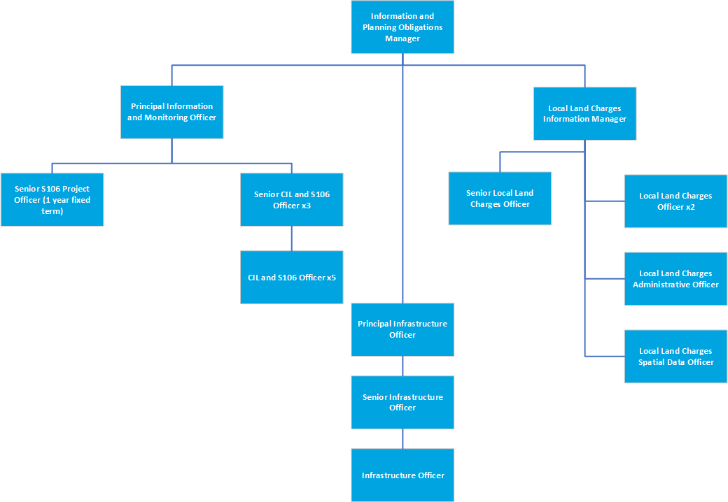

Person Specification

Job Title:  Principal Infrastructure Officer | Grade:  PO5
Section:  Information and Planning Obligations | Directorate:  Environment and Community Services
Responsible to:  Information and Planning Obligations Team Manager | Responsible for:  Senior Infrastructure Officer  Infrastructure Officer
Post Number/s: | Last Review Date:  May 2022

Our Values and Behaviours

The values and behaviours we seek from our staff draw on the high standards of the two boroughs, and we prize these qualities in particular:

Being open. This means we share our views openly, honestly and in a thoughtful way. We encourage new ideas and ways of doing things. We appreciate and listen to feedback from each other.

Being supportive. This means we drive the success of the organisation by making sure that our colleagues are successful. We encourage others and take account of the challenges they face. We help each other to do our jobs.

Being positive. Being positive and helpful means we keep our goals in mind and look for ways to achieve them. We listen constructively and help others see opportunities and the way forward. We have a ‘can do’ attitude and are continuously looking for ways to help each other improve.

Person Specification Requirements | Assessed by  A  & I/ T/ C (see below for explanation)
Knowledge
A proven understanding of Local Government decision-making and delivery processes. | A/I/T
A detailed knowledge of planning legislation and delivery of infrastructure in a London and Local Authority context; including CIL regulations, S106 planning obligations and Infrastructure Delivery Plans. | A/I/T
Knowledge and understanding of performance management and staff  development and the ability to apply that knowledge to setting challenging  targets for yourself and team members to ensure optimum service delivery. | A/I/T
An advanced knowledge of the Microsoft Office package, particularly Excel, and ability to use a wide range of computer software to collate, query, analyse, interpret, and present data, such as Microsoft Power BI. | A/I/T
Experience
Experience of successfully developing and managing large-scale initiatives and projects, including financial information management, project monitoring and evaluating delivery of value for money. . | A/I
Experience of providing high quality evidence-based reports or recommendations to senior decision-makers. | A/I
Experience of supervising and mentoring junior staff so that they can become self-reliant in dealing the technical and people issues and deliver a high-quality programme of work according to deadlines. | A/I
Experience of working at pace in a high-pressure environment | A/I/T
Experience of communicating and influencing at a senior level with excellent political awareness, in communications with internal and external stakeholders. | A/I
Skills
Ability to build trust and manage effective working relationships at all levels, both verbally and in writing. | A/I/T
Ability to analyse and interpret complex data and present key facts  including policy implications in the preparation of reports, policy  formulation and other material. | A/I/T
Ability to lead on designated projects with minimum supervision. | A/I
Ability to organise own workload and work within agreed timeframes to  maintain high quality decision making at speed and to achieve set deadlines  and targets, having a methodical approach to work with high levels of accuracy and ability to pay meticulous attention to detail. | A/I/T
A self-starter with the ability to get to grips with work quickly and independently. | A/I
A clear understanding and commitment to take effective action to promote  equality and the value of diversity in service delivery and employment. | A/I
Flexible approach to working hours, location and getting the job done and  the ability to attend meetings and other events outside normal working  hours, occasionally at short notice. | A/I
Qualifications
A degree or other appropriate technical qualification in a relevant field (e.g. planning) | A,C

A – Application form / CV
I – Interview
T – Test
C - Certificate

