Job Profile comprising Job Description and Person Specification
Job Description

Job Title:  Public Health Lead | Grade:  PO6
Section:  Public Health | Directorate:  Adult Social Care and Public Health
Responsible to following manager:  Senior Public Health Lead (Targeted Interventions and Children) | Responsible for following staff:  N/A
Post Number/s:  POS001061 | Last review date:  June 2025

Working for the Richmond & Wandsworth Better Service Partnership

We’re Richmond & Wandsworth Better Service Partnership, the shared public service team for Richmond and Wandsworth Councils. Like any local authority, our role is to deliver the agenda of our elected members on behalf of the people who live and work in our part of the world. We deliver key services to our communities including social care, public health, children’s services, housing and regeneration and environmental and community services.

Our joint workforce creates efficiency and resilience by bringing more creativity to the way we work, more objectivity and adaptability too, helping us deliver better services for all our residents.

We’re here to help our communities thrive in a changing world, and to be there for the people who need us most we believe we need to keep adapting. That’s why, at Richmond & Wandsworth Better Service Partnership, you’ll be at the forefront of innovation in local government, and we’ll invest in you and offer you opportunities to grow in a way only our unique organisation can.

Job Purpose
The Public Mental Health Lead will play a key role in supporting the development and delivery of a cross-council Public Mental Health Strategy for Wandsworth. Working closely with the Senior Public Health Lead, the postholder will contribute to the design and implementation of strategic programmes that promote mental health and wellbeing among residents. The role involves building and strengthening partnerships within the council and engaging with external stakeholders, including health services, voluntary and community sector organisations, to ensure a coordinated and impactful approach to improving population mental health.

Specific Duties and Responsibilities
Some duties have been mapped against the Public Health Skills and Knowledge Framework (PHSKF) for guidance. Relevant descriptors are shown in brackets.

- Plan, organise, implement and evaluate Public Health projects relating to specific topic areas, including support for commissioning of services and associated pathways, in order to improve outcomes for residents. (A1.5, A2.4, A2.5, B3.3)

- Apply specialist Public Health skills, knowledge and experience in a multiagency and multidisciplinary environment.

- Use Public Health skills to support the SWL Integrated Care Board (SWLICB) and wider health and social care partners on specific topic areas, including influencing partners to ensure that Public Health priorities and principles are reflected in commissioning plans.

- Manage multi-agency and multi-disciplinary partnerships with Council and ICB officers, GPs, local stakeholders, neighbouring local authorities and regional and national bodies, such as NHS England and Public Health England.

- Support the development of long-term strategic plans and projects on behalf of the boroughs in relation to Public Health issues which impact on a range of community agencies and strategic partnerships, and work with partners to enable appropriate implementation. (A4.3, B2.4, C1.5)

- Use specialist expert skills, knowledge and experience to collate, analyse, interpret and communicate epidemiological and statistical information from a variety of sources, including Government statistics and public consultations, and to make judgements about a range of possible solutions to Public Health problems. (A1.2, A1.5, C2.2)

- Identify and assess the health and healthcare needs within the boroughs, leading on specific Joint Strategic Needs Assessments, using a range of highly specialist quantitative and qualitative methodologies.

- Identify, implement and evaluate Public Health interventions and models of service provision which the post holder decides are the most appropriate in terms of their evidence base and cost effectiveness, taking into account their ethical and political consequences. (A4.4, A5.2, B2.3, B4.1, B4.2, C3.4)

- Create written reports and deliver presentations on behalf of the Public Health department to Council, ICB and partnership groups, conferences and seminars in order to influence major stakeholders. This includes communicating Public Health issues to residents, GPs and local stakeholders, in consultation with the Senior Public Health Lead. (B4.2, B4.3, C2.2

- Ensure that effective communication, including media (radio, press, etc) and social media, is developed by the staff/teams, in line with Borough requirements, liaising closely with the communications team. (C2.1, C2.4)

- Commission, oversee or participate in Public Health research projects and audits as well as contribute to, respond to and advise on the development of patient and public surveys. (A4.3, A4.6, A5.5, C2.5)

Generic Duties and Responsibilities

- To contribute to the continuous improvement of the services of Richmond & Wandsworth Better Service Partnerships.

- To comply with relevant Codes of Practice, including the Code of Conduct and policies concerning data protection, handling complaints and health and safety.

- To adhere to security controls and requirements as mandated by Richmond and Wandsworth procedures and local risk assessments to maintain confidentiality, integrity, availability and legal compliance of information and systems

- To promote equality, diversity, and inclusion, maintaining an awareness of the equality and diversity protocol/policy and working to create and maintain a safe, supportive and welcoming environment where all people are treated with dignity and their identity and culture are valued and respected.

- To understand both Councils’ duties and responsibilities for safeguarding children, young people and adults as they apply to the roles within the Councils.

- The profile is not intended to be an exhaustive list of the duties the post holder will carry out. Other reasonable duties commensurate with the level of the post, including supporting emergency and priority situations, will form part of the role.
Additional Information
- Effectively manage a delegated budget for specific commissioned services and/or projects, with supervision from Senior Public Health Lead. Write bids to secure funding for Public Health and partnership projects.

- Responsible for the management of member(s) of the Public Health team, as allocated to the post holder – including direct line management and/or project/matrix management of staff.

- Act as a deputy for the Senior Public Health Lead as required.

- Initiate, develop and commission training and education programmes for the benefit of health and other professional staff and evaluate effectiveness, including presentations to small groups, conferences, students, meetings, and networks.

- Post holder may be expected to work flexibly across two locations (Wandsworth Town Hall and Richmond Civic Centre).

- The Shared Staffing Arrangement will keep its structures under continual review and as a result the post holder should expect to carry out any other reasonable duties within the overall function, commensurate with the level of the post.

- The post holder will be expected to participate in the organisation’s staff appraisal scheme and departmental audit and ensure appraisal and development of any staff for which s/he is responsible.

Team structure

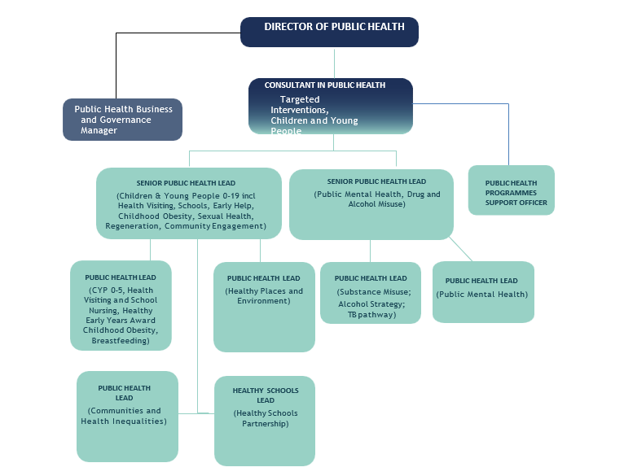
Person Specification

Job Title:  Public Health Lead | Grade:  PO6
Section:  Public Health | Directorate:  Adult Social Care and Public Health
Responsible to:  Senior Public Health Lead (Targeted Interventions and Children) | Responsible for:  N/A
Post Number/s:  POS001061 | Last Review Date:  June 2025

Our Values
THINK BIGGER
EMBRACE DIFFERENCE
CONNECT BETTER
LEAD BY EXAMPLE
PUT PEOPLE FIRST

Our Values are embedded across Richmond & Wandsworth Better Service Partnership and throughout all roles and responsibilities at all levels of the organisation. Please familiarise yourself with our values as they are an integral part of our recruitment and selection process.

Person Specification Requirements |  |  |  | Assessed by  A/I/T/C  (see below for explanation)
 | Knowledge | Essential | Desirable | Assessed
 | Proven experience of working collaboratively across multi-agency partnerships to develop and implement innovative approaches that improve population mental health outcomes. |  |  | A / I
 | Understanding of public mental health, including evidence-based strategies and interventions to improve mental wellbeing at a population level. |  |  | A / I
 | Understanding of social and political environment, including national and local policy, strategies, and guidance. |  |  | A / I A / I / T
 | Understanding of epidemiology and statistics, public health practice, health promotion, health economics, health care evaluation. |  |  | A / I / T
 | Experience | Essential | Desirable | Assessed
 | Substantial experience in public health or health-related posts and facilitating change in practice. |  |  | A / I
 | Experience of project management. |  |  | A / I
 | Skills | Essential | Desirable | Assessed
 | Excellent communicator in oral, written and presentation skills. Ability to create complex, high quality written material, including statistical tables, for a wide readership. |  |  | A / I / T
 | Ability to think strategically, creatively, analyse and communicate, manage problems, and develop solutions. |  |  | A / I / T
 | Demonstrated ability to design, coordinate, and deliver public health workshops and group-based interventions, ensuring alignment with population health needs and strategic public health priorities. |  |  | A / I
 | Ability to develop strategic action plans, ensuring that objectives and key actions are Specific, Measurable, Achievable, Relevant, and Time-bound (SMART). |  |  | A / I
 | Effective team member with strong interpersonal, influencing and facilitation skills. |  |  | A / I
 | Flexible, pro-active, uses initiative, prioritises, manages own workload, and works well under pressure and to tight timeframes with minimal supervision. |  |  | A / I
 | Ability to carry out research and evaluate research carried out by others. |  |  | A / I
 | Ability to analyse and interpret information for effective decision making. |  |  | A / I
 | Computer literate to enable reports, presentations, spread sheets, databases, and artwork to be produced. |  |  | A / I / T
 | Ability to manage budgets and prepare bids for external funding. |  |  | A / I
 | Qualifications | Essential | Desirable | Assessed
 | Higher degree or postgraduate qualification relevant to public health or equivalent knowledge gained through experience/post-graduate training. |  |  | A / I / C

A – Application form / CV
I – Interview
T – Test
C - Certificate

