Job Profile comprising Job Description and Person Specification
Job Description

Job Title: Storytelling and Case Studies Officer | Grade:  P04
Section:  Communications | Directorate:  Chief Executive
Responsible to following manager:  Senior Communications Manager – Marketing, Publications and Partnerships | Responsible for following staff:  N/A
Post Number/s:  pending | Last review date:

Working for the Richmond/Wandsworth Shared Staffing Arrangement

This role is employed under the Shared Staffing Arrangement between Richmond and Wandsworth Councils. The overall purpose of the Shared Staffing Arrangement is to provide the highest quality of service at the lowest attainable cost.

Staff are expected to deliver high quality and responsive services wherever they are based, as well as having the ability to adapt to sometimes differing processes and expectations.

The Shared Staffing Arrangement aims to be at the forefront of innovation in local government and the organisation will invest in the development of its staff and ensure the opportunities for progression that only a large organisation can provide.

The Communications Team is at the centre of the Council and has a high impact on the services and audiences it serves. It provides strategic leadership on media relations, public relation, event management, community engagement, publications, social media management and monitoring, branding, design and the councils websites. It is also responsible for the operational oversight, delivery and coordination of all communications activity across the wider council.

Job Purpose
As the Storytelling and Case Studies Officer you will play a pivotal role in crafting compelling narratives and real-life examples that showcase the impact and success stories of the Council’s initiatives, projects, and services. You will collaborate closely with various teams to gather, analyse, and present data and anecdotes that resonate with our audience, whether they are stakeholders, businesses, or the residents.

Specific Duties and Responsibilities

- To confidently lead account areas, and directly work with Cabinet members and senior leaders, external stakeholders and suppliers.
- To make empowered, informed and expert decisions around the right communications solution to a range of council initiatives.
- Communications Account lead for the Councillor
- Content Creation: Develop engaging and persuasive written content, including case studies, success stories, testimonials, and narratives that effectively communicate the value and impact of the Council’s work
- Research and Analysis: Conduct research to gather relevant data, testimonials, and anecdotes to support storytelling efforts.
- Collaboration: Work closely with communications colleagues and subject matter experts, to collect information and insights for storytelling purposes.
- Interviewing: Conduct interviews with stakeholders, clients, beneficiaries, and team members to gather first-hand accounts and testimonials that illustrate the impact of our initiatives.
- Writing and Editing: Write clear, concise, and compelling stories tailored to different audiences and channels. Edit and proofread content to ensure accuracy, consistency, and adherence to brand guidelines.
- Content Distribution: Collaborate with communications colleagues to distribute stories through various channels, including websites, social media, newsletters, press releases, and presentations.
- Storybank Management: Maintain a repository of case studies, success stories, testimonials, and other relevant content for future reference and use in marketing and communications efforts.
Generic Duties and Responsibilities

- To contribute to the continuous improvement of the services of the Boroughs of Wandsworth and Richmond.

- To comply with relevant Codes of Practice, including the Code of Conduct and policies concerning data protection and health and safety.

- To adhere to security controls and requirements as mandated by the SSA’s policies, procedures and local risk assessments to maintain confidentiality, integrity, availability and legal compliance of information and systems

- To promote equality, diversity, and inclusion, maintaining an awareness of the equality and diversity protocol/policy and working to create and maintain a safe, supportive and welcoming environment where all people are treated with dignity and their identity and culture are valued and respected.

- To understand both Councils’ duties and responsibilities for safeguarding children, young people and adults as they apply to the role within the council.

- The profile is not intended to be an exhaustive list of the duties the post holder will carry out. Other reasonable duties commensurate with the level of the post, including supporting emergency and priority situations, will form part of the role.
Additional Information
Our Values
THINK BIGGER
EMBRACE DIFFERENCE
CONNECT BETTER
LEAD BY EXAMPLE
PUT PEOPLE FIRST

Our Values are embedded across the SSA and throughout all roles and responsibilities at all levels of the organisation. Please familiarise yourself with our values as they are an integral part of our recruitment and selection process.

Team structure

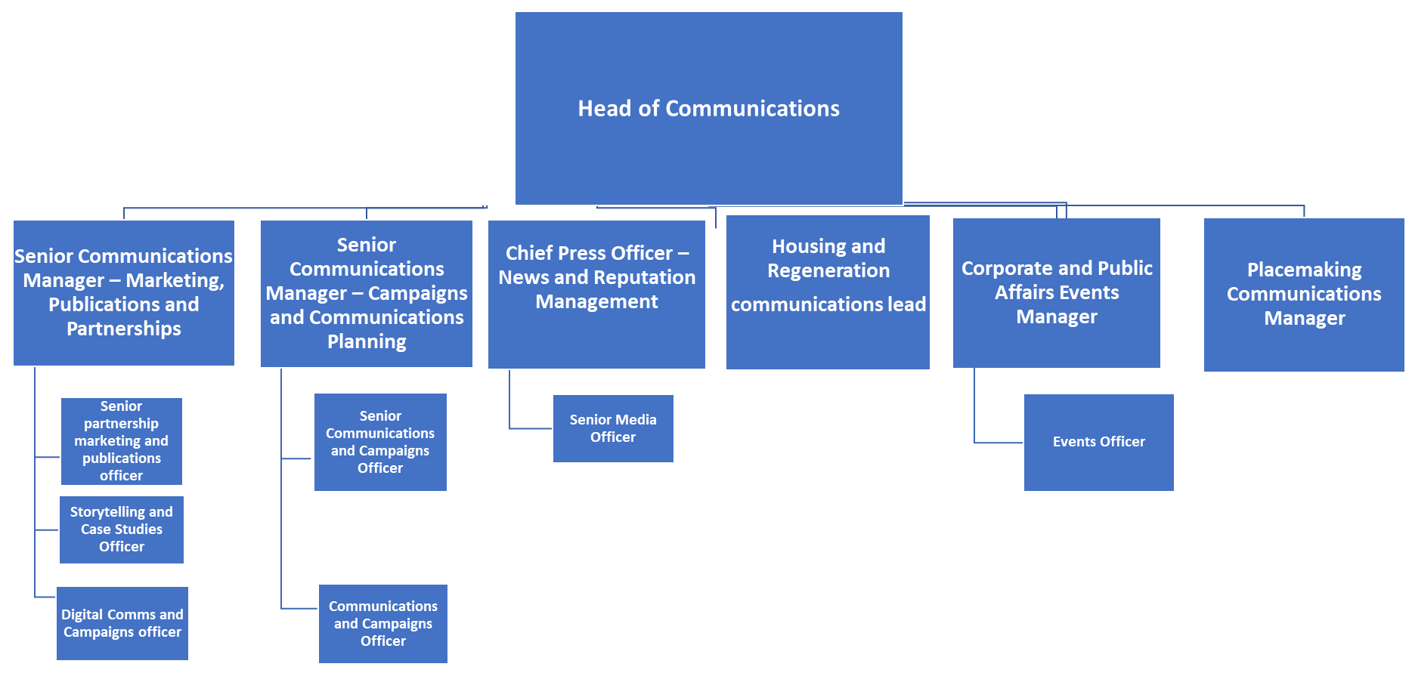

Person Specification

Job Title: Storytelling and Case studies Officer | Grade: P03-5
Section: Communications | Directorate: Chief Executive
Responsible to: Senior Communications Manager, Marketing Publications and Partnerships | Responsible for: N/A
Post Number/s: | Last Review Date: May 2024

Our Values and Behaviours

The values and behaviours we seek from our staff draw on the high standards of the two boroughs, and we prize these qualities in particular:

Being open. This means we share our views openly, honestly and in a thoughtful way. We encourage new ideas and ways of doing things. We appreciate and listen to feedback from each other.

Being supportive. This means we drive the success of the organisation by making sure that our colleagues are successful. We encourage others and take account of the challenges they face. We help each other to do our jobs.

Being positive. Being positive and helpful means we keep our goals in mind and look for ways to achieve them. We listen constructively and help others see opportunities and the way forward. We have a ‘can do’ attitude and are continuously looking for ways to help each other improve.

Person Specification Requirements |  |  |  | Assessed by  A/I/T/C  (see below for explanation)
 | Knowledge | Essential | Desirable | Assessed
 | Proficiency in using mobile video capture and editing equipment/software, and using social media platforms. | x |  | A&I
 | Cultural competence – an ability to understand, build relationships and connect across diverse groups and communities. | x |  | I
 | Experience | Essential | Desirable | Assessed
 | Proven experience in storytelling, content creation, or journalism, including experience conducting interviews and gathering testimonials from diverse stakeholders. | x |  | A
 | Excellent writing, editing, and storytelling skills, with the ability to translate complex information into compelling narratives. | x |  | A
 | Knowledgeable of Wandsworth borough. |  | x | A
 | Skills | Essential | Desirable | Assessed
 | Excellent interpersonal skills, with the ability to build relationships and collaborate effectively with diverse stakeholders. | x |  | T
 | Strong writing and editing skills, with the ability to craft compelling and engaging content for diverse audiences. | x |  | I&T
 | Ability to work collaboratively in a fast-paced, deadline-driven environment. | x |  | A&I
 | Qualifications | Essential | Desirable | Assessed
 | Bachelor's degree in digital marketing, communications, public relations, journalism, or a related field |  | x | A

A – Application form / CV
I – Interview
T – Test
C - Certificate

