Job Profile comprising Job Description and Person Specification

Job Description

Job Title:  Redaction Software Implementation Specialist | Grade:  P04
Section:  Resident Engagement (Information Governance) | Directorate:  Chief Executive Group
Responsible to following manager:  Information and Transparency Manager | Responsible for following staff:  N/A
Post Number/s:  1 year FTC | Last review date: April 2024

Working for the Richmond/Wandsworth Shared Staffing Arrangement

This role is employed under the Shared Staffing Arrangement (SSA) between Richmond and Wandsworth Councils. The overall purpose of the Shared Staffing Arrangement is to provide the highest quality of service at the lowest attainable cost.

Staff are expected to deliver high quality and responsive services wherever they are based, as well as having the ability to adapt to sometimes differing processes and expectations.

The Shared Staffing Arrangement aims to be at the forefront of innovation in local government and the organisation will invest in the development of its staff and ensure the opportunities for progression that only a large organisation can provide.

Job Purpose:

- To act as the Council’s redaction specialist and to lead and coordinate the implementation of the redaction software solution across the organisation. To develop project plans, timelines, and milestones to ensure successful software deployment. To collaborate with key stakeholders across the Council’s directorates and potentially with some external stakeholders to gather requirements and customise the software to meet organisational needs.

- To act as the primary administrator for the redaction software, ensuring its optimal performance and functionality. To work with the vendor and IT colleagues in order to manage upgrades and the overall security of the system. To be a point of contact for user queries and provide, documentation, user training and support to ensure effective utilisation of the redaction solution. To provide user training and support to ensure effective utilisation of the redaction solution.

- To assist information governance colleagues in driving forward the IG improvement agenda including its ongoing development, implementation and promotion.

Specific Duties and Responsibilities

- To lead the successful implementation of redaction software for Subject Access Requests (SAR) and Freedom of Information requests (FOI) as well as other potential case types, through effective project management and stakeholder engagement to ensure seamless integration and customisation to meet organisational requirements.

- To lead on the development of a redaction policy and staff guidance that compliments existing Information Governance, SAR and FOI policies and procedures.

- To provide specialist redaction advice and support throughout the redaction lifecycle particularly in relation to SARs and to directly support on complicated or sensitive case work.

- To be a key figure in maintaining GDPR compliance within the redaction process, staying informed about data protection regulations, and collaborating with legal and compliance teams to interpret and implement guidelines. To conduct regular audits to ensure compliance with data protection standards.

- To optimise Software performance by acting as the primary administrator for the redaction software, overseeing user accounts, permissions, and access controls. Provide ongoing support and training to users, while continuously refining redaction processes based on evolving business needs and compliance standards.

- As required to assist the Information Governance Team in relation to validating, co-ordinating and monitoring Subject Access Requests under the Data Protection Act (DPA) 2018 and UK General Data Protection Regulation (GDPR) and dealing with Information Rights requests more generally.

- To develop and maintain expertise in redaction techniques and best practices. To stay informed about advancements in redaction software and recommend upgrades or enhancements as necessary. To collaborate with internal stakeholders to refine redaction processes based on evolving business needs and compliance requirements.

Generic Duties and Responsibilities

- To contribute to the continuous improvement of the services of the Boroughs of Wandsworth and Richmond.

- To comply with relevant Codes of Practice, including the Code of Conduct and policies concerning data protection and health and safety.

- To adhere to security controls and requirements as mandated by the SSA’s policies, procedures and local risk assessments to maintain confidentiality, integrity, availability and legal compliance of information and systems.

- To promote equality, diversity, and inclusion, maintaining an awareness of the equality and diversity protocol/policy and working to create and maintain a safe, supportive and welcoming environment where all people are treated with dignity and their identity and culture are valued and respected.

- To understand both Councils’ duties and responsibilities for safeguarding children, young people and adults as they apply to the role within the council.

- The profile is not intended to be an exhaustive list of the duties the post holder will carry out. Other reasonable duties commensurate with the level of the post, including supporting emergency and priority situations, will form part of the role.

Additional Information
- While the Information Governance Team works predominantly from home the postholder will be expected to work flexibly across two locations (Wandsworth and Richmond) with targeted time in the office.

Current team structure

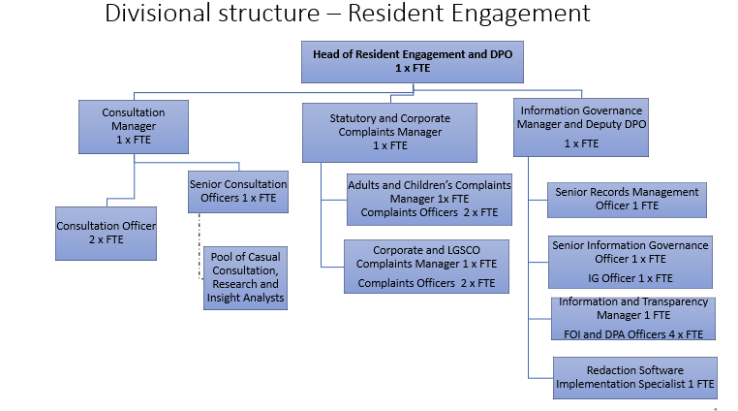

Person Specification

Job Title:  Redaction Software Implementation Specialist | Grade:  P04
Section:  Resident Engagement (Information Governance) | Directorate:  Chief Executive Group
Responsible to following manager:  Information and Transparency Manager | Responsible for following staff:  N/A
Post Number/s:  1 year FTC | Last review date: April 2024

Our Values
THINK BIGGER
EMBRACE DIFFERENCE
CONNECT BETTER
LEAD BY EXAMPLE
PUT PEOPLE FIRST

Our Values are embedded across the SSA and throughout all roles and responsibilities at all levels of the organisation. Please familiarise yourself with our values as they are an integral part of our recruitment and selection process.

Person Specification Requirements | Assessed by  A & I/ T/ C (see below for explanation)
Knowledge |  | Essential | Desirable | Assessed
In-depth understanding of Information Governance software, ideally including redaction software, techniques, and best practices. | A & I | x
Demonstrable knowledge of project management methodologies to lead and coordinate software implementation projects. | A & I | x
Comprehensive knowledge of UK GDPR requirements and updates, with the ability to interpret and implement guidelines within the redaction process. | A & I | x
Familiarity with information governance principles and their application in handling Subject Access Requests (SARs) under the Data Protection Act (DPA) 2018 and UK GDPR. | A & I | x
Good understanding of data protection standards and the ability to conduct regular audits to ensure compliance. | A & I |  | x
Experience |  | Essential | Desirable | Assessed
Proven experience in leading and coordinating the implementation of software solutions, preferably redaction or wider information governance software. | A & I | x
Previous involvement in configuring and maintaining user accounts, permissions, and access controls within software systems. | A & I |  | x
Successfully working collaboratively with colleagues from all levels of seniority to gather requirements and customise software to meet organisational needs in relation to redaction, information governance, data protection or information security. | A & I | x
Experience in providing advice and dealing with information compliance issues including co-ordinating and responding to information rights casework under the data protection legislation (including but not limited to SAR’s) and providing best practice advice and training to colleagues | A & I | x
Skills |  | Essential | Desirable | Assessed
Strong project management skills, with the ability to develop project plans, timelines, and milestones. | A & I | x
Strong IT skills, including familiarity with software configuration, processes, security, administration, user training and maintenance ideally with an information governance or redaction software. | A & I | x
Ability to confidently communicate and influence colleagues from all levels of seniority in order to help deliver an information governance improvement agenda and all key aspects of this role | A & I | x
Experience of working on own initiative with minimal supervision to create innovative solutions; recognising when to escalate matters through the management chain | A & I | x
Ability to organise and prioritise own workload, to work under pressure and meet deadlines | A & I | x
Analytical and problem-solving skills to refine redaction processes based on compliance requirements and business needs. | A & I |  | x
Experience of working effectively as part of a team | A & I |  | x
Qualifications
Relevant degree; relevant professional certification / qualification; or evidence of continued study in the areas of information governance, data protection, information technology and information security. | A & I, C |  | x
Certification in project management would be an advantage |  |  | x

A – Application form
I – Interview
T – Test
C - Certificate

