**Job Profile comprising Job Description and Person**

**Specification**

**Job Description**

|  |  |
| --- | --- |
| **Job Title:** | **Grade**: |
| FM Maintenance Officer  Fabric | PO6 |
| **Section:** | **Directorate:** |
| Property Services – Facilities  Management | Housing & Regeneration |
| **Responsible to following manager:** | **Responsible for following staff:**  Fabric Engineers x2 FTE’s |
| FM Maintenance Manager |
| **Post Number/s** | **Last review date:**  July 2022 |
| 1 |

**Working for the Richmond/Wandsworth Shared Staffing Arrangement**

This role is employed under the Shared Staffing Arrangement between Richmond and Wandsworth Councils. The overall purpose of the Shared Staffing Arrangement is to provide the highest quality of service at the lowest attainable cost.

Staff are expected to deliver high quality and responsive services wherever they are based, as well as having the ability to adapt to sometimes differing processes and expectations.

The Shared Staffing Arrangement aims to be at the forefront of innovation in local government and the organisation will invest in the development of its staff and ensure the opportunities for progression that only a large organisation can provide.

**Job Purpose**

Responsible for assisting the FM Maintenance Manager in the delivery of statutory compliant FM building services to all properties in Wandsworth and Richmond Council’s SSA estate.

Deputise for the FM Maintenance Manager during periods of annual leave, sickness, training absence.

1

Ensure that all Mandatory and Statutory Planned Preventative Maintenance and any associated remedial work is current and compliant.

Management of in-house engineers and external Contractors to ensure that planned, remedial and reactive maintenance is delivered within defined budget and to high standards whilst complying with all Health & Safety requirements.

**Specific Duties and Responsibilities**

1. Support the FM Maintenance Manager in ensuring the day to day management of statutory compliance, planned preventative and reactive maintenance across the Council’s estate.

2. Lead on the FM responsible buildings for Fire Risk Assessment and management of

Asbestos under the control of Asbestos regulations

3. Provide cover for the FM Maintenance Manager during times of training, sickness, and annual leave

4. Management of the directly employed FM Fabric engineers, integrated term contractors and supply chain partners. Includes the management of technically qualified staff including Building Fabric and specialist trades.

5. Support the FM Maintenance Manager to develop and implement planned preventative maintenance plans to CIBSE Guide M and SFG20 industry best practice.

6. Support the ongoing development of the Concerto CAFM system ensuring that assets are verified and maintained and operated in accordance with current legislation and to their optimum efficiency

7. Mentor and provide technical and professional support to the FM Fabric Team.

Effectively delegate to the Fabric Engineers and engender a ‘One Team’ Team approach to FM building Fabric and specialist trade Services delivery.

8. Undertake regular quality inspections to ensure high standards of workmanship

for both direct labour, and contractor’s work.

9. Identify skills and knowledge gaps to ensure directly and indirectly employed staff are trained, upskilled and competent to undertake their responsibilities safely and to a high standard.

10. Ensure the highest levels of Health and Safety are achieved across the Council’s estate and that both direct labour and external contractors are following the Councils policies and RAMS

2

11. Support the FM Maintenance Manager and Technical Services Manager to manage the FM maintenance budgets; ensuring that Planned Maintenance is effective in reducing Reactive Maintenance expenditure.

12. Support the FM Technical Services Manager, FM Maintenance Manager and FM Projects

Officer in the delivery of technically complex capital works projects.

13. Ensure that effective risk management controls systems are in place to ensure a high standard of service delivery.

14. Ensure compliance with all budget management and financial requirements through the effective monitoring of purchase orders issued and works undertaken to ensure clear audit trails and financial accountability in line with the Councils financial regulations.

15. Work in partnership with external contractors, supply chain partners and key stakeholders to ensure the effective delivery of high-quality Building Fabric service to meet and exceed customer expectations and develop strong collaborative working relationships.

16. Comply with Council’s Procurement policies.

17. Identify opportunities for innovation, continuous improvement which deliver cost efficiencies without compromising service levels.

18. Cultivate and maintain professional collaborative working relationships with customers, contractors, suppliers, customers, and key stakeholders

19. Use a range of communication methods, including presentations and progress reports to a range of internal and external stakeholders as required.

20. Ensure that good practice and continuous improvement from lessons learned is embedded into the delivery of all FM Building Fabric works and projects.

21. Other tasks as directed by the line manager that are commensurate with the role and within the skill set of the officer.

**Generic Duties and Responsibilities**

• To contribute to the continuous improvement of the services of the Boroughs of

Wandsworth and Richmond.

• To comply with relevant Codes of Practice, including the Code of Conduct and policies concerning data protection and health and safety.

3

• To adhere to security controls and requirements as mandated by the SSA’s policies, procedures, and local risk assessments to maintain confidentiality, integrity, availability and legal compliance of information and systems

• To promote equality, diversity, and inclusion, maintaining an awareness of the equality and diversity protocol/policy and working to create and maintain a safe, supportive, and welcoming environment where all people are treated with dignity and their identity and culture are valued and respected.

• To understand both Councils’ duties and responsibilities for safeguarding children, young people, and adults as they apply to the role within the council.

• The Shared Staffing Arrangement will keep its structures under continual review and as a result the post holder should expect to carry out any other reasonable duties within the overall function, commensurate with the level of the post.

**Additional Information**

To work within allocated budgets, and maintain stock lists and inventories of tools, materials, and equipment.

The Post Holder will be expected to adopt a ‘one team delivery’ approach using both

in-house and external resources to ensure a proactive and professional service delivery.

**Manages:**

Two in house fabric engineers plus several external hard services contractors

4

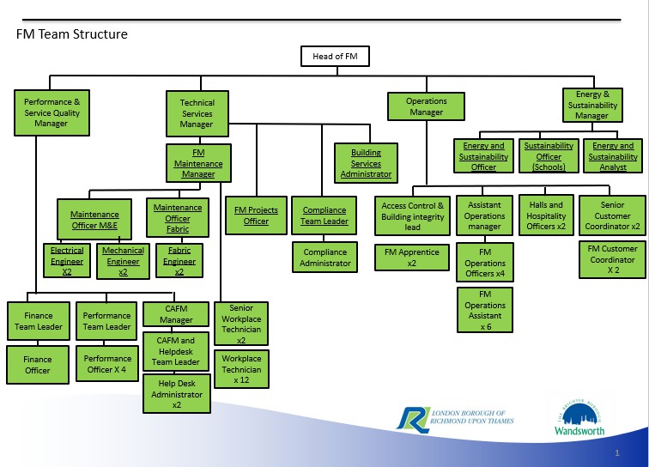

5

**Person Specification**

|  |  |
| --- | --- |
| **Job Title:** | **Grade**: |
| FM Maintenance Officer - Fabric Bias | PO6 |
| **Section:** | **Directorate:** |
| Property Services – Facilities Management | Housing & Regeneration |
| **Responsible to following manager:** | **Responsible for following staff:**  FM Engineers (fabric) x2 |
| FM Maintenance Manager |
| **Post Number/s** | **Last review date:** |
| 1 |

**Our Values and Behaviours**

The values and behaviours we seek from our staff draw on the high standards of the two boroughs, and we prize these qualities in particular:

• taking responsibility and being accountable for achieving the best possible outcomes – a ‘can do’ attitude to work

• continuously seeking better value for money and improved outcomes at lower cost

• focusing on residents and service users, and ensuring they receive the highest standards of service provision

• taking a team approach that values collaboration and partnership working.

**Being open.** This means we share our views openly, honestly and in a thoughtful way. We encourage new ideas and ways of doing things. We appreciate and listen to feedback from each other.

**Being supportive.** This means we drive the success of the organisation by making sure that our colleagues are successful. We encourage others and take account of the challenges they face. We help each other to do our jobs.

**Being positive.** Being positive and helpful means, we keep our goals in mind and look for ways to achieve them. We listen constructively and help others see opportunities and the way forward. We have a ‘can do’ attitude and are continuously looking for ways to help each other improve.

6

Sensitivity: Official

|  |  |
| --- | --- |
| **Requirements** | **Assessed by**  **A &** I**/ T/ C** |
| **Knowledge** | |
| Thorough knowledge of FM fabric building services, CIBSE Guide M and SFG20 standards | A & I |
| Extensive knowledge of the Council’s properties, assets, and  operations. Aligning asset management strategy to ensure optimum  resilience to the Council’s operations. | A & I |
| Knowledge of contractual matters and their impact upon the delivery  of an operational service | A & I |
| Good understanding of Fabric Services including but not limited to:  floors, roofs, walls, ceilings, windows/ frames, underground and overground drainage and doors/ shutters. | A & I |
| An understanding of building services systems | A & I |
| **Experience** | |
| Experience of managing an FM Building Fabric function in a multi-site local authority. | A & I |
| Managing, training, and mentoring technical operational staff | A & I |
| Managing complex technical projects | A & I |
| Change management in a dynamic, pressurised environment  Good working knowledge of Concerto CAFM system |  |
| **Skills** | |
| Technically competent | A & I |
| Team management | A & I |
| Excellent organisational skills, ability to quickly identify pragmatic  solutions to complex operational problems | A & I |
| Good verbal and written skills | A & I |
| Ability to organise and prioritise own workload to meet tight deadlines  whilst managing a variable workload and changing priorities.  Ability to plan and co-ordinate activities of self and Team in context of conflicting priorities  Ability to think creatively and develop new solutions to resolve problems.  Demonstrate an innovative approach with the ability to identify and deliver improvements. | A & I |
| **Qualifications** | |
| Vocational qualifications in relevant building services, property or FM subjects (e.g. CIBSE, RICS, BIFM) or significant relevant experience in FM Contract management.  Health and Safety Qualification e.g Nebosh, IOSH | A & I |

7

Sensitivity: Official

**A = Application form / CV I = Interview**

**T = Test**

**C = Certificate**

8

Sensitivity: Official