Job Profile comprising Job Description and Person Specification
Job Description

Job Title:  Caseworker – HIA | Grade:  PO1
Section:  HIA | Directorate:  Housing & Regeneration
Responsible to following manager:  Jasber Dodson | Responsible for following staff:  N/A
Post Number/s: | Last review date:  April 2016

Working for the Richmond/Wandsworth Shared Staffing Arrangement

This role is employed under the Shared Staffing Arrangement between Richmond and Wandsworth Councils. The overall purpose of the Shared Staffing Arrangement is to provide the highest quality of service at the lowest attainable cost.

Staff are expected to deliver high quality and responsive services wherever they are based, as well as having the ability to adapt to sometimes differing processes and expectations.

The Shared Staffing Arrangement aims to be at the forefront of innovation in local government and the organisation will invest in the development of its staff and ensure the opportunities for progression that only a large organisation can provide.

Job Purpose

To provide advice, support and assistance to clients requiring disabled adaptations to enable them to live independently in their homes. To determine grant eligibility by undertaking financial assessments and acting as an advocate on behalf of clients to access a range of statutory and voluntary services.

Specific Duties and Responsibilities

- To have an in-depth working knowledge of the HIA in order to assist, advise and support clients through the process and to promote the work of the team by working closely with a range of internal and external agencies.
- To work closely with clients who have a range of disabilities or who exhibit aggressive/challenging behaviour with empathy respect and understanding.
- To carry out home visits to complete grant application forms, carry out a holistic review using a checklist and undertake financial assessments to determine eligibility to grant assistance.
- To have a detailed working knowledge of the benefits system to assist clients in making applications and to appeal/challenge decisions where necessary in order to maximise their income.
- To have a working knowledge of services and support available for vulnerable clients. Make referrals where appropriate and look for alternative funding for clients to assist with adaptations, including making charitable applications on their behalf.
- To discuss proposed adaptations in detail with customers and support them through this process. To prepare and allocate cases to surveyors, monitor timescales and chase progress to meet the targets of the team. To support and maintain regular contact with clients.
- To correspond with a range of individuals and partner organisations and keep accurate and up to date IT records and produce and monitor information on a quarterly basis.
- To assist the team leader in regularly reviewing the work of the team, updating and changing policies and procedures as required.
- To work closely with Social Services departments, OT’s, external contractors, charitable, voluntary and statutory agencies and represent the team by attending meetings and forums as required.
- To work methodically in order to meet individual targets and be flexible and adaptable to meet the changing priorities and demands within the team.

Generic Duties and Responsibilities

- To contribute to the continuous improvement of the services of the Boroughs of Wandsworth and Richmond.

- To comply with relevant Codes of Practice, including the Code of Conduct and policies concerning data protection and health and safety.

- To adhere to security controls and requirements as mandated by the SSA’s policies, procedures and local risk assessments to maintain confidentiality, integrity, availability and legal compliance of information and systems

- To promote equality, diversity, and inclusion, maintaining an awareness of the equality and diversity protocol/policy and working to create and maintain a safe, supportive and welcoming environment where all people are treated with dignity and their identity and culture are valued and respected.

- To understand both Councils’ duties and responsibilities for safeguarding children, young people and adults as they apply to the role within the council.

- The Shared Staffing Arrangement will keep its structures under continual review and as a result the post holder should expect to carry out any other reasonable duties within the overall function, commensurate with the level of the post.
Additional Information
- To maximise benefits and access funding from charitable sources on behalf of individuals.
- To induct and train new members of staff on the work of the HIA.
- To undertake risk assessments and visit vulnerable clients in their homes.
- Must have use of motorised transport and be able to carry out visits and/or be able to carry out visits using public transport.

Team structure

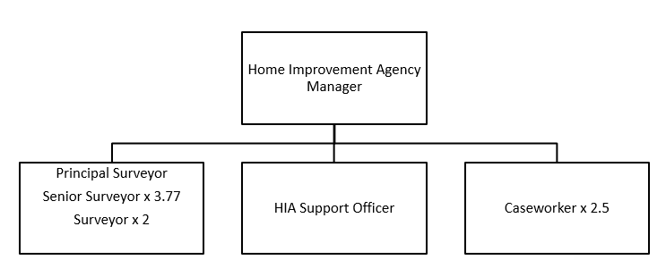
Person Specification

Job Title:  Caseworker HIA | Grade:  PO1
Section:  HIA | Directorate:  Housing & Regeneration
Responsible to:  HIA Manager | Responsible for:  N/A
Post Number/s: | Last Review Date:  April 2016

Our Values and Behaviours

The values and behaviours we seek from our staff draw on the high standards of the two boroughs, and we prize these qualities in particular:

Being open. This means we share our views openly, honestly and in a thoughtful way. We encourage new ideas and ways of doing things. We appreciate and listen to feedback from each other.

Being supportive. This means we drive the success of the organisation by making sure that our colleagues are successful. We encourage others and take account of the challenges they face. We help each other to do our jobs.

Being positive. Being positive and helpful means, we keep our goals in mind and look for ways to achieve them. We listen constructively and help others see opportunities and the way forward. We have a ‘can do’ attitude and are continuously looking for ways to help each other improve.

Person Specification Requirements | Assessed by  A  & I/ T/ C (see below for explanation)
Knowledge
HIA grant process | A/I
Housing and Welfare benefits legislation | A/I
Experience
Experience of working in a HIA or similar environment | A/I
Undertaking Complex financial assessments | A/I
Experience of working in a multi-agency environment.  Experience of undertaking risk assessments and working with clients who exhibit challenging behaviour.  Experience of working with clients who are vulnerable due to old age, physical disabilities and mental health. | A/I  A/I  A/I
Skills
Excellent level of oral and written communication skills. | A/T/I
Ability to collect and analyse complex data and information from a range of sources. | A/I
To build and maintain effective professional relationships with individuals across a range of organisations. | A/I
Qualifications

A – Application form / CV
I – Interview
T – Test
C - Certificate

