Job Profile comprising Job Description and Person Specification
Job Description

Job Title:  Mobile Cemetery Operative | Grade:  Scale 5
Section:  Contracts & Leisure (Parks) | Directorate:  Environment & Community Services
Responsible to following manager:  Cemetery Operations Supervisor | Responsible for following staff:  N/A
Post Number/s: | Last review date: April 2016

Working for the Richmond/Wandsworth Shared Staffing Arrangement

This role is employed under the Shared Staffing Arrangement between Richmond and Wandsworth Councils. The overall purpose of the Shared Staffing Arrangement is to provide the highest quality of service at the lowest attainable cost.

Staff are expected to deliver high quality and responsive services wherever they are based, as well as having the ability to adapt to sometimes differing processes and expectations.

The Shared Staffing Arrangement aims to be at the forefront of innovation in local government and the organisation will invest in the development of its staff and ensure the opportunities for progression that only a large organisation can provide.

Job Purpose
To ensure all graves are prepared correctly, in compliance with Health and Safety Legislation, Burial Law (the Local Authorities Cemeteries Order 1977), and the Institute of Cemetery and Crematorium Management (ICCM) Code of Safe Working Practice in Cemeteries.

Specific Duties and Responsibilities
- Responsible for the general grounds maintenance operations, which includes but is not limited to, mowing, planting, pruning, weeding, hedge cutting, turfing and path maintenance to improve the general appearance of the cemeteries.

- To assist customers with their enquiries, many of whom may be recently bereaved, ensuring the information is accurate and given in a sympathetic manner.

- To ensure the grounds and areas surrounding open graves are safe and accessible for mourners, visitors, and staff. To ensure all equipment is maintained and checked prior to use daily, being stored safely and correctly.

- To carry out exhumations under supervision, and to the instruction of the faculty / licence, as and when required, ensuring that all protective clothing is worn to prevent contamination.

- To be a visible presence to officers on site during funerals to oversee the burial to ensure no problems occur.

- To identify and report any breaches of site security, cemetery regulations or anti-social behaviour to the Supervisor.

- To drive necessary vehicles between and on sites to carry out the above duties, and to open and close the cemetery gates and toilets at the specified times, having checked all members of the public have left.

- To carry out policies and procedures which ensure that customer needs are met, and which reflect the Council’s core values. To promote the cemeteries service and ensure that a positive image is maintained to all our customers and external organisations.

- To undertake all relevant and compulsory Council provided training.

- To operate machinery to manufacturer’s instructions and appropriate to the post-holder’s driving qualifications and licence.

- To demonstrate an understanding of the importance of customer care in the provision of the Cemeteries Service.

- To ensure all facilities, fixtures and fittings in the cemetery are maintained, clean and serviceable.

- To be suitably dressed and presentable in line with a bereavement services environment.

Generic Duties and Responsibilities

- To contribute to the continuous improvement of the services of the Boroughs of Wandsworth and Richmond.

- To comply with relevant Codes of Practice, including the Code of Conduct and policies concerning data protection and health and safety.

- To adhere to security controls and requirements as mandated by the SSA’s policies, procedures and local risk assessments to maintain confidentiality, integrity, availability and legal compliance of information and systems

- To promote equality, diversity, and inclusion, maintaining an awareness of the equality and diversity protocol/policy and working to create and maintain a safe, supportive and welcoming environment where all people are treated with dignity and their identity and culture are valued and respected.

- To understand both Councils’ duties and responsibilities for safeguarding children, young people and adults as they apply to the role within the council.

- The profile is not intended to be an exhaustive list of the duties the post holder will carry out. Other reasonable duties commensurate with the level of the post, including supporting emergency and priority situations, will form part of the role.

Team structure
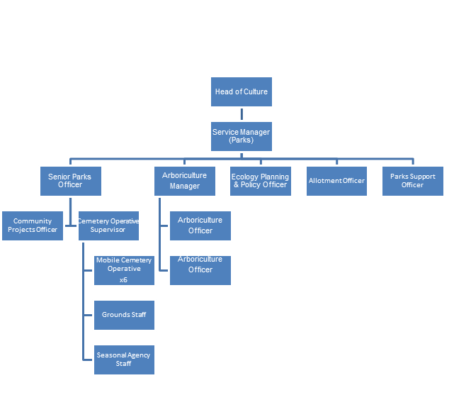
Person Specification

Job Title:  Mobile Cemetery Operative | Grade:  Scale 5
Section:  Contracts and Leisure (Parks) | Directorate:  Environment & Community Services
Responsible to:  Cemetery Operations Supervisor | Responsible for:  N/A
Post Number/s: | Last Review Date: April 2016

Our Values and Behaviours

The values and behaviours we seek from our staff draw on the high standards of the two boroughs, and we prize these qualities in particular:

Being open. This means we share our views openly, honestly and in a thoughtful way. We encourage new ideas and ways of doing things. We appreciate and listen to feedback from each other.

Being supportive. This means we drive the success of the organisation by making sure that our colleagues are successful. We encourage others and take account of the challenges they face. We help each other to do our jobs.

Being positive. Being positive and helpful means we keep our goals in mind and look for ways to achieve them. We listen constructively and help others see opportunities and the way forward. We have a ‘can do’ attitude and are continuously looking for ways to help each other improve.

Person Specification Requirements |  |  |  | Assessed by  A/I/T/C  (see below for explanation)
 | Knowledge | Essential | Desirable | Assessed
 | Proven experience of using digging machines, and safely excavating graves by hand, in accordance with ICCM Code of Safe Working Practice, and Health and Safety legislation, and the Local Authorities Cemeteries Order 1977 | x |  | A/I
 | Experience | Essential | Desirable | Assessed
 | Experience of prioritising workloads and taking appropriate action in an emergency. | X |  | A/I
 | Skills | Essential | Desirable | Assessed
 | Ability to understand, interpret and follow manufacturer’s instructions. | X |  | A/I
 | Qualifications | Essential | Desirable | Assessed
 | NVQ, or similar, in Horticulture |  | X | A/I
 | Qualified to the ICCM Code of Safe Working Practice in the provision of graves, with due regard to Health and Safety within the cemetery grounds. |  | X | A/I

A – Application form / CV
I – Interview
T – Test
C - Certificate

