Job Profile comprising Job Description and Person Specification
Job Description

Job Title:  Library Assistant | Grade:  SSA Scale 2 - 4
Section:  Culture and Leisure - Libraries | Directorate:  Environment and Community Services
Responsible to following manager:  Community Libraries Manager or  Sunday Manager | Responsible for following staff:  N/A
Post Number/s: Post Number/s:  RWE1367A; RWE1299; RWE1296; RWE1263; RWE1269; RWE1267; RWE1268; RWE1264; RWE1265; RWE1305; RWE1275A; RWE1275;  RWE1273; RWE1271; RWE1274;  RWE1271A; RWE1272; RWE1277A; RWE1272A; RWE1281; R3013480; R3013842; RWE1279; RWE1280;  R3015655; RWE1282; RWE1311; RWE1303B; RWE1274A; RWE1295; RWE1270; RWE1297; RWE1293; RWE1294; RWE1365; RWE1366; RWE3002; RWE1302; RWE1298A; RWE1300; RWE1303C; RWE1304; RWE1303A; RWE1306A; RWE1306; RWE1368; RWE1368A; RWE1377A; RWE1310; RWE1298; RWE1377; RWE1309B; RWE1307; RWE1308; RWE1309A; RWE1309; RWE1378; RWE1330; RWE1330F; RWE1324; RWE1325; RWE1326; RWE1336; RWE1323; RWE1346; RWE1329; RWE1332; RWE1331; RWE1327; RWE1333; RWE1331A; RWE1334; RWE1335; RWE1332A; RWE1338; R3013493; RWE1337; RWE1339; RWE1339B; RWE1277; R3012902  RWE1276; R3017093; R3013499; R3017094; R3017185; R3018657; R3017095; R3017121; R3015462; R3018658 | Last review date:  March 2024

Working for the Richmond & Wandsworth Better Service Partnership

This role is employed under the Richmond & Wandsworth Better Service Partnership. The overall purpose of Richmond & Wandsworth is to provide the highest quality of service at the lowest attainable cost.

Staff are expected to deliver high quality and responsive services wherever they are based, as well as having the ability to adapt to sometimes differing processes and expectations.

Richmond & Wandsworth Better Service Partnership aims to be at the forefront of innovation in local government and the organisation will invest in the development of its staff and ensure the opportunities for progression that only a large organisation can provide.

Job Purpose
Richmond upon Thames operates a high performing public library service which is very well regarded within the community. The role of a Library Assistant is to assist with the provision of this borough-wide service, ensuring a high level of effective customer service by carrying out a range of administrative duties to facilitate the libraries’ day to day operation.

Modern public libraries are busy and stimulating spaces, open to all members of the community and Library Assistants need to be resilient, confident and resourceful in order to deal with the often complex and challenging issues that occur as a result.

The majority of work carried out by Library Assistants involves frontline customer service, dealing with the issue, return, care and maintenance of resources, searching for information, dealing with enquiries, assisting with events and helping visitors to access the full range of services provided by the Borough’s libraries.

Specific Duties and Responsibilities
- To work on a customer service desk carrying out a range of duties using library management systems, including cash handling, answering customer enquiries and providing a high level of customer care.

- To assist library users to use the public access computers, e-resources, self-service kiosks, scanners, fiche readers and copiers.

- To deliver children’s activities including Tiny Teddies, storytimes, class visits, Chatterbooks reading groups and workshops.

- To deliver IT support to library users, including introductory IT sessions and awareness on a variety of topics, promote and demonstrate the use of eResources, provide basic IT troubleshooting and assist with information and data retrieval.

- To assist in delivering ICT awareness to customers and other staff with the aim of increasing digital and information literacy and promoting the use of online resources and collections.

- To carry out scheduled daily, weekly and monthly administration duties and routines in a timely and efficient manner, including weekly banking, email correspondence, recording room hire requests, booking search room appointments and issuing event tickets.

- To support new or inexperienced members of staff.

- To promote library services, resources, activities and events with the public.

- To assist with the maintenance and promotion of stock in a variety of formats, including shelving, shelf tidying, filing, storage and display of resources, ensuring efficient access to all materials.

- To assist team members with a variety of library promotional activities for adults and children such as author talks, reading festival events, workshops and community events and celebrations.

- To open and close buildings as required and to be responsible for the security of the building and its contents whilst open to the public.

- To help create and maintain a welcoming, comfortable and safe environment for both customer and colleagues by being proactive in safety awareness, reporting concerns to a senior member of staff and logging routine maintenance requests and incident reports in a timely and responsible manner.

- To welcome pre-arranged local community groups to the library, ensuring they have a positive experience and to work in partnership with local community and Friends Groups.

- To support, oversee and encourage library volunteers, ensuring they are treated as part of the library service team and recognising the value they bring to the service as a whole.

- To contribute to the active engagement of residents and stakeholders with the development of library services, to include assisting with surveys of library users and non-users and public consultation exercises.

Generic Duties and Responsibilities

- To contribute to the continuous improvement of the services of Richmond & Wandsworth Better Service Partnerships.

- To comply with relevant Codes of Practice, including the Code of Conduct and policies concerning data protection and health and safety.

- To adhere to security controls and requirements as mandated by Richmond and Wandsworth procedures and local risk assessments to maintain confidentiality, integrity, availability and legal compliance of information and systems

- To promote equality, diversity, and inclusion, maintaining an awareness of the equality and diversity protocol/policy and working to create and maintain a safe, supportive and welcoming environment where all people are treated with dignity and their identity and culture are valued and respected.

- To understand both Councils’ duties and responsibilities for safeguarding children, young people and adults as they apply to the roles within the Councils.

- The profile is not intended to be an exhaustive list of the duties the post holder will carry out. Other reasonable duties commensurate with the level of the post, including supporting emergency and priority situations, will form part of the role.
Additional Information
- Working in a library can be both mentally and physically demanding with long periods of standing, carrying and reshelving resources and ongoing interaction with the public.

- Library Assistants will be required to work flexibly to the exigencies of the organisation, including up to two evenings per week and two Saturdays in every four weekends.

- Library Assistants (Sunday) will be required to work on Sunday during the scheduled opening hours.

- The post-holder must be able to work in any library in the borough as directed and will be required to travel around the borough and attend occasional meetings outside the borough.

- The post-holder will be required to wear an ID lanyard when on public duty.

- The post holder must be suitable to work with children and vulnerable adults and will be required to undergo a Disclosure & Barring Service (DBS) check.

- The post-holder will be required to uphold service values and perform to the required standards of behaviour including timekeeping, personal appearance, customer care and taking responsibility.

Team structure

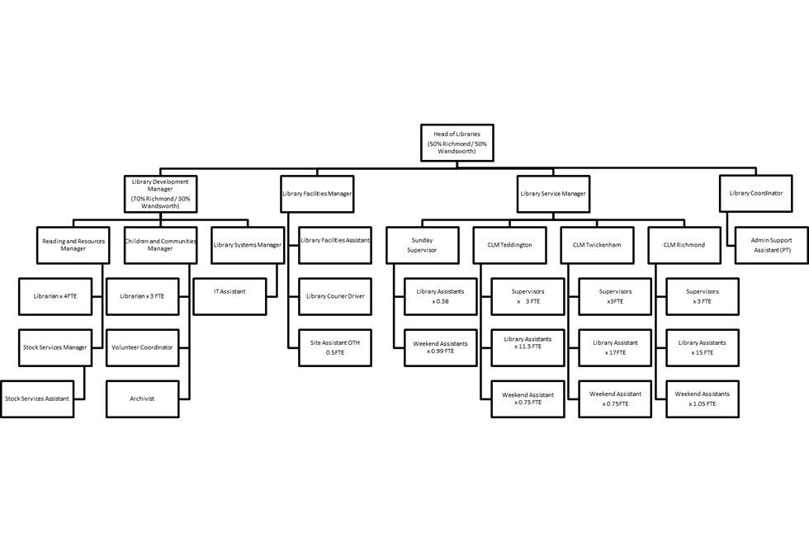
Person Specification

Job Title:  Library Assistant | Grade:  SSA Scale 2 - 4
Section:  Culture and Leisure - Libraries | Directorate:  Environment and Community Services
Responsible to following manager:  Community Libraries Manager or  Sunday Manager | Responsible for following staff:  N/A
Post Number/s:  RWE1367A; RWE1299; RWE1296; RWE1263; RWE1269; RWE1267; RWE1268; RWE1264; RWE1265; RWE1305; RWE1275A; RWE1275;  RWE1273; RWE1271; RWE1274;  RWE1271A; RWE1272; RWE1277A; RWE1272A; RWE1281; R3013480; R3013842; RWE1279; RWE1280;  R3015655; RWE1282; RWE1311; RWE1303B; RWE1274A; RWE1295; RWE1270; RWE1297; RWE1293; RWE1294; RWE1365; RWE1366; RWE3002; RWE1302; RWE1298A; RWE1300; RWE1303C; RWE1304; RWE1303A; RWE1306A; RWE1306; RWE1368; RWE1368A; RWE1377A; RWE1310; RWE1298; RWE1377; RWE1309B; RWE1307; RWE1308; RWE1309A; RWE1309; RWE1378; RWE1330; RWE1330F; RWE1324; RWE1325; RWE1326; RWE1336; RWE1323; RWE1346; RWE1329; RWE1332; RWE1331; RWE1327; RWE1333; RWE1331A; RWE1334; RWE1335; RWE1332A; RWE1338; R3013493; RWE1337; RWE1339; RWE1339B; RWE1277; R3012902  RWE1276; R3017093; R3013499; R3017094; R3017185; R3018657; R3017095; R3017121; R3015462; R3018658 | Last Review Date:  March 2024

Our Values
THINK BIGGER
EMBRACE DIFFERENCE
CONNECT BETTER
LEAD BY EXAMPLE
PUT PEOPLE FIRST

Our Values are embedded across Richmond & Wandsworth Better Service Partnership and throughout all roles and responsibilities at all levels of the organisation. Please familiarise yourself with our values as they are an integral part of our recruitment and selection process.

Person Specification Requirements |  |  |  | Assessed by  A/I/T/C  (see below for explanation)
 | Knowledge | Essential | Desirable | Assessed
 | Awareness of the range of resources and services currently delivered by libraries and the importance of libraries within communities. | ü |  | A/I
 | Practical knowledge of e-resources, social media and web applications. |  | ü | A/I
 | Practical knowledge of using a range of IT software and programmes. | ü |  | A/I/T
 | Strong oral, aural and written understanding of English. | ü |  | A/I/T

Experience | Essential | Desirable | Assessed
Experience of working with the public in a retail, academic or information service either in a paid or voluntary capacity. |  | ü | A/I
Experience of working in a pressurised environment where consistently high standards of service delivery are required |  | ü | A/I
Practical experience of using IT, social media and web applications and resolving basic IT issues | ü |  | A/I/T
Experience of answering queries and resolving problems. |  | ü | A/I
Experience of working as part of an effective team and supporting colleagues |  | ü | A/I
Skills | Essential | Desirable | Assessed
Ability to multi-task in a busy environment. | ü |  | A/I
Ability to work without close supervision, retain information and apply procedures as instructed. | ü |  | A/I
Ability and confidence to apply knowledge to assist customers with solving basic IT /PC troubleshooting. | ü |  | A/I
Ability and confidence to deal with challenging situations in a calm and effective manner. | ü |  | A/I
Ability to communicate clearly and with understanding when working with the public, including when using the telephone, email and social media. | ü |  | A/I/T
Qualifications | Essential | Desirable | Assessed
Maths and English to GCSE level or equivalent. |  | ü | A/C

A – Application form / CV
I – Interview
T – Test
C - Certificate

