Job Profile comprising Job Description and Person Specification
Job Description

Job Title:  Technical Services Manager | Grade:  MG2
Section:  Property Services - FM Building Services | Directorate:  Housing & Regeneration
Responsible to following manager:  Head of FM | Responsible for following staff:  x 27 FTEs
Post Number/s:  1 | Last review date:

Working for the Richmond/Wandsworth Shared Staffing Arrangement

This role is employed under the Shared Staffing Arrangement between Richmond and Wandsworth Councils. The overall purpose of the Shared Staffing Arrangement is to provide the highest quality of service at the lowest attainable cost.

Staff are expected to deliver high quality and responsive services wherever they are based, as well as having the ability to adapt to sometimes differing processes and expectations.

The Shared Staffing Arrangement aims to be at the forefront of innovation in local government and the organisation will invest in the development of its staff and ensure the opportunities for progression that only a large organisation can provide.

Job Purpose

Technical Services within FM covers Maintenance Services, Compliance and Project Delivery and this role manages these three key areas.

Responsible for managing the delivery of statutory compliant FM Maintenance across buildings in the Wandsworth and Richmond estate.

Manage the Compliance Team to ensure all FM responsible properties compliant with statutory and mandatory legislation.

Manage the delivery of all FM related projects and assist other directorates to make bids for capital revenue to fund relevant projects as required. Oversee projects from initiation to end of defects liability period, demonstrating innovation, quality, value for money and timely completion of works.

Manage all accommodation moves which include both small scale ‘churn’ moves and large decanting and reinstatements within budget and time scales to align with the Councils accommodation strategy and agile working.

To provide technical support to the energy and sustainability team to implement the Councils climate change and sustainability strategy through innovative energy and CO2 reduction which will include design reviews of consultant’s proposals.

Develop plans, strategies, and processes to move towards smart buildings with the focus on building user satisfaction, comfort and wellbeing.

Specific Duties and Responsibilities

- . Day to day management of statutory compliance, planned preventative, reactive maintenance and building compliance across the Council’s estate.
- Management of the directly employed FM Building Services Team and integrated contractors and supply chain partners. Including management of technically qualified staff including but not limited to mechanical and electrical trades.
- Determining cost effective maintenance plans that can be delivered within budget to industry best practice and ensure statutory compliance.
- Support the formulation and development of BMS strategy to ensure that assets are maintained and operated in accordance with current legislation and to their optimum efficiency to align with the accommodation strategy and new ways of working.
- Responsible for delivery of accommodation moves to support the accommodation strategy and agile working.
- Mentor and provide technical and professional support to the FM Building Services Team. Effectively delegate to the FM Building Services Supervisors and engender a ‘One Team’ Team approach between FM internal staff and contractors.
- Undertake regular quality inspections to audit and ensure high standards of workmanship.
- Identify skills and knowledge gaps to ensure directly and indirectly employed staff are trained, upskilled and competent to undertake their responsibilities safely and to a high standard.
- Ensure the highest levels of Health and Safety are achieved across the Council’s estate working with the Corporate Safety team to mitigate risk and respond to emergency situations.
- Coordinate and work closely with Design Service (the in-house consultancy Service) and the PMO (Project Management Office) in preparing Capital bids and delivering projects for all corporate assets.
- Support and assist the Design Service technical consultancy expertise in confirming the scope of remedial and project works.
- Champion and deliver all FM actions that are part of the Councils’ sustainability strategies and action plans including the decarbonisation of buildings and net zero carbon by 2030.
- Support and assist the Design Service to ensure the preparation of appropriate technical specifications for all projects works with particular focus on maintainability and alignment with the agreed FM strategy. Provide input into the prioritisation of capital and revenue expenditure to develop risk-based works programmes.
- Manage the FM Building Services budget ensuring compliance with all budget management, procurement, and financial requirements through the effective monitoring of purchase orders issued and works undertaken to ensure clear audit trails and financial accountability.
- Work in partnership with external contractors, supply chain partners and key stakeholders to ensure the effective delivery of high-quality building services management to meet and exceed customer expectations and develop strong collaborative working relationships.
- Oversee and implement building services aligned to and compliant with Council’s Procurement policies.
- Identify opportunities for innovation, continuous improvement which deliver cost efficiencies without compromising service levels.
- Cultivate and maintain professional collaborative working relationships with customers, service users, contractors, suppliers, consultants, and key stakeholders.
- Use a range of communication methods, including presentations and progress reports to a range of internal and external stakeholders as required.
- Ensure that good practice and continuous improvement from lessons learned is embedded into the delivery of all building services works and projects.
- Prepare reports and attend committee meetings as required to present business cases to Councillors.
- Review all hard services contracts, KPI’s and service level agreements to ensure they are fit for purpose and provide value for money. Write specifications for hard services contracts and evaluate tender returns as necessary to meet the service requirements of the Councils.

Generic Duties and Responsibilities

- To contribute to the continuous improvement of the services of the Boroughs of Wandsworth and Richmond.

- To comply with relevant Codes of Practice, including the Code of Conduct and policies concerning data protection and health and safety.

- To adhere to security controls and requirements as mandated by the SSA’s policies, procedures and local risk assessments to maintain confidentiality, integrity, availability and legal compliance of information and systems

- To promote equality, diversity, and inclusion, maintaining an awareness of the equality and diversity protocol/policy and working to create and maintain a safe, supportive and welcoming environment where all people are treated with dignity and their identity and culture are valued and respected.

- To understand both Councils’ duties and responsibilities for safeguarding children, young people and adults as they apply to the role within the council.

- The profile is not intended to be an exhaustive list of the duties the post holder will carry out. Other reasonable duties commensurate with the level of the post, including supporting emergency and priority situations, will form part of the role.
Additional Information
To review, monitor and manage the allocated “hard FM” capital and revenue budgets raising any potential issues with the HoFM and AD Property Service

Team structure
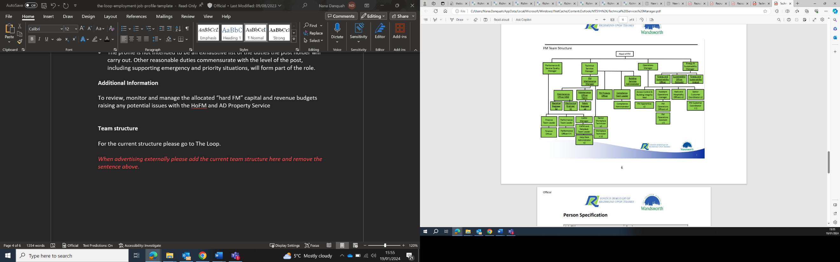

Person Specification

Job Title:  Technical Services Manager | Grade: MG2
Section: FM Building Services - Property Services | Directorate: Housing & Regeneration
Responsible to: Head of FM | Responsible for: X27 FTEs
Post Number/s: 1 | Last Review Date:

Our Values and Behaviours

The values and behaviours we seek from our staff draw on the high standards of the two boroughs, and we prize these qualities in particular:

Being open. This means we share our views openly, honestly and in a thoughtful way. We encourage new ideas and ways of doing things. We appreciate and listen to feedback from each other.

Being supportive. This means we drive the success of the organisation by making sure that our colleagues are successful. We encourage others and take account of the challenges they face. We help each other to do our jobs.

Being positive. Being positive and helpful means we keep our goals in mind and look for ways to achieve them. We listen constructively and help others see opportunities and the way forward. We have a ‘can do’ attitude and are continuously looking for ways to help each other improve.

Person Specification Requirements |  |  |  | Assessed by  A/I/T/C  (see below for explanation)
 | Knowledge | Essential | Desirable | Assessed
 | Thorough knowledge of mechanical and electrical building services, CIBSE Guide M and SFG20 standards | x |  | I/A
 | Extensive knowledge of the Council’s properties, assets, and operations. Aligning asset management strategy to ensure optimum resilience to the Council’s operations | x |  | I/A
 | Knowledge of contractual matters and their impact upon the delivery of an operational service | x |  | I/A
 | Design of building services systems | x |  | I/A
 | Building Regulations |  | x | I/A
 | All aspects of statutory compliance |  | x | I/A
 | Experience | Essential | Desirable | Assessed
 | Extensive experience of managing FM Building Services in a multi-site local authority. | x |  | I/A
 | Managing, training, and mentoring technical operational staff | x |  | I/A
 | Managing complex technical projects |  | X | I/A
 | Designing of building services systems |  | X
 | Project Management including RIBA stages | X
 | Dealing with Building Control, Planning & Listed Building Consents |  | X
 | Managing Compliance in a multi-site portfolio | X | X
 | Change management in a dynamic, pressurised environment |  | X
 | Skills | Essential | Desirable | Assessed
 | Technically competent in the delivery of hard FM services in a local government environment | X |  | I/A
 | Team management - managing a diverse range of staff including direct reports as well as external consultants and contractors | X |  | I/A
 | Excellent organisational skills, ability to quickly identify pragmatic solutions to complex operational problems | X |  | I/A
 | Ability to organise and prioritise own workload to meet tight deadlines whilst managing a variable workload and changing priorities. Ability to plan and co-ordinate activities of self and Team in context of conflicting priorities Ability to think creatively and develop new solutions to resolve problems. Demonstrate an innovative approach with the ability to identify and deliver improvements. | X |  | I/A
 | Good verbal and written skills |  | X
 | Qualifications | Essential | Desirable | Assessed
 | Degree in Building Services or approved equivalent | X |  | C

A – Application form / CV
I – Interview
T – Test
C - Certificate

