Job Profile comprising Job Description and Person Specification
Job Description

Job Title:  South London Careers Hub Project support Officer | Grade:  SO1
Section:  South London Partnership | Directorate:  Chief Executive
Responsible to following manager:  Strategic Lead – South London Careers Hub | Responsible for following staff:  n/a
Post Number/s:  1 | Last review date:  August 2023

Working for the South London Partnership under the Richmond/Wandsworth Shared Staffing Arrangement

The South London Partnership (SLP) is a cross-party five borough sub-regional partnership of Croydon, Kingston upon Thames, Merton, Richmond upon Thames and Sutton. It has a small dynamic core team working closely with politicians, chief executives, senior managers and subject specialists in each of the five boroughs, as well as London and local stakeholders and partners. Together they have forged an ambitious programme of work that is securing greater sub-regional collaboration and traction on areas including health, skills and innovation.

The SLP boroughs collaborate sub-regionally on things where they can secure more together than individually. The SLP team focuses on areas where collaboration leads to increased influence, increased powers and funding and better delivery of the services our residents need. All SLP posts are employed under the Richmond and Wandsworth Shared staffing Arrangement.

Job Purpose

Operating across the five boroughs of Croydon, Sutton, Merton, Kingston and Richmond, the South London Partnership delivers the Mayor’s Career Hub Project which has been set up to improve links between employers and schools and colleges, to create powerful, lasting connections.

As part of the ICP priorities fund the South London Partnership have been awarded funding to deliver a health and care work experience project which will support 100 work experience opportunities for secondary school students within South London.

The South London Careers Hub are looking for a Project Support Officer, to work with the Operational Lead and project staff to support delivery of the Health and Care work experience project. The project support officer will assist with the comms and marketing of the project, to connect schools and colleges to employers within the health and care sector.

The Project Support Officer will take responsibility for the administrative support of the project, working with the Operational Lead to ensure successful delivery of the project.

- Support the Strategic Lead, South London Careers Hub and other officers by taking forward project work on the implementation of plans relating to the Health and Care Work experience project.

- Manage projects, relating to the South London Careers Hub and support the South London Careers Hub with key strategic projects.

- Assist the Strategic Lead in establishing and maintaining project reporting in relation to the Health and Care work experience project and the South London Careers Hub.

- Ensure that robust project reports and data sets are produced, and an analysis is completed to track performance on the Health and Care work experience project.

Specific Duties and Responsibilities

- To co-ordinate and provide project support and delivery, relating to South London Careers Hub operations, including the Health and Care work experience project being delivered across the SLP boroughs.

- To work with the Strategic Lead to coordinate specific areas of work relating to the South London Careers Hub and the Health and Care work experience. Ensuring that robust administrative arrangements are in place to successfully deliver the South London Careers Hub programme of work.

- Ensure reporting mechanisms are in place, to successfully report on the performance of the South London Careers Hub programme, including the health and care work experience project and that risks and challenges are identified and work with the Operational Lead to mitigate these.

- Identify and represent the South London Careers Hub, including the health and care project at relevant pan London and local events, both virtually and in person, as appropriate.

- Work alongside the Operational Lead and School Engagement Lead to develop marketing and innovative communication methods to increase the awareness of the South London Careers Hub and the Health and Care Work Experience project.

- To provide support to commissioning and contract management of financial information for each of the above area projects.

Generic Duties and Responsibilities

- To contribute to the continuous improvement of the services of the SLP.

- To comply with relevant Codes of Practice, including the Code of Conduct and policies concerning data protection and health and safety.

- To adhere to security controls and requirements as mandated by the SSA’s policies, procedures and local risk assessments to maintain confidentiality, integrity, availability and legal compliance of information and systems.

- To promote equality, diversity, and inclusion, maintaining an awareness of the equality and diversity protocol/policy and working to create and maintain a safe, supportive and welcoming environment where all people are treated with dignity and their identity and culture are valued and respected.

- To understand both Councils’ duties and responsibilities for safeguarding children, young people and adults as they apply to the role within the council.

- The profile is not intended to be an exhaustive list of the duties the post holder will carry out. Other reasonable duties commensurate with the level of the post, including supporting emergency and priority situations, will form part of the role.

Team structure

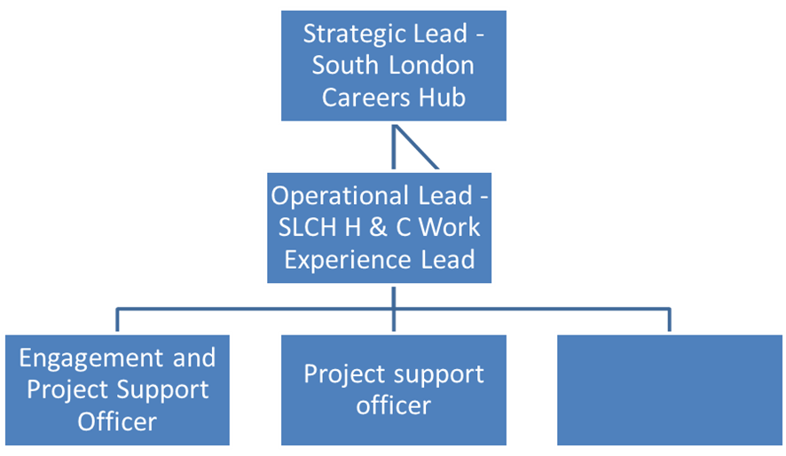
Person Specification

Job Title:  South London Careers Hub Project Support Officer | Grade:  SO1
Section:  South London Partnership | Directorate:  Chief Executive
Responsible to following manager:  Strategic Lead – South London Careers Hub | Responsible for following staff:  n/a
Post Number/s:  TBC | Last review date:  March 2024

Our Values
THINK BIGGER
EMBRACE DIFFERENCE
CONNECT BETTER
LEAD BY EXAMPLE
PUT PEOPLE FIRST

Our Values are embedded across the SSA and throughout all roles and responsibilities at all levels of the organisation. Please familiarise yourself with our values as they are an integral part of our recruitment and selection process.

Person Specification Requirements |  |  |  | Assessed by  A/I/T/C  (see below for explanation)
 | Knowledge | Essential | Desirable | Assessed
 | A good understanding of the employment and skills opportunities and challenges across the South London Partnership areas | E |  | A, I
 | Knowledge of social media, online communication platforms and digital marketing techniques to reach a range of different organisations and people | E |  | A, I
 | Experience | Essential | Desirable | Assessed
 | Experience of appropriately managing budgets and commissioning activity | E |  | A, I
 | Experience of working on projects with KPIs and performance outcomes | E |  | A, I
 | Skills | Essential | Desirable | Assessed
 | Ability to collect, collate, summarise and analyse information and draft high quality reports for management | E |  | A, I
 | Competence in the use of Microsoft Word, Excel. Basic knowledge of and ability to use standard IT packages (Microsoft Office and Outlook) | E |  | A, I
 | Ability to develop, maintain and review a range of different project management reporting, including information technology systems | E |  | A, I
 | Ability to organise and prioritise own workload, to work under pressure and meet deadlines | E |  | A, I
 | Good oral, written and presentation skills to provide clear and concise messages in a variety of internal and external contexts | E |  | A, I
 | Qualifications | Essential | Desirable | Assessed
 | Degree level or equivalent |  | D | A

A – Application form / CV
I – Interview
T – Test
C - Certificate

