**Job Profile comprising Job Description and Person Specification**

**Job Description**

|  |  |
| --- | --- |
| **Job Title:**  Planning Apprentice  (Chartered Town Planning Apprenticeship) | **Grade**:  Scale 5 – Scale 6 |
| **Section:**  Planning and Transport Strategy Division  Spatial and Transport Planning Service | **Directorate:**  Environment and Community Services |
| **Responsible to following manager:**  Spatial Planning and Design Team Manager | **Responsible for following staff:**  N/A |
| **Post Numbers:** TBC (4 posts) | **Last review date:** March 2022 |

**Working for the Richmond/Wandsworth Shared Staffing Arrangement**

This role is employed under the Shared Staffing Arrangement between Richmond and Wandsworth Councils. The overall purpose of the Shared Staffing Arrangement is to provide the highest quality of service at the lowest attainable cost.

Staff are expected to deliver high quality and responsive services wherever they are based, as well as having the ability to adapt to sometimes differing processes and expectations.

The Shared Staffing Arrangement aims to be at the forefront of innovation in local government and the organisation will invest in the development of its staff and ensure the opportunities for progression that only a large organisation can provide.

**Job Purpose:**

The Planning Apprentice role offers a career development opportunity with practical experience in the workplace and professional recognition as a Chartered Town Planner (MRTPI) through completion of a RTPI accredited degree.

The postholder will work within the Planning and Transport Strategy Division to support the work of teams across Richmond and Wandsworth, to include: Strategic Developments, Development Management, Enforcement, Spatial Planning and Design and Planning Obligations.

Duties include assisting with the delivery of a high quality, robust and transparent Planning Service, ensuring decision making within tight timeframes. To ensure that the Planning and Transport Strategy Division is recognised as delivering an excellent planning service for all of our customers. Under supervision, the Planning Apprentice will assist in an area of planning policy, conservation or urban design, contributing to Local Plan development and providing comprehensive and detailed advice on planning applications, pre-application advice requests and correspondence to agreed and identifiable timescales. With support, the Planning Apprentice will assist with processing a caseload of planning applications, pre-application advice requests and correspondence to agreed and identifiable time scales. The Planning Apprentice will assist in delivering a well-reasoned officer recommendation which delivers a successful planning outcome. To undertake appropriate training to help them acquire the skills and knowledge so that they can become self-reliant in dealing with technical and people issues.

**Specific Duties and Responsibilities:**

1. To support the delivery of a range of planning projects and casework across the Shared Staffing Arrangement’s Planning Service, under the supervision of a Senior or Principal Planner, and under the management of a Team Manager, with support from a work-based mentor during the completion of the apprenticeship.
2. To assist in the processing of planning applications, including in the provision of pre-application advice, and in dealing with other types of applications, ensuring that work is carried out effectively and efficiently to identifiable deadlines.
3. To assist in the investigation of alleged breaches of planning control and negotiate with those responsible for the breaches to achieve a satisfactory resolution, where possible.
4. To assist and contribute to the development of the Richmond and Wandsworth Local Plans and other planning guidance, including on work relating to policy formulation and supporting evidence base.
5. To assist in the collection and analysis of data and information for the Planning Service, including monitoring progress on developments and the implementation of the boroughs’ development plan documents and policies.
6. To assist in providing planning policy, urban design and heritage conservation comments to straightforward applications and pre-applications.
7. To assist on work to assess, engage and set out clear and robust policy formulation including taking responsibility for accurate and well-written officer reports.
8. To assist on the preparation of evidence for written representation planning and enforcement appeals as well as for Examinations in Public on Local Plans.
9. To assist in the preparation and review of Conservation Area Appraisals and Management Strategies / Plans as required to ensure an up-to-date guidance is available for all conservation areas.
10. To assist in administering, governing and managing Richmond’s and Wandsworth’s Design Review Panels and in the preparation and making of Tree Preservation Orders as required.
11. To assist in Section 106 planning obligations and Community Infrastructure Levy work as required, and in the consideration of infrastructure provision to deliver the key priorities set out in the Local Plans and to mitigate the impact of development.
12. To ensure that all planning work is undertaken with due regard to national, regional and local planning policy and guidance.
13. To take part in and actively contribute to the preparation for public consultation and engagement exercises relating to the development and review of local planning policies and other guidance, including on conservation and urban design related matters as well as any associated research and information, in line with the appropriate statutory and legislative requirements.
14. To develop and maintain an up-to-date knowledge of national and regional planning policy and guidance, including relevant legislation.
15. To assist in meeting service-wide and corporate performance indicators, targets and customer service standards for the full range of your own workload.
16. To undertake administrative tasks relating to the work of the Planning Service as required.

**CRITERIA FOR PROGRESSION TO SCALE 6**

1. To be able to work both independently and as an effective team member, undertaking a variety of work using own initiative, including management of own workload and adapting to changing priorities and deadlines.
2. To carry out straightforward planning related work under minimal supervision.
3. To research, prepare and write up reports or briefing papers for colleagues and managers under minimal supervision.
4. To contribute to slightly more complex planning projects, casework or appeals, including assessing, negotiating and setting out recommendations on straightforward planning applications.
5. To assist on projects or components of larger projects in order to deliver organisational objectives as well as enabling agreed changes in planning practice and processes to take place, taking personal responsibility for detailed project management as required.
6. To assist in identifying issues and proposing improvements within the context of current and future service requirements in order to continually deliver high quality, customer focused planning services to managers and our full range of customers.
7. On occasion, to present your own recommendations to internal and public meetings on basic planning issues in a clear and concise manner.

**Generic Duties and Responsibilities**

* To contribute to the continuous improvement of the services of the Boroughs of Wandsworth and Richmond.
* To comply with relevant Codes of Practice, including the Code of Conduct and policies concerning data protection and health and safety.
* To adhere to security controls and requirements as mandated by the SSA’s policies, procedures and local risk assessments to maintain confidentiality, integrity, availability and legal compliance of information and systems
* To promote equality, diversity, and inclusion, maintaining an awareness of the equality and diversity protocol/policy and working to create and maintain a safe, supportive and welcoming environment where all people are treated with dignity and their identity and culture are valued and respected.
* To understand both Councils’ duties and responsibilities for safeguarding children, young people and adults as they apply to the role within the council.
* The Shared Staffing Arrangement will keep its structures under continual review and as a result the post holder should expect to carry out any other reasonable duties within the overall function, commensurate with the level of the post.

**Additional Information**

The Planning Apprentice is based within the wider Planning Service (Planning and Transport Strategy division). Throughout the apprenticeship, the postholder will rotate within the Planning Service; this will include roles in:

* + Spatial Planning and Design, whereby this includes planning policy, information and monitoring, urban design and heritage conservation;
  + Development Management, including in Enforcement and Strategic Development

Community Infrastructure Levy and Section 106 planning obligations..

**Structure**

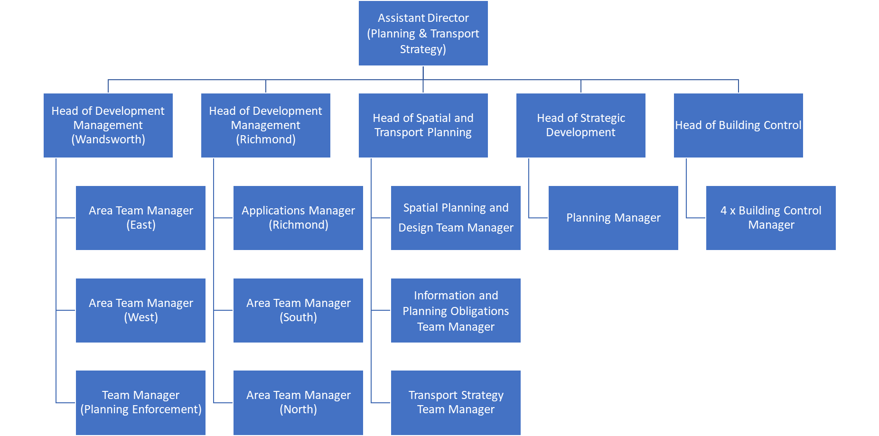

**Person Specification**

|  |  |
| --- | --- |
| **Job Title:**  Planning Apprentice  (Chartered Town Planning Apprenticeship) | **Grade**:  Scale 5 – Scale 6 |
| **Section:**  Planning and Transport Strategy Division  Spatial and Transport Planning Service | **Directorate:**  Environment and Community Services |
| **Responsible to following manager:**  Spatial Planning and Design Team Manager | **Responsible for following staff:**  N/A |
| **Post Numbers:** TBC (4 posts) | **Last review date:** March 2022 |

**Our Values and Behaviours**

The values and behaviours we seek from our staff draw on the high standards of the two boroughs, and we prize these qualities in particular:

**Being open.** This means we share our views openly, honestly and in a thoughtful way. We encourage new ideas and ways of doing things. We appreciate and listen to feedback from each other.

**Being supportive.** This means we drive the success of the organisation by making sure that our colleagues are successful. We encourage others and take account of the challenges they face. We help each other to do our jobs.

**Being positive.** Being positive and helpful means we keep our goals in mind and look for ways to achieve them. We listen constructively and help others see opportunities and the way forward. We have a ‘can do’ attitude and are continuously looking for ways to help each other improve.

|  |  |
| --- | --- |
| **Person Specification Requirements** | **Assessed by**  **A**  **&**  **I/ T/ C (see below for explanation)** |
| **Knowledge** | |
| Understanding of local government, the communities it serves and the services it provides. Experience of working in a political environment is desirable but not essential. | A/I/T |
| **Experience** | |
| Experience of conducting research and using evidence to draw conclusions. | A/I |
| Experience of working collaboratively to achieve an agreed outcome. | A/I |
| Experience of using IT systems, including word-processing, database and spreadsheet software (mainly Microsoft Office applications) and use of Internet and virtual platforms such as Teams, Zoom and/or Skype. | A/I |
| **Skills** | |
| Ability to express yourself confidently and to present arguments clearly and succinctly both on paper and in person. | A/I |
| Good report writing skills and the ability to prepare briefing notes and other documents or research reports in clear and concise English. | A/I |
| Ability to use effective means of communication in order to resolve problems. | A/I |
| Ability to analyse and interpret information and data. | A/I |
| Ability to work on designated projects with supervision. | A/I |
| Ability to organise own workload, prioritise tasks to meet deadlines and respond flexibly to frequently changing needs and priorities. | A/I |
| Ability to use initiative to identify solutions to problem solving and demonstrating a 'can-do' attitude to improvements in service delivery. | A/I |
| Ability to assist in identifying need for change and to introduce and manage changes designed to improve service delivery. | A/I |
| A good understanding of own strengths and development needs together with a commitment to self-improvement. | A/I |
| Ability to demonstrate an understanding and commitment to equality, diversity and inclusion. | A/I |
| **Qualifications** | |
| Educated to degree level, minimum 2:2 attainment. An undergraduate degree in planning or related disciplines within the built environment is desirable but not essential. | A/C |

**A – Application form**

**I – Interview**

**T – Test**

**C – Certificate**