Job Profile comprising Job Description and Person Specification
Job Description

Job Title:  Policy and Review Officer | Grade:  SO1 – PO3
Section:  Policy, Performance, Analysis and Communications | Directorate:  Chief Executive’s Group
Responsible to following manager:  Policy and Review Manager | Responsible for following staff:  n/a
Post Number/s:  RWC0140 | Last Review Date:  February 2025

Working for the Richmond & Wandsworth Better Service Partnership
We’re Richmond & Wandsworth Better Service Partnership, the shared public service team for Richmond and Wandsworth Councils. Like any local authority, our role is to deliver the agenda of our elected members on behalf of the people who live and work in our part of the world. We deliver key services to our communities including social care, public health, children’s services, housing and regeneration and environmental and community services.
Our joint workforce creates efficiency and resilience by bringing more creativity to the way we work, more objectivity and adaptability too, helping us deliver better services for all our residents.
We’re here to help our communities thrive in a changing world, and to be there for the people who need us most we believe we need to keep adapting. That’s why, at Richmond & Wandsworth Better Service Partnership, you’ll be at the forefront of innovation in local government, and we’ll invest in you and offer you opportunities to grow in a way only our unique organisation can.

Job Purpose

The post holders will support the Head of Policy and Strategy in the delivery of key policy analysis, policy development and service review, and project oversight. The post will assist in the development of corporate policy initiatives.

Specific Duties and Responsibilities

- Support the adoption of innovative practice within the Better Service Partnership, helping us to become an organisation which thinks bigger, by maintaining an awareness of best and emerging practice from across local government and the wider public sector.
- Be curious about opportunities to work differently and challenge the status quo, and suggest options for how Richmond and Wandsworth could pilot new ways of working.
- Support the sharing of knowledge and best practice within and across the organisation, including facilitating an internal innovation network.
- Support a positive and proactive approach to delivering the Councils' external facing equality work, reflecting the Councils’ commitment to embracing difference and putting our residents first. This includes working with services to develop strong Equality Impact Needs Assessments and equality comments on service proposals, and identifying opportunities to make Richmond and Wandsworth fairer boroughs for everyone who lives or works here.
- Engage with strategic partners and relevant London and national networks, contributing to an organisation which connects better and maximises opportunities to share learning and work collaboratively.
- Support the delivery of cross-cutting and high profile projects, helping each council's administration to deliver their goals for the boroughs.
- Contribute to the production of each Council's corporate plan, including supporting services with their service planning, work with departments to collect regular updates on its delivery, and produce reports for senior officers and members on progress.
- Maintain an awareness of relevant policy and legislation changes, and produce at pace high-quality, detailed written and verbal briefings for senior officers and councillors on request and contribute to the production of routine briefings.
- Produce well-written, concise reports on a range of topics, synthesising quantitative and qualitative data with other research, for review by management and/or Council committee.

Progression criteria

SO2
- Responds directly to enquiries from Members, including Executive Members.
- Provides support to senior staff on more complex or cross cutting reviews / projects.

PO1
- Takes a collaborative role in complex policy developments / service reviews / projects
- Works on his/her own initiative to identify and develop options for emerging and best practice.

PO2
- Develops areas of policy / review / project expertise and ensures that the service head and manager is kept fully abreast of changes or developments and practice is amended to reflect these.

PO3
- Able to carrying out the full range of duties with minimal supervision and demonstrating initiative.
- Able to deputise for the Team Manager as needed.
- Prepares and updates project plans
- Takes a leading role in service review and drafts Board, Committee / cabinet papers with relevant recommendations.
- Builds good relationships with senior managers, directors and partners and is able to advise them confidently on issues of policy.

Generic Duties and Responsibilities

To contribute to the continuous improvement of the services of Richmond & Wandsworth Better Service Partnerships.

· To comply with relevant Codes of Practice, including the Code of Conduct and policies concerning data protection, handling complaints and health and safety.

· To adhere to security controls and requirements as mandated by Richmond and Wandsworth procedures and local risk assessments to maintain confidentiality, integrity, availability and legal compliance of information and systems

· To promote equality, diversity, and inclusion, maintaining an awareness of the equality and diversity protocol/policy and working to create and maintain a safe, supportive and welcoming environment where all people are treated with dignity and their identity and culture are valued and respected.

· To understand both Councils’ duties and responsibilities for safeguarding children, young people and adults as they apply to the roles within the Councils.

· The profile is not intended to be an exhaustive list of the duties the post holder will carry out. Other reasonable duties commensurate with the level of the post, including supporting emergency and priority situations, will form part of the role.

Additional Information
- Maybe required to attend meetings such as committees, working groups and Partnerships outside of the normal working day.

- Post holder will be expected to work flexibly across two locations (Wandsworth Town Hall and Richmond Civic Centre), and be in the office at least two days each week.

Current team structure
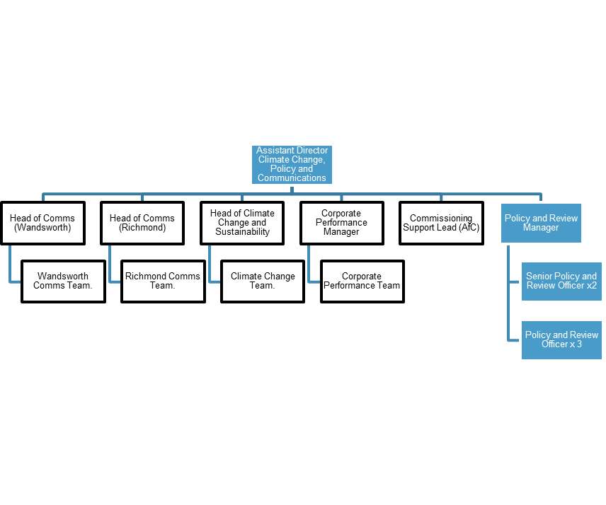

Person Spec

Job Title:  Policy and Review Officer | Grade:  SO1 – PO3
Section:  Policy, Performance and Analysis | Directorate:  Chief Executive’s Group
Responsible to following manager:  Head of Policy and Strategy | Responsible for following staff:  n/a
Post Number/s: | Last Review Date:  February 2025

Our Values and Behaviours

As an organisation, we have recently defined a new set of values which set out the standards we expect from our staff. Our new values have been built to capture the best of how we work together and to inspire the change we need to create in our culture.
As an organisation that’s come together to represent a broader part of London, our values reaffirm our commitment to embrace difference, to connect even more deeply and widely and to show compassion and empathy for the people we work with and the people we serve.
Our values are:
- Think Bigger
- Embrace Difference
- Connect Better
- Lead by Example
- Put people first

Person Specification Requirements |  |  | Assessed by  A/I/T/C  (see below for explanation)
Knowledge | Essential | Desirable | Assessed
Knowledge of policy development as it relates to local government and the delivery of services. |  |  | A/I/T
Knowledge of equality, diversity, and inclusion delivery as it relates to the public sector. |  |  | A/I
Experience | Essential | Desirable | Assessed
Some experience of operating in a political environment, recognising and handling in an appropriate manner, confidential or sensitive information and distinguishing between political and non-political activities. |  |  | A/I
Experience of successfully managing own workload in an environment where deadlines and priorities frequently change and are often conflicting. |  |  | A/I/T
Skills | Essential | Desirable | Assessed
Ability to communicate effectively and authoritatively both orally and in writing to a variety of audiences. |  |  | A/I
Ability to accurately analyse numeric, financial, textual and performance data and present your findings in a clear and coherent way to a variety of audiences. |  |  | A/I/T
Ability to exercise tact and diplomacy, and first rate interpersonal, negotiation and influencing skills. |  |  | A/I
Ability to work at pace, juggle priorities, and assimilate new information quickly, and ability to make sound decision and judgements under pressure. |  |  | A/I/T
Ability to deliver projects, and create a positive, collaborative environment. |  |  | A/I
Demonstrable ability to use IT applications to manage and manipulate information and of researching information (textual, financial and statistical) from a variety of sources to present it in a consistent, concise and understandable way, both orally and in writing. |  |  | A/I/T
Experience of managing a varied workload and responding flexibly to changing needs and priorities, often with limited supervision. |  |  | A/I
Ability to work both independently and as an effective team member, using initiative and adapting to changing priorities and deadlines in a calm, well-organised and methodical manner. |  |  | A/I
Qualifications | Essential | Desirable | Assessed
Educated to degree level in a related subject area or equivalent through work experience. |  |  | A/C

A – Application form / CV
I – Interview
T – Test
C - Certificate

