Job Profile comprising Job Description and Person Specification
Job Description

Job Title:  Community Safety Anti-Social Behaviour Officer | Grade:  SO2
Section:  Community Safety Service | Directorate:  Chief Executives Group
Responsible to following manager:  Neighbourhoods and Criminal Justice Manager | Responsible for following staff:  N/A
Post Number/s:  POS001087, POS001088, POS001089 | Last review date: July 2025

Working for the Richmond & Wandsworth Better Service Partnership

We’re Richmond & Wandsworth Better Service Partnership, the shared public service team for Richmond and Wandsworth Councils. Like any local authority, our role is to deliver the agenda of our elected members on behalf of the people who live and work in our part of the world. We deliver key services to our communities including social care, public health, children’s services, housing and regeneration and environmental and community services.

Our joint workforce creates efficiency and resilience by bringing more creativity to the way we work, more objectivity and adaptability too, helping us deliver better services for all our residents.

We’re here to help our communities thrive in a changing world, and to be there for the people who need us most we believe we need to keep adapting. That’s why, at Richmond & Wandsworth Better Service Partnership, you’ll be at the forefront of innovation in local government, and we’ll invest in you and offer you opportunities to grow in a way only our unique organisation can.

Job Purpose

This is a really exciting opening within the Richmond and Wandsworth Safer and Stronger Communities Team. The Service works on key themes including Serious Violence, Offender Management, Anti-Social Behaviour, Neighbourhoods, Domestic Abuse, Prevent and Radicalisation and Hate Crime.

The post-holder will be responsible for strengthening the response to tackling anti-social behaviour and crime in Wandsworth borough, supported by the Neighbourhoods and Criminal Justice Manager.

The Anti-Social Behaviour Officer will work specifically in the North Battersea area, and key functions will be coordination of a community safety approach to ASB and crime, knowledge of enforcement tools and powers, experience of managing a caseload, project management within this key theme of work and the collaboration and connectiveness of various statutory and community organisations.

You need to be able to work well under pressure, prioritise your own workload, communicate openly and honestly with your colleagues and especially your manager on capacity.

We hope the candidate can bring their own initiative and any innovative ideas to this exciting new role.

Specific Duties and Responsibilities
To support the Neighbourhood and Criminal Justice Manager around the proactive management of anti-social behaviour and other crime issues in North Battersea area. This will include Battersea Park, Falconbrook, Shaftesbury and Queenstown and St Marys wards.
Some of the duties will include:
- To act as the Anti-social Behaviour (ASB) Officer for the Community Safety Service, assisting with the development of policies, processes, and procedures, to ensure that the Council is meeting its obligations under Section 17 of the Crime and Disorder Act 1998, The ASB Crime and Policing Act 2014 and the Crime and Policing Bill 2025.
- Work in partnership with key agencies to ensure a cohesive and effective response to anti-social behaviour across the North Battersea wards.
- To support residents experiencing ASB, to provide early intervention, enforcement, and prevention work to reduce ASB in the community.
- Lead on the delivery of a North Battersea Community Safety Action plans. Meet with relevant partners to ensure actions are on track for completion by the end of the financial year. Review and revise actions as needed with support of the Neighbourhoods and Criminal Justice Manager.
- Developing strong relationships with both internal, and external stakeholders to ensure delivery
- Building strong links with the local community, and voluntary organisations
- Organising/attending community events, and representing the Safer and Stronger Communities Team at these events
- Working to the deliverables within the Community Safety strategy, particularly around how the partnership responds to crime and ASB
- Lead on wider community safety initiatives across North Battersea area. Act as the single point of contact for project leads and provide support around complex cases and issues. Ensure timely and detailed quarterly reports are back to the funder.
- Develop and have input into problem solving plans in hotspot locations. Work in partnership with Community Safety Officers and input into multi-agency task and finish groups with the aim of delivering actions to respond to issues and concerns of anti-social behaviour.
- Act as the link officer for the Community Multi-Agency Risk Assessment Conference Meeting (CMARAC) and Anti-Social Case Review to support victims and tackle problem individuals in the North Battersea area.
- Work with officers across the service on area-based problem solving where an offender has been identified as causing crime, anti-social behaviour or serious violence. Look at the Victim, Offender, Location, Time (VOLT) model.
- To have a robust knowledge on information sharing between statutory partners.
- Develop and share best practice with our neighbouring boroughs and boroughs across London.
- Supporting delivery of Neighbourhood Watch and Wandsworth Business Against Crime across the North Battersea area.
- Carrying out ad-hoc Neighbourhoods tasks as directed by line manager

Generic Duties and Responsibilities

- To contribute to the continuous improvement of the services of Richmond & Wandsworth Better Service Partnerships.

- To comply with relevant Codes of Practice, including the Code of Conduct and policies concerning data protection and health and safety.

- To adhere to security controls and requirements as mandated by Richmond and Wandsworth procedures and local risk assessments to maintain confidentiality, integrity, availability and legal compliance of information and systems

- To promote equality, diversity, and inclusion, maintaining an awareness of the equality and diversity protocol/policy and working to create and maintain a safe, supportive and welcoming environment where all people are treated with dignity and their identity and culture are valued and respected.

- To understand both Councils’ duties and responsibilities for safeguarding children, young people and adults as they apply to the roles within the Councils.

- The profile is not intended to be an exhaustive list of the duties the post holder will carry out. Other reasonable duties commensurate with the level of the post, including supporting emergency and priority situations, will form part of the role.
Additional Information
- Post holder will be expected to work flexibly across two locations (Wandsworth Town Hall and Richmond Civic Centre), in addition to spending time on site in North Battersea. Due to the nature of the post, the majority of time will be spent in the office, or on site. Where necessary and authorised the post-holder can work from home.

Team structure

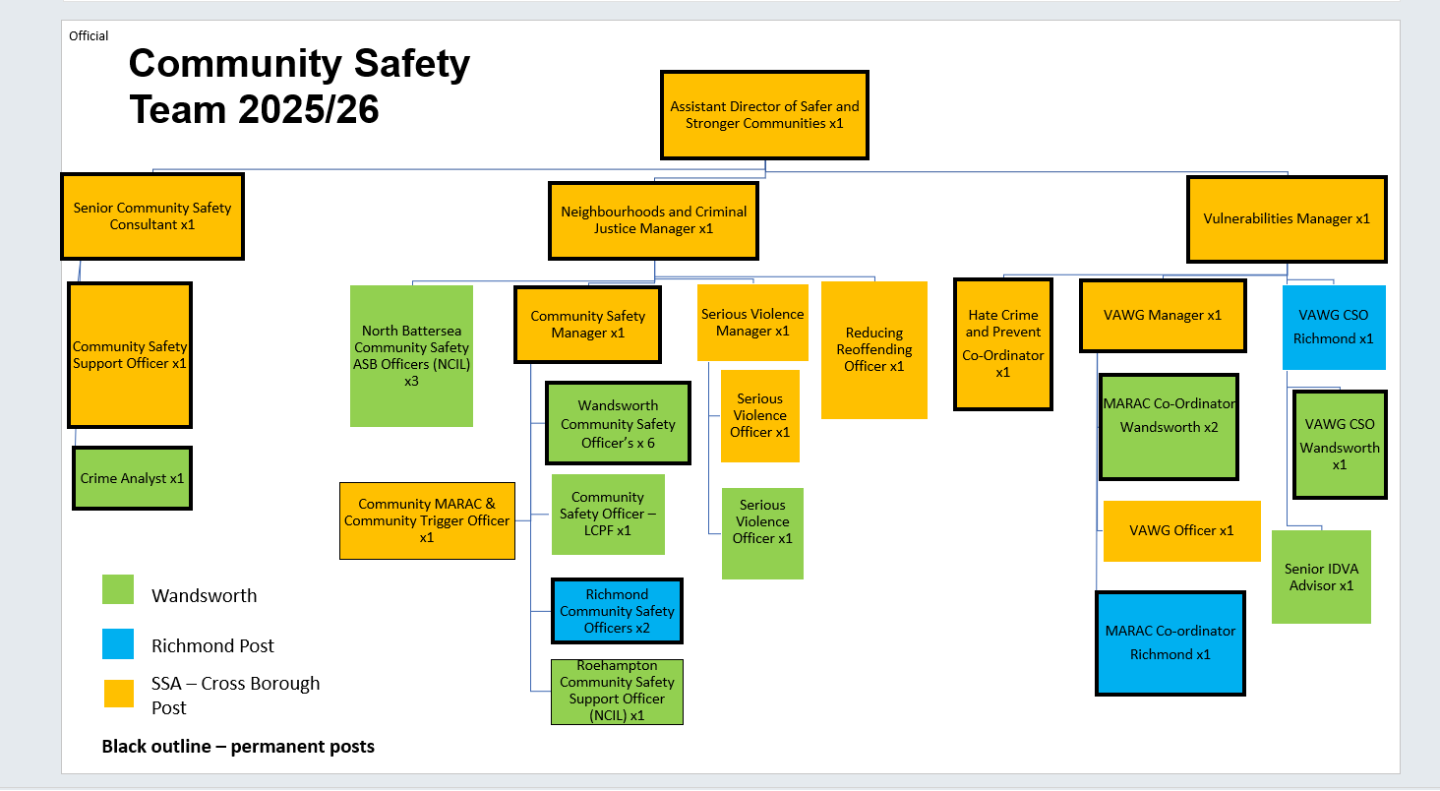

Person Specification

Community Safety Anti-Social Behaviour Officer | Grade:  SO2
Section:  Community Safety Service | Directorate:  Chief Executives Group
Responsible to following manager:  Neighbourhoods and Criminal Justice Manager | Responsible for following staff:  N/A
Post Number/s:  POS001087, POS001088, POS001089 | Last review date: July 2025

Our Values
THINK BIGGER
EMBRACE DIFFERENCE
CONNECT BETTER
LEAD BY EXAMPLE
PUT PEOPLE FIRST

Our Values are embedded across Richmond & Wandsworth Better Service Partnership and throughout all roles and responsibilities at all levels of the organisation. Please familiarise yourself with our values as they are an integral part of our recruitment and selection process.

Person Specification Requirements |  |  |  | Assessed by  A/I/T/C  (see below for explanation)
 | Knowledge | Essential | Desirable | Assessed
 | An understanding of key legislation around crime anti-social behaviour, policy and procedure relating to anti-social behaviour and Wandsworth’s Community Safety priorities. | x |  | A I
 | An understanding of how agencies work in partnership in these defined fields. | x |  | A I
 | An understanding of multi-agency panels, information sharing and data protection | x |  | A I
 | An understanding and experience of community led engagement in improving the perception levels of public confidence in, localities, and through what means this can be achieved. |  | X | A I
 | Knowledge of factors which contribute to anti-social behaviour. |  | x | A I
 | Experience | Essential | Desirable | Assessed
 | Experience of issuing or delivering ASB enforcement orders or powers. | x |  | A I
 | Experience of partnership or multi-agency work in order to achieve a shared objective. | x |  | A I
 | Experience of engaging and building trusted and effective relationships with other service providers, voluntary and community sector groups, and statutory partner agencies. | X |  | A I
 | Experience of project management relevant to the role especially experience leading a problem solving plan. Ensuring that objectives are clearly outlined, communicated and reported on as needed. | x |  | A I
 | Experience of minute taking and writing actions. | x |  | A I
 | Experience in time management and being able to prioritise your tasks. | x |  | A I
 | Skills | Essential | Desirable | Assessed
 | Excellent time management and organisational skills with the ability to meet set deadlines | x |  | A I
 | Exceptional interpersonal skills, able to build strong relationships quickly. | x |  | A I
 | Experience in using Microsoft Office applications (Word, Excel, Outlook, Sharepoint) and the ability to work with case management systems | x |  | A I
 | Ability to communicate effectively both orally and in writing with a range of colleagues and partner agencies | x |  | A I
 | Experience in minute taking, administration and report writing | x |  | A I
 | Ability to build effective relationships both internally and externally, including colleagues and partner agencies. | x |  | A I
 | Qualifications | Essential | Desirable | Assessed
 | N/A

A – Application form / CV
I – Interview
T – Test
C - Certificate

