Job Profile comprising Job Description and Person Specification
Job Description

Job Title:  Assistant Project Officer – Business Development | Grade:  SC6 – SO2
Section:  Design Service, Property Services | Directorate:  Housing & Regeneration
Responsible to following manager:  Business Development Officer | Responsible for following staff:
Post Number/s: | Last review date:

Working for the Richmond/ Wandsworth Shared Staffing Arrangement
This role is employed under the Shared Staffing Arrangement between Richmond and Wandsworth Councils. The overall purpose of the Shared Staffing Arrangement is to provide the highest quality of service at the lowest attainable cost.
Staff are expected to deliver high quality and responsive services wherever they are based, as well as having the ability to adapt to sometimes differing processes and expectations.
The Shared Staffing Arrangement aims to be at the forefront innovation in local government and the organisation will invest in your development and ensure the opportunities for progression that only a large organisation can provide.

Job Purpose:

Assist in undertaking the service delivery of:

- Business development and technical support.
- Financial, resources, fee income and budget management.

NB the level of responsibility and complexity of projects or role is determined by the position on the linked grade

Specific Duties and Responsibilities:

- To ensure that the services for both Councils are dealt with on an equitable basis to deliver the standards required for each, as agreed annually by the Executives of both Councils.

- To provide supervision as required to assigned staff and take responsibility for the allocation and checking of work by staff

- To advise and support managers on relevant matters affecting the service

- To contribute as required to performance review and improvement measures on an ongoing basis, helping to ensure that a customer focus is embedded within the function and innovative and creative solutions are evaluated to securing the highest quality and value for money function.

- To contribute as required to change programmes within the service

- To act as deputy for the Business Development Officer as required.

- To support the strategic development, evaluation and implementation of the service’ multi-faceted business plan to ensure the service meet its development deadlines and standards.

  - Marketing and Identity
  - Business Opportunities
  - Quality control and Document management systems
  - Conformity and compliance
  - CPD Strategy
  - Client relations/ reporting
  - IT Strategy
  - Transitional strategy
  - Office environment

You will be expected to assist in identifying statutory and legal requirements and policy implications, define roles and responsibilities for each, develop simple system/ process maps for the implementation of each strategy, monitor/review regularly and update as required.

- To assist in project managing the programme for the above ensuring the smooth development and implementation of each strategy

- To assist in evaluating existing working practises and develop complex databases, spread sheets and templates and streamline processes. This includes assisting in administering the project management software.

- To assist in producing statistical, monitoring and performance reports for the Business Managers when required.

- Provide support to the Design Service in relation to the project management/fee income software.

- Assist in updating staff regularly on the development and progress of all strategies in quarterly workshops.

- To ensure the confidentiality of business and information is maintained at all times.

Progression to S01

- Liaise with clients and contractors in matters of the project development and construction.

- Undertakes research, prepares reports and makes recommendations on works of a simplistic nature.

- Evaluate statutory regulations as applicable and reports to Team Leader as required.

- Contributes to meetings on behalf of the Team.

Progression to SO2

- Assist in cost and budgetary control.

- Work with minimum supervision on more complex tasks.

- Assists in the supervision of Consultants.

- Gives detailed advice to the Team Leader when appropriate.

Generic Duties and Responsibilities

- To contribute to the continuous improvement of the services of the Borough’s of Wandsworth and Richmond.

- To comply with relevant Codes of Practice, including the Code of Conduct, and policies concerning data protection and health and safety.

- To adhere to security controls and requirements as mandated by the SSA’s policies, procedures and local risk assessments to maintain confidentiality, integrity, availability and legal compliance of information and systems.

- To promote equality, diversity, and inclusion, maintaining an awareness of the equality and diversity protocol/policy and work to create and maintain a safe, supportive and welcoming environment where all people are treated with dignity and their identity and culture are valued and respected.

- To understand both Council’s duties and responsibilities for safeguarding children, young people and adults as they apply to your role within the council.

- The Shared Staffing Arrangement will keep its structures under continual review and as a result the post holder should expect to carry out any other reasonable duties within the overall function, commensurate with the level of the post.
Additional Information
- Delivery of Design Team Trading account of £3 million per annum.

- Management of capital schemes in excess of £100m

- Management of Revenue projects up to £2 million per annum

- Attendance at evening meetings required

- The Design Services operates as an internal consultancy and therefore wins work in competition. Critical to its success is achieving high-levels of customer care and customer satisfaction.

Team Structure

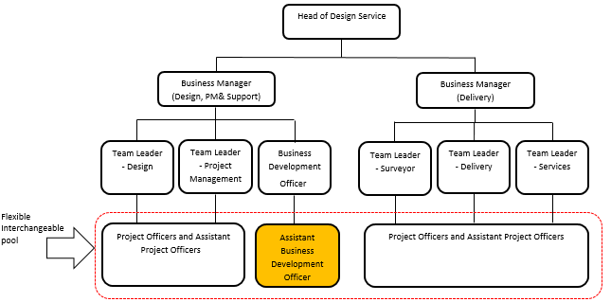

Person Specification

Job Title:  Assistant Project Officer – Business Development | Grade:  SC6 – SO2
Section:  Design Service, Property Services | Directorate:  Housing & Regeneration
Responsible to following manager:  Team Leader – Business Development | Responsible for following staff:
Post Number/s: | Last review date:

Our Values and Behaviours
The values and behaviours we seek from our staff draw on the high standards of the two boroughs, and we prize these qualities in particular –

- taking responsibility and being accountable for achieving the best possible outcomes – a ‘can do’ attitude to work
- continuously seeking better value for money and improved outcomes at lower cost
- focussing on residents and service users, and ensuring they receive the highest standards of service provision.
- taking a team approach that values collaboration and partnership working

Person Specification Requirements | Assessed by  A  & I/ T/ C (see below for explanation)
A – Application form I – Interview T – Test C – Certificate (original evidence)
Knowledge
Thorough understanding of the Data Protection. | I
Knowledge of information security principles and application of policies. | I
Experience
Experience of using Word and Excel at advanced level and Powerpoint at intermediate level (or other similar software packages). | I
Skills
Ability to effectively lead, manage and motivate a collaborative working team ethos. | I
Communication skills: ability to communicate clearly, diplomatically and effectively with a diverse range of people; demonstrate a high standard of grammatical English. | I
Ability to develop positive effective working relationships with a range of people. | I
Ability to effectively train and counsel officers and senior management to attain their compliance. | I
Ability to pay attention to detail and a produce work of a consistently high standard. | I
Ability to organise individual and team workloads and adapt to meet constantly changing demands and deadlines and to work under pressure. | I
Numerical and statistical skills: able to carry out mathematical calculations, check the accuracy of data and interpret and present it simply and concisely. | I
Analytical skills: be adept at evaluating information, understanding processes, detecting problems and identifying and applying effective solutions. | I
Qualifications
N/A

These values and behaviours will be developed further as the SSA becomes established.

