Job Profile comprising Job Description and Person Specification
Job Description

Job Title:  Homelessness Prevention and Solutions Officer | Grade:  PO1
Section:  Housing Assessment and Adaptations | Directorate:  Housing and Regeneration
Responsible to following manager:  Deputy Manager: Homelessness Prevention and Solutions | Responsible for following staff:  N/A
Post Number/s: | Last review date:  January 2024

Working for the Richmond & Wandsworth Better Service Partnership

This role is employed under the Richmond & Wandsworth Better Service Partnership. The overall purpose of Richmond & Wandsworth is to provide the highest quality of service at the lowest attainable cost.

Staff are expected to deliver high quality and responsive services wherever they are based, as well as having the ability to adapt to sometimes differing processes and expectations.

Richmond & Wandsworth Better Service Partnership aims to be at the forefront of innovation in local government and the organisation will invest in the development of its staff and ensure the opportunities for progression that only a large organisation can provide.

Job Purpose

Job Purpose

Specific Duties and Responsibilities

- To provide comprehensive advice and information covering a range of housing issues including:
- Housing and tenancy rights in both the private and social rented sectors, and for homeowners
- Financial advice including welfare benefits, maximising income, and tackling debt
- Housing options including private rented sector, housing register, specialist accommodation such as refuges, low-cost home ownership
- The Council’s statutory duties under the homelessness legislation

- To triage homeless applications made to the Council, assessing priority for further action, and making appointments for an assessment of housing need as necessary.

- To assess the housing and wider needs of individuals and households, including by interview in and across both boroughs, to find tailored solutions to meet their immediate and longer-term housing needs in a manner which is considerate and empathetic towards the applicant’s perspective.

- To understand the resources that are available in Richmond for meeting the needs of applicants who may require specialist housing and/or support services, making referrals where appropriate

- Work with Social Services, the Police, Probation and other agencies across the Richmond and Wandsworth boroughs to enable applicants to access the services needed to meet their support needs and enable them to live independently.

- To take the Homelessness Preventions and Solutions Service out into the community by providing housing surgeries in the Job Centre Plus, Children’s Centres and other locations as required.

- To visit applicants in their homes in and across both boroughs to mediate and negotiate with the homeowner/housing provider to prevent homelessness wherever possible

- To use the Homelessness Prevention budget to provide innovative and cost-effective housing solutions to prevent and relieve homelessness.

- To assist with the continual improvement of the housing service across the SSA through:

- the development of the information available for customers including personal housing plans, advice leaflets, website content
- Identifying opportunities to work with new service providers
- Involvement in projects or new initiatives to prevent or relieve homelessness
- referrals to support agencies, helping to address problems with benefit claims and advising on options to maximise income, reviewing progress against Personal Housing Plans, making home visits where necessary/beneficial.

- To work with Managers and Deputy Managers in the Housing Assessment Service to ensure that appropriate service cover is always provided across both housing offices and to promote and develop the highest customer care standards. To assist with the training and induction of newly appointed colleagues as directed.

- To participate in the operation of a duty rota system for reception interviews and telephones in and across both boroughs. and to ensure its effective operation. To be available to interview customers as directed across both boroughs.

- To work as part of a team with colleagues, sharing knowledge and experience to ensure continuous development and improvement across the SSA.

- To represent the Housing Assessment Service at internal and external meetings and case conferences across the SSA as relevant to the role.

- To undertake homelessness investigations, create and seek the applicant’s agreement to a bespoke and scenario specific personal housing plan, to issue statutory decisions and to discharge/end duties in accordance with the homelessness legislation

- To manage a caseload of applicants who have approached the Council for assistance under the Homelessness Reduction Act, keeping your caseload under review and taking timely action to minimise the time in temporary accommodation and ensuring the Council’s duties are met within statutory timescales.

- To undertake comprehensive casework such as negotiating with landlords/family members, completing casenotes

Generic Duties and Responsibilities

- To contribute to the continuous improvement of the services of Richmond & Wandsworth Better Service Partnerships.

- To comply with relevant Codes of Practice, including the Code of Conduct and policies concerning data protection, handling complaints and health and safety.

- To adhere to security controls and requirements as mandated by Richmond and Wandsworth procedures and local risk assessments to maintain confidentiality, integrity, availability and legal compliance of information and systems

- To promote equality, diversity, and inclusion, maintaining an awareness of the equality and diversity protocol/policy and working to create and maintain a safe, supportive and welcoming environment where all people are treated with dignity and their identity and culture are valued and respected.

- To understand both Councils’ duties and responsibilities for safeguarding children, young people and adults as they apply to the roles within the Councils.

- The profile is not intended to be an exhaustive list of the duties the post holder will carry out. Other reasonable duties commensurate with the level of the post, including supporting emergency and priority situations, will form part of the role.
Additional Information
- To regularly travel, within and/or outside of the boroughs in the performance of the duties of the post.
- Attends large scale emergency responses as directed e.g. urgent temporary rehousing scenarios and/or other civil contingencies.

Team structure

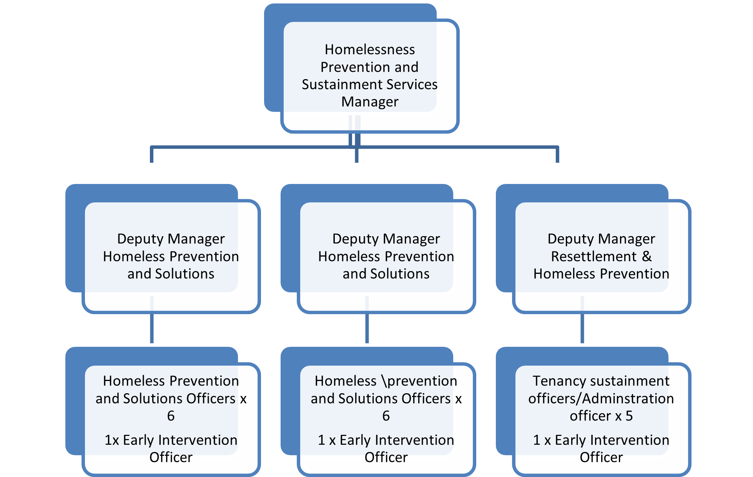
Person Specification

Job Title: | Grade:
Section: | Directorate:
Responsible to: | Responsible for:
Post Number/s: | Last Review Date:

Our Values
THINK BIGGER
EMBRACE DIFFERENCE
CONNECT BETTER
LEAD BY EXAMPLE
PUT PEOPLE FIRST

Our Values are embedded across Richmond & Wandsworth Better Service Partnership and throughout all roles and responsibilities at all levels of the organisation. Please familiarise yourself with our values as they are an integral part of our recruitment and selection process.

Person Specification Requirements |  |  |  | Assessed by  A/I/T/C  (see below for explanation)
 | Knowledge | Essential | Desirable | Assessed
 | Knowledge of the causes of homelessness and the impact of homelessness on households | X |  | A/I
 | Knowledge of the current Code of Guidance for Local Authorities, relevant Housing Act legislation, including security if tenure and private tenants’ rights, and caselaw |  | X | A/I
 | Knowledge of services, benefits and support available to applicants experiencing housing problems |  | X
 | Experience | Essential | Desirable | Assessed
 | Experience of working in a busy public facing service, eg customer services, housing or lettings service | X |  | A/I
 | Experience of carrying out interviews, investigations, negotiations | X |  | A/I
 | Experience of working with people who are homeless or in other stressful situations |  | X | A/I
 | Experience of working successfully to performance targets and deadlines | X |  | A/I
 | Experience of effective record keeping, including electronically held information | X |  | A/I
 | Skills | Essential | Desirable | Assessed
 | To be able to have honest conversations with customers about their housing options and support their decision making while managing expectations | X |  | A/I
 | Excellent interpersonal skills including active listening and negotiating | X |  | A/I
 | Excellent communication skills including the ability to write detailed case notes and technical letters | X |  | A/I
 | Ability to work unsupervised, prioritise workloads  and achieve targets and deadlines | X |  | A/I
 | Ability to gather information and interpret complex issues eg. Case law and legislation quickly, to think creatively about problems and identify solutions |  | X | A/I
 | Ability to work effectively with people from diverse backgrounds and circumstances. |  | X | A/I
 | Qualifications | Essential | Desirable | Assessed
 | Minimum of 2 A Level grade C and above or equivalent | X |  | C

A – Application form / CV
I – Interview
T – Test
C - Certificate

