Job Profile comprising Job Description and Person Specification
Job Description

Job Title:  Community MARAC and Community Trigger Support Officer | Grade:  SO1 - £30,954  Fixed term until 31 March 2025
Section:  Community Safety Service | Directorate:  Chief Executives Group
Responsible to following manager:  Community Safety Team Manager | Responsible for following staff:  N/A
Post Number/s:  1 | Last review date: N/A

Working for the Richmond/Wandsworth Shared Staffing Arrangement

This role is employed under the Shared Staffing Arrangement between Richmond and Wandsworth Councils. The overall purpose of the Shared Staffing Arrangement is to provide the highest quality of service at the lowest attainable cost.

Staff are expected to deliver high quality and responsive services wherever they are based, as well as having the ability to adapt to sometimes differing processes and expectations.

The Shared Staffing Arrangement aims to be at the forefront of innovation in local government and the organisation will invest in the development of its staff and ensure the opportunities for progression that only a large organisation can provide.

Job Purpose

This is a really exciting opening within the Richmond and Wandsworth Community Safety Service.

The Service works on key themes including Serious Violence, Offender Management, Anti-Social Behaviour, Neighbourhoods, Domestic Abuse, Prevent and Radicalisation and Hate Crime.

The post-holder will be required to support the work of the Community Safety Service as we seek to reduce crime and anti-social behaviour.

This will predominately involve working across the Neighbourhoods and Anti-Social Behaviour theme across Richmond and Wandsworth boroughs.

Key functions will be coordination and project management within this key theme of work. Tasks will include, leading on the coordination of Community Multi-Agency Risk Assessment Conference (CMARAC) meetings and Community Triggers (ASB Case Reviews); promoting the CMARAC purpose to increase referrals, receiving new referrals, reviewing risk and risk assessments, putting together agendas, minute taking, recording actions, and assigning to agencies, following up on actions through the case management system and collating information for reports.

You will also be responsible for rolling out the ECINS case management system across the service as the project lead. Knowledge of ECINS is therefore desirable but not essential as you will be trained. With the aim to increase partnership engagement and shared contribution to the system.

We are looking for someone who is hard-working and has good experience in co-ordinating and administrating, you need to be able to work well under pressure, prioritise your own workload, communicate openly and honestly with your colleagues and your manager on capacity.

We hope the candidate can bring their own initiative and any innovative ideas on how we make the working processes smarter to ensure the safety of residents.

Specific Duties and Responsibilities
Some of the co-ordination and project duties will include:
- Coordinate and facilitate monthly panel meetings and keep a record of key decisions made.

- Maintain and keep a record of the cohort using ECINS.

- To be the service lead for the ECINS project, rolling out the case management system to all the high risk panels through organised project management.

- Coordinate all external agencies to engage with CMARAC and Community Trigger panels including briefing and training as required

- To liaise with applicants of the Community Trigger process as the single point of contact if directed by management.

- To receive information from various partners and be able to collate this into a chronological document and report setting our clearly all the key information.

- To follow up with agencies after a panel or board meetings for an update and to log it on the ECINS case management system.

- To send out the monthly (or as required) case list via email for various meetings.

- Attend other relevant meetings to contribute to the intelligence and discussion regarding cases such as high-risk professional meetings.

- To ensure the governance for various panels and boards across the service are updated annually and shared with partners, including delivery plans information sharing agreements and terms of reference.

- To build strong relationships with organisations at both operational and Senior Management level

- To have a robust knowledge on information sharing between statutory partners.

- To support the officers within the team on coordination of problem area profiles which have been identified as causing crime and anti-social behaviour within the borough.

- To administer any emails that come into the CMARAC, Community Trigger and shared inboxes.

- Being efficient at the use of Microsoft Office including Excel spreadsheets to log information.

Generic Duties and Responsibilities

- To contribute to the continuous improvement of the services of the Boroughs of Wandsworth and Richmond.

- To comply with relevant Codes of Practice, including the Code of Conduct and policies concerning data protection and health and safety.

- To adhere to security controls and requirements as mandated by the SSA’s policies, procedures and local risk assessments to maintain confidentiality, integrity, availability and legal compliance of information and systems

- To understand and comply with GDPRS requirements laid out within the Data Protection Act 1998 and any procedures adopted by Richmond and Wandsworth Councils.

- To promote equality, diversity, and inclusion, maintaining an awareness of the equality and diversity protocol/policy and working to create and maintain a safe, supportive and welcoming environment where all people are treated with dignity and their identity and culture are valued and respected.

- To understand both Councils’ duties and responsibilities for safeguarding children, young people and adults as they apply to the role within the council.

- The Shared Staffing Arrangement will keep its structures under continual review and as a result the post holder should expect to carry out any other reasonable duties within the overall function, commensurate with the level of the post.
Additional Information
- This is a position working across Richmond and Wandsworth Councils.

- Post holder will be expected to work flexibly across two locations (Wandsworth Town Hall and Richmond Civic Centre) and where necessary and authorised will be required to work from home.

- This is a fixed term contract paid by the Mayor’s Office for Policing and Crime until 31 March 2025.

- This role will be subject to enhanced DBS.

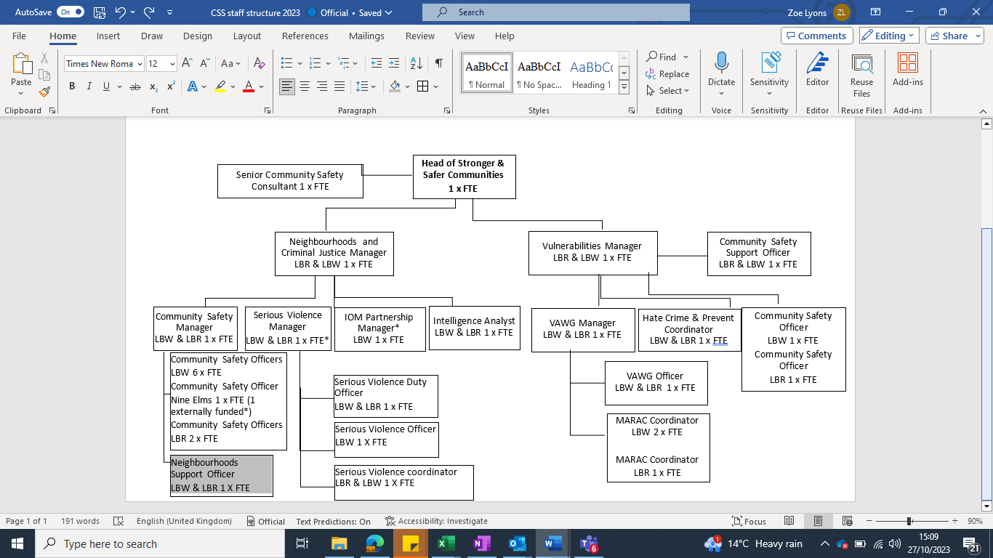

Person Specification

Community MARAC and Community Trigger Support Officer | Grade:  SO1 - £30,954  Fixed term until 31 March 2025
Section:  Community Safety Service | Directorate:  Chief Executives Group
Responsible to following manager:  Community Safety Team Manager | Responsible for following staff:  N/A
Post Number/s:  1 | Last review date: N/A

Our Values and Behaviours

The values and behaviours we seek from our staff draw on the high standards of the two boroughs, and we prize these qualities in particular:
- Being open. This means we share our views openly, honestly and in a thoughtful way. We encourage new ideas and ways of doing things. We appreciate and listen to feedback from each other.

- Being supportive. This means we drive the success of the organisation by making sure that our colleagues are successful. We encourage others and take account of the challenges they face. We help each other to do our jobs.

- Being positive. Being positive and helpful means we keep our goals in mind and look for ways to achieve them. We listen constructively and help others see opportunities and the way forward. We have a ‘can do’ attitude and are continuously looking for ways to help each other improve.

Person Specification Requirements |  |  |  | Assessed by  A/I/T/C  (see below for explanation)
 | Knowledge | Essential | Desirable | Assessed
 | Understanding of key legislation around crime, anti-social behaviour, Richmond and Wandsworth’s Community Safety priorities. | A/I
 | An understanding of how agencies work in partnership and how to overcome some of the barriers which may be experienced. | A/I
 | An understanding of multi-agency panels, information sharing and data protection | A/I
 | Experience | Essential | Desirable | Assessed
 | Experience of partnership or multi-agency work to achieve a shared objective. | A/I
 | Experience of minute taking, writing actions producing reports. | A/I
 | Experience of managing a project from start to finish. |  | A/I
 | Experience of working in Community Safety or equivalent sector. |  | A/I
 | Skills | Essential | Desirable | Assessed
 | Exceptional interpersonal skills, able to build strong relationships quickly.  Strong organisation and time management skill, able to prioritise own workload with competing and fast changing demands. | A/I
 |  | A/I
 | Experience in using Microsoft Office applications (Word, Excel, Outlook, Sharepoint) and | A/I
 | The ability to work with case management systems (experience in using ECINs is desirable but not essential) |  | A/I
 | Qualifications | Essential | Desirable | Assessed
 | N/A

A – Application form / CV
I – Interview
T – Test
C - Certificate

