Job Profile comprising Job Description and Person Specification
Job Description

Job Title:  Policy and Programme Lead (Climate  Change and Sustainability) | Grade:  PO5-PO6
Section:  Climate Change and Sustainability | Directorate:  Chief Executive’s Group
Responsible to following manager:  Head of Climate Change and Sustainability | Responsible for following staff:  Project Officer (Climate Change and Sustainability)
Post Number/s: | Last review date:  May 2022

Working for the Richmond & Wandsworth Better Service Partnership

We’re Richmond & Wandsworth Better Service Partnership, the shared public service team for Richmond and Wandsworth Councils. Like any local authority, our role is to deliver the agenda of our elected members on behalf of the people who live and work in our part of the world. We deliver key services to our communities including social care, public health, children’s services, housing and regeneration and environmental and community services.

Our joint workforce creates efficiency and resilience by bringing more creativity to the way we work, more objectivity and adaptability too, helping us deliver better services for all our residents.

We’re here to help our communities thrive in a changing world, and to be there for the people who need us most we believe we need to keep adapting. That’s why, at Richmond & Wandsworth Better Service Partnership, you’ll be at the forefront of innovation in local government, and we’ll invest in you and offer you opportunities to grow in a way only our unique organisation can.

Job Purpose

Do you want to be at the forefront of tackling the climate emergency? Are you passionate about and experienced in delivering climate action? Are you motivated by delivering net zero and sustainable places for half a million Londoners?

In July 2019 Richmond Council and Wandsworth Council declared Climate Emergencies and have taken significant action since then to reduce carbon emissions from the organisation and both boroughs as whole. Wandsworth Council published its 10 year Environment and Sustainability Strategy in July 2019 and Richmond has recently published a new Climate and Nature Strategy which takes the borough through until 2030. Both strategies are underpinned by ambitious action plans that involve services across all the whole organisation, as well as specific strategies focused on Retrofit and Climate Adaptation and Resilience. These action plans cover the operations of both councils, the estates of both councils, reducing carbon emissions from the borough as whole, improving the climate resilience of both boroughs as well as engagement and behaviour change programmes which look to involve residents, local groups, local businesses and partners in taking action to improve the environment and reduce carbon emissions.

This role will support the delivery of the two strategies and their supporting action plans. The postholder will lead the delivery of individual actions, working closely with the wider Climate Change and Sustainability Team as well as other teams across the organisation. This role will specifically lead on the delivery of the Climate Adaptation and Resilience elements of the action plans, alongside a focus on transport, air quality and biodiversity as well as carbon emissions reporting.

Specific Duties and Responsibilities

- To programme manage the action plans which underpin the Richmond and Wandsworth strategies. This will involve liaising with senior officers to identify actions taken, critically appraising if actions are on track and working with senior officers to bring actions back on deadline, where required.

- To work closely with officers across the organisation to deliver the agreed engagement and behaviour change strategies. It will also require liaison with local groups, local businesses, stakeholders, partners, residents and staff.

- To lead on providing formal reports to Members on the progress of both the action plans and on providing detailed briefings to Members, both written and face to face, as required. This will include the Leaders of both councils and Cabinet Members/Committee Chairs

- To lead on the updating of the annual action plans.

- To undertake research and detailed policy analysis that helps to determine the implications and opportunities arising from policy and legislation changes in relation to climate change, sustainability and the environment.

- To keep up-to-date with policy changes and initiatives in other councils, public sector bodies and developments in other countries and critically assesses the opportunities for learning as they might apply to services in the organisation – presenting options to senior managers and members as required.

- To lead the development of cross cutting policy as it relates to climate change, sustainability and the environment.

- As required, to lead and co-ordinate project teams that deliver high profile cross cutting projects.

- To represent both councils at meetings with stakeholders, local groups, partners, businesses and residents and build relationships across all these stakeholder groups.

- To represent the council at pan-London or national meetings and to establish a peer network across councils in order that ideas can be shared.

- To manage the Project Officer (Climate Change and Sustainability)

Generic Duties and Responsibilities

- To contribute to the continuous improvement of the services of Richmond & Wandsworth Better Service Partnerships.

- To comply with relevant Codes of Practice, including the Code of Conduct and policies concerning data protection, handling complaints and health and safety.

- To adhere to security controls and requirements as mandated by Richmond and Wandsworth procedures and local risk assessments to maintain confidentiality, integrity, availability and legal compliance of information and systems

- To promote equality, diversity, and inclusion, maintaining an awareness of the equality and diversity protocol/policy and working to create and maintain a safe, supportive and welcoming environment where all people are treated with dignity and their identity and culture are valued and respected.

- To understand both Councils’ duties and responsibilities for safeguarding children, young people and adults as they apply to the roles within the Councils.

- The profile is not intended to be an exhaustive list of the duties the post holder will carry out. Other reasonable duties commensurate with the level of the post, including supporting emergency and priority situations, will form part of the role.
Additional Information

Team structure
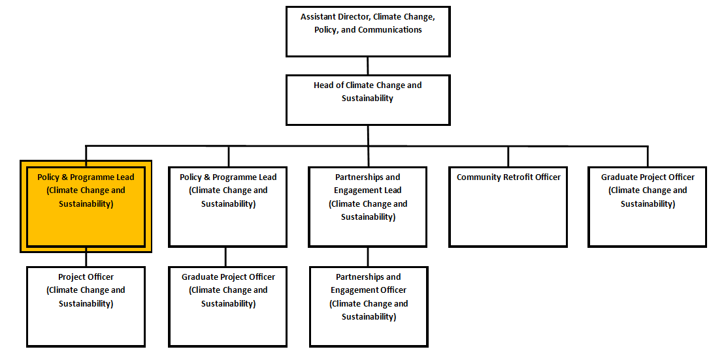
Person Specification

Job Title:  Policy and Programme Lead (Climate  Change and Sustainability) | Grade:  PO5-PO6
Section:  Climate Change and Sustainability | Directorate:  Chief Executive’s Group
Responsible to following manager:  Head of Climate Change and Sustainability | Responsible for following staff:  Project Officer (Climate Change and Sustainability)
Post Number/s: | Last review date:  May 2022

Our Values
THINK BIGGER
EMBRACE DIFFERENCE
CONNECT BETTER
LEAD BY EXAMPLE
PUT PEOPLE FIRST

Our Values are embedded across Richmond & Wandsworth Better Service Partnership and throughout all roles and responsibilities at all levels of the organisation. Please familiarise yourself with our values as they are an integral part of our recruitment and selection process.

Person Specification Requirements |  |  |  | Assessed by  A/I/T/C  (see below for explanation)
 | Knowledge | Essential | Desirable | Assessed
 | Knowledge of policy development as it relates to local government and the  delivery of services | X |  | A/I
 | Knowledge of the wider context within which local government operates  (including commissioning) | X |  | A/I
 | Knowledge of the climate change and sustainability agenda | X |  | A/I
 | Experience | Essential | Desirable | Assessed
 | Experience of operating in a political environment, recognising and handling in an appropriate manner, confidential or sensitive information and distinguishing between political and non-political activities. | X |  | A/I
 | Experience of successfully managing own workload in an environment where deadlines and priorities frequently change and are often conflicting | X |  | A/I
 | Experience of working and negotiating with and constructively challenging senior officers in a local government setting | X |  | A/I
 | Experience of working with leading members and councillors |  | X | A/I
 | Experience of managing high profile, ambitious climate change and sustainability related projects or programmes | X |  | A/I
 | Skills | Essential | Desirable | Assessed
 | Ability to communicate effectively and authoritatively both orally and in writing, with councillors, officers, partner organisations and the public. | X |  | A/I
 | Ability to accurately analyse numeric, financial, textual and performance data and present your findings in a clear and coherent way to a variety of audiences | X |  | A/I
 | Ability to oversee the delivery of projects / programmes and/or leading reviews of council services and making recommendations for change. | X |  | A/I
 | Ability to exercise tact and diplomacy, and first rate interpersonal, negotiation and influencing skills. | X |  | A/I
 | Ability to lead and manage cross-departmental teams to deliver specific projects and/or reviews. | X |  | A/I
 | Ability to work at pace, juggle priorities, and assimilate new information quickly and ability to make sound decision and judgements under pressure. | X |  | A/I
 | Demonstrable ability to use IT applications to manage and manipulate information and of researching information (textual, financial and statistical) from a variety of sources to present it in a consistent, concise and understandable way, both orally and in writing. | X |  | A/I
 | Experience of managing a complex workload, achieving targets and responding flexibly to changing needs and priorities, often with limited supervision | X |  | A/I
 | Ability to work both independently and as an effective team member, using initiative and adapting to changing priorities and deadlines in a calm, well organised and methodical manner. | X |  | A/I
 | Ability to line manage direct reports | X |  | A/I
 | Qualifications | Essential | Desirable | Assessed
 | Educated to degree level in a climate change and sustainability related subject area or equivalent through work experience | X |  | A

A – Application form / CV
I – Interview
T – Test
C - Certificate

