Job Profile comprising Job Description and Person Specification
Job Description

Job Title:  Project Officer | Grade:  PO2 – PO3 linked
Section:  Corporate Project Office | Directorate:  Chief Executive’s
Responsible to following manager:  Anna Sadler | Responsible for following staff:  N/A
Post Number/s: | Last review date:  September 2023

Working for the Richmond/Wandsworth Shared Staffing Arrangement

This role is employed under the Shared Staffing Arrangement between Richmond and Wandsworth Councils. The overall purpose of the Shared Staffing Arrangement is to provide the highest quality of service at the lowest attainable cost.

Staff are expected to deliver high quality and responsive services wherever they are based, as well as having the ability to adapt to sometimes differing processes and expectations.

The Shared Staffing Arrangement aims to be at the forefront of innovation in local government and the organisation will invest in the development of its staff and ensure the opportunities for progression that only a large organisation can provide.

Job Purpose

To work within the Corporate Programme Office (CPO) for Wandsworth and Richmond Councils, leading on a number of workstreams to improve project and programme management across the organisation. This includes the monitoring and reporting of key council capital projects and other priority programmes, creation and implementation of efficiencies in these processes, as well as direct management of a small portfolio of projects.

The CPO provides leadership on the improvement of project management processes in the SSA, including the introduction of support tools, templates, guidance, documentation and key standards around reporting expectations.
Specific Duties and Responsibilities

To lead on co-ordinating timely, accurate and regular reporting to Director’s Board of the Council’s capital and revenue programmes, with focus on embedding reporting processes that provide the earliest insight into issues and risks.

Support the Head of the Corporate Project Office to review, initiate and implement improvements within the reporting processes to create efficiencies across Directorates and the organisation.

To lead on and project manage a small portfolio of projects as specified by the Head of the Corporate Project Office, responsibilities may include maintaining project documentation, chairing key Project Board meetings, preparing presentations and/or project reports/risk registers/programmes, or managing resident consultations.

To review existing tools, templates and resources and create new ones in line with the improved approach to project and programme management. To maintain these resources and ensure they are fit for purpose.

To work with the Learning and Development team to establish a learning and development offer which enhances project and programme management capability in the workforce. As well as delivering aspects of this offer as appropriate.

Responsibility for invoice processing and setting up systems for the proper recording of expenditure and budget monitoring.

To build strong relationships and collaborate with key stakeholders , including officers and lead members, to ensure a robust understanding of their initial and ongoing requirements and the most effective delivery of workstreams.

To provide project management advice and support as required.

To be responsible for any project associated communications and engagement activity with key stakeholders and Council Members. This may include internal and external communications, consultation periods, providing website updates and producing briefings for Members and officers.

To set and maintain high standards of working, seeking out good practice and continually looking to improve ways of working.

The post holder will be expected to attend events outside of normal working hours and at weekends during consultation periods and where required.

Organise own workload and prioritise work tasks to meet deadlines and respond flexibly to frequently changing needs and priorities across several work streams / projects simultaneously.

Generic Duties and Responsibilities

- To contribute to the continuous improvement of the services of the Boroughs of Wandsworth and Richmond.

- To comply with relevant Codes of Practice, including the Code of Conduct and policies concerning data protection and health and safety.

- To adhere to security controls and requirements as mandated by the SSA’s policies, procedures and local risk assessments to maintain confidentiality, integrity, availability and legal compliance of information and systems

- To promote equality, diversity, and inclusion, maintaining an awareness of the equality and diversity protocol/policy and working to create and maintain a safe, supportive and welcoming environment where all people are treated with dignity and their identity and culture are valued and respected.

- To understand both Councils’ duties and responsibilities for safeguarding children, young people and adults as they apply to the role within the council.

- The profile is not intended to be an exhaustive list of the duties the post holder will carry out. Other reasonable duties commensurate with the level of the post, including supporting emergency and priority situations, will form part of the role.

Additional Information

May require evening and weekend work during consultation periods and for one off events or Committee meetings.

The team are hybrid working, very flexible, and based in and out of London, but there is an expectation that you will attend any in person meetings that are required as well as team meetings, subject to prior agreement with the Head of Corporate Project Office.

Team structure
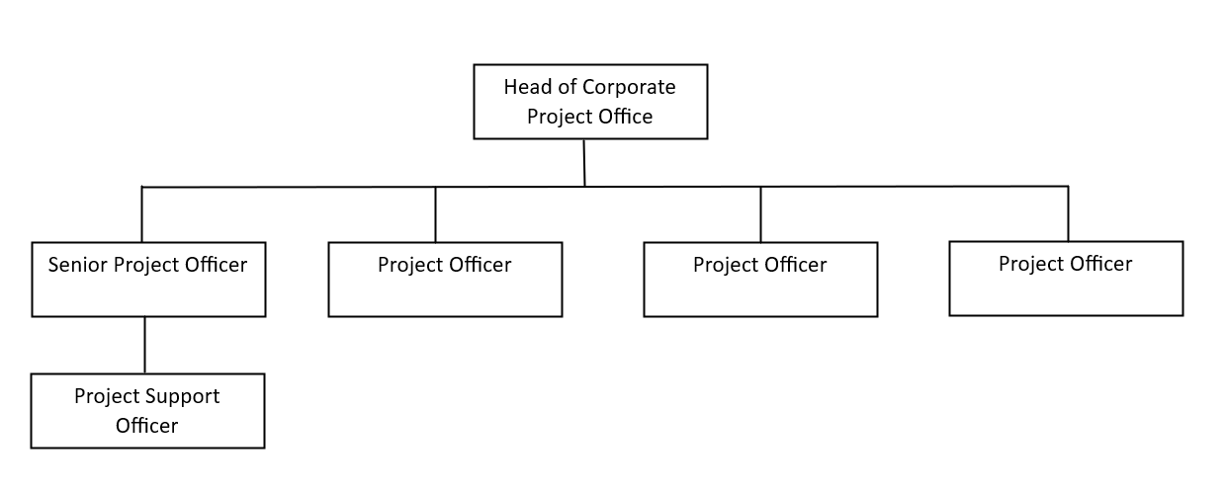
Person Specification

Job Title:  Project Officer | Grade:  PO2 – PO3 linked
Section:  Corporate Project Office | Directorate:  Chief Executive’s
Responsible to following manager:  Anna Sadler | Responsible for following staff:  N/A
Post Number/s: | Last review date:  September 2023

Our Values and Behaviours

The values and behaviours we seek from our staff draw on the high standards of the two boroughs, and we prize these qualities in particular:

Think bigger. Our work is important and challenging. It takes a mix of vision, idealism and ideas to do it well. We use our imagination and creativity to see further, solve problems and make positive change. We find time to plan ahead. We’re ambitious. We’re not afraid to do things differently or challenge the status quo.

Embrace difference . Our energy and empathy, our strength and ideas come from our mix of different minds. Whoever we are, whatever gender or sexuality, ethnicity or cultural background, whatever health conditions or impairments we may or may not have, however we think and whatever we believe, we support each other to bring our unique perspectives and experiences to work. We don’t stand by, we stand up for each others’ differences and call out bad behaviour when we see it.

Connect Better. We’re a big team working across two boroughs. The way we connect, share and collaborate with each other and our partners makes the difference for our residents. We’re open to ideas and inspiration from different places, across our organisation and beyond. We build bridge and break down barriers inside and out. We’re ready to adapt and adjust to get the most out of working with each other.

Lead by example. Whoever we are, whatever we do and whatever role we play, we can all show leadership. We all bring different skills and experience, but we’re united by the pride we take in our work and by the standards we set on behalf of residents. We’re always ready and ready for anything. We’re dependable, we strive to improve and we support each other. Whoever we are and whatever we do, we’re prepared to step up and take responsibility.

Put people first. Our work is all about people. About how we, as people, do the best we can to help the people of Richmond and Wandsworth to thrive. We put ourselves in the other person’s shoes. We treat each other with compassion and respect. And whatever we do, we focus on what it means for the people who we work with and the people who we serve.

Person Specification Requirements |  |  |  | Assessed by  A/I/C
 | Knowledge | Essential | Desirable | Assessed
 | Knowledge of projects and/or programme management methods and processes | X |  | A/I
 | Knowledge of reporting mechanisms and processes, particularly financial reporting on capital projects and programmes. |  | X | A/I
 | Knowledge of good practice, tools, templates and resources which support project management and delivery. | X |  | A/I
 | Experience | Essential | Desirable | Assessed
 | At least 1 year experience of successfully managing the day to day delivery of a range of projects / programmes | X |  | A
 | Experience using Microsoft packages such as Excel, Word, Outlook, Teams, Project, Sharepoint. | X |  | A/I
 | Some experience or understanding of successfully using standardised project and programme management methodologies | X |  | A/I
 | Experience of financial reporting, budget management systems, forecasting and budgeting. |  | X | A/I
 | Initiating and implementing change or improvement programmes. |  | X | A/I
 | Skills | Essential | Desirable | Assessed
 | Build relationships with a variety of people and work collaboratively to achieve successful outcomes | X |  | A/I
 | Organise own workload, prioritise work tasks to meet deadlines and respond flexibly to frequently changing needs and priorities | X |  | A/I
 | Collect / collate, analyse, summarise and present information, including statistical and financial information for a range of audiences | X |  | A/I
 | Ability to communicate effectively orally and in-writing, changing styles to suit the audience. | X |  | A/I
 | Qualifications | Essential | Desirable | Assessed
 | Educated to degree level or equivalent |  | X | A
 | Project and programme management qualification |  | X | A

A – Application form / CV
I – Interview
C - Certificate

