Job Profile comprising Job Description and Person Specification

Job Description

Job Title:  Performance Analyst – Health & Social Care Integration | Grade:  PO3
Section:  Health & Care Integration | Directorate:  Adult Social Care and Public Health
Responsible to following manager:  Adults Performance Manager | Responsible for following staff:  Nil
Post Number/s: RWAHSC1 | Last review date:  April 2021

Working for the Richmond/Wandsworth Shared Staffing Arrangement

This role is employed under the Shared Staffing Arrangement between Richmond and Wandsworth Councils. The overall purpose of the Shared Staffing Arrangement is to provide the highest quality of service at the lowest attainable cost.

Staff are expected to deliver high quality and responsive services wherever they are based, as well as having the ability to adapt to sometimes differing processes and expectations.

The Shared Staffing Arrangement aims to be at the forefront of innovation in local government and the organisation will invest in the development of its staff and ensure the opportunities for progression that only a large organisation can provide.

Job Purpose

This role will support the Directorate by delivering analysis and monitoring for key work programmes focused on health and care integration and associated services including:
- Supporting the Development and monitoring of the Better Care Fund Plans in Richmond and Wandsworth
- Overseeing and monitoring the performance of hospital discharge including Discharge to Assess pathways and reablement
- Produce information and monitoring to support the Integrated Care System and Primary Care Networks programmes, for both boroughs
- Development, analysis, and monitoring of a South West London Integrated Hospital Discharge offer

The post holder will undertake research and provide interpretation and analysis of health and social care data and information including demand modelling, benchmarking, and use of other analytical and business intelligence tools.

Specific Duties and Responsibilities
- To support the development, production, updating and monitoring of the Better Care Fund (BCF) and other strategic plans
- Ensure the timely and accurate submission of quarterly monitoring reports to the Better Care Fund liaising with partners across Health and Social Care
- Prepare and disseminate monthly monitoring Performance Reports and templates for BCF and Senior Management meetings showing progress against targets for key BCF metrics
- To provide accurate business intelligence and analytical information including demographic, demand, and capacity needs analysis to enable effective joint planning and service integration and redesign.
- Gathering, collating, and analysing quantitative and qualitative data from internal and external sources using benchmarking, demand modelling and other analytical tools
- To interpret performance information for the dissemination of relevant performance monitoring reports to Senior Management, Committee, Overview and Scrutiny, and external Partners to enable effective decision making, highlighting areas that may cause risk to the organisation, and supporting managers to undertake appropriate actions to address them.

- Support the evaluation of joint initiatives by identifying and collating relevant data sources and business intelligence to understand whether stated outcomes are being met
- To thoroughly understand the department’s business processes and recording systems and integrated models of service provision.

- To contribute towards the development of good working relations and collaborative arrangements with relevant third-party organisations (including the NHS, private, voluntary sector, and other public organisations) to forge effective partnership working and smooth sharing of patient information

Generic Duties and Responsibilities
- To contribute to the continuous improvement of the services of the Boroughs of Wandsworth and Richmond
- To comply with relevant Codes of Practice, including the Code of Conduct and policies concerning data protection and health and safety
- To adhere to security controls and requirements as mandated by the SSA’s policies, procedures and local risk assessments to maintain confidentiality, integrity, availability and legal compliance of information and systems
- To promote equality, diversity, and inclusion, maintaining an awareness of the equality and diversity protocol/policy and working to create and maintain a safe, supportive, and welcoming environment where all people are treated with dignity and their identity and culture are valued and respected
- To understand both Councils’ duties and responsibilities for safeguarding children, young people and adults as they apply to the role within the councils
- The Shared Staffing Arrangement will keep its structures under continual review and as a result the post holder should expect to carry out any other reasonable duties within the overall function, commensurate with the level of the post
Additional Information
The post sits within a matrix management system will a dotted line of management into the Assistant Director of Health and Care Integration.
This post holds no line management responsibility.
Current Team Structure
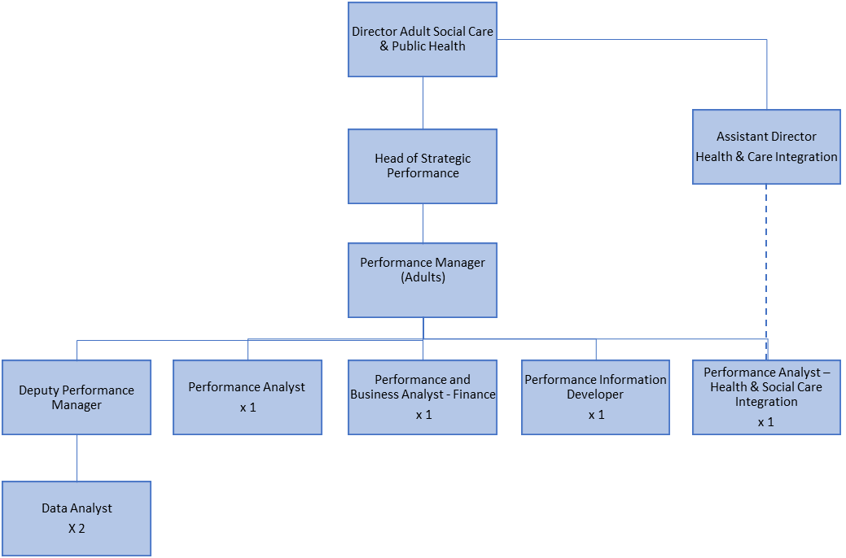
Person Specification

Job Title:  Performance Analyst – Health & Social Care Integration | Grade:
Section:  Health & Care Integration | Directorate:  Adult Social Services
Responsible to following manager:  Adults Performance Manager | Responsible for following staff:  Nil
Post Number: | Last review date:  April 2021

Our Values and Behaviours

The values and behaviours we seek from our staff draw on the high standards of the two boroughs, and we prize these qualities in particular:

Being open. This means we share our views openly, honestly and in a thoughtful way. We encourage new ideas and ways of doing things. We appreciate and listen to feedback from each other.

Being supportive. This means we drive the success of the organisation by making sure that our colleagues are successful. We encourage others and take account of the challenges they face. We help each other to do our jobs.

Being positive. Being positive and helpful means, we keep our goals in mind and look for ways to achieve them. We listen constructively and help others see opportunities and the way forward. We have a ‘can do’ attitude and are continuously looking for ways to help each other improve.

Person Specification Requirements |  | Assessed by  A  & I/ C (see below for explanation)
Knowledge
1 | Knowledge of health or social care is desirable | A/I
2 | Excellent understanding of the use of analytical tools and techniques | A/I
3 | Understanding of data security and confidentiality issues | A/I
Experience
4 | Experience of using demand modelling tools desirable | A/I
5 | Analysing demographic, benchmarking and other types of large complex datasets and information | A/I/T
6 | Experience of working alongside internal and external stakeholders | A/I
7 | Using web-based business intelligence tools and applications such as Power BI to present information | A/I
8 | Experience of successfully managing own workload in an environment where deadlines and priorities frequently change and are often conflicting | A/I
Skills
9 | Advanced MS Excel, Word and PowerPoint skills. | A/I/T
10 | High level numerical and statistical skills
11 | Excellent written communication skills, with the ability to choose content and style of reports to suit the audience | A/I
12 | Ability to accurately analyse and interpret detailed data and present reports to a range of audiences and contribute towards debate | A/I/T
13 | To be curious about data identifying when information doesn’t look right and acting on those findings to improve data collection processes | A/I
14 | Excellent interpersonal skills including the ability to communicate effectively at all levels including with partner organisations. | A/I
15 | Proactive self-starter with the ability to work as part of a team and independently using own initiative | A/I
Qualifications
16 | Educated to degree level in a related subject area or equivalent through work experience | A/C

A – Application form
I – Interview
C - Certificate
T- Test

