Job Profile comprising Job Description and Person
Specification
Job Description
Job Title: Prevent and Hate Crime Coordinator | Grade: PO4
Section: Community Safety Service | Directorate: Chief Executives Group
Responsible to following manager:  Vulnerabilities Manager | Responsible for following staff:  N/A
Post Number/s: | Last review date: 8 August 2025

Working for the Richmond & Wandsworth Better Service Partnership
We’re Richmond & Wandsworth Better Service Partnership, the shared public service team for Richmond and Wandsworth Councils. Like any local authority, our role is to deliver the agenda of our elected members on behalf of the people who live and work in our part of the world. We deliver key services to our communities including social care, public health, children’s services, housing and regeneration and environmental and community services.
Our joint workforce creates efficiency and resilience by bringing more creativity to the way we work, more objectivity and adaptability too, helping us deliver better services for all our residents.
We’re here to help our communities thrive in a changing world, and to be there for the people who need us most we believe we need to keep adapting. That’s why, at Richmond & Wandsworth Better Service Partnership, you’ll be at the forefront of innovation in local government, and we’ll invest in you and offer you opportunities to grow in a way only our unique organisation can.

Job Purpose:

This post will play a key function in ensuring that the work of the Councils, the Community Safety Partnership and its voluntary sector partners builds social cohesion in our communities, safeguards vulnerable individuals from radicalisation, and reduces hate crime. The post will mobilise effective multi-agency implementation of the Prevent and Protect duties and will also drive the Council’s partnership work on hate crime and social cohesion initiatives.

The post holder will build and continuously evolve the partnership’s understanding of the key, risks, vulnerabilities, challenges and protective factors for local communities related to radicalisation, terrorism, community tensions and hate crime, including through policy advice and training development and delivery. The post holder will work closely with local
communities, senior council officers, elected councillors as well as statutory and voluntary sector partners, representing the Council at relevant local, regional and national meetings.
We are looking for someone with an excellent understanding of safeguarding and thematic and policy understanding of community cohesion, radicalisation, counterterrorism and hate crime. The post holder should have strong communication and mobilisation skills. This post will work across Richmond and Wandsworth.

Specific Duties and Responsibilities:
- To provide operational and strategic leadership and support to enable the Councils and key partners to deliver on the following areas: a) Prevent and Protect; b) community cohesion and c) hate crime, providing a visible presence and building key stakeholder and inter-agency relationships across the partnership.

- To develop an excellent local and national picture of the drivers, prevalence, vulnerabilities to and mitigation measures for extremism and radicalisation of all kinds. This will include supporting development of the partnership’s analytical capacity and data-driven approaches and coordinating and quality assuring the partnership’s Counter Terrorism Local Profile (CTLP).

- To stay abreast of all relevant national and local policy developments, emerging statutory guidance and best practice, providing advice to the partnership to support work that is effective and at pace with fast-evolving trends.

- To support community and partner efforts to build resilient and cohesive communities, engaging with and expanding a local network of public sector professionals, community and faith leaders and voluntary and community sector (VCS) organisations with the aim of improving social cohesion, reducing vulnerabilities to radicalisation and hate-based violence, and ensuring that the views of residents and key stakeholders inform decision-making.

- To support agencies in delivering statutory responsibilities relating to the Prevent and Protect duties, including:

- To manage coordination of the Prevent and Protect Strategic Delivery Group, work with partners and senior management on agenda-setting, and play a central role in developing and mobilising partnership delivery of annual Strategic Delivery Plans.
- To coordinate and play a lead role in direct delivery of a training offer that embeds capacity across the multi-agency workforce, increasing awareness of the evolving landscape of radicalisation and ensuring appropriate quality and quantity of Prevent referrals.
- To ensure effective operation of the Channel Panel, working closely with the Chair/Deputy Chair, Counter Terrorism Policing, education partners and other panel members to a) safeguard individuals referred to Channel through effective problem-solving on complex cases; b) to ensure compliance, and c) ensure high quality protocols and interventions that embed best practice.
- To support Council preparedness and implementation of emerging Protect Duty guidance within the statutory timeframe for compliance.

- To lead in identifying and delivering effective partnership interventions to raise awareness of hate crime, improve reporting pathways and promote inclusivity. This will include efforts to enhance existing partnership coordination mechanisms for hate crime, delivering on the planning and implementation of annual Hate Crime Awareness Week activities, and seeking to identify opportunities for grant-funded project work.

- To lead and attend relevant meetings with and on behalf of the Service and Community Safety Partnership when necessary, which may be local, regional or national.

- To ensure that Information Sharing Protocols are in place and adhered to and that information and intelligence is submitted and shared, where appropriate, in a timely manner.

- To support the Vulnerabilities Manager in ensuring effective corporate oversight of these key areas, including by preparing Freedom of Information request responses, monitoring and reporting on corporate KPIs, and other functions as may be required.

Generic Duties and Responsibilities

- To contribute to the continuous improvement of the services of Richmond & Wandsworth Better Service Partnerships.

- To comply with relevant Codes of Practice, including the Code of Conduct and policies concerning data protection, handling complaints and health and safety.

- To adhere to security controls and requirements as mandated by Richmond and Wandsworth procedures and local risk assessments to maintain confidentiality, integrity, availability and legal compliance of information and systems

- To promote equality, diversity, and inclusion, maintaining an awareness of the equality and diversity protocol/policy and working to create and maintain a safe, supportive and welcoming environment where all people are treated with dignity and their identity and culture are valued and respected.

- To understand both Councils’ duties and responsibilities for safeguarding children, young people and adults as they apply to the roles within the Councils.

- The profile is not intended to be an exhaustive list of the duties the post holder will carry out. Other reasonable duties commensurate with the level of the post, including supporting emergency and priority situations, will form part of the role.
Additional Information
Post holder will be expected to work flexibly across the boroughs of Richmond and Wandsworth, with hybrid arrangements including presence at Wandsworth Town Hall and Twickenham Civic Centre where required and work from home provision.

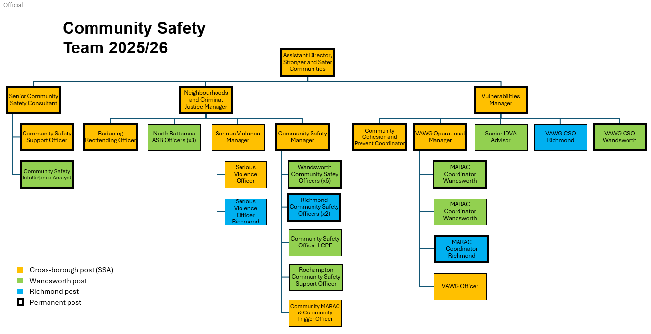
Current team structure

Person Specification

Job Title: Prevent and Hate Crime Coordinator | Grade: PO4
Section: Community Safety Service | Directorate: Chief Executives Group
Responsible to following manager:  Vulnerabilities Manager | Responsible for following staff:  N/A
Post Number/s: | Last review date: 8 August 2025
Job Title:  Prevent and Hate Crime Coordinator | Grade: PO4

Our Values
THINK BIGGER
EMBRACE DIFFERENCE
CONNECT BETTER
LEAD BY EXAMPLE
PUT PEOPLE FIRST

Our Values are embedded across Richmond & Wandsworth Better Service Partnership and throughout all roles and responsibilities at all levels of the organisation. Please familiarise yourself with our values as they are an integral part of our recruitment and selection process.

Person Specification Requirements |  |  | Assessed by  A /I/ T/ C (see below for explanation)
Knowledge | Essential | Desirable | Assessed
A good understanding of violent and non-violent extremism and the risk and protective factors for individuals vulnerable to radicalisation. | E |  | A/I
A good understanding of the social cohesion, including factors that promote or undermine it and strategies to increase community cohesion. | E |  | A/I
A strong understanding of and commitment to Equality, Diversity and Inclusion as well as safeguarding, and how these may be promoted within this role. | E |  | A/I
A good understanding of Prevent and Protect legislation and statutory responsibilities for Local Authorities. |  | D | A/I
A good understanding of national strategies and policies to address respond to hate crime and the impact of hate crime on local communities. |  | D | A/I
Experience | Essential | Desirable | Assessed
Extensive experience of multi-agency partnership working with both public and voluntary sector stakeholders. | E |  | A/I
Experience working within multi-cultural and multi-faith stakeholder groups and in roles requiring high levels of cultural competency. | E |  | A/I
Experience in policy analysis and application of policy guidance to practical work. | E |  | A/I
Experience of delivering presentations, trainings, workshops and briefings to varied audiences. | E |  | A/I
Experience of working in a political environment and being politically astute. |  | D | A/I
Experience working in a safeguarding setting requiring the effective management of sensitive or confidential information and vulnerable individuals. |  | D | A/I
Skills | Essential | Desirable | Assessed
Ability to work both independently and as a member of a team, organising and prioritising a complex workload. | E |  | A/I
Excellent written and verbal communication skills, including the ability to sell ideas and concepts and articulate shared vision across a range of stakeholders. | E |  | A/I
Strong analytical and problem-solving skills, providing creative solutions to problems and, whilst considering policy and procedure, is also confident in adopting innovative approaches. | E |  | A/I
Strong business planning and strategic thinking skills, with the ability to ensure work is structured to deliver against broader Council or partnership strategies, goals, timeframes and processes. | E |  | A/I
ICT literate, including proficient use of the Internet and all mainstream MS programs, with the ability to learn others as required. | E |  | A/I
Qualifications | Essential | Desirable | Assessed
Educated at degree level or an equivalent work-related qualification or equivalence by experience | E |  | A/I
Evidence of continuing professional development |  | D | A/I

A – Application form
I – Interview
T – Test
C - Certificate

