Job Profile comprising Job Description and Person Specification
Job Description

Job Title:  Community Safety Support Officer | Grade:  SO1 - £32,980
Section:  Community Safety Service | Directorate:  Chief Executives Group
Responsible to following manager:  Community Safety Team Manager | Responsible for following staff:  N/A
Post Number/s:  1 | Last review date: N/A

Working for the Richmond & Wandsworth Better Service Partnership

This role is employed under the Richmond & Wandsworth Better Service Partnership. The overall purpose of Richmond & Wandsworth is to provide the highest quality of service at the lowest attainable cost.

Staff are expected to deliver high quality and responsive services wherever they are based, as well as having the ability to adapt to sometimes differing processes and expectations.

Richmond & Wandsworth Better Service Partnership aims to be at the forefront of innovation in local government and the organisation will invest in the development of its staff and ensure the opportunities for progression that only a large organisation can provide.

Job Purpose

This is a really exciting opening within the Richmond and Wandsworth Safer and Stronger Communities Team. The Service works on key themes including Serious Violence, Offender Management, Anti-Social Behaviour, Neighbourhoods, Domestic Abuse, Prevent and Radicalisation and Hate Crime.

The post-holder will be required to support the work of the Safer and Stronger Communities Team as we seek to respond to crime and anti-social behaviour. This will involve working within the Neighbourhoods and Criminal Justice theme to support the wider place shaping work around the Alton Estate regeneration scheme. You will support the area’s Community Safety Officer to deliver a coordinated community safety approach both before, during, and after, the regeneration programme.

We are looking for someone who is hard-working and has some experience in community safety. As well as co-ordinating, and supporting projects, you need to be able to work well under pressure, prioritise your own workload, communicate openly and honestly with your colleagues and especially your manager on capacity.

We hope the candidate can bring their own initiative and any innovative ideas to this exciting new role.

Specific Duties and Responsibilities

To support the Community Safety Officer around the delivery of a co-ordinated community safety approach to the Alton Estate.
Some of the duties will include:
- Supporting delivery of Neighbourhood Watch and Wandsworth Business Against Crime across the Alton Estate
- Supporting the delivery of a Roehampton Community Safety Action plan
- Developing strong relationships with both internal, and external stakeholders to ensure delivery
- Building strong links with the local community, and voluntary organisations
- Organising/attending community events, and representing the Safer and Stronger Communities Team at these events
- Working to the deliverables within the Community Safety strategy, particularly around how the partnership responds to crime and ASB
- Supporting wider community safety initiatives across the Alton Estate
- Supporting the Community Safety Officer with administration tasks, such as updating problem solving plans, coordinating task and finish groups, and minuting meetings
- Carrying out ad-hoc Neighbourhoods tasks as directed by line manager

Generic Duties and Responsibilities

- To contribute to the continuous improvement of the services of Richmond & Wandsworth Better Service Partnerships.

- To comply with relevant Codes of Practice, including the Code of Conduct and policies concerning data protection and health and safety.

- To adhere to security controls and requirements as mandated by Richmond and Wandsworth procedures and local risk assessments to maintain confidentiality, integrity, availability and legal compliance of information and systems

- To promote equality, diversity, and inclusion, maintaining an awareness of the equality and diversity protocol/policy and working to create and maintain a safe, supportive and welcoming environment where all people are treated with dignity and their identity and culture are valued and respected.

- To understand both Councils’ duties and responsibilities for safeguarding children, young people and adults as they apply to the roles within the Councils.

- The profile is not intended to be an exhaustive list of the duties the post holder will carry out. Other reasonable duties commensurate with the level of the post, including supporting emergency and priority situations, will form part of the role.
Additional Information
- Post holder will be expected to work flexibly across two locations (Wandsworth Town Hall and Richmond Civic Centre), in addition to spending time on site at the Alton Estate. Due to the nature of the post, the majority of time will be spent in the office, or on site. Where necessary and authorised the post-holder can work from home.

Team structure
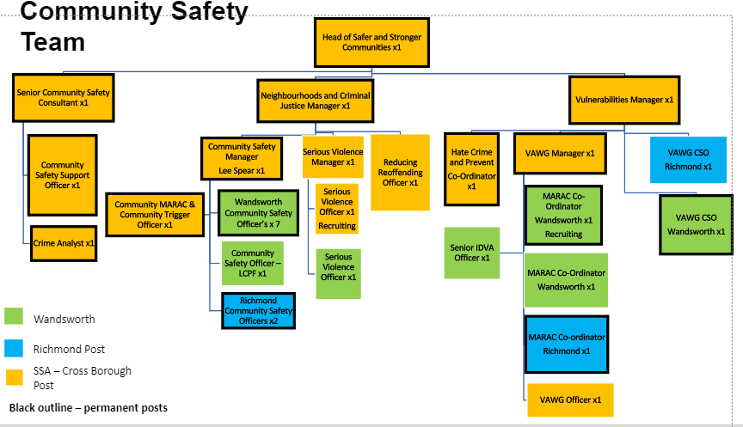

Person Specification

Neighbourhoods Support Officer | Grade:  SO1 - £32,980
Section:  Community Safety Service | Directorate:  Chief Executives Group
Responsible to following manager:  Community Safety Team Manager | Responsible for following staff:  N/A
Post Number/s:  1 | Last review date: N/A

Our Values
THINK BIGGER
EMBRACE DIFFERENCE
CONNECT BETTER
LEAD BY EXAMPLE
PUT PEOPLE FIRST

Our Values are embedded across Richmond & Wandsworth Better Service Partnership and throughout all roles and responsibilities at all levels of the organisation. Please familiarise yourself with our values as they are an integral part of our recruitment and selection process.

Person Specification Requirements |  |  |  | Assessed by  A/I/T/C  (see below for explanation)
 | Knowledge | Essential | Desirable | Assessed
 | Some understanding of key legislation, policy and procedure relating to anti-social behaviour | x |  | A I
 | An understanding of how agencies work in partnership in these defined fields. | x |  | A I
 | An understanding of multi-agency panels, information sharing and data protection | x |  | A I
 | Experience | Essential | Desirable | Assessed
 | Experience of partnership or multi-agency work in order to achieve a shared objective. | x |  | A I
 | Experience of minute taking and writing actions. | x |  | A I
 | Experience in time management and being able to prioritise your tasks. | x |  | A I
 | Skills | Essential | Desirable | Assessed
 | Excellent time management and organisational skills with the ability to meet set deadlines | x |  | A I
 | Experience in using Microsoft Office applications (Word, Excel, Outlook, Sharepoint) and the ability to work with case management systems | x |  | A I
 | Ability to communicate effectively both orally and in writing with a range of colleagues and partner agencies | x |  | A I
 | Experience in minute taking, administration and report writing | x |  | A I
 | Ability to build effective relationships both internally and externally, including colleagues and partner agencies. | x |  | A I
 | Qualifications | Essential | Desirable | Assessed
 | N/A

A – Application form / CV
I – Interview
T – Test
C - Certificate

