Job Profile comprising Job Description and Person Specification
Job Description

Job Title:  Corporate and Public Affairs Events Manager | Grade:  P06
Section:  Communications | Directorate:  Chief Executive
Responsible to following manager:  Head of Communications | Responsible for following staff:  n/a
Post Number/s:  pending | Last review date:

Working for the Richmond/Wandsworth Shared Staffing Arrangement

This role is employed under the Shared Staffing Arrangement between Richmond and Wandsworth Councils. The overall purpose of the Shared Staffing Arrangement is to provide the highest quality of service at the lowest attainable cost.

Staff are expected to deliver high quality and responsive services wherever they are based, as well as having the ability to adapt to sometimes differing processes and expectations.

The Shared Staffing Arrangement aims to be at the forefront of innovation in local government and the organisation will invest in the development of its staff and ensure the opportunities for progression that only a large organisation can provide.

The Communications Team is at the centre of the Council and has a high impact on the services and audiences it serves. It provides strategic leadership on media relations, public relation, event management, community engagement, publications, social media management and monitoring, branding, design and the councils websites. It is also responsible for the operational oversight, delivery and coordination of all communications activity across the wider council.

Job Purpose

As the Corporate Events Manager you will be responsible for drawing together multiple cross-cutting council teams, to successfully project manage, plan, coordinate, and execute a wide range of corporate events to support the Council’s objectives and enhance stakeholder engagement. From conferences and policy launches to stakeholder meetings and community activities, you will play a key role in ensuring the seamless execution of events that reflect our brand, values, and mission.

Specific Duties and Responsibilities

- You will lead on designing insight led targeted public affairs face to face influencing initiatives with local, regional and national stakeholders including the Mayor of London and senior national government figures.
- Event Planning: Lead the end-to-end planning process for council events, including defining objectives, developing event concepts, creating timelines, and managing budgets.
- Public Affairs: Design insight led targeted public affairs face to face influencing initiatives with local, regional and national stakeholders including the Mayor of London and senior national government figures.
- Management: Empower, mentor and manage an Events Officer, and convene and lead a matrix of cross cutting event teams across multiple concurrent events.
- Venue Selection and Logistics: Research and secure venues that align with event requirements and budget constraints. Coordinate logistics such as catering, audiovisual equipment, transportation, and accommodations.
- Program Development: Collaborate with internal stakeholders to develop event agendas, speaker programs, and entertainment options that align with event objectives and audience preferences.
- Vendor Management: Identify and manage relationships with event vendors, including caterers, audiovisual providers, decorators, and transportation companies. Negotiate contracts and ensure vendors deliver high-quality services within budget and timeline constraints.
- Promotion and Marketing: Work closely with communications colleagues to promote events through various channels, including email campaigns, social media, websites, and print materials. Develop compelling event messaging and collateral to attract attendees and generate excitement.
- Registration and Attendee Management: Implement registration systems and processes to efficiently manage attendee registration, ticketing, and check-in. Provide support and assistance to attendees before, during, and after events to ensure a positive experience.
- On-Site Coordination: Oversee all aspects of event execution on-site, including set-up, registration, speaker management, technical support, and attendee engagement. Troubleshoot any issues or emergencies that may arise during events.
- Post-Event Evaluation: Collect feedback from attendees, sponsors, and stakeholders to evaluate event success and identify areas for improvement. Analyse event metrics, such as attendance, engagement, and satisfaction, to measure ROI and inform future event planning efforts.
Generic Duties and Responsibilities

- To contribute to the continuous improvement of the services of the Boroughs of Wandsworth and Richmond.

- To comply with relevant Codes of Practice, including the Code of Conduct and policies concerning data protection and health and safety.

- To adhere to security controls and requirements as mandated by the SSA’s policies, procedures and local risk assessments to maintain confidentiality, integrity, availability and legal compliance of information and systems

- To promote equality, diversity, and inclusion, maintaining an awareness of the equality and diversity protocol/policy and working to create and maintain a safe, supportive and welcoming environment where all people are treated with dignity and their identity and culture are valued and respected.

- To understand both Councils’ duties and responsibilities for safeguarding children, young people and adults as they apply to the role within the council.

- The profile is not intended to be an exhaustive list of the duties the post holder will carry out. Other reasonable duties commensurate with the level of the post, including supporting emergency and priority situations, will form part of the role.
Additional Information
Our Values
THINK BIGGER
EMBRACE DIFFERENCE
CONNECT BETTER
LEAD BY EXAMPLE
PUT PEOPLE FIRST

Our Values are embedded across the SSA and throughout all roles and responsibilities at all levels of the organisation. Please familiarise yourself with our values as they are an integral part of our recruitment and selection process.

Team structure

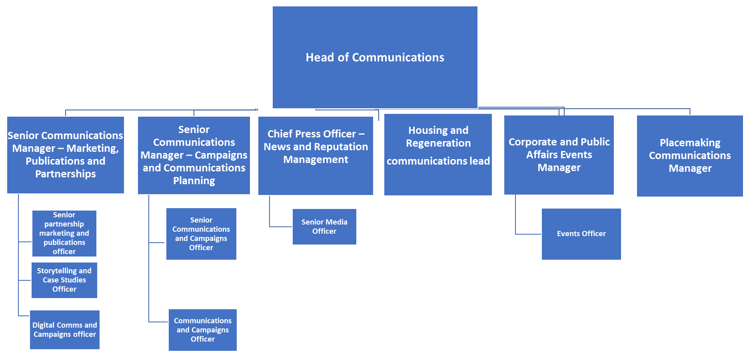

Person Specification

Job Title: Corporate and Public Affairs Events | Grade: P06
Section: Communications | Directorate: Chief Executive
Responsible to: Head of Communications | Responsible for:  Events Officer
Post Number/s: | Last Review Date: May 2024

Our Values and Behaviours

The values and behaviours we seek from our staff draw on the high standards of the two boroughs, and we prize these qualities in particular:

Being open. This means we share our views openly, honestly and in a thoughtful way. We encourage new ideas and ways of doing things. We appreciate and listen to feedback from each other.

Being supportive. This means we drive the success of the organisation by making sure that our colleagues are successful. We encourage others and take account of the challenges they face. We help each other to do our jobs.

Being positive. Being positive and helpful means we keep our goals in mind and look for ways to achieve them. We listen constructively and help others see opportunities and the way forward. We have a ‘can do’ attitude and are continuously looking for ways to help each other improve.

Person Specification Requirements |  |  |  | Assessed by  A/I/T/C  (see below for explanation)
 | Knowledge | Essential | Desirable | Assessed
 | Outstanding writing, editing, and verbal communication skills | x |  | A&T
 | Knowledge of local government policies and issues |  | x | A&I
 | Excellent interpersonal skills, with the ability to build relationships and collaborate effectively with diverse stakeholders. | x |  | I
 | Experience | Essential | Desirable | Assessed
 | Proven experience in event planning and execution, preferably in a local authority, corporate or agency setting. | x |  | A
 | Demonstrated ability to draft compelling content, case study development and digital communications output. | x |  | A
 | Excellent communication and interpersonal skills, with the ability to collaborate effectively with internal teams, external vendors, and stakeholders at all levels. | x |  | A&I
 | Knowledgeable of Wandsworth borough. |  | x | A
 | Skills | Essential | Desirable | Assessed
 | Ability to tailor messages for different audiences. | x |  | T
 | Strategic thinking and problem-solving abilities, with a results-driven mindset | x |  | I&T
 | Strong organisational and project management skills, with the ability to manage multiple projects simultaneously and meet tight deadlines | x |  | A&I
 | Ability to remain calm and composed under pressure and adapt quickly to changing circumstances. |  |  | A&I
 | Proficiency in event management software, such as Cvent, Eventbrite, or RegOnline, and Microsoft Office suite. |  | x | A&T
 | Willingness to work flexible hours, including evenings and weekends, to support event execution as needed. | x |  | I
 | Qualifications | Essential | Desirable | Assessed
 | Bachelor's degree in event management, hospitality management, marketing, or a related field. |  | x | A

A – Application form / CV
I – Interview
T – Test
C - Certificate

