Job Profile comprising Job Description and Person Specification
Job Description

Job Title:  Energy Management Officer | Grade:  PO3
Section:  Housing Compliance | Directorate:  Housing and Regeneration
Responsible to following manager:  Strategic Technical and Compliance Manager | Responsible for following staff:  As directed temporary staff/trainees
Post Number/s:  2 | Last review date:  February 2022

Working for the Richmond/Wandsworth Shared Staffing Arrangement

This role is employed under the Shared Staffing Arrangement between Richmond and Wandsworth Councils. The overall purpose of the Shared Staffing Arrangement is to provide the highest quality of service at the lowest attainable cost.

Staff are expected to deliver high quality and responsive services wherever they are based, as well as having the ability to adapt to sometimes differing processes and expectations.

The Shared Staffing Arrangement aims to be at the forefront of innovation in local government and the organisation will invest in the development of its staff and ensure the opportunities for progression that only a large organisation can provide.

Job Purpose
The post holder will be responsible for helping shape and advising on the Department’s energy management strategy. This will include the management of contracts relating to energy provision, metering and billing services, electric vehicle charging points across the Council’s estates and, solar PV and solar thermal installations across its stock on behalf of the Department.

The post holder will be responsible for developing business cases for the Department for a range of heating and energy matters relating to residential stock. This will include managing and maintaining data collection and analysis and reporting on the performance of appropriate operational contractors and projects.

The post holder will be required to assist with ongoing operational work associated with these areas, including setting, and reviewing tariffs, and monitoring performance.

Specific Duties and Responsibilities
- Project manage environmental sustainability initiatives ensuring successful delivery through cross department working within the Council and with partners, assisting internal and external project teams as required.
- Manage complex sustainability data collection, coordinating with key stakeholders and senior management. Interpret, collate, and report relevant data related to energy management to senior management, this will include critical analysis of performance.

- Manage and monitor contractor performance, developing key performance indicators’, service level agreements and conditions of contracts. Liaise with external contractors to ensure the correct installation and certification of technology is fitted, maintaining relevant records and systems.

- Where appropriate commission services and manage contracts and service providers. Ensure terms and conditions are uniformed to reflect management and charging processes. Identify opportunities for innovation and continuous improvement.

- Engage with external stakeholders and senior management to ensure that energy management and sustainability services deliver best practice. Manage relationships with external stakeholders, such as the Government, GLA, utility companies, and the private sector, and represent the Department within inter agency meetings, chairing meetings as required.

- Keep abreast of changes in policy or legislation related to energy management, including keeping up to date with best practice in the sector and critically assessing the opportunities for learning. Monitor for changes in regulations and technological changes and provide understanding of how this impacts the Council. Ensure the Council is compliant in relevant legalisation.

- Conduct research as required in relation to new green technologies, including heat networks, EV charging and associated services. Monitor changes to carbon reporting and technical innovation in energy conservation and reduction.

- Develops training courses for housing staff in relation to energy management to ensure compliance with council standards of service delivery and statutory and regulatory requirements. Ensure strategy, policy and procedures are implemented. Build positive relationships to share ideas and best practise.

- Deliver a customer focused metering and billing service, meeting all relevant regulation, and agreed service level standards. Set and review tariffs, on a block-by-block basis using a methodology specific to these metered and billed systems. Work with the Council’s Finance Department and debt management support to refer cases for early intervention debt management.

- Ensure effective engagement and communication with residents in the use of new green technologies. Produce clear communication material, devise and commission surveys and audits, this will include presenting findings to senior managers and residents. Attend resident meetings where necessary to communicate improvements and or changes in service.

- Support the development of the heat network metering and billing operation, with a strong focus on operational delivery and customer service standards. Be responsible for the commissioning of metering systems on new build schemes to ensure smooth handovers. Work across teams to deliver this challenging work programme so that metering of energy use and consumption based charging is part of day-to-day working and easy for residents and staff to operate.

- Assists the Strategic Technical and Compliance Manager in matters relating to energy efficiency, including compliance with relevant legislation and bidding for funding as appropriate.

Generic Duties and Responsibilities

- To contribute to the continuous improvement of the services of the Boroughs of Wandsworth and Richmond.

- To comply with relevant Codes of Practice, including the Code of Conduct and policies concerning data protection and health and safety.

- To adhere to security controls and requirements as mandated by the SSA’s policies, procedures and local risk assessments to maintain confidentiality, integrity, availability and legal compliance of information and systems

- To promote equality, diversity, and inclusion, maintaining an awareness of the equality and diversity protocol/policy and working to create and maintain a safe, supportive and welcoming environment where all people are treated with dignity and their identity and culture are valued and respected.

- To understand both Councils’ duties and responsibilities for safeguarding children, young people and adults as they apply to the role within the council.

- The profile is not intended to be an exhaustive list of the duties the post holder will carry out. Other reasonable duties commensurate with the level of the post, including supporting emergency and priority situations, will form part of the role.
Additional Information
- The post is managed by the Strategic Technical Compliance Manager with the work programme and areas of responsibility agreed with this Manager and Assistant Director (Housing Strategy, Compliance and Enablement). The post holder will be expected to have the skills and experience to undertake work and projects to a high degree independently and provide working material as good first draft for review.

- As required undertakes a supervisory role for temporary members of staff and/or trainee posts and provides client-side services where work is contracted.

- To ensure that the services for both Councils are dealt with on an equitable basis to deliver the standards required for each, as agreed annually by the Executives of both Councils.

Team structure

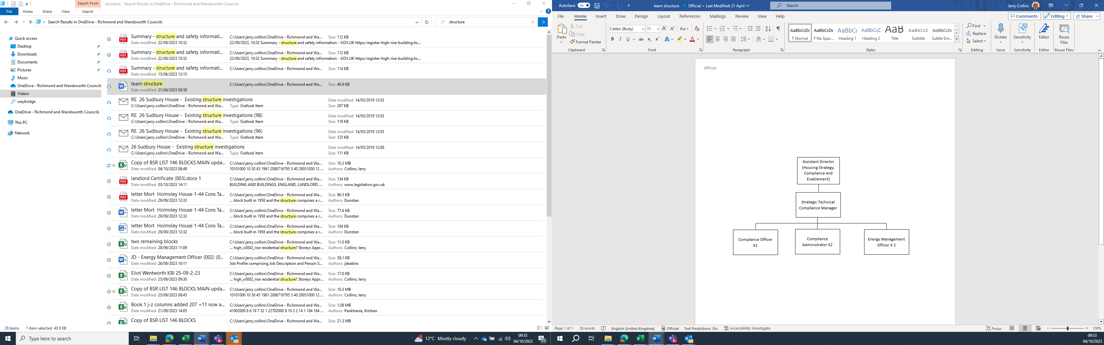
Person Specification

Job Title:  Energy Management Officer | Grade: PO3
Section:  Housing Compliance | Directorate:  Housing and Regeneration
Responsible to:  Strategic Technical and Compliance Manager | Responsible for:  As directed temporary staff/trainees
Post Number/s:  2 | Last Review Date:  Oct 2023

Our Values and Behaviours

The values and behaviours we seek from our staff draw on the high standards of the two boroughs, and we prize these qualities in particular:

Being open. This means we share our views openly, honestly and in a thoughtful way. We encourage new ideas and ways of doing things. We appreciate and listen to feedback from each other.

Being supportive. This means we drive the success of the organisation by making sure that our colleagues are successful. We encourage others and take account of the challenges they face. We help each other to do our jobs.

Being positive. Being positive and helpful means we keep our goals in mind and look for ways to achieve them. We listen constructively and help others see opportunities and the way forward. We have a ‘can do’ attitude and are continuously looking for ways to help each other improve.

Person Specification Requirements |  |  |  | Assessed by  A/I/T/C  (see below for explanation)
 | Knowledge | Essential | Desirable | Assessed
 | Knowledge and understanding of energy management systems, energy infrastructure, delivery models, processes, and energy markets. |  |  | A&I
 | Knowledge and up-to-date understanding of the legislation and practice relating to the role, in particular procurement and energy management, and how they apply to local authorities. |  |  | A&I
 | An understanding of wider council and corporate objectives and how housing services can assist in delivering these objectives. |  |  | A&I
 | Experience | Essential | Desirable | Assessed
 | Experience in developing energy management services, involving service users and stakeholders in project/service development. |  |  | A&I
 | Experience of the principles and application of project and contract management and procurement. |  |  | A&I
 | Experience of managing and maintaining complex sustainability data collection and analysis, interpreting, collating and reporting relevant data. |  |  | A&I
 | Skills | Essential | Desirable | Assessed
 | Demonstrable ability to use IT applications to manage and manipulate information and for researching information from a variety of sources to present it in a consistent, concise and understandable way. |  |  | A & T
 | Ability to communicate effectively both orally and in writing, to research and draft reports, letters, and communication material, and to present written material to a variety of sources. |  |  | A&I
 | Ability to manage complex workloads, achieving targets, and responding flexibly to changing needs and priorities, often with limited supervision. |  |  | A&I
 | Ability to form and manage effective stakeholder relationships, with good negotiating skills that have led to positive outcomes. |  |  | A&I
 | Ability to work both independently and as an effective team member, using initiative and adapting to changing priorities and deadlines in a calm, well-organised and methodical manner. |  |  | A&I
 | Ability to oversee the delivery of projects / programmes and/or leading reviews of energy management systems and making recommendations for change. |  |  | A&I
 | Ability to exercise effective judgement within constrained timescales and resources, within a highly scrutinised and regulated environment. |  |  | A&I
 | Qualifications | Essential | Desirable | Assessed
 | Educated to degree level in a related subject area or industry or sector level qualification, or through equivalent through work experience. |  |  | A&C

A – Application form / CV
I – Interview
T – Test
C - Certificate

