Dear Applicant

Thank you for your interest in a position within the Wandle Learning Trust, a community of schools and services committed to providing an outstanding education for local children and young people. We are a young, ambitious Trust whose vision is:

* To create a **community of outstanding schools** with the highest expectations of all students, regardless of their backgrounds or starting points.
* A firm commitment to the belief **every child** should be given every opportunity **to fulfil their potential**.
* To develop a **learning culture** where **bold and innovative teachers** can make a difference;
* To sustain excellence and **growth** across our community of schools;
* To deliver **high quality professional development** for all members of staff;
* To **secure accountability** based on **transparent** leadership.

Founded in January 2018 by Headteachers from Chesterton Primary School and Chestnut Grove Academy, we have since been joined by the growing primary free school Paxton Academy which is moving into a brand-new school building in Spring 2020.

Chesterton Primary is now rated top in Wandsworth for the % of students making expected progress. The school is also rated 8th out of 99 schools in Wandsworth for the % of pupils meeting greater depth.

A Level results from Chestnut Grove Academy’s sixth form place them in the top 10% of sixth forms nationally for the progress their students make between the end of Y11 and the end of Y13. Overall 85% of all entries were graded A*-C making Chestnut Grove the highest performing sixth form within Wandsworth based on that measure.

Within the Trust we also have a sector leading teaching school, and have been awarded Maths, English and Early Years Hub status on the basis of our excellence in those areas.

What drives all of us who work within the Trust is the knowledge that we can make a difference. We constantly challenge ourselves with one simple question - what will our impact be on the outcomes and opportunities for the children and young people in our schools? That question will continue to inspire us as we grow student numbers and play an increasing role in the communities we serve.

If you share our commitment to partnership, collaboration and the highest standards of professionalism in the best interests of children, we very much look forward to receiving your application.

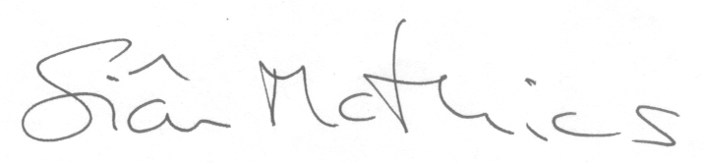Yours sincerely

Sian Mathias

Chair of Wandle Learning Trust